**BJJD- Spring Microservices**

# Project Architecture

We are going to create a Spring Microservices which is based on Spring Boot. It uses Spring Cloud and kubernetes dependencies as well. There are following microservices we are going to develop:

1. **Config-server** (will not use parent pom):
2. **eureka-server** (will not use parent pom):This application is developed to register all the microservices. So that every microservice can communicate with each other without knowing their IP address of the microservice.
3. **gateway-service (Zuul):** A gateway is a single-entry point into the system, used to handle requests by routing them to the corresponding microservice.
4. **Cloud-gateway-service** (will not use parent pom): A gateway is a single-entry point into the system, used to handle requests by routing them to the corresponding microservice
5. **common-service** (will not use parent pom): It is library which will be used by other microservices.
6. **user-service:** User Service is developed to manage the user profile and its role and authorized module can be accessed by user. User details can be cached for retrieval using Hazelcast Cache.
7. **auth-service:** Authentication Service is used for validating user credentials, and issuing tokens. Authentication service can call any user-mgmt-service to validate the user credentials with the DB or any other source.
8. **project-service:** Project Service is developed to manage the project related information such as creating new project, delete, updating. Project details can be cached for retrieval using Hazelcast Cache.
9. **people- service:**
10. **account-service:**
11. **data-upload-service**
12. **message-sender-service**
13. **Kafka-producer-service**
14. **Kafka-consumer-service**
15. **Others**
    1. Get LoggedInUser Details in other microservices
    2. Cache using Hazelcast (Embedded Distributed Cache)
    3. Sleuth, Zipkin and ELK Stack
    4. K8s: It contains the common files used in Kubernetes.
    5. Kubernetes with Helm
    6. Istio (Service Mesh: Sidecar Container: Grafana, Kaili and Distributed tracing using Jager)
    7. Cache Service

## Microservices in Dev Environment

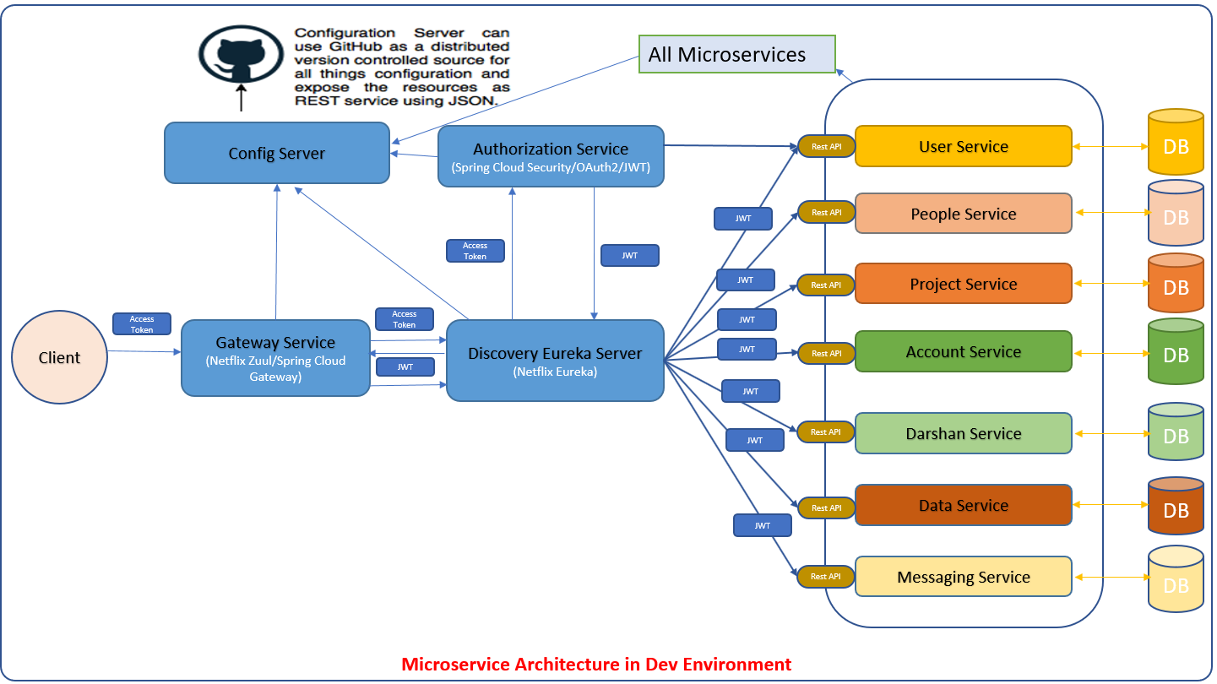

## Microservices in Production Environment (Kubernetes)

* Microservices architecture with OAuth2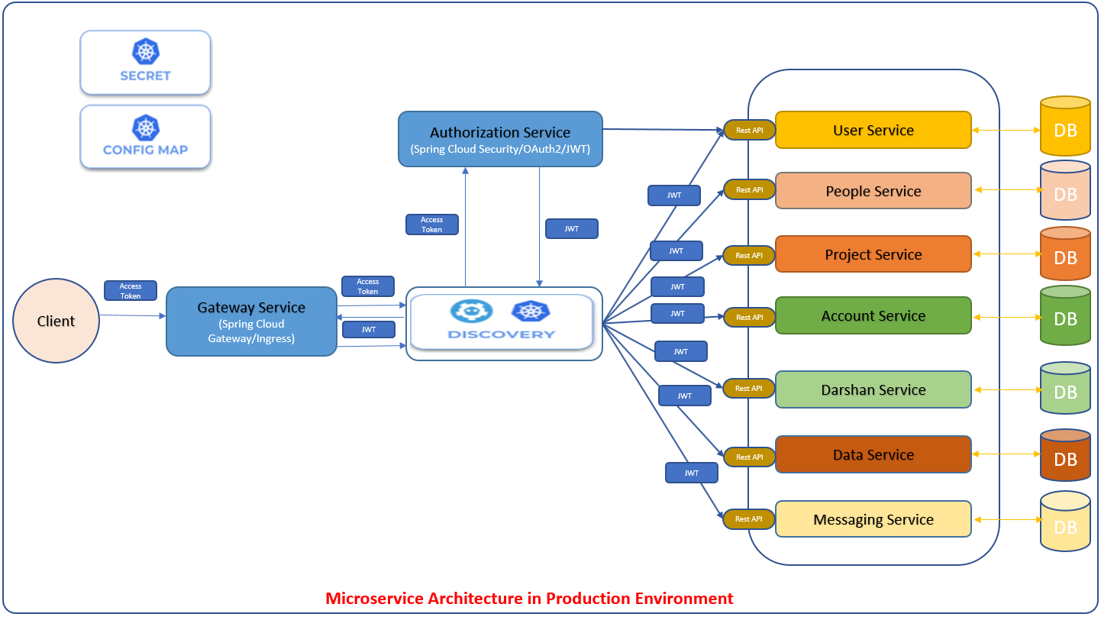

## Microservices with OAuth2 in Dev Environment

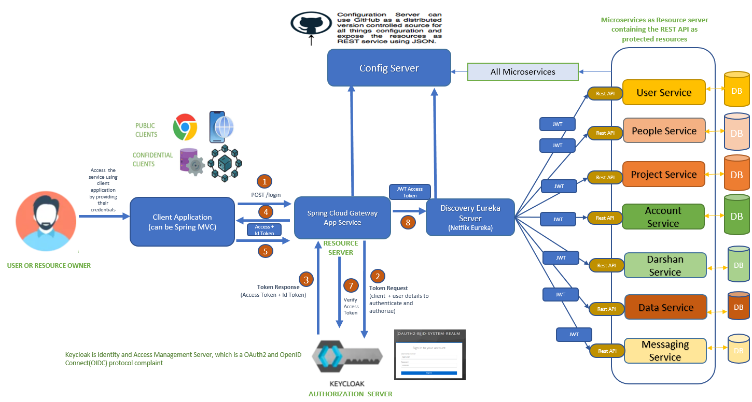

## Multi Module Project

We are going to create a Spring Microservices multi module project as shown in the diagram below

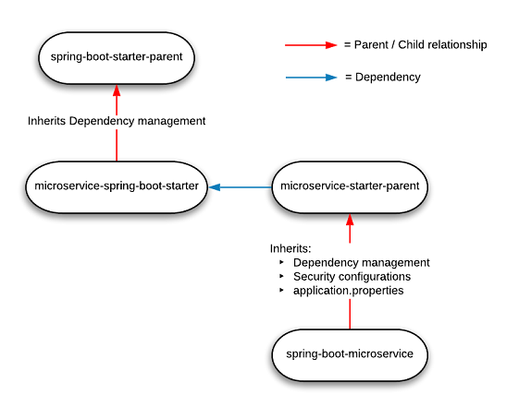

**Parent pom.xml**

Parent pom.xml will be inherited by other microservices.

* + Spring Cloud Starter Config: This dependency is required to connect to the Config Server
  + Spring Boot Starter Parent: update the version: 2.3.4.RELEASE highlighted in yellow colour.
  + Spring Cloud version: upgraded to Hoston.SR4. It is highlighted in yellow colour.
  + Maven Jar Plugin Version: After the above updates, pom is giving compiler error in pom.xml so downgraded version of maven jar plugin to 3.1.1. It is highlighted in yellow colour.
  + Lombok: For getters, setters and constructors etc.
  + Profiles: There are two profiles configured in maven
    1. Dev:
       1. It will pull the application configuration properties from config server.
       2. It will use Eureka Server
       3. It will use the mysql database locally.
       4. It will use Zipkin for distributed tracing. Dependency will be required for the Zipkin.
       5. It will use net.logstash.logback dependency required for logstash.
       6. It will not use Kubernetes discovery strategy for Hazelcast cache
    2. Prod:
       1. It will use configuration and secrets of kubernetes instead of properties from config server.
       2. Eureka client will be disable and it will not use Eureka Server to discover any other microservices. It will use Kubernetes discovery client to discover any microservice.
       3. spring-cloud-starter-kubernetes-all: This dependency will be used only when profile will be prod.
       4. Configured the Kubernetes Discovery Strategy. this configuration will form a Hazelcast with all Hazelcast instances assigned to services in the current namespace.
       5. We will use service mesh ISTIOS for Zipkin ad logstash. So, dependency of logstash and Zipkin is not required.
       6. It will use the mysql AWS RDS database remotely.

<project xmlns=*"http://maven.apache.org/POM/4.0.0"* xmlns:xsi=*"http://www.w3.org/2001/XMLSchema-instance"*

xsi:schemaLocation=*"http://maven.apache.org/POM/4.0.0 http://maven.apache.org/xsd/maven-4.0.0.xsd"*>

<modelVersion>4.0.0</modelVersion>

<groupId>com.jmk</groupId>

<artifactId>bjjd-microservices</artifactId>

<version>0.0.1.RELEASE</version>

<packaging>pom</packaging>

<parent>

<groupId>org.springframework.boot</groupId>

<artifactId>spring-boot-starter-parent</artifactId>

<version>2.3.4.RELEASE</version>

<relativePath /> <!-- lookup parent from repository -->

</parent>

<properties>

<java.version>11</java.version>

<maven.compiler.source>${java.version}</maven.compiler.source>

<maven.compiler.target>${java.version}</maven.compiler.target>

<springfox-version>2.7.0</springfox-version>

<hibernate.version>5.4.10.Final</hibernate.version>

<spring-cloud.version>Hoxton.SR8</spring-cloud.version>

<maven-jar-plugin.version>3.1.1</maven-jar-plugin.version>

<jib-maven-plugin.version>3.1.1</jib-maven-plugin.version>

<jmk-version>0.0.1.RELEASE</jmk-version>

</properties>

<dependencies>

<!-- Spring Boot Starter Dependencies -->

<dependency>

<groupId>org.springframework.boot</groupId>

<artifactId>spring-boot-starter-web</artifactId>

</dependency>

<dependency>

<groupId>org.springframework.boot</groupId>

<artifactId>spring-boot-starter-tomcat</artifactId>

</dependency>

<!-- Actuator is mainly used to expose operational information about the

running application — health, metrics, info, dump, env, etc. -->

<dependency>

<groupId>org.springframework.boot</groupId>

<artifactId>spring-boot-starter-actuator</artifactId>

</dependency>

<!-- Spring Cloud Starter Dependencies -->

<!-- Spring Cloud Starter Config is required to connect config server -->

<dependency>

<groupId>org.springframework.cloud</groupId>

<artifactId>spring-cloud-starter-config</artifactId>

</dependency>

<!-- Distributed Logging Api -->

<dependency>

<groupId>org.springframework.cloud</groupId>

<artifactId>spring-cloud-starter-sleuth</artifactId>

</dependency>

<!-- Spring Hystrix : Circuit Breaker-->

<dependency>

<groupId>org.springframework.cloud</groupId>

<artifactId>spring-cloud-starter-netflix-hystrix</artifactId>

</dependency>

<!-- Spring Open Feign Client -->

<dependency>

<groupId>org.springframework.cloud</groupId>

<artifactId>spring-cloud-starter-openfeign</artifactId>

</dependency>

<!-- Spring Cloud Netflix Eureka Client -->

<dependency>

<groupId>org.springframework.cloud</groupId>

<artifactId>spring-cloud-starter-netflix-eureka-client</artifactId>

</dependency>

<!-- Spring Netflix ribbon LoadBalancer -->

<dependency>

<groupId>org.springframework.cloud</groupId>

<artifactId>spring-cloud-starter-netflix-ribbon</artifactId>

</dependency>

<!--SpringFox dependencies -->

<dependency>

<groupId>io.springfox</groupId>

<artifactId>springfox-swagger2</artifactId>

<version>${springfox-version}</version>

</dependency>

<dependency>

<groupId>io.springfox</groupId>

<artifactId>springfox-swagger-ui</artifactId>

<version>${springfox-version}</version>

</dependency>

<dependency>

<groupId>com.github.joschi.jackson</groupId>

<artifactId>jackson-datatype-threetenbp</artifactId>

<version>2.6.4</version>

</dependency>

<!-- Lombok data -->

<dependency>

<groupId>org.projectlombok</groupId>

<artifactId>lombok</artifactId>

<scope>compile</scope>

</dependency>

<!-- spring-boot-starter-test “Starter”, which imports both Spring Boot

test modules as well as JUnit, AssertJ, Hamcrest, and a number of other useful

libraries. -->

<dependency>

<groupId>org.springframework.boot</groupId>

<artifactId>spring-boot-starter-test</artifactId>

<scope>test</scope>

</dependency>

<dependency>

<groupId>org.junit.vintage</groupId>

<artifactId>junit-vintage-engine</artifactId>

<scope>test</scope>

</dependency>

</dependencies>

<dependencyManagement>

<dependencies>

<dependency>

<groupId>org.springframework.cloud</groupId>

<artifactId>spring-cloud-dependencies</artifactId>

<version>${spring-cloud.version}</version>

<type>pom</type>

<scope>import</scope>

</dependency>

</dependencies>

</dependencyManagement>

<profiles>

<profile>

<id>dev</id>

<activation>

<activeByDefault>true</activeByDefault>

</activation>

<properties>

<spring.profiles.active>dev</spring.profiles.active>

</properties>

<dependencies>

<dependency>

<groupId>net.logstash.logback</groupId>

<artifactId>logstash-logback-encoder</artifactId>

<version>6.6</version>

</dependency>

<!-- Zipkin:distributed tracing system which provides a UI to see the traces -->

<dependency>

<groupId>org.springframework.cloud</groupId>

<artifactId>spring-cloud-starter-zipkin</artifactId>

</dependency>

</dependencies>

</profile>

<profile>

<id>prod</id>

<properties>

<spring.profiles.active>prod</spring.profiles.active>

</properties>

<dependencies>

<dependency>

<groupId>org.springframework.cloud</groupId>

<artifactId>spring-cloud-starter-kubernetes-all</artifactId>

<!-- <version>1.1.2.RELEASE</version> -->

</dependency>

</dependencies>

</profile>

</profiles>

<build>

<sourceDirectory>src/main/java</sourceDirectory>

<plugins>

<plugin>

<groupId>org.springframework.boot</groupId>

<artifactId>spring-boot-maven-plugin</artifactId>

<executions>

<execution>

<goals>

<goal>repackage</goal>

</goals>

</execution>

</executions>

</plugin>

</plugins>

</build>

<modules>

<module>common-service</module>

<module>user-service</module>

<module>project-service</module>

<module>account-service</module>

<module>darshan-service</module>

<module>data-upload-service</module>

<module>eureka-server</module>

<module>message-sender-service</module>

<module>people-service</module>

<module>config-server</module>

<module>auth-service</module>

<module>gateway-service</module>

<module>cloud-gateway-service</module>

<!-- Additional Modules -->

<module>kafka-producer-service</module>

<module>kafka-consumer-service</module>

<module>cache-service</module>

</modules>

</project>

# Config-server

This application is used to externalize properties or resource files out of server where the values of those resources vary during runtime – usually different configurations that will differ in each environment.

1. Create the config server – It will point to config server git repository and will provide the access of the all the properties to its related microservice.
2. Create the config server git repo – It will maintain the application.properties of the microservices.
3. Update the microservices to point config server – To make changes in the new or existing microservice so that it can access its application .properties using config server.

### **A. Create the config server**

* Create Spring Boot Project

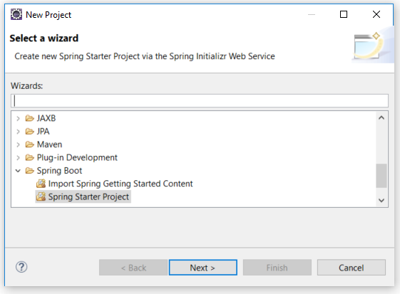

* Click on next

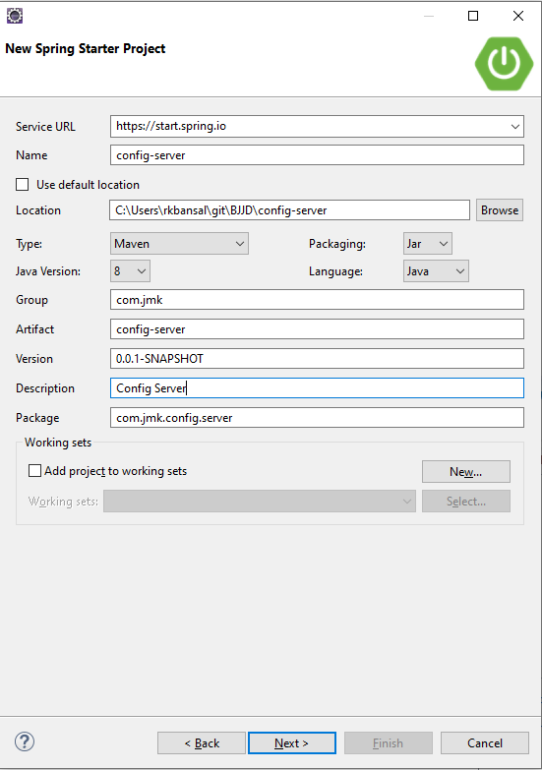

* **Select the dependencies: Spring Cloud Config – Config Server and Click on Finish.**

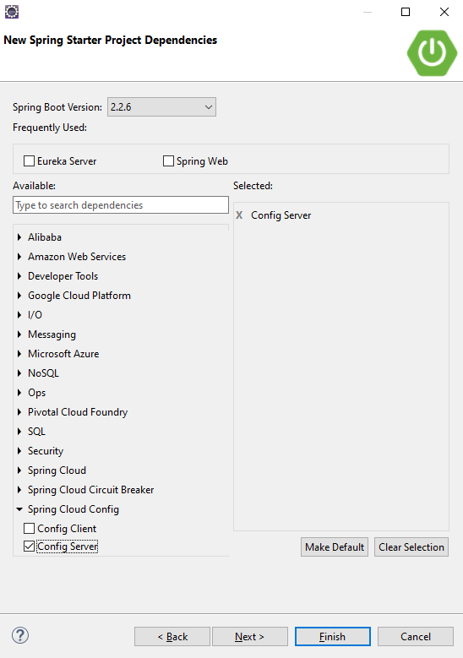

* **Import the project in eclipse.**

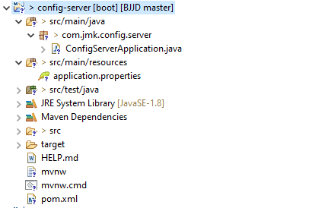

* Dependencies already imported can be seen in pom.xml but need to update with the following changes
  + Spring Cloud Config server: This dependency is required to configure the config server along with dependency management circled in blue colour in the below picture.
  + Spring Boot Starter Parent: update the version - 2.3.4.RELEASE highlighted in yellow colour.
  + Spring Cloud version: upgraded to Hoston.SR4. It is highlighted in yellow colour.
  + Maven Jar Plugin Version: After the above updates, pom is giving compiler error in pom.xml so downgraded version of maven jar plugin to 3.1.1. It is highlighted in yellow colour.

<?xml version=*"1.0"* encoding=*"UTF-8"*?>

<project xmlns=*"http://maven.apache.org/POM/4.0.0"* xmlns:xsi=*"http://www.w3.org/2001/XMLSchema-instance"*

xsi:schemaLocation=*"http://maven.apache.org/POM/4.0.0 https://maven.apache.org/xsd/maven-4.0.0.xsd"*>

<modelVersion>4.0.0</modelVersion>

<parent>

<groupId>org.springframework.boot</groupId>

<artifactId>spring-boot-starter-parent</artifactId>

<version> 2.3.4.RELEASE</version>

<relativePath/> <!-- lookup parent from repository -->

</parent>

<groupId>com.jmk</groupId>

<artifactId>config-server</artifactId>

<version>0.0.1-RELEASE</version>

<name>config-server</name>

<description>Config Server</description>

<properties>

<java.version>11</java.version>

<spring-cloud.version>Hoxton.SR8</spring-cloud.version>

<maven-jar-plugin.version>3.1.1</maven-jar-plugin.version>

</properties>

<dependencies>

<dependency>

<groupId>org.springframework.cloud</groupId>

<artifactId>spring-cloud-config-server</artifactId>

</dependency>

<dependency>

<groupId>org.springframework.boot</groupId>

<artifactId>spring-boot-starter-actuator</artifactId>

</dependency>

<dependency>

<groupId>org.springframework.boot</groupId>

<artifactId>spring-boot-starter-test</artifactId>

<scope>test</scope>

</dependency>

</dependencies>

<dependencyManagement>

<dependencies>

<dependency>

<groupId>org.springframework.cloud</groupId>

<artifactId>spring-cloud-dependencies</artifactId>

<version>${spring-cloud.version}</version>

<type>pom</type>

<scope>import</scope>

</dependency>

</dependencies>

</dependencyManagement>

<build>

<plugins>

<plugin>

<groupId>org.springframework.boot</groupId>

<artifactId>spring-boot-maven-plugin</artifactId>

</plugin>

</plugins>

</build>

</project>

* **Enable the annotation @EnableConfigServer**

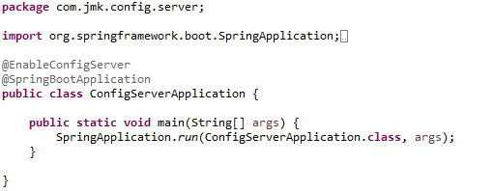

* **Update the application.properties with the git repository will be created in this section after this step.**

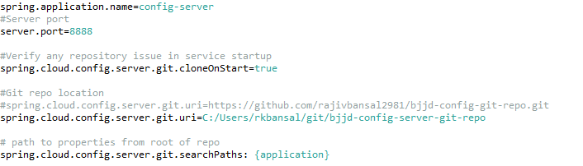

### **B. Create the config server git repo**

The next essential step is to create a local git repository. It can easily be converted to a remote repository later by configuring its URL in the properties file. We will place the external property file [configuration], which will be used by the Config server microservice to provide the external configuration of properties.

* Make sure you have git shell installed in your machine and you can run git bash from command prompt. To verify it open command prompt and type git, if it recognizes the command then you probably have the git prompt installed, if not please follow git website, download and install as per the instruction.
* Now Create a directory **bjjd-config-server-git-repo** in location: C:\Users\rkbansal\git\bjjd-config-server-git-repo
* Create microservice name wise folder in **bjjd-config-server-git-repo**. For example:

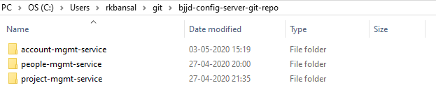

* Structure of any project can be seen:

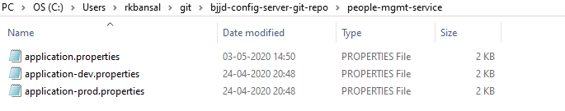

* Let’s look into any properties file. For e.g. application.properties of people-mgmt-service

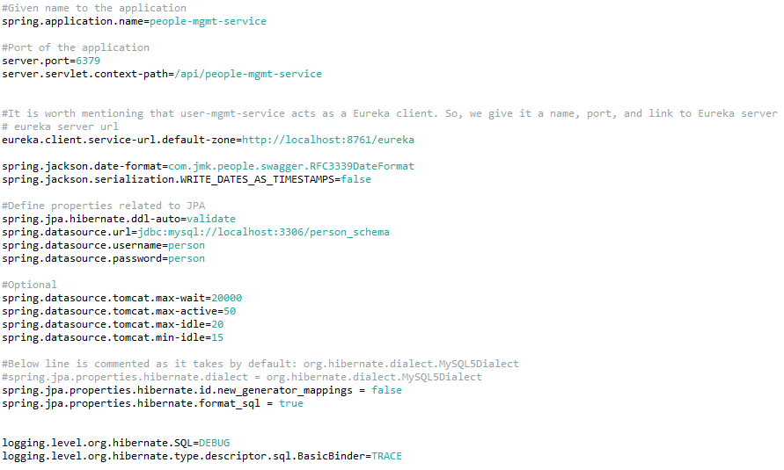

* Open the command prompt and go to the **bjjd-config-server-git-repo** in location: C:\Users\rkbansal\git\bjjd-config-server-git-repo
  + Git Command to initialize the git repository:
    - git init
  + Git command to add the code in the git repository:
    - Git add .
  + Git command to commit the code in the git repository:
    - Git commit -m “Initial Commit”

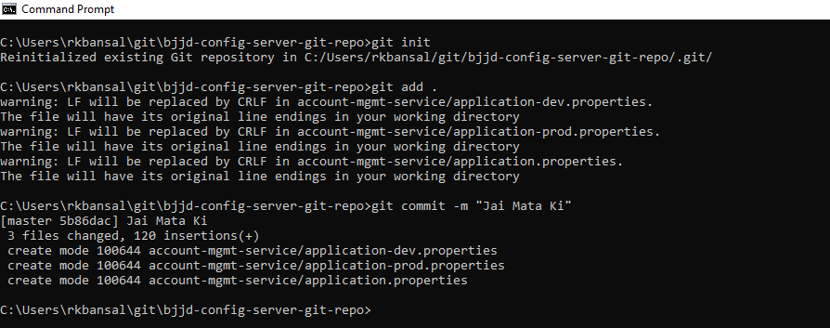

* After creating the git repository, it can be imported in Eclipse as GIT repository and as a General Project.

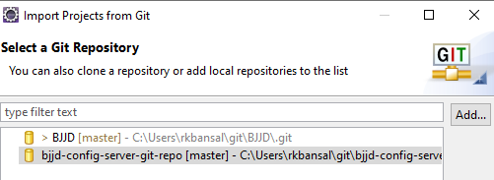

* Import as a General Project

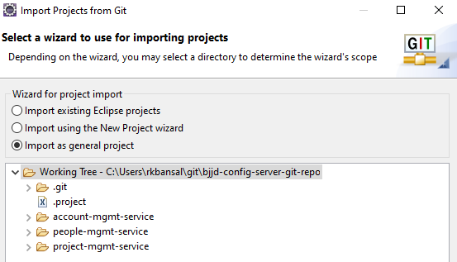

* This project can be seen in eclipse

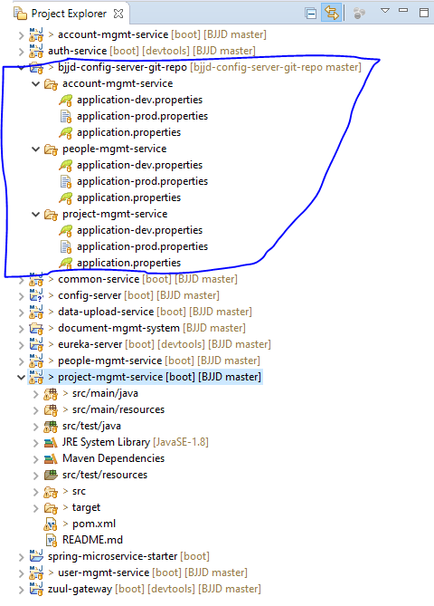

* Point the git repo from Config Server

Update the application.properties in the src\main\resources directory of spring-config-sever project and add below lines.



* To verify the Config server configuration, run the Config Server application and check the following URL:
  + URL to check the dev properties of people-mgmt-service : <http://localhost:8888/people-mgmt-service/dev>



* + URL to check the prod properties of people-mgmt-service : <http://localhost:8888/people-mgmt-service/prod>



### **C. [Optional]Move the local config server git repo to GitHub**

1. After performing the step B.
2. Follow the below steps to create the remote, empty folder/repository in GitHub named:
   1. Login to your GitHub account.
   2. At the top right of any GitHub page, you should see a '+' icon. Click that, then select 'New Repository'.
   3. Give your repository a name--ideally the same name as your local project. If I'm building a bjjd-config-server-git-repo  application, its folder will be called 'bjjd-config-server-git-repo' on my computer, and 'bjjd-config-server-git-repo' will be the GitHub repository name as well.
   4. Click 'Create Repository'. The next screen you see will be important, so don't close it.

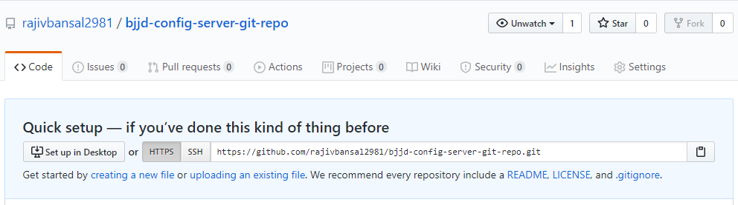

1. Connect your local project folder to your empty folder/repository(https://github.com/rajivbansal2981/bjjd-config-server-git-repo.git) on GitHub
   1. Go back to your project in the terminal/command line.

cd C:\Users\rkbansal\git\bjjd-config-server-git-repo

* 1. In your terminal/command line, type git remote add origin [copied web address]

git remote add origin <https://github.com/rajivbansal2981/bjjd-config-server-git-repo.git>

* 1. Push your branch to GitHub and provide user id and password when prompted

git push origin master

* 1. Go back to the folder/repository screen on Github that you just left, and refresh it you should see your files there.

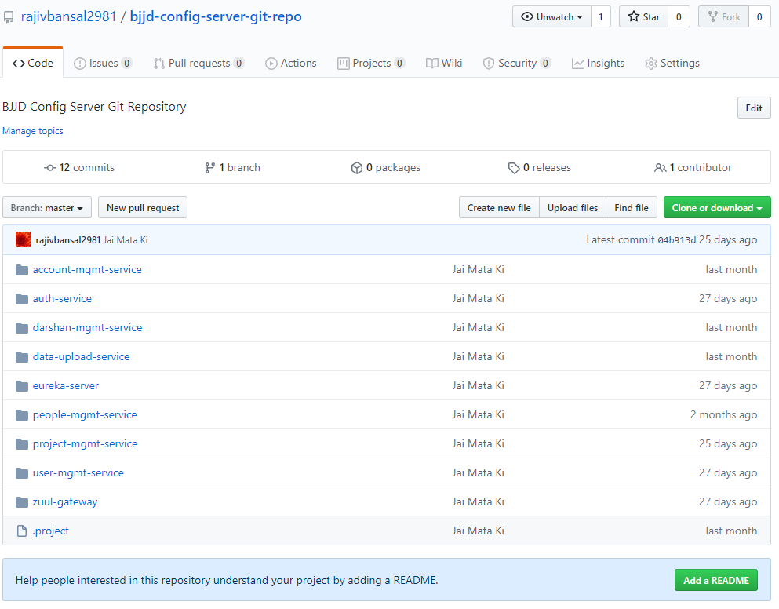

1. To update the application.properties of project: config-server and enable the git URI path for GitHub

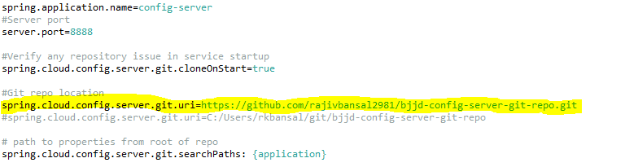

4. Connect your l

### **D. Update the microservices to point config server**

In this step, we need to make changes in the new or existing microservices so that it can access its application.properties using config server.

**For example:** people-mgmt-service

**Perquisite:** people-mgmt-service’s pom should be updated with the following changes:

* + Spring Cloud Starter Config: This dependency is required to connect to the Config Server
  + Spring Boot Starter Parent: update the version : 2.3.4.RELEASE highlighted in yellow colour.
  + Spring Cloud version: upgraded to Hoston.SR4. It is highlighted in yellow colour.
  + Maven Jar Plugin Version: After the above updates, pom is giving compiler error in pom.xml so downgraded version of maven jar plugin to 3.1.1. It is highlighted in yellow colour.
* Need to make the changes in pom.xml of people-mgmt-service

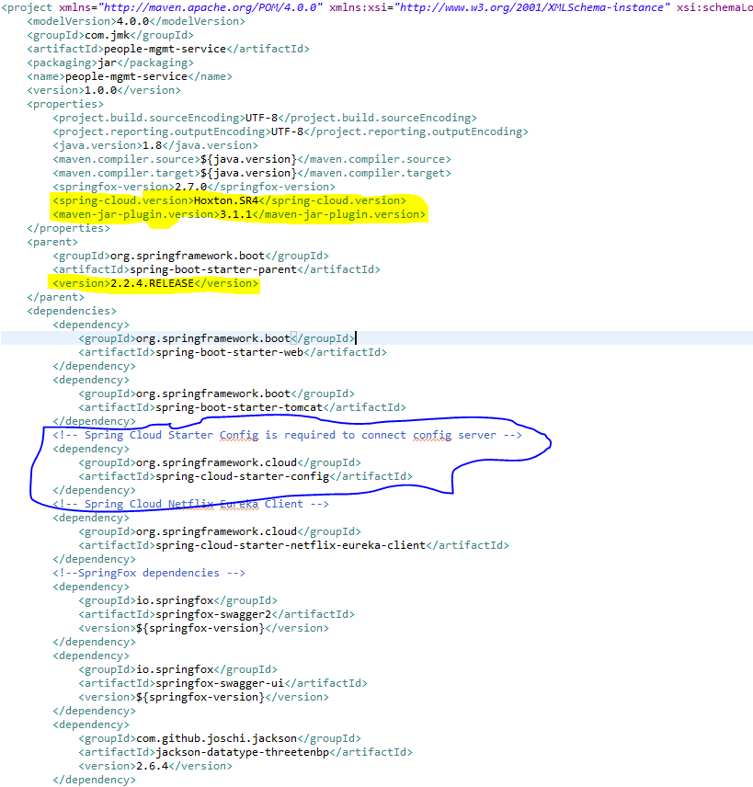

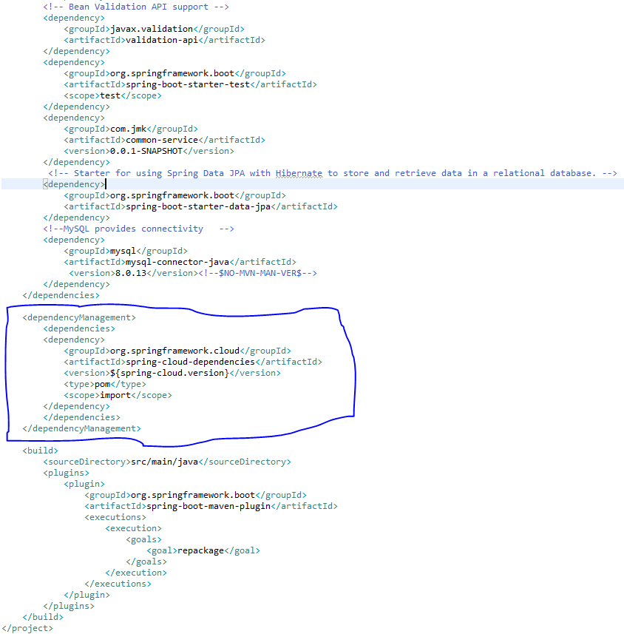

* Moved the main application.properties along with different profiles to git repository: **bjjd-config-server-git-repo**



* In the people-mgmt-service, still there will be an application.properties file but it will have following minimum details:
  + Name of the application
  + Active default profile
  + Cloud config server URI with port

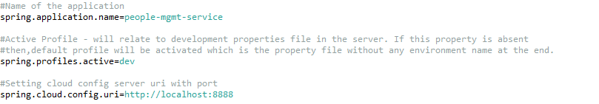

* To verify all the changes, run the following applications in the order:
  + ConfigServerApplication
  + EurekaServerApplication
  + PeopleMgmtRestApplication

Directly hitting the people-mgmt-project running on 6379 and fetch the member details based on the id

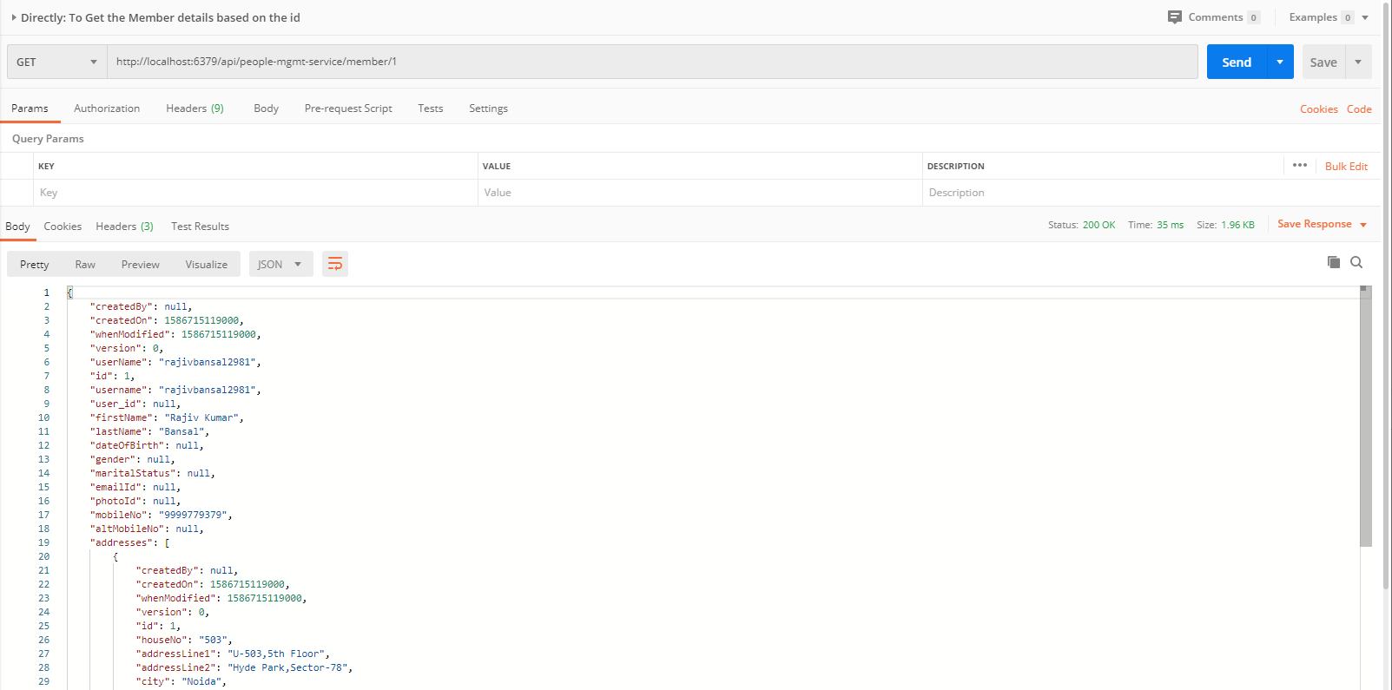

# Eureka-server

Eureka Server or service will register every microservice and then the client microservice will look up the Eureka server to get a dependent microservice to get the job done without knowing the IP address of dependent microservice.

Eureka Server is owned by Netflix and in this, Spring Cloud offers a declarative way to register and invoke services by Java annotation.

It’s duty to give names to each microservice. Why?

* No need to hardcode the IP addresses of microservices.
* What if services use dynamic IP addresses; when autoscaling.

So, every service register itself with Eureka, and pings Eureka server to notify that it’s alive.

This application is developed to register all the microservices. So that every microservice can communicate with each other without knowing their IP address of the microservice.

* Create Spring Boot Project



* Click on next

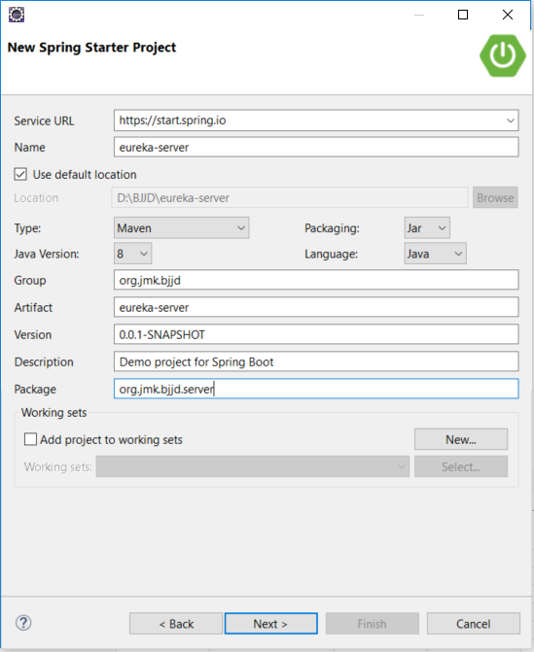

* Click on **Next** and **Finish** and created project will look as per the below screenshot:

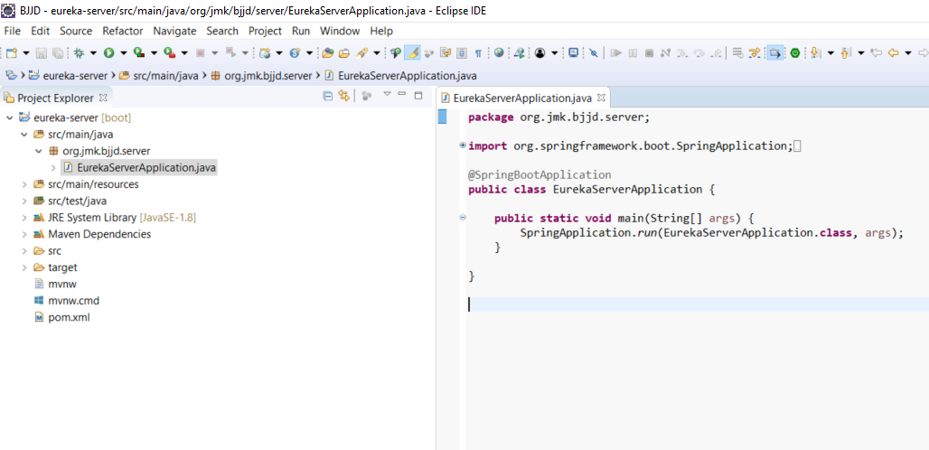

* Add the following dependencies in pom.xml with the following considerations:
  1. Spring Cloud Starter Config: This dependency is required to connect to the Config Server
  2. Spring Boot Starter Parent: update the version: 2.3.4.RELEASE highlighted in yellow colour.
  3. Spring Cloud version: upgraded to Hoston.SR. It is highlighted in yellow colour.
  4. Maven Jar Plugin Version: After the above updates, pom is giving compiler error in pom.xml so downgraded version of maven jar plugin to 3.1.1. It is highlighted in yellow colour.
  5. Web
  6. Eureka Server
  7. DevTools (optional)

<?xml version=*"1.0"* encoding=*"UTF-8"*?>

<project xmlns=*"http://maven.apache.org/POM/4.0.0"*

xmlns:xsi=*"http://www.w3.org/2001/XMLSchema-instance"*

xsi:schemaLocation=*"http://maven.apache.org/POM/4.0.0 http://maven.apache.org/xsd/maven-4.0.0.xsd"*>

<modelVersion>4.0.0</modelVersion>

<parent>

<groupId>org.springframework.boot</groupId>

<artifactId>spring-boot-starter-parent</artifactId>

<version> 2.3.4.RELEASE</version>

<relativePath/> <!-- lookup parent from repository -->

</parent>

<groupId>com.jmk</groupId>

<artifactId>eureka-server</artifactId>

<version>0.0.1-RELEASE</version>

<name>eureka-server</name>

<description>Demo project for Spring Boot</description>

<properties>

<java.version>11</java.version>

<spring-cloud.version>Hoxton.SR8</spring-cloud.version>

<maven-jar-plugin.version>3.1.1</maven-jar-plugin.version>

</properties>

<dependencies>

<dependency>

<groupId>org.springframework.boot</groupId>

<artifactId>spring-boot-starter</artifactId>

</dependency>

<dependency>

<groupId>org.springframework.boot</groupId>

<artifactId>spring-boot-starter-web</artifactId>

</dependency>

<!-- Spring Cloud Starter Config is required to connect config server -->

<dependency>

<groupId>org.springframework.cloud</groupId>

<artifactId>spring-cloud-starter-config</artifactId>

</dependency>

<!-- https://mvnrepository.com/artifact/org.springframework.cloud/spring-cloud-starter-netflix-eureka-server -->

<dependency>

<groupId>org.springframework.cloud</groupId>

<artifactId>spring-cloud-starter-netflix-eureka-server</artifactId>

</dependency>

<dependency>

<groupId>org.springframework.boot</groupId>

<artifactId>spring-boot-starter-test</artifactId>

<scope>test</scope>

</dependency>

<!-- https://mvnrepository.com/artifact/org.springframework.boot/spring-boot-devtools -->

<dependency>

<groupId>org.springframework.boot</groupId>

<artifactId>spring-boot-devtools</artifactId>

<optional>true</optional>

</dependency>

</dependencies>

<dependencyManagement>

<dependencies>

<dependency>

<groupId>org.springframework.cloud</groupId>

<artifactId>spring-cloud-dependencies</artifactId>

<version>${spring-cloud.version}</version>

<type>pom</type>

<scope>import</scope>

</dependency>

</dependencies>

</dependencyManagement>

<build>

<plugins>

<plugin>

<groupId>org.springframework.boot</groupId>

<artifactId>spring-boot-maven-plugin</artifactId>

</plugin>

</plugins>

</build>

</project>

* Moved the following main application.properties along with different profiles to git repository: **bjjd-config-server-git-repo**

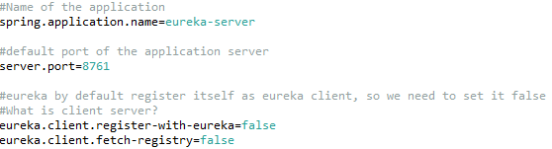

* In this application, still there will be an application.properties file but it will have the following minimum details:
  + Name of the application
  + Active Default Profile
  + Cloud Config server URI with port

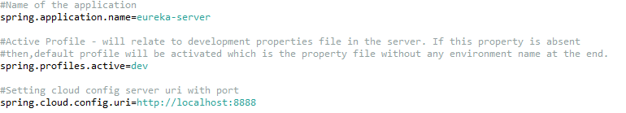

* Made changes in the **EurekaServerApplication** Class

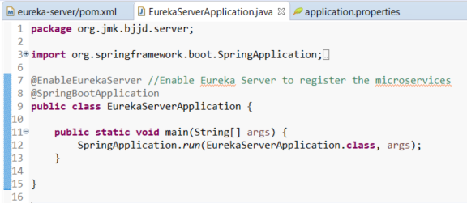

* Run the application as **Spring Boot App**: EurekaServerApplication

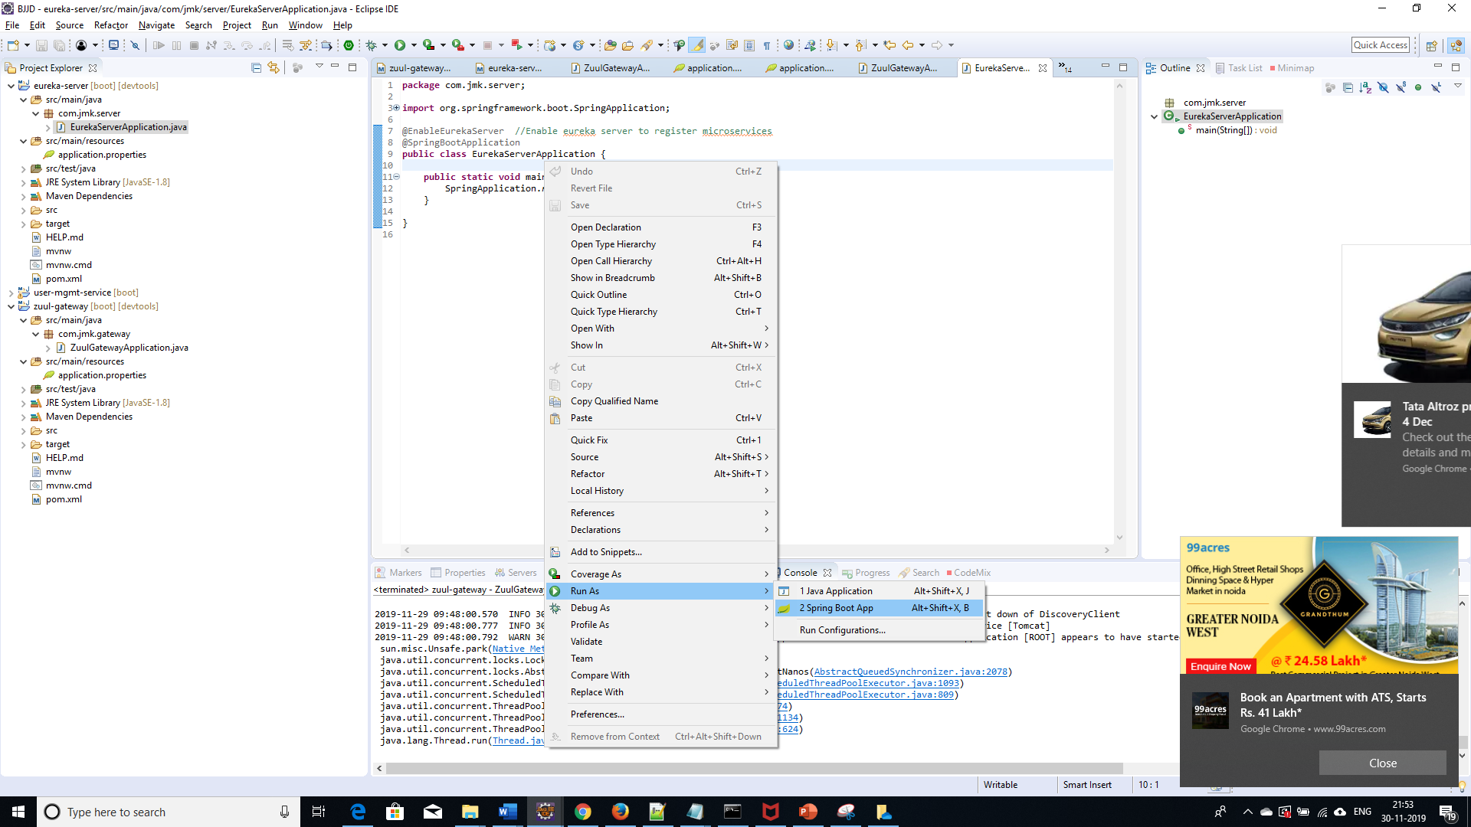

* Open the browser and enter the url: <http://localhost:8761/>

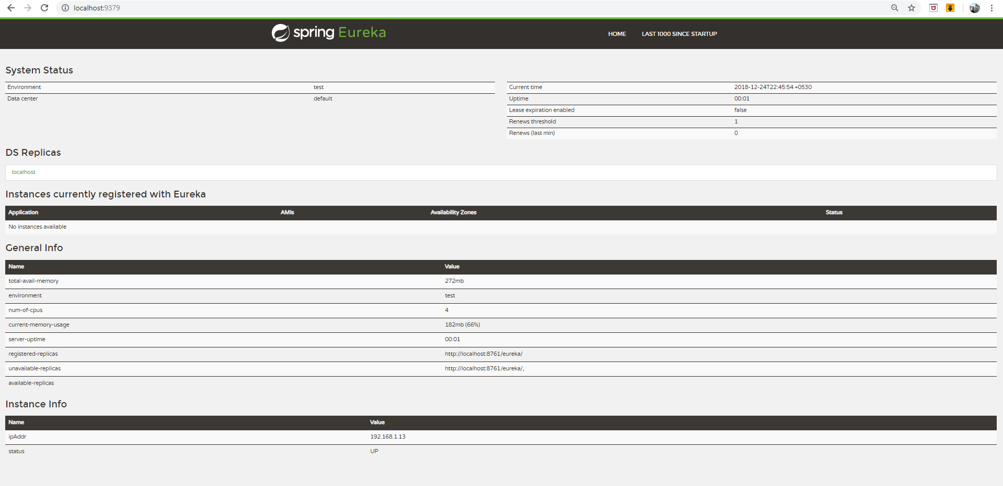

# Common-service

When we have common configuration variables, models, Enum classes, common logic and general exception handling, used by multiple microservices, like the one we have JwtConfig, Status Enum, User Model related classes used in the Authentication Services and User Management Service.

* To do so, just create a new project (service), call it ‘common-service’, and follow the same steps as we did with the image service. So, In pom.xml file

<?xml version=*"1.0"* encoding=*"UTF-8"*?>

<project xmlns=*"http://maven.apache.org/POM/4.0.0"* xmlns:xsi=*"http://www.w3.org/2001/XMLSchema-instance"*

xsi:schemaLocation=*"http://maven.apache.org/POM/4.0.0 https://maven.apache.org/xsd/maven-4.0.0.xsd"*>

<modelVersion>4.0.0</modelVersion>

<parent>

<groupId>org.springframework.boot</groupId>

<artifactId>spring-boot-starter-parent</artifactId>

<version> 2.3.4.RELEASE</version>

<relativePath/> <!-- lookup parent from repository -->

</parent>

<groupId>com.jmk</groupId>

<artifactId>common-service</artifactId>

<version>0.0.1-RELEASE</version>

<name>common-service</name>

<description>Demo project for Spring Boot</description>

<properties>

<java.version>11</java.version>

<springfox-version>2.7.0</springfox-version>

<maven-jar-plugin.version>3.1.1</maven-jar-plugin.version>

</properties>

<dependencies>

<dependency>

<groupId>org.springframework.boot</groupId>

<artifactId>spring-boot-starter</artifactId>

</dependency>

<dependency>

<groupId>org.springframework.boot</groupId>

<artifactId>spring-boot-starter-web</artifactId>

</dependency>

<!-- Entity to Model mapper -->

<dependency>

<groupId>org.modelmapper</groupId>

<artifactId>modelmapper</artifactId>

<version>2.3.5</version>

</dependency>

<!-- Spring Cloud Open Feign Client to handle the Feign Exceptions -->

<dependency>

<groupId>org.springframework.cloud</groupId>

<artifactId>spring-cloud-starter-openfeign</artifactId>

<version>2.1.4.RELEASE</version>

</dependency>

<!-- Lombok data -->

<dependency>

<groupId>org.projectlombok</groupId>

<artifactId>lombok</artifactId>

<scope>provided</scope>

</dependency>

<!--SpringFox dependencies -->

<dependency>

<groupId>io.springfox</groupId>

<artifactId>springfox-swagger2</artifactId>

<version>${springfox-version}</version>

</dependency>

<dependency>

<groupId>io.springfox</groupId>

<artifactId>springfox-swagger-ui</artifactId>

<version>${springfox-version}</version>

</dependency>

<dependency>

<groupId>org.springframework.boot</groupId>

<artifactId>spring-boot-starter-test</artifactId>

<scope>test</scope>

</dependency>

</dependencies>

</project>

* In Application.properties, no need to define anything as it will be used a JAR file in other microservices
* Put all the
  + common configuration variables,
  + Classes, Enum classes, or logic, used by multiple microservices,
  + like the one we had JwtConfig, Status Enum, User Model related classes used in the Authentication Services and User Management Service
  + Model classes of all the microservices.
* Now, to be able to call JwtConfig class, User Model related classes from other services, like auth and gateway, we just need to add the common service in pom.xml as dependency.
* Add the dependency of common-service in auth-service’s pom.xml or any other microservice which is dependent on common-service.

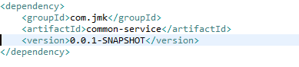

* Now we can use the common configurations and classes.

### **Exception Handling**

Handling errors correctly in APIs while providing meaningful error messages is a very desirable feature, as it can help the API client properly respond to issues. The default behaviour tends to be returning stack traces that are hard to understand and ultimately useless for the API client. Partitioning the error information into fields also enables the API client to parse it and provide better error messages to the user.

#### **Making Error Responses Clearer**

Throughout this article, we’ll be using the [source code hosted on GitHub](https://github.com/brunocleite/spring-boot-exception-handling) of an application that implements a REST API for retrieving objects that represent birds. It has the features described in this article and a few more examples of error handling scenarios. Here’s a summary of endpoints implemented in that application:

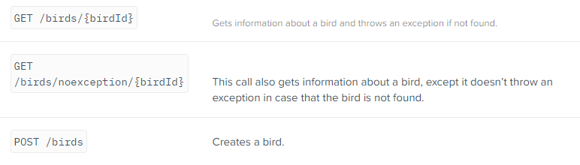

The Spring framework MVC module comes with some great features to help with error handling. But it is left to the developer to use those features to treat the exceptions and return meaningful responses to the API client.

Let’s look at an example of the default Spring Boot answer when we issue an HTTP POST to the /birds endpoint with the following JSON object, that has the string “aaa” on the field “mass,” which should be expecting an integer:

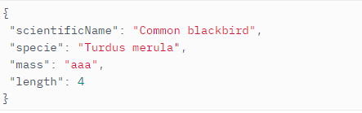

The Spring Boot default answer, without proper error handling:

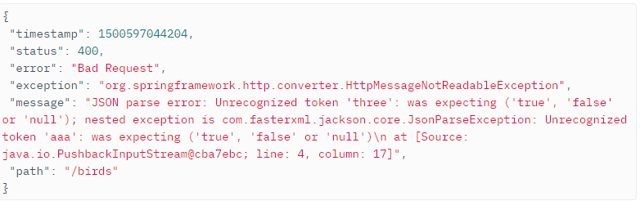

Well… the response message has some good fields, but it is focused too much on what the exception was. By the way, this is the class DefaultErrorAttributes from Spring Boot. The timestamp field is an integer number that doesn’t even carry information of what measurement unit the timestamp is in. The exception field is only interesting to Java developers and the message leaves the API consumer lost in all the implementation details that are irrelevant to them. And what if there were more details that we could extract from the exception that the error originated from? So, let’s learn how to treat those exceptions properly and wrap them into a nicer JSON representation to make life easier for our API clients.

As we’ll be using Java 8 date and time classes, we first need to add a Maven dependency for the Jackson JSR310 converters. They take care of converting Java 8 date and time classes to JSON representation using the @JsonFormat annotation:

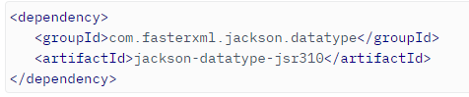

Ok, so let’s define a class for representing API errors. We’ll be creating a class called ApiError and its associated classes that has enough fields to hold relevant information about errors that happen during REST calls.

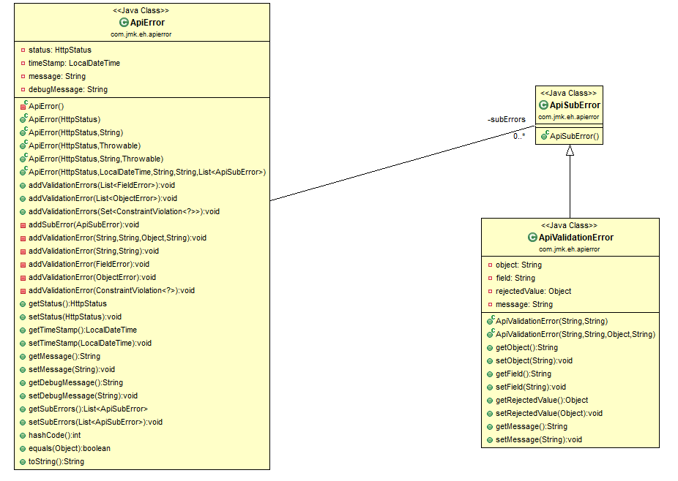

**ApiError Class:**

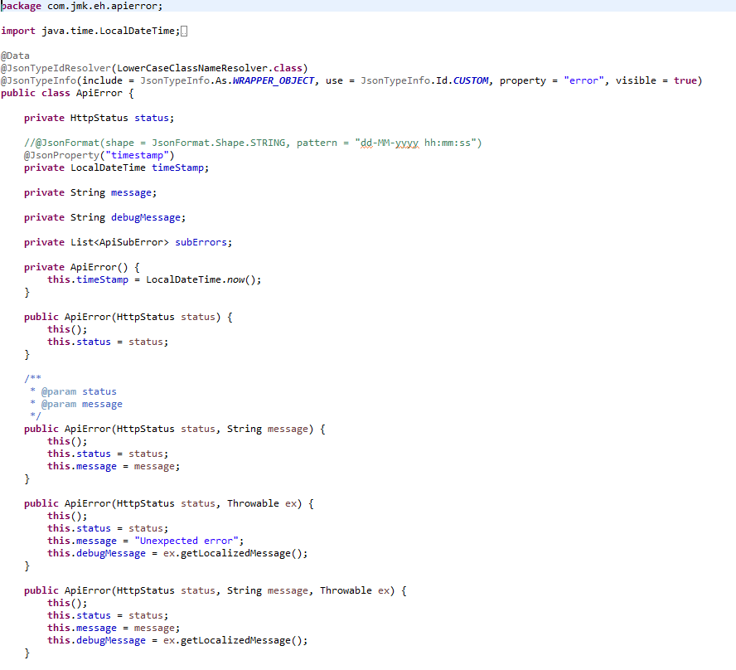

* The status property holds the operation call status. It will be anything from 4xx to signalize client errors or 5xx to mean server errors. A common scenario is a http code 400 that means a BAD\_REQUEST, when the client, for example, sends an improperly formatted field, like an invalid email address.
* The timestamp property holds the date-time instance of when the error happened.
* The message property holds a user-friendly message about the error.
* The debugMessage property holds a system message describing the error in more detail.
* The subErrors property holds an array of sub-errors that happened. This is used for representing multiple errors in a single call. An example would be validation errors in which multiple fields have failed the validation. The ApiSubError class is used to encapsulate those.

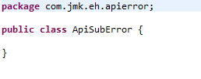

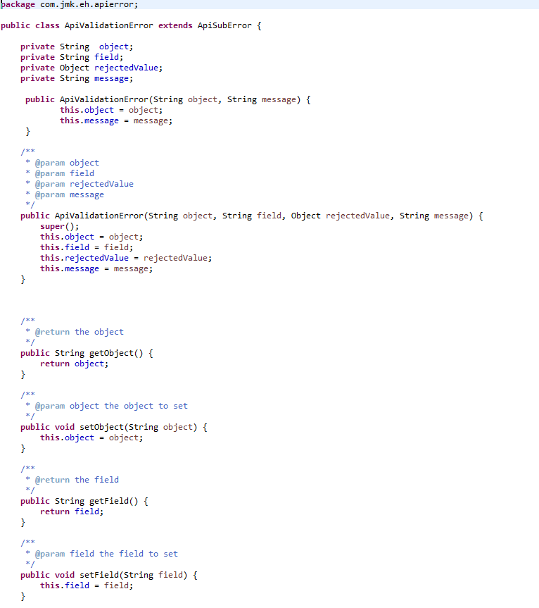

So then the ApiValidationError is a class that extends ApiSubError and expresses validation problems encountered during the REST call.

Below, you’ll see some examples of JSON responses that are being generated after we have implemented the improvements described here, just to get an idea of what we’ll have by the end of this article.

Here is an example of JSON returned when an entity is not found while calling endpoint GET /birds/2:

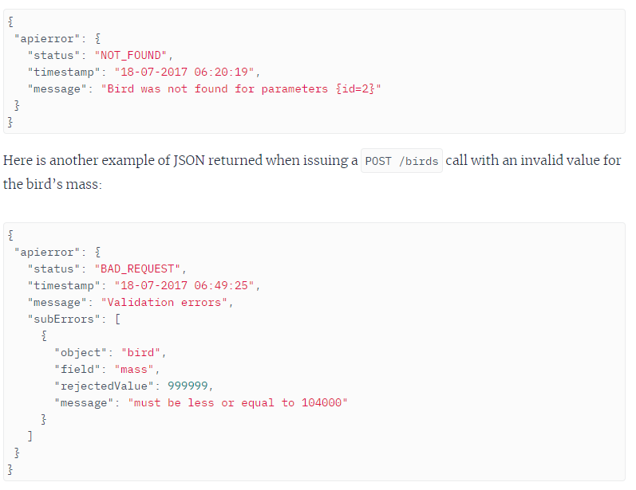

#### **Spring Boot Error Handling**

Let’s explore some of the Spring annotations that will be used to handle exceptions.

[RestController](https://docs.spring.io/spring/docs/current/javadoc-api/org/springframework/web/bind/annotation/RestController.html) is the base annotation for classes that handle REST operations.

* [**ExceptionHandler**](https://docs.spring.io/spring/docs/current/javadoc-api/org/springframework/web/bind/annotation/ExceptionHandler.html): It is a Spring annotation that provides a mechanism to treat exceptions that are thrown during execution of handlers (Controller operations). This annotation, if used on methods of controller classes, will serve as the entry point for handling exceptions thrown within this controller only. Altogether, the most common way is to use @ExceptionHandler on methods of @ControllerAdvice classes so that the exception handling will be applied globally or to a subset of controllers.
* [**ControllerAdvice**](https://docs.spring.io/spring/docs/current/javadoc-api/org/springframework/web/bind/annotation/ControllerAdvice.html)**:** It is an annotation introduced in Spring 3.2, and as the name suggests, is “Advice” for multiple controllers. It is used to enable a single ExceptionHandler to be applied to multiple controllers. This way we can in just one place define how to treat such an exception and this handler will be called when the exception is thrown from classes that are covered by this ControllerAdvice.

The subset of controllers affected can defined by using the following selectors on @ControllerAdvice: annotations(), basePackageClasses(), and basePackages(). If no selectors are provided, then the ControllerAdvice is applied globally to all controllers.

So, by using @ExceptionHandler and @ControllerAdvice, we’ll be able to define a central point for treating exceptions and wrapping them up in an ApiError object with better organization than the default Spring Boot error handling mechanism.

#### **Handling Exceptions**

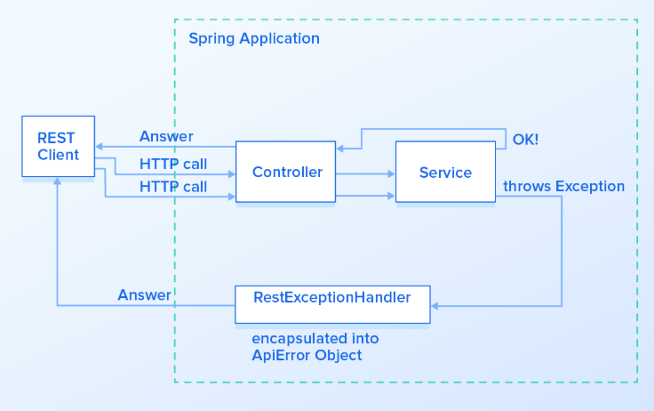

The next step is to create the class that will handle the exceptions. For simplicity, we are calling it RestExceptionHandler and it must extend from Spring Boot’s ResponseEntityExceptionHandler. We’ll be extending ResponseEntityExceptionHandler as it already provides some basic handling of Spring MVC exceptions, so we’ll be adding handlers for new exceptions while improving the existing ones.

Overriding Exceptions Handled In ResponseEntityExceptionHandler

If you take a look into the source code of ResponseEntityExceptionHandler, you’ll see a lot of methods called handle\*\*\*\*\*\*() like handleHttpMessageNotReadable() or handleHttpMessageNotWritable(). Let’s first see how can we extend handleHttpMessageNotReadable() to handle HttpMessageNotReadableException exceptions. We just have to override the method handleHttpMessageNotReadable() in our RestExceptionHandler class:

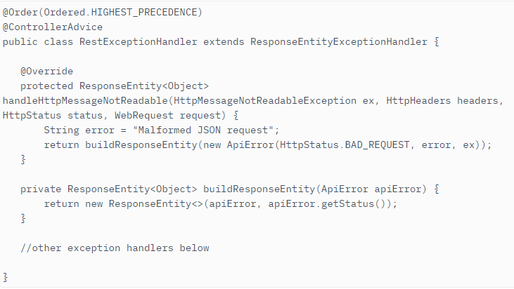

We have declared that in case of a HttpMessageNotReadableException being thrown, the error message will be “Malformed JSON request” and the error will be encapsulated inside the ApiError object. Below we can see the answer of a REST call with this new method overridden:

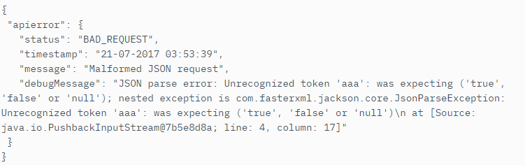

##### **Handling Rest Custom Exceptions**

Now we’ll see how to create a method that handles an exception that is not yet declared inside Spring Boot’s ResponseEntityExceptionHandler.

A common scenario for a Spring application that handles database calls is to have a call to find a record by its ID using a repository class. But if we look into the CrudRepository.findOne() method, we’ll see that it returns null if an object is not found. That means that if our service just calls this method and returns directly to the controller, we’ll get an HTTP code 200 (OK) even if the resource isn’t found. In fact, the proper approach is to return a HTTP code 404 (NOT FOUND) as specified in the [HTTP/1.1 spec](https://www.w3.org/Protocols/rfc2616/rfc2616-sec10.html).

To handle this case, we’ll be creating a custom exception called EntityNotFoundException. This one is a custom created exception and different from javax.persistence.EntityNotFoundException, as it provides some constructors that ease the object creation, and one may choose to handle the javax.persistence exception differently.

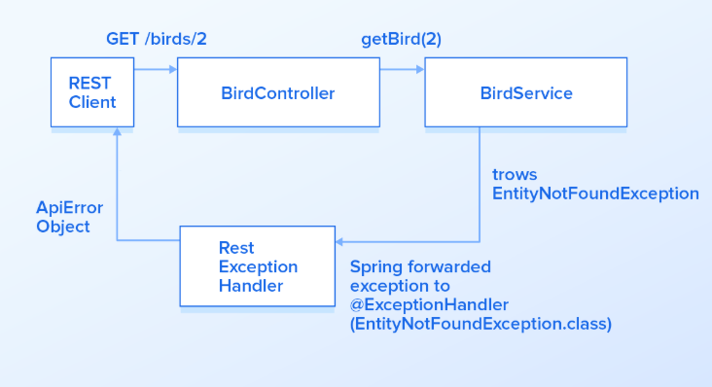

That said, let’s create an ExceptionHandler for this newly created EntityNotFoundException in our RestExceptionHandler class. To do that, create a method called handleEntityNotFound() and annotate it with @ExceptionHandler, passing the class object EntityNotFoundException.class to it. This signalizes Spring that every time EntityNotFoundException is thrown, Spring should call this method to handle it. When annotating a method with @ExceptionHandler, it will accept a wide range of auto-injected parameters like WebRequest, Locale and others as described [here](https://docs.spring.io/spring/docs/current/javadoc-api/org/springframework/web/bind/annotation/ExceptionHandler.html). We’ll just provide the exception EntityNotFoundException itself as a parameter for this handleEntityNotFound method.

Source Code of the Custom exception classes discussed above.

###### **EntityNotFoundException**

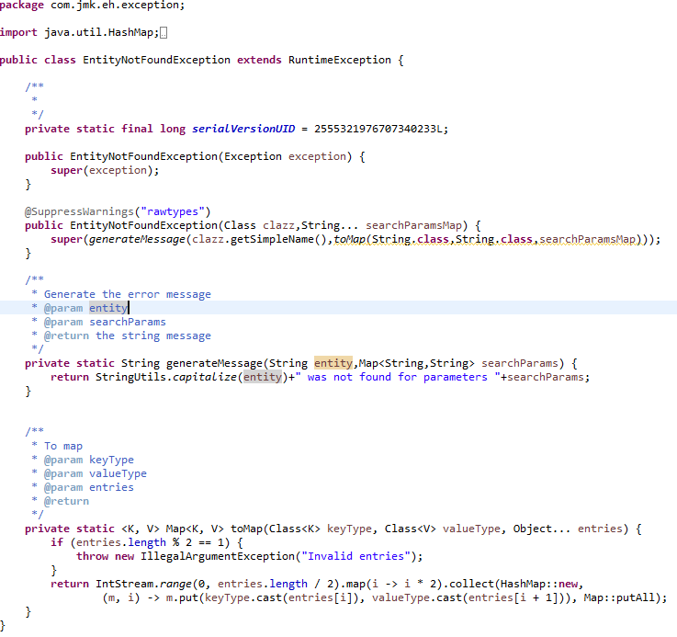

###### **StatusNotActiveException**

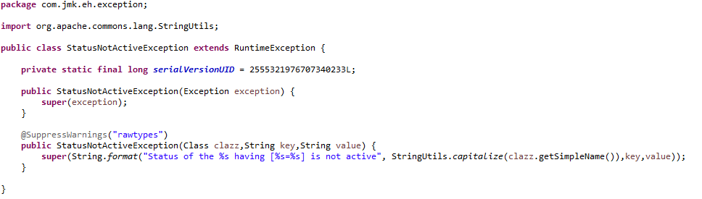

* **RestExceptionHandler**

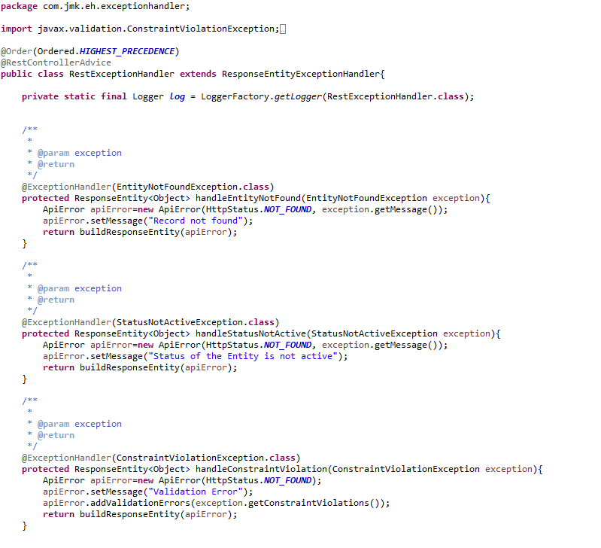

Great! In the handleEntityNotFound() method, we are setting the HTTP status code to NOT\_FOUND and using the new exception message. Here is what the response for the GET /birds/2 endpoint looks like now:

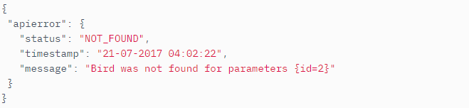

##### **Handling Feign Exceptions**

OpenFeign’s FeignException doesn’t bind to a specific HTTP status (i.e. doesn’t use Spring’s @ResponseStatus annotation), which makes Spring default to 500 whenever faced with a FeignException.

*Sample response when FeignException occurs*

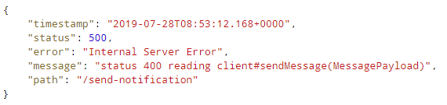

That’s because the root cause for FeignException may not be even related to Http status code sent by remote web service.

In order to propagate the actual error message to the client, we can write our custom ExceptionHandler using a ControllerAdvice.

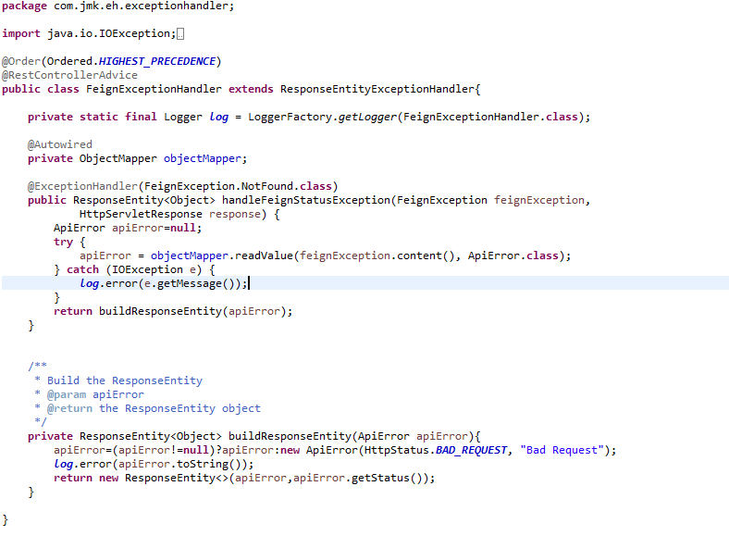

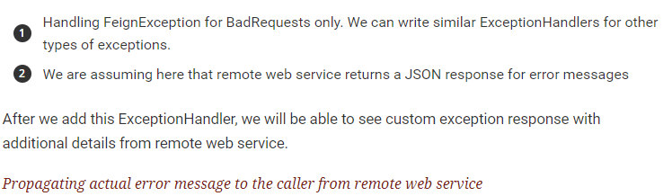



# Gateway-service (Zuul)

## Description

A gateway is a single-entry point into the system, used to handle requests by routing them to the corresponding microservice.

It’s a proxy, gateway, an intermediate layer between the users and your services.

Eureka server solved the problem of giving names to services instead of hardcoding their IP addresses.

But, still, we may have more than one service (instances) running on different ports. So, Zuul …

1. Maps between a prefix path, say/gallery/\*\* and a service gallery-service. It uses Eureka server to route the requested service.
2. It loads balances (using Ribbon) between instances of a service running on different ports.
3. *What else?* We can filter requests, add authentication, etc.
4. *It’s worth mentioning that Zuul acts as a Eureka client. So, we give it a name, port, and link to Eureka server (same as we did with image service).*

## Coding

* Create Spring Boot Project



* Click on next and fill the required details shown in the below screen:

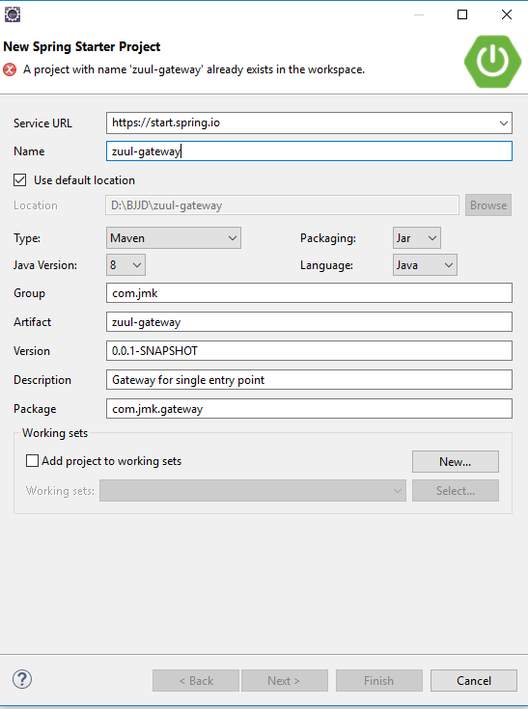

* Add the following dependencies in the pom.xml with the following considerations:
  1. bjjd-microservices Parent: It contains common dependencies of Spring Boot, Spring Cloud and kubeternetes etc.
  2. Common-service: It will keep all the dto models, exception handling and common configurations.
  3. Sql-connector: to connect with the MySQL database.
  4. jib-maven-plugin: A Maven plugin for building docker container images for your Java applications and pushed to the docker hub.
  5. Zuul: Gateway API for single entry point.

It’s worth mentioning that Zuul acts as a Eureka client. So, we give it a name, port, and link to Eureka server (same as we did with other microservice).

<?xml version=*"1.0"* encoding=*"UTF-8"*?>

<project xmlns=*"http://maven.apache.org/POM/4.0.0"*

xmlns:xsi=*"http://www.w3.org/2001/XMLSchema-instance"*

xsi:schemaLocation=*"http://maven.apache.org/POM/4.0.0 https://maven.apache.org/xsd/maven-4.0.0.xsd"*>

<modelVersion>4.0.0</modelVersion>

<parent>

<groupId>com.jmk</groupId>

<artifactId>bjjd-microservices</artifactId>

<version>0.0.1.RELEASE</version>

</parent>

<artifactId>gateway-service</artifactId>

<name>gateway-service</name>

<description>Gateway for single entry point</description>

<dependencies>

<dependency>

<groupId>org.springframework.cloud</groupId>

<artifactId>spring-cloud-starter-netflix-zuul</artifactId>

</dependency>

<dependency>

<groupId>org.springframework.boot</groupId>

<artifactId>spring-boot-devtools</artifactId>

<optional>true</optional>

</dependency>

<dependency>

<groupId>com.jmk</groupId>

<artifactId>common-service</artifactId>

<version>${jmk-version}</version>

</dependency>

<dependency>

<groupId>org.springframework.boot</groupId>

<artifactId>spring-boot-starter-security</artifactId>

</dependency>

<dependency>

<groupId>io.jsonwebtoken</groupId>

<artifactId>jjwt</artifactId>

<version>0.9.0</version>

</dependency>

<dependency>

<groupId>javax.xml.bind</groupId>

<artifactId>jaxb-api</artifactId>

<version>2.3.0</version>

</dependency>

</dependencies>

<build>

<plugins>

<plugin>

<groupId>com.google.cloud.tools</groupId>

<artifactId>jib-maven-plugin</artifactId>

<version>${jib-maven-plugin.version}</version>

<configuration>

<to>

<image>registry.hub.docker.com/rajivbansal2981/gateway-service:${jmk-version}</image>

<auth>

<username>rajivbansal2981</username>

<password>rajiv379</password>

</auth>

</to>

</configuration>

</plugin>

</plugins>

</build>

</project>

* Main application.properties file which can further refer the following based on the selected maven profile.
  1. application-dev.properties
  2. application-prod.properties
* application.properties : @spring.profiles.active@ determines which properties file will be referred based on the maven profile: dev or prod

There will be an application.properties file but it will have the following minimum details:

* + - Name of the application
    - Active Default Profile
    - Cloud Config server URI with port

#Name of the application

spring.application.name=gateway-service

#Active Profile - will relate to development properties file in the server. If this property is absent

#then,default profile will be activated which is the property file without any environment name at the end.

spring.profiles.active=@spring.profiles.active@

#Setting cloud config server uri with port

spring.cloud.config.uri=http://localhost:8888

* application-dev.properties moved to the git repository: **bjjd-config-server-git-repo** and will be selected if maven profile is dev

#Name of the application

spring.application.name=gateway-service

#Port of the application

server.port=1379

#It is worth mentioning that Zuul acts as a Eureka client. So, we give it a name, port, and link to Eureka server URL

eureka.client.service-url.default-zone=http://localhost:8761/eureka

#Spring profile

spring.profiles.active=${SPRING\_ACTIVE\_PROFILE:dev}

#spring.cloud.kubernetes.discovery.include-not-ready-addresses=true

# A prefix that can added to beginning of all requests.

#zuul.prefix=/api

# Disable accessing services using service name (i.e. gallery-service).They should be only accessed through the path defined below.

zuul.ignored-services=\*

zuul.ribbon.eager-load.enabled= true

zuul.sensitiveHeaders=Cookie,Set-Cookie

spring.sleuth.sampler.probability = 1.0

hystrix.command.default.execution.isolation.thread.timeoutInMilliseconds=5000000

ribbon.ReadTimeout=20000000

ribbon.ConnectTimeout=20000000

logstash.host=localhost

logstash.queue-size=1000

logstash.port=5000

#######--------Microservice Path Mappings -------################

#AUTH-SERVICE

zuul.routes.auth-service.path=/api/auth-service/auth/\*\*

zuul.routes.auth-service.service-id=AUTH-SERVICE

# By default, all requests to gallery service for example will start with: "/gallery/"

# if request is "/gallery/view/1", gallery service will get "/view/1".In case of auth, we need to pass the "/auth/" in the path to auth service. So, set strip-prefix to false

zuul.routes.auth-service.strip-prefix=false

zuul.routes.auth-service.sensitive-headers=Cookie,Set-Cookie

#USER-SERVICE

zuul.routes.user-service.path=/api/user-service/user/\*\*

zuul.routes.user-service.service-id=USER-SERVICE

zuul.routes.user-service.strip-prefix=false

zuul.routes.user-service.sensitiveHeaders=Cookie,Set-Cookie

#PROJECT-SERVICE

zuul.routes.project-service.path=/api/project-service/project/\*\*

zuul.routes.project-service.service-id=PROJECT-SERVICE

zuul.routes.project-service.strip-prefix=false

zuul.routes.project-service.sensitiveHeaders=Cookie,Set-Cookie

#PEOPLE-SERVICE

zuul.routes.people-service.path=/api/people-service/\*\*

zuul.routes.people-service.service-id=PEOPLE-SERVICE

zuul.routes.people-service.strip-prefix=false

zuul.routes.people-service.sensitiveHeaders=Cookie,Set-Cookie

#ACCOUNT-SERVICE

zuul.routes.account-service.path=/api/account-service/\*\*

zuul.routes.account-service.service-id=ACCOUNT-SERVICE

zuul.routes.account-service.strip-prefix=false

zuul.routes.account-service.sensitiveHeaders=Cookie,Set-Cookie

#DARSHAN-SERVICE

zuul.routes.darshan-service.path=/api/darshan-service/\*\*

zuul.routes.darshan-service.service-id=DARSHAN-SERVICE

zuul.routes.darshan-service.strip-prefix=false

zuul.routes.darshan-service.sensitiveHeaders=Cookie,Set-Cookie

#DATA-UPLOAD-SERVICE

zuul.routes.data-upload-service.path=/api/data-upload-service/\*\*

zuul.routes.data-upload-service.service-id=DATA-UPLOAD-SERVICE

zuul.routes.data-upload-service.strip-prefix=false

zuul.routes.data-upload-service.sensitiveHeaders=Cookie,Set-Cookie

#MESSAGE-SENDER-SERVICE

zuul.routes.message-sender-service.path=/api/message-sender-service/\*\*

zuul.routes.message-sender-service.service-id=MESSAGE-SENDER-SERVICE

zuul.routes.message-sender-service.strip-prefix=false

zuul.routes.message-sender-service.sensitiveHeaders=Cookie,Set-Cookie

#KAFKA-PRODUCER-SERVICE

zuul.routes.kafka-producer-service.path=/api/kafka-producer-service/\*\*

zuul.routes.kafka-producer-service.service-id=KAFKA-PRODUCER-SERVICE

zuul.routes.kafka-producer-service.strip-prefix=false

zuul.routes.kafka-producer-service.sensitiveHeaders=Cookie,Set-Cookie

* application-prod.properties: It will be selected if maven profile is prod.
  1. Eureka Clients registrations with Eureka server need to be disabled in Kubernetes.

#Application Name

spring.application.name=gateway-service

#Port of the application

server.port=1379

#Spring profile

spring.profiles.active=${SPRING\_ACTIVE\_PROFILE:prod}

spring.cloud.kubernetes.discovery.all-namespaces=true

#It is worth mentioning that user-service acts as a Eureka client. So, we give it a name, port, and link to Eureka server

# Eureka server url

#eureka.client.service-url.default-zone=http://localhost:8761/eureka

eureka.client.enabled=false

eureka.client.serviceUrl.registerWithEureka=false

spring.sleuth.sampler.probability = 1.0

spring.jackson.date-format=com.jmk.user.swagger.RFC3339DateFormat

spring.jackson.serialization.WRITE\_DATES\_AS\_TIMESTAMPS=false

# A prefix that can added to beginning of all requests.

#zuul.prefix=/api

# Disable accessing services using service name (i.e. gallery-service).They should be only accessed through the path defined below.

zuul.ignored-services=\*

zuul.ribbon.eager-load.enabled= true

zuul.sensitiveHeaders=Cookie,Set-Cookie

hystrix.command.default.execution.isolation.thread.timeoutInMilliseconds=5000000

ribbon.ReadTimeout=20000000

ribbon.ConnectTimeout=20000000

#######--------Microservice Path Mappings -------################

#AUTH-SERVICE

zuul.routes.auth-service.path=/api/auth-service/auth/\*\*

zuul.routes.auth-service.service-id=auth-service

# By default, all requests to gallery service for example will start with: "/gallery/"

# if request is "/gallery/view/1", gallery service will get "/view/1".In case of auth, we need to pass the "/auth/" in the path to auth service. So, set strip-prefix to false

zuul.routes.auth-service.strip-prefix=false

zuul.routes.auth-service.sensitive-headers=Cookie,Set-Cookie

#USER-SERVICE

zuul.routes.user-service.path=/api/user-service/user/\*\*

zuul.routes.user-service.service-id=user-service

zuul.routes.user-service.strip-prefix=false

zuul.routes.user-service.sensitiveHeaders=Cookie,Set-Cookie

#PROJECT-SERVICE

zuul.routes.project-service.path=/api/project-service/project/\*\*

zuul.routes.project-service.service-id=project-service

zuul.routes.project-service.strip-prefix=false

zuul.routes.project-service.sensitiveHeaders=Cookie,Set-Cookie

#PEOPLE-SERVICE

zuul.routes.people-service.path=/api/people-service/\*\*

zuul.routes.people-service.service-id=people-service

zuul.routes.people-service.strip-prefix=false

zuul.routes.people-service.sensitiveHeaders=Cookie,Set-Cookie

#ACCOUNT-SERVICE

zuul.routes.account-service.path=/api/account-service/\*\*

zuul.routes.account-service.service-id=account-service

zuul.routes.account-service.strip-prefix=false

zuul.routes.account-service.sensitiveHeaders=Cookie,Set-Cookie

#DARSHAN-SERVICE

zuul.routes.darshan-service.path=/api/darshan-service/\*\*

zuul.routes.darshan-service.service-id=darshan-service

zuul.routes.darshan-service.strip-prefix=false

zuul.routes.darshan-service.sensitiveHeaders=Cookie,Set-Cookie

#DATA-UPLOAD-SERVICE

zuul.routes.data-upload-service.path=/api/data-upload-service/\*\*

zuul.routes.data-upload-service.service-id=data-upload-service

zuul.routes.data-upload-service.strip-prefix=false

zuul.routes.data-upload-service.sensitiveHeaders=Cookie,Set-Cookie

#MESSAGE-SENDER-SERVICE

zuul.routes.message-sender-service.path=/api/message-sender-service/\*\*

zuul.routes.message-sender-service.service-id=message-sender-service

zuul.routes.message-sender-service.strip-prefix=false

zuul.routes.message-sender-service.sensitiveHeaders=Cookie,Set-Cookie

#KAFKA-PRODUCER-SERVICE

zuul.routes.kafka-producer-service.path=/api/kafka-producer-service/\*\*

zuul.routes.kafka-producer-service.service-id=kafka-producer-service

zuul.routes.kafka-producer-service.strip-prefix=false

zuul.routes.kafka-producer-service.sensitiveHeaders=Cookie,Set-Cookie

* Finally, make the changes in the GatewayServiceApplication to enable Zuul and Eureka Client.
  + Enable Discovery Client so that it can register with Eureka Server and it supports Kubernetes Discovery System.
  + Enable Zuul for Gateway entry point
  + Enable Swagger2 for API Documentation

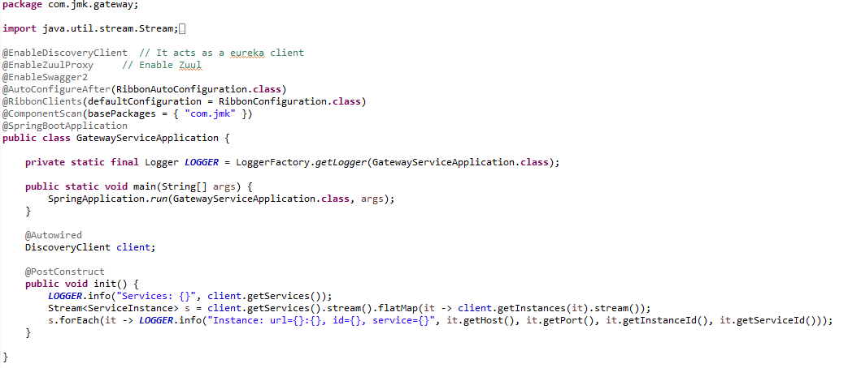

* Need to make changes in this gateway-service application to enable authenticate the user before routing to other microservices.

Can refer the Authentication Service to know about the other changes mentioned below done in this gateway-service



* We use Spring Cloud Netflix Zuul, which is integrated with Kubernetes discovery via Ribbon client. It is exposing Swagger documentation for all our sample microservices distributed across multiple namespaces. The configuration of routes is pretty simple. We just need to use the Spring Cloud Kubernetes discovery feature. In application-prod.properties, please specify the following property.

spring.cloud.kubernetes.discovery.all-namespaces:"true"

While Zuul proxy is automatically integrated with DiscoveryClient we may easily configure dynamic resolution Swagger endpoints exposed by microservices. we may start testing our applications using the Swagger UI exposed on the gateway. But here, we get an unexpected surprise.

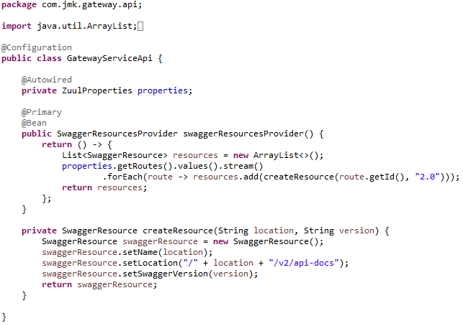

* If we get an unexpected surprise… The discovery across all namespaces does not work for the Ribbon client. It only works for DiscoveryClient. I think that Ribbon auto-configuration should respect the property spring.cloud.kubernetes.discovery.all-namespaces, but in that case, we don’t have any other choice than prepare a workaround. Our workaround is to override Ribbon client auto-configuration provided within Spring Cloud Kubernetes. We are using DiscoveryClient directly for it as shown below.

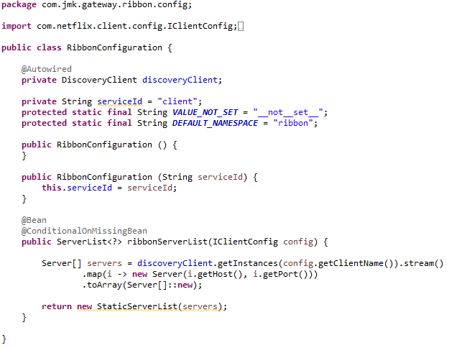

## Testing

### Run in Dev Environment

* Run the application as **Spring Boot App** in the following order
  + EurekaServerApplication
  + GatewayServiceApplication

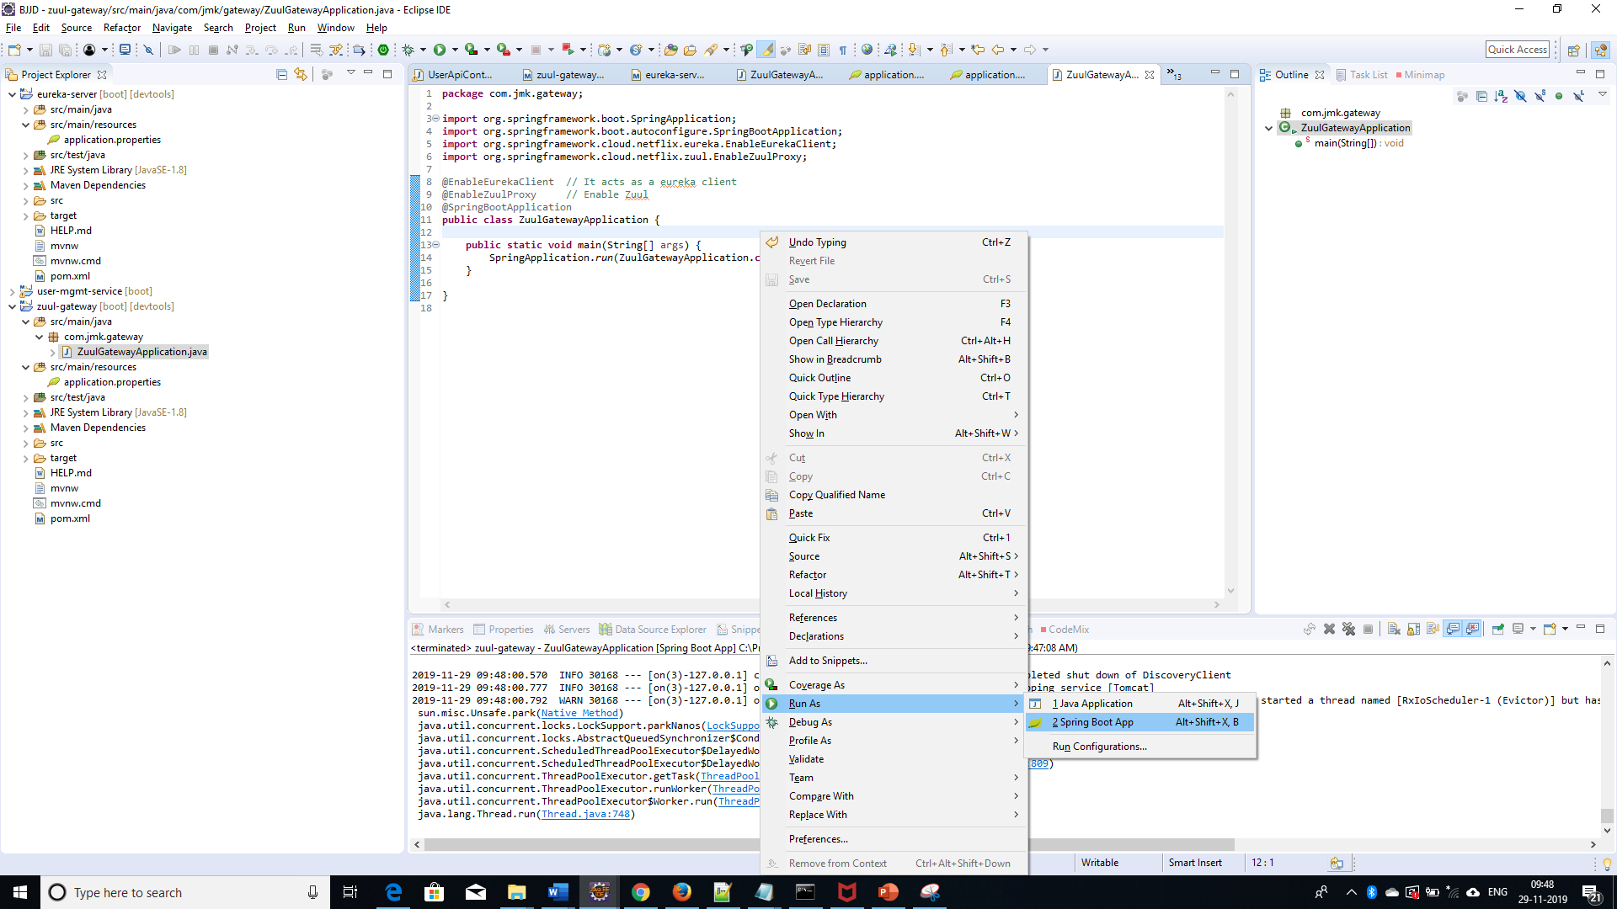

* Open the browser of Eureka Server at localhost:8761, you should see the running zuul-gateway microservices and enter the url: <http://localhost:8761/>

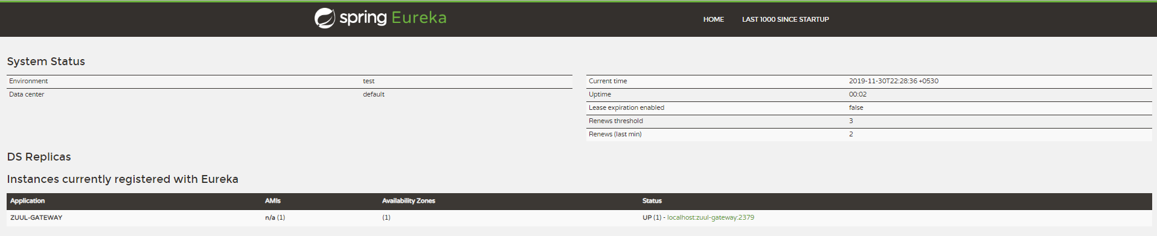

### Run in Kubernetes Environment

* Running the application in Kubernetes Environment

Following are the steps to run the application in the Kubernetes:

* 1. Create the docker image for the application jar file and pushed into the docker hub using the below command:

**Command**: mvn clean install -DskipTests -Pprod jib:build

* 1. Create the folder k8s which contains the following files:
     + namespace.yaml (Located in main K8s folder: bjjd-microservices\k8s\namespace.yaml)
     + deployment.yaml (Located in application’s K8s folder: bjjd-microservices\gateway-service\k8s\deployment.yaml)
     + kustomization.yaml (Located in application’s K8s folder: bjjd-microservices\gateway-service\k8s\kustomization.yaml)
  2. Connect to the kubernetes cluster
* **Command**: gcloud container clusters get-credentials jmk-cluster --zone us-central1-c --project logical-lock-315311
* **Output**
  1. Run the command to create the namespace: bjjd-system in the kubernetes environment:
     + **File:** Namespace.yaml

apiVersion: v1

kind: Namespace

metadata:

name: bjjd-system

* + - **Command**: kubectl apply -f namespace.yaml
    - **Output**:



* 1. Create the kustomization file will be the central point of your base and it describes the resources you use. For example, configmaps, secrets, and it can refer to the resources file: deployment.yaml which is to create the deployment and service in the kubernetes.
* **File**: kustomization.yaml

apiVersion: kustomize.config.k8s.io/v1beta1

kind: Kustomization

namespace: bjjd-system

configMapGenerator:

- name: gateway-service-configmap

literals:

- application.port=1379

- spring.active.profile=prod

resources: #Adding the following yaml resources

- deployment.yaml

* + - **File**: deployment.yaml : to create the deployment and service in the kubernetes

apiVersion: apps/v1

kind: Deployment

metadata:

name: gateway-service

labels:

app: gateway-service

#namespace: default

spec:

replicas: 1

minReadySeconds: 45

selector:

matchLabels:

app: gateway-service

strategy:

rollingUpdate:

maxSurge: 25%

maxUnavailable: 25%

type: RollingUpdate

template:

metadata:

labels:

app: gateway-service

spec:

containers:

- name: gateway-service

image: rajivbansal2981/gateway-service:0.0.1-RELEASE

imagePullPolicy: IfNotPresent #IfNotPresent or Always

ports:

- name: http

containerPort: 1379 # The port that the container exposes

env:

- name: SPRING\_ACTIVE\_PROFILE

valueFrom:

configMapKeyRef:

name: gateway-service-configmap

key: spring.active.profile

restartPolicy: Always

terminationGracePeriodSeconds: 60

---

apiVersion: v1

kind: Service

metadata:

name: gateway-service

labels: #PODS

app: gateway-service

namespace: default

spec:

type: NodePort #NodePort or LoadBalancer or ClusterIP

selector:

app: gateway-service

ports:

- name: http

port: 1379

targetPort: 1379

* + - Command: kubectl apply -k ./
    - Output:

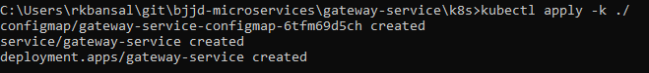

* 1. To check all the application running successfully.
* **Command**: kubectl get pods --namespace bjjd-system -o wide
* **Output**:
  1. We have specified the in the service type as Nodeport, so that it can be accessible outside to the client.

Nodeport is used to expose a service on the same port across all the nodes of a cluster. An internal routing mechanism ensures that the request is forwarded to the appropriate pods on each node. This is typically used for services with external consumers.

NOTE: This is the Rest API which ideally, we should expose as Nodeport or LoadBalancer so that it can be accessible to the client. It will be acting as Single Entry Point only.

* + - Command: kubectl get services --namespace bjjd-system -o wide
    - Output:



* + - To create the firewall rule for the Node’s TCP port:
      * 1. Command: gcloud compute firewall-rules create bjjd-node-port1 --project logical-lock-315311 --allow tcp:32021

Name: bjjd-node-port

Project Id: project logical-lock-315311

Allowed TCP Port: 31924

* + - * 1. Output
    - To access the gateway-service outside the kubernetes using Node’s TCP port:
      * To get the pod details to find the associated Node
        + Command: kubectl get pods --namespace bjjd-system -o wide
        + Output:
      * To get the Node IP Address

Command: kubectl get nodes --namespace bjjd-system -o wide

Output



Node IP with TCP Port

35.222.148.176:32021

* + - * Now gateway service is ready and if any microservice to be called then request will be processed through this API Gateway. For example, auth-service is validating the user credentials.

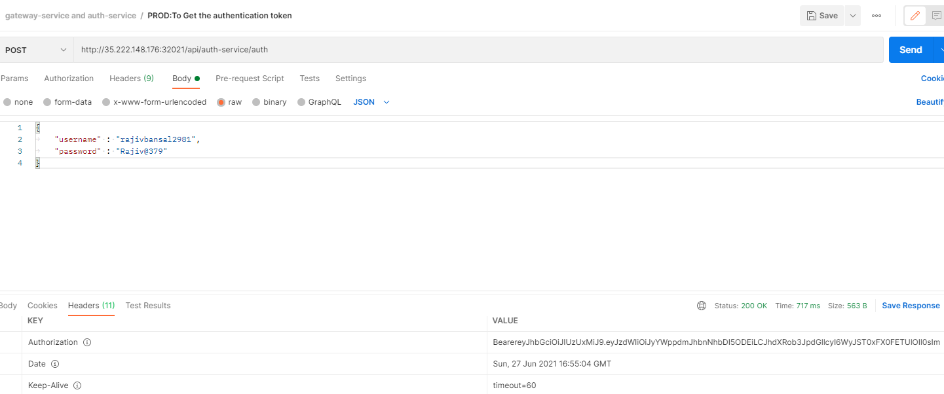

* 1. To access the gateway-service from outside the cluster, using LoadBalancer IP Service
     + If we define service as LoadBalancer in the deployment.yaml

apiVersion: v1

kind: Service

metadata:

name: gateway-service

labels: #PODS

app: gateway-service

namespace: default

spec:

type: LoadBalancer #NodePort or LoadBalancer or ClusterIP

selector:

app: gateway-service

ports:

- name: http

port: 1379

targetPort: 1379

* + - Run the following commands to access the gateway-service from outside:
      * **Apply the changes of deployment.yaml file**
        1. **Command**: kubectl apply -k ./
        2. **Output**:

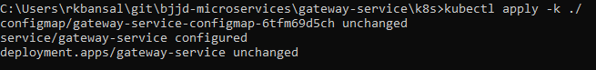

* + - * To check the services again:
        1. Command: kubectl get services --namespace bjjd-system -o wide
        2. Output:

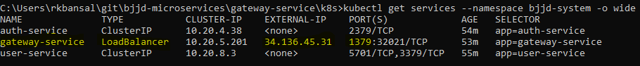

* + - * Now gateway service is ready and if any microservice to be called then request will be processed through this API Gateway. For example, auth-service is validating the user credentials.

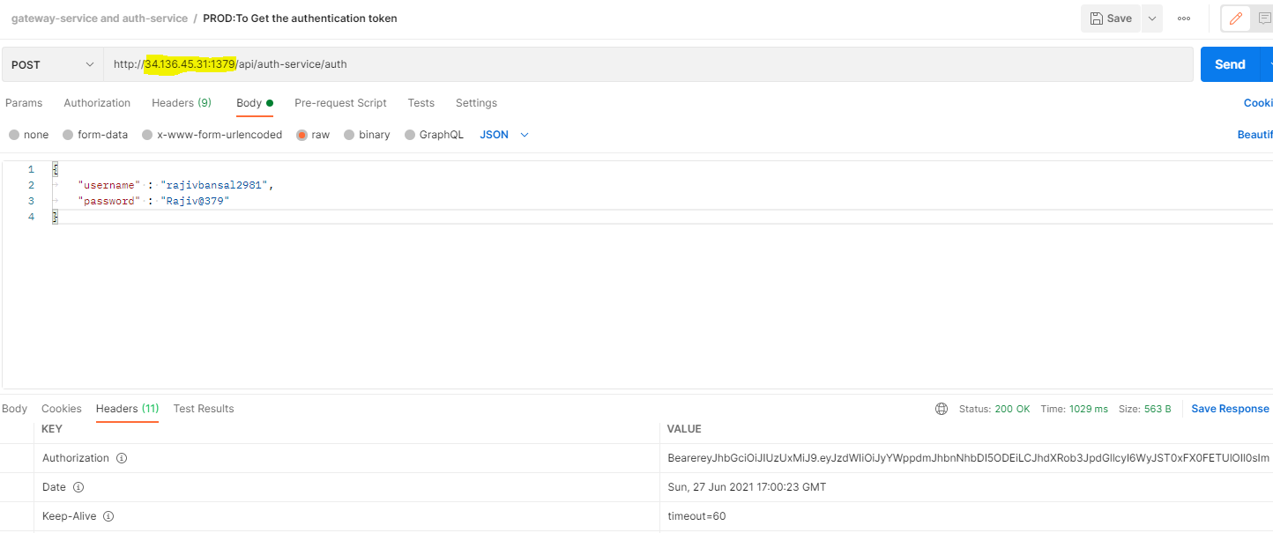

# Spring Cloud Gateway Service

## Description

An API Gateway acts as a single-entry point for a collection of microservices. Any external client cannot access the microservices directly but can access them only through the application gateway.

A gateway is a single-entry point into the system, used to handle requests by routing them to the corresponding microservice.

Spring Cloud Gateway aims to provide a simple, yet effective way to route to APIs and provide cross cutting concerns to them such as: security, monitoring/metrics, and resiliency.

In a previous project gateway-service, we have used Netflix Zuul. **Zuul is a blocking API.** A blocking gateway api makes use of as many threads as the number of incoming requests. So, this approach is more resource intensive. **If no threads are available to process incoming request, then the request has to wait in queue.**  
In this tutorial we will be implementing API Gateway using Spring Cloud Gateway. **Spring Cloud Gateway is a non-blocking API.** When using non-blocking API, a thread is always available to process the incoming request. These requests are then processed asynchronously in the background and once completed the response is returned. **So, no incoming request never gets blocked when using Spring Cloud Gateway.**

[Spring Cloud Gateway](https://www.baeldung.com/spring-cloud-gateway) is an intelligent proxy service often used in microservices. One of its most interesting features is the concept of [filters](https://cloud.spring.io/spring-cloud-gateway/reference/html/#glossary) (*WebFilter* or *GatewayFilter*).

*WebFilter,* together with [*Predicate* factories](https://www.baeldung.com/spring-cloud-gateway-routing-predicate-factories), incorporate the complete routing mechanism. **Spring Cloud Gateway provides many built-in***WebFilter***factories that allow interacting with the HTTP requests before reaching the proxied service and the HTTP responses before delivering the result to the client**. It is also possible to implement [custom filters](https://www.baeldung.com/spring-cloud-custom-gateway-filters).

***WebFilter* Factories**

*WebFilter* (or *GatewayFilter*) factories allow modifying the inbound HTTP requests and outbound HTTP responses. In this sense, it offers a set of interesting functionalities to apply before and after interacting with the downstream services.

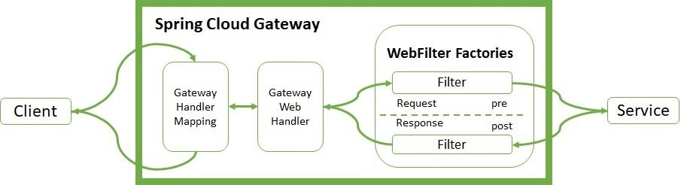

The Handler Mapping manages the client's request. It checks whether it matches some configured route. Then, it sends the request to the Web Handler to execute the specific filter chain for this route. The dotted line splits the logic between pre- and post-filter logic. The income filters run before the proxy request. The output filters enter into action when they receive the proxy response. Filters provide mechanisms to modify the process in between.

## Features

Spring Cloud Gateway features:

* Built on the top of Spring Framework 5, Spring WebFlux, Project Reactor and Spring Boot 2.0
* It provides cross-cutting concerns such as:
  + Security
  + Monitoring/metrics
  + Resilency
* Able to match routes on any request attribute.
* Predicates and filters are specific to routes.
* Circuit Breaker integration.
* Spring Cloud DiscoveryClient integration
* Easy to write Predicates and Filters
* Request Rate Limiting
* Path Rewriting

## Implementation Phase 1: Single Entry Point

### Coding

* Create Spring Boot Project



* Click on next and fill the required details shown in the below screen:

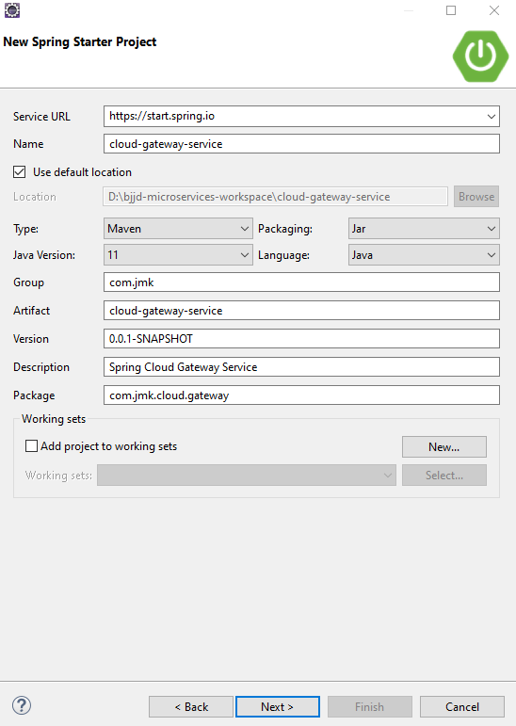

* Add the following dependencies in the pom.xml with the following considerations:

1. Spring Cloud Starter Config: This dependency is required to connect to the Config Server
2. Spring Boot Starter Parent: update the version: 2.3.4.RELEASE highlighted in yellow colour.
3. Spring Cloud version: upgraded to Hoston.SR8. It is highlighted in yellow colour.
4. Maven Jar Plugin Version: After the above updates, pom is giving compiler error in pom.xml so downgraded version of maven jar plugin to 3.1.1. It is highlighted in yellow colour.
5. Common-service: It will keep all the dto models, exception handling and common configurations.
6. jib-maven-plugin: A Maven plugin for building docker container images for your Java applications and pushed to the docker hub.
7. spring-cloud-starter-gateway: Gateway API for single entry point.
8. spring-cloud-starter-netflix-eureka-client: to access the other microservices in Eureka Server so that routes the request to appropriate microservice

It’s worth mentioning that spring-cloud-starter-gateway acts as a Discovery client. So, we give it a name, port, and link to Eureka server (same as we did with other microservice).

<?xml version=*"1.0"* encoding=*"UTF-8"*?>

<project xmlns=*"http://maven.apache.org/POM/4.0.0"* xmlns:xsi=*"http://www.w3.org/2001/XMLSchema-instance"*

xsi:schemaLocation=*"http://maven.apache.org/POM/4.0.0 https://maven.apache.org/xsd/maven-4.0.0.xsd"*>

<modelVersion>4.0.0</modelVersion>

<parent>

<groupId>org.springframework.boot</groupId>

<artifactId>spring-boot-starter-parent</artifactId>

<version>2.3.4.RELEASE</version>

<relativePath /> <!-- lookup parent from repository -->

</parent>

<artifactId>cloud-gateway-service</artifactId>

<name>cloud-gateway-service</name>

<description>Spring Cloud Gateway Service</description>

<properties>

<java.version>11</java.version>

<maven.compiler.source>${java.version}</maven.compiler.source>

<maven.compiler.target>${java.version}</maven.compiler.target>

<springfox-version>2.7.0</springfox-version>

<hibernate.version>5.4.10.Final</hibernate.version>

<spring-cloud.version>Hoxton.SR8</spring-cloud.version>

<maven-jar-plugin.version>3.1.1</maven-jar-plugin.version>

<jib-maven-plugin.version>3.1.1</jib-maven-plugin.version>

<jmk-version>0.0.1.RELEASE</jmk-version>

</properties>

<dependencies>

<dependency>

<groupId>org.springframework.boot</groupId>

<artifactId>spring-boot-starter</artifactId>

</dependency>

<dependency>

<groupId>org.springframework.boot</groupId>

<artifactId>spring-boot-starter-actuator</artifactId>

</dependency>

<!-- Spring Cloud Starter Config is required to connect config server -->

<dependency>

<groupId>org.springframework.cloud</groupId>

<artifactId>spring-cloud-starter-config</artifactId>

</dependency>

<!-- Spring Cloud Netflix Eureka Client -->

<dependency>

<groupId>org.springframework.cloud</groupId>

<artifactId>spring-cloud-starter-netflix-eureka-client</artifactId>

</dependency>

<dependency>

<groupId>org.springframework.cloud</groupId>

<artifactId>spring-cloud-starter-gateway</artifactId>

</dependency>

<!-- Distributed Logging Api -->

<dependency>

<groupId>org.springframework.cloud</groupId>

<artifactId>spring-cloud-starter-sleuth</artifactId>

</dependency>

<!-- Zipkin:distributed tracing system which provides a UI to see the traces -->

<dependency>

<groupId>org.springframework.cloud</groupId>

<artifactId>spring-cloud-starter-zipkin</artifactId>

</dependency>

<dependency>

<groupId>net.logstash.logback</groupId>

<artifactId>logstash-logback-encoder</artifactId>

<version>6.6</version>

</dependency>

<dependency>

<groupId>org.springframework.boot</groupId>

<artifactId>spring-boot-starter-test</artifactId>

<scope>test</scope>

</dependency>

</dependencies>

<dependencyManagement>

<dependencies>

<dependency>

<groupId>org.springframework.cloud</groupId>

<artifactId>spring-cloud-dependencies</artifactId>

<version>${spring-cloud.version}</version>

<type>pom</type>

<scope>import</scope>

</dependency>

</dependencies>

</dependencyManagement>

<profiles>

<profile>

<id>dev</id>

<activation>

<activeByDefault>true</activeByDefault>

</activation>

<properties>

<spring.profiles.active>dev</spring.profiles.active>

</properties>

<!-- Spring Cloud Starter Kubernetes is required for Kubernetes -->

</profile>

<profile>

<id>prod</id>

<properties>

<spring.profiles.active>prod</spring.profiles.active>

</properties>

<dependencies>

<dependency>

<groupId>org.springframework.cloud</groupId>

<artifactId>spring-cloud-starter-kubernetes-all</artifactId>

<!-- <version>1.1.2.RELEASE</version> -->

</dependency>

</dependencies>

</profile>

</profiles>

<build>

<sourceDirectory>src/main/java</sourceDirectory>

<plugins>

<plugin>

<groupId>org.springframework.boot</groupId>

<artifactId>spring-boot-maven-plugin</artifactId>

<executions>

<execution>

<goals>

<goal>repackage</goal>

</goals>

</execution>

</executions>

</plugin>

<plugin>

<groupId>com.google.cloud.tools</groupId>

<artifactId>jib-maven-plugin</artifactId>

<version>${jib-maven-plugin.version}</version>

<configuration>

<to>

<image>registry.hub.docker.com/rajivbansal2981/cloud-gateway-service:0.0.1.RELEASE</image>

<auth>

<username>rajivbansal2981</username>

<password>rajiv379</password>

</auth>

</to>

</configuration>

</plugin>

</plugins>

</build>

</project>

* Main application.properties file which can further refer the following based on the selected maven profile.
  1. application-dev.properties
  2. application-prod.properties
* application.properties : @spring.profiles.active@ determines which properties file will be referred based on the maven profile: dev or prod

There will be an application.properties file but it will have the following minimum details:

* + - Name of the application
    - Active Default Profile
    - Cloud Config server URI with port

#Name of the application

spring.application.name=cloud-gateway-service

#Active Profile - will relate to development properties file in the server. If this property is absent

#then,default profile will be activated which is the property file without any environment name at the end.

spring.profiles.active=@spring.profiles.active@

#Setting cloud config server uri with port

spring.cloud.config.uri=http://localhost:8888

* application-dev.properties moved to the git repository: **bjjd-config-server-git-repo** and will be selected if maven profile is dev

#Name of the application

spring.application.name=cloud-gateway-service

#Port of the application

server.port=8080

#Spring profile

spring.profiles.active=dev

#It is worth mentioning that Zuul acts as a Eureka client. So, we give it a name, port, and link to Eureka server URL

eureka.client.service-url.default-zone=http://localhost:8761/eureka

eureka.client.fetch-registry=true

eureka.client.register-with-eureka=true

spring.sleuth.sampler.probability = 1.0

hystrix.command.default.execution.isolation.thread.timeoutInMilliseconds=5000000

ribbon.ReadTimeout=20000000

ribbon.ConnectTimeout=20000000

* application-prod.properties: It will be selected if maven profile is prod.
  1. Eureka Clients registrations with Eureka server need to be disabled in Kubernetes.

#Application Name

spring.application.name=cloud-gateway-service

#Port of the application

server.port=8080

#Spring profile

spring.profiles.active=${SPRING\_ACTIVE\_PROFILE:prod}

spring.cloud.kubernetes.discovery.all-namespaces=true

#It is worth mentioning that user-service acts as a Eureka client. So, we give it a name, port, and link to Eureka server

# eureka server url

#eureka.client.service-url.default-zone=http://localhost:8761/eureka

eureka.client.enabled=false

eureka.client.serviceUrl.registerWithEureka=false

* Finally, make the changes in the CloudGatewayServiceApplication to enable Zuul and Eureka Client.
  + Enable Discovery Client so that it can register with Eureka Server and it supports Kubernetes Discovery System.
  + Enable RestController

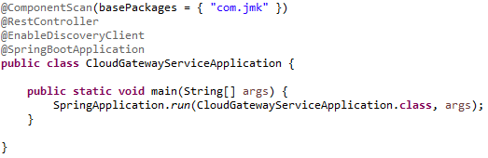

* RouteLocatorConfiguration is used to handle requests by routing them to the corresponding microservice.

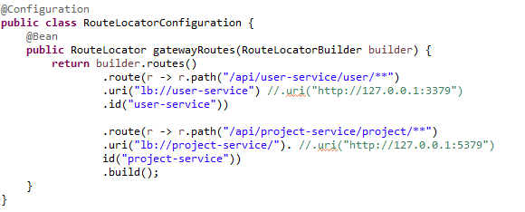

### Testing

#### **Run in Dev Environment**

* Run the application as **Spring Boot App** in the following order
  + EurekaServerApplication
  + ConfigServerApplication
  + CloudGatewayServiceApplication
  + UserServiceApplication
* To check the applications are ready in the Eureka Server: <http://localhost:8761/>

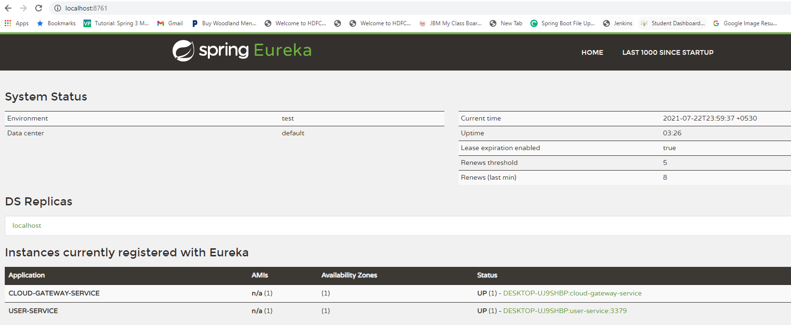

* To get the user details based on the username via gateway: CloudGatewayServiceApplication.

http://localhost:8080/api/user-service/user/findByUsername?username=rajivbansal2981

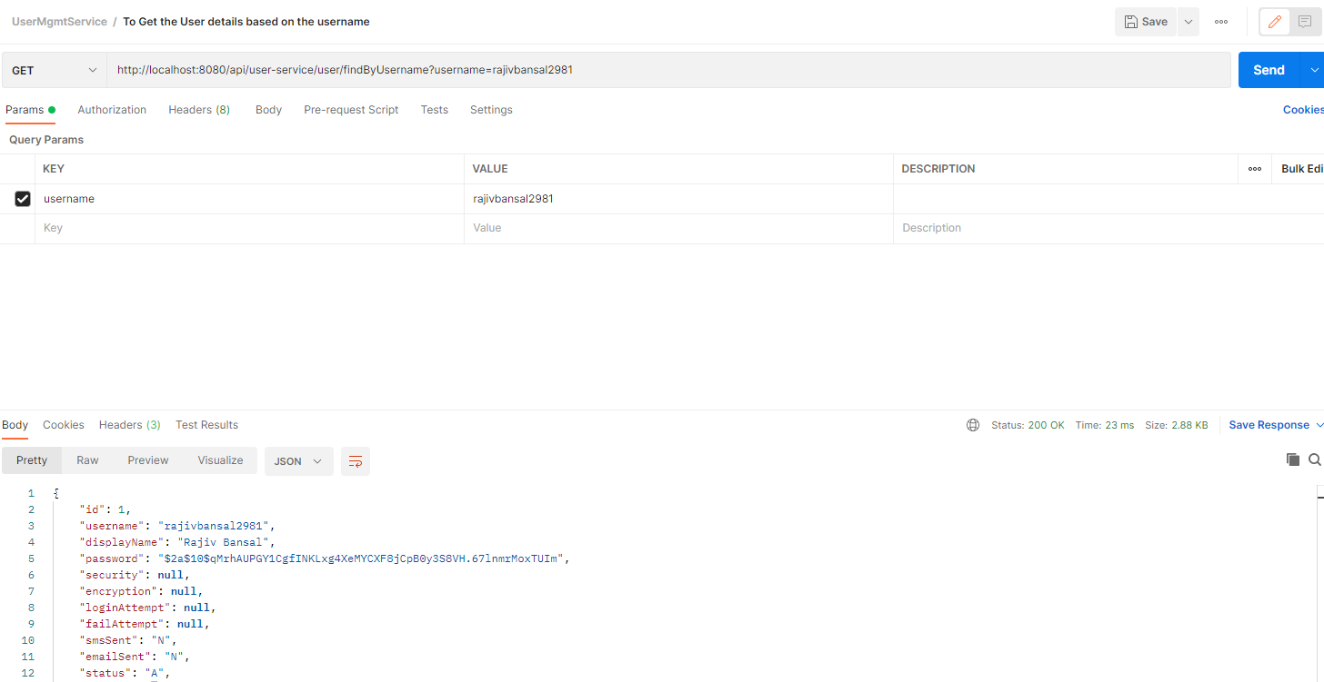

## Implementation Phase 2: OAuth2 Security with KeyCloak

### Description

OAuth 2 is industry standard protocol, developed for authorization between services. Present version of this protocol is 2.0, hence the name OAuth2.0 released in 2013.

Auth in OAuth stands for open authorization but NOT authentication.

OAuth2 Terminology

* **Resource or Protected Resource:** Anything which needs to be accessed by external service, which needs authorization.
* **Resource Owner:** Owner of the protected resource.
* **Resource Server:** A server which serves or hosts or stores the protected resource. For examples:
  + Google Drive a resource server which stores our images, documents.
  + Microservices: a resource server which contains the protected API.
* **Client**: A service or Application which is accessing the resource through Resource Owner.
  + Type of Client
    - Public Client: Web, Mobile, Desktop, Smart TV Apps which can be accessed by public.
    - Confidential Client: Remote Shell scripts, CRON Jobs running on remote server, Microservices, etc.
* **Authorization Server**: Server that generates and validates Access tokens for Clients and permission of Users.
  + Options in Market
    - AWS Cognito
    - Microsoft Azure AD
    - Google Identity Platform
    - Okta
    - Key Cloak
    - Spring Authorization Server

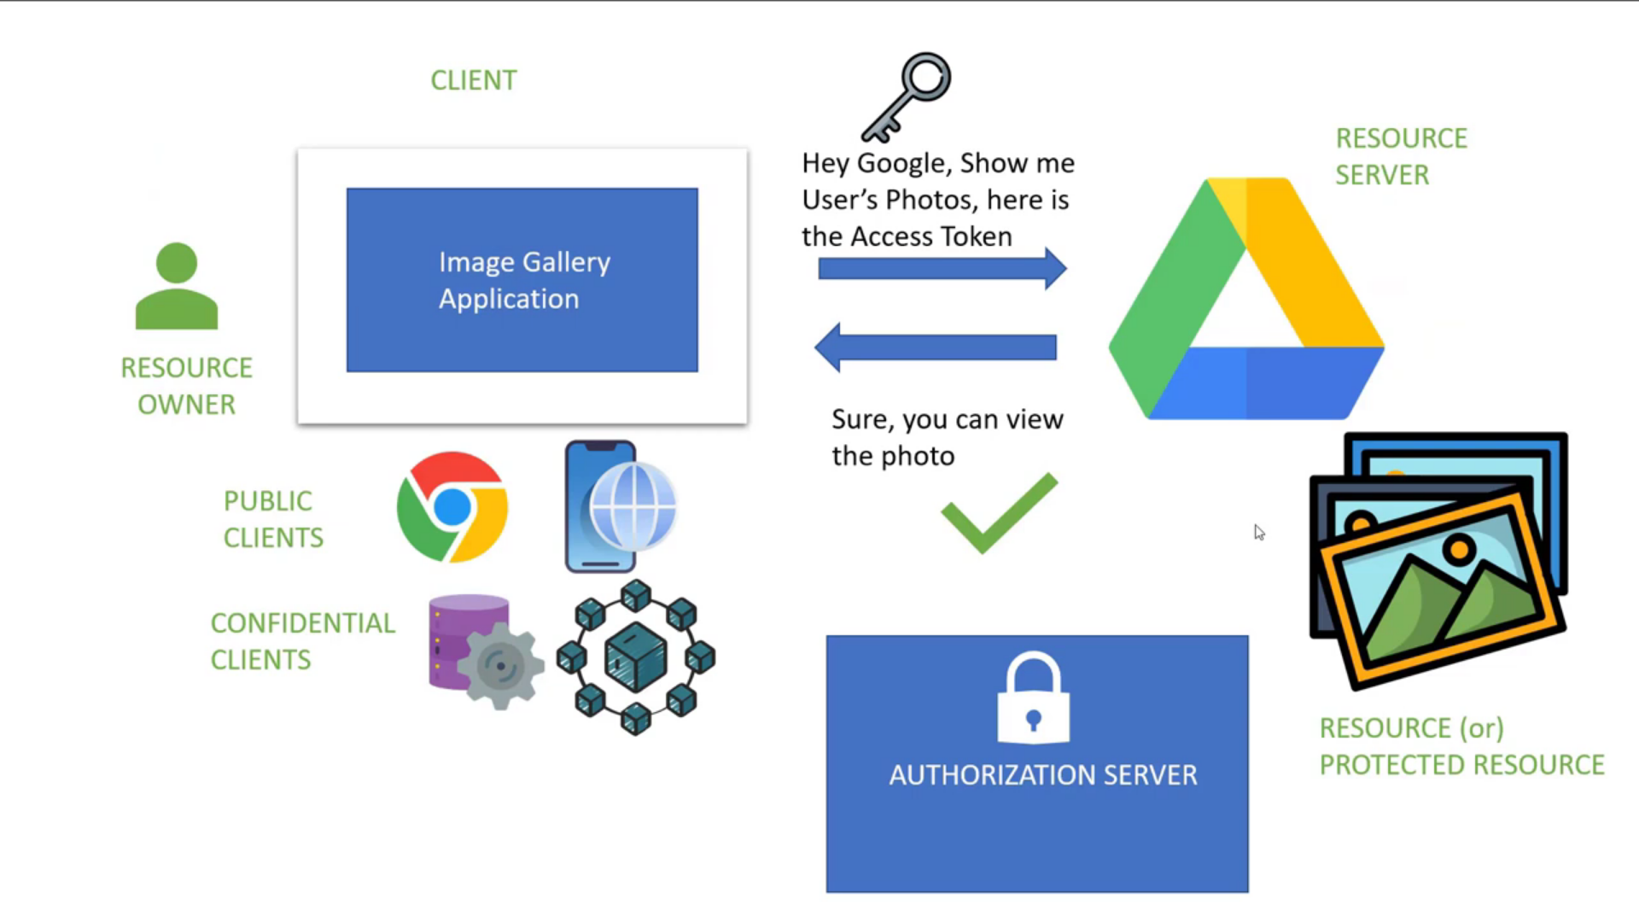

**Example:** When Resource Owner try to access our photos stored in Google Drive with the help of other application named: Image Gallery Application.

**Step 1**: When Resource Owner try to access our photos stored in Google Drive (Resource Server) using the Image Gallery Application. Google Drive as a resource server redirects the request to Authorization Server to validate the resource owner credentials and then Authorization Server asks for the credentials of the Resource Owner with the access view whatever the Image Gallery Application wants.

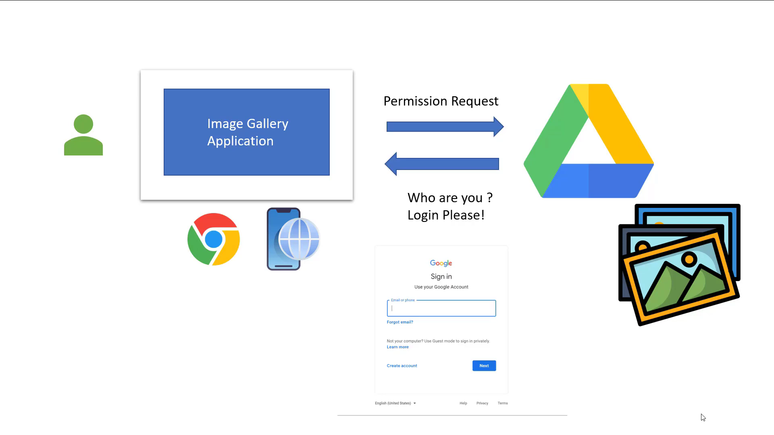

**Step 2:** Resource Owner provides his credentials and Google Authorization Server validates and provides the access token to the Image Gallery application.

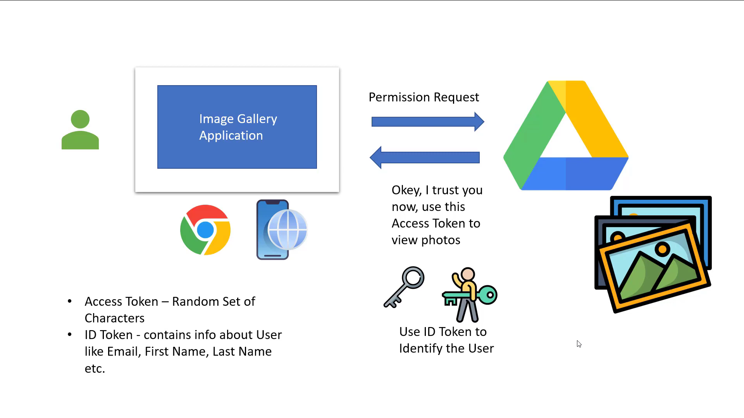

**Step 3:** When Image Gallery Application sends the access token with the request to view the photos. Authorization Server validates the access token and allow the application to the view the photos.

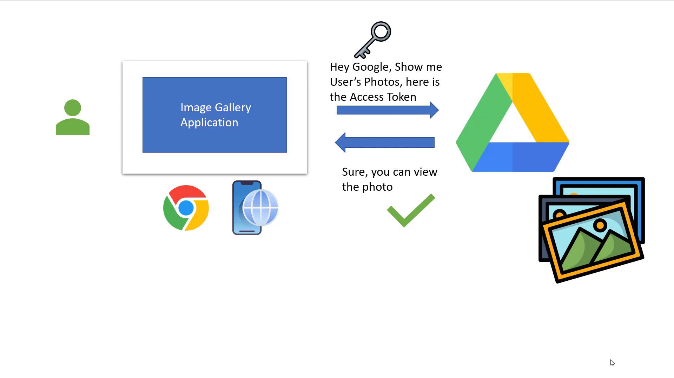

**OIDC**

OIDC stands for OpenID Connect is protocol built on the top of OAuth2.

It acts as an Identity layer which provides the additional token to the client application called ID token contains the user related information.

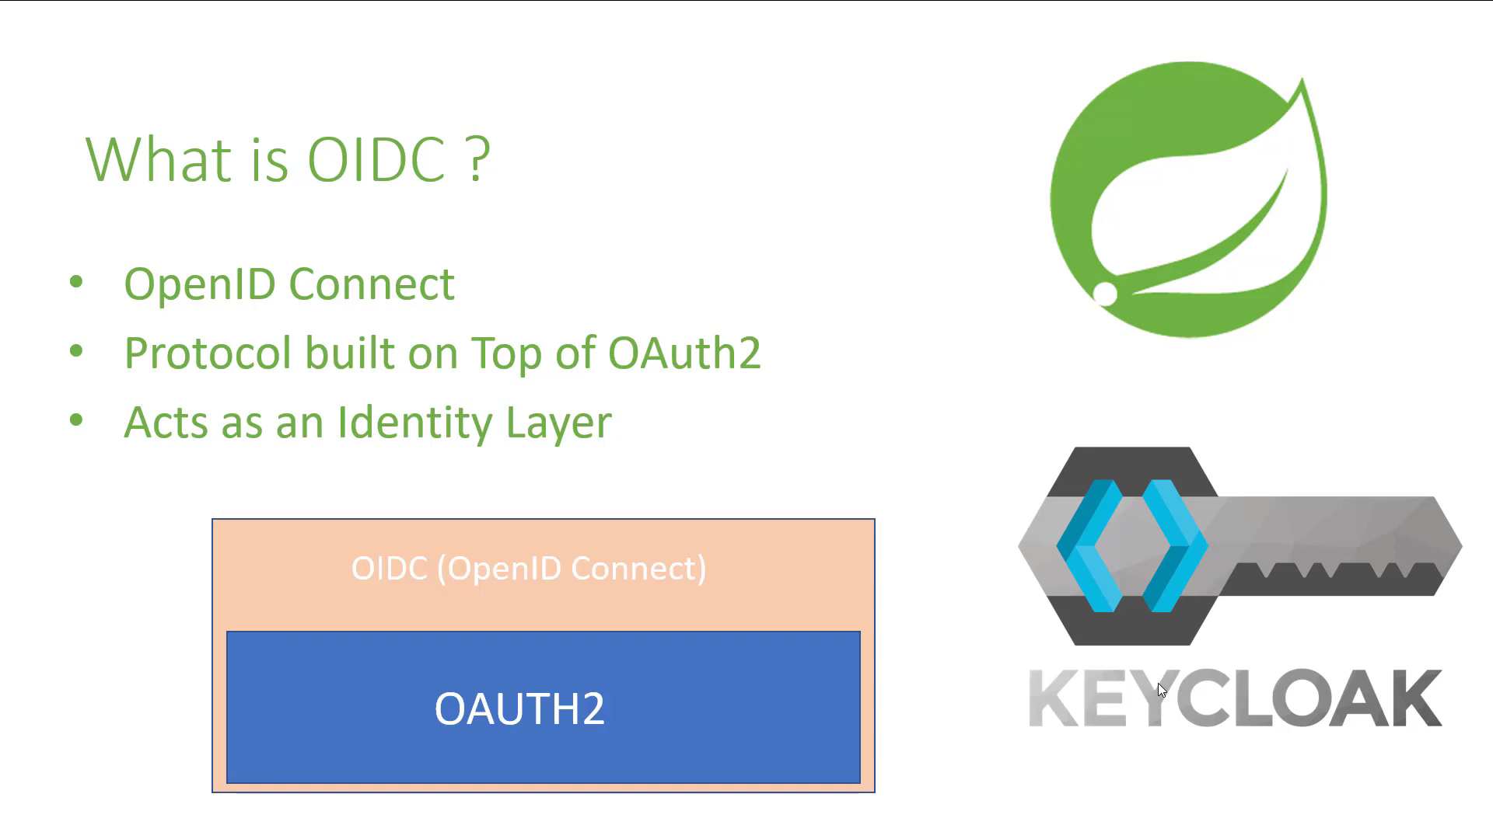

Keycloak is an Open-Source Identity and Access Management Server for modern Applications and Services. It OIDC protocol built on the top of OAuth2 so it returns the both following information.

* + 1. Access token: Used to verify user is authorized to Access the resource.
    2. ID token: used to verify the User Information and Identity of User.



Here’s a brief summary of the protocol:

* Browser visits application. The application notices the user is not logged in, so it redirects the browser to Keycloak to be authenticated. The application passes along a callback URL (a redirect URL) as a query parameter in this browser redirect that Keycloak will use when it finishes authentication.
* Keycloak authenticates the user and creates an *identity* and *access* token. Keycloak redirects back to the application using the callback URL provided earlier and additionally adding the *identity* and *access* tokens as query parameters in the callback URL.
* The application extracts the *identity* and *access* tokens from the callback URL and use in all the request for that user.

The diagram shows flow of how we implement User Registration, User Login and Authorization process. A legal JWT must be added to HTTP Authorization Header if Client accesses protected resources.

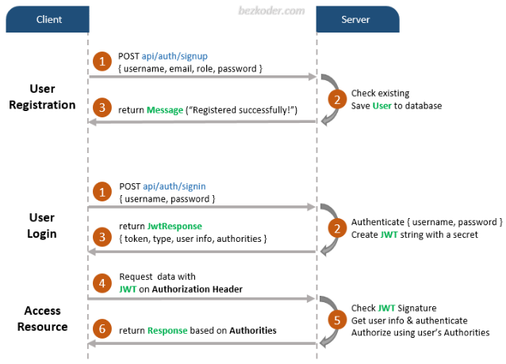

Need to implement refresh token

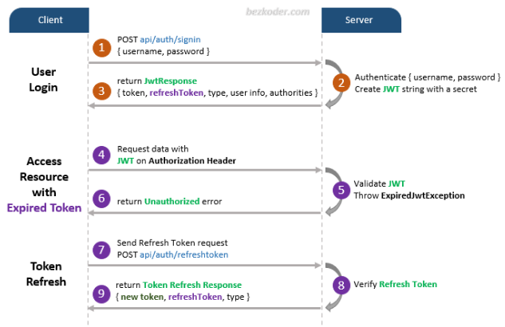

### Types of OAuth2 patterns

There are three types OAuth2 patterns, using Keycloak as authorization server:

* **OpenID Connect Authentication** - the pattern used for end-user authentication shown in the above picture. **[ Used Authorization Grant Type: Password Credentials]**
* **Token Relay** - when an OAuth2 consumer service or application, like the API gateway, acts as a client and forwards the incoming token to outgoing resource requests.
* **Client Credentials Grant** - the pattern to use when the authorized requestor is another service. In this case, we talk about machine to machine, m2m, or service to service authorization. **[ Used Authorization Grant Type: Client Credentials]**

**We will discuss the OAuth2 patterns in detail**:

#### OpenID Connect Authentication

The pattern used for end-user authentication shown in the above picture.

OpenID Connect defines a mechanism for End-User authentication based on the OAuth2 authorization code flow. In this pattern, the Authorization Server returns an Authorization Code to the application, which can then exchange it for an ID Token and an Access Token directly. The Authorization Server authenticates the application with a ClientId and ClientSecret before the exchange happens. As you can see in the diagram below, OpenID and OAuth2 patterns make extensive use of HTTP redirections, some of which have been omitted for clarity.

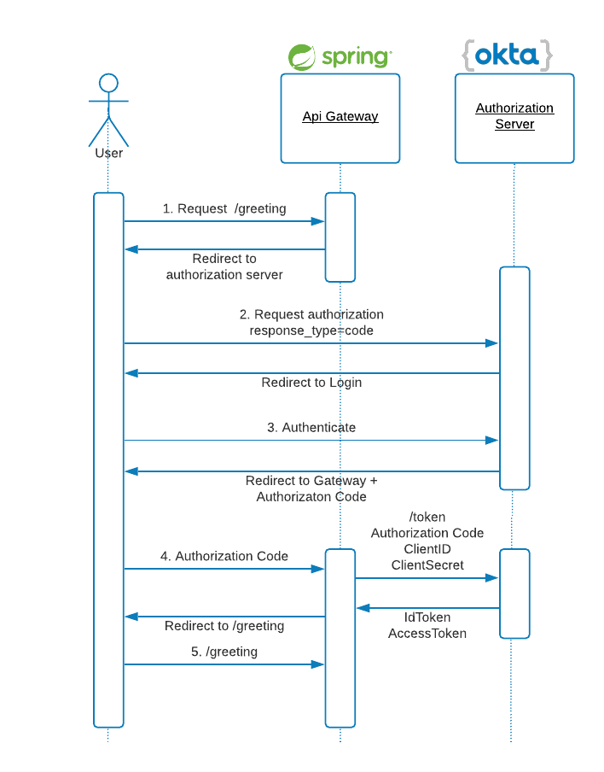

#### Token Relay

A Token Relay happens when an OAuth2 consumer, for example the API Gateway, acts as a client and forwards the accessToken to the routed service. And one microservice can forward the access token to another in the authorization request header using Feign Client.

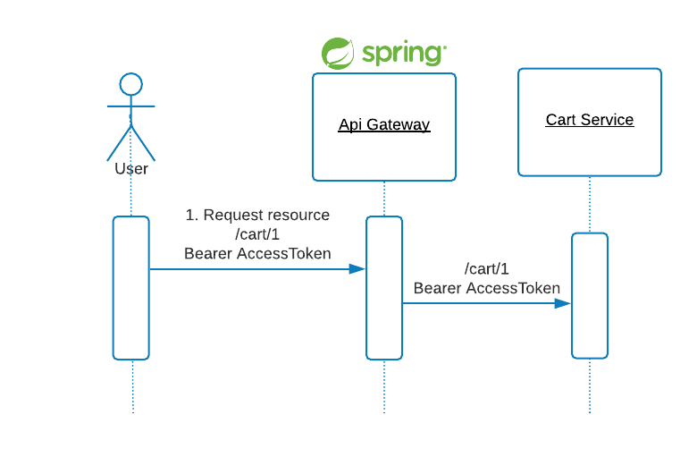

* API Gateway acts as a client and forwards the accessToken to the routed service.

Updating RouteLocatorConfiguration which is used to handle requests by routing them to the corresponding microservice.

* + Adding TokenRelay so that we can carry forward the access token and id token to forwarded microservice.

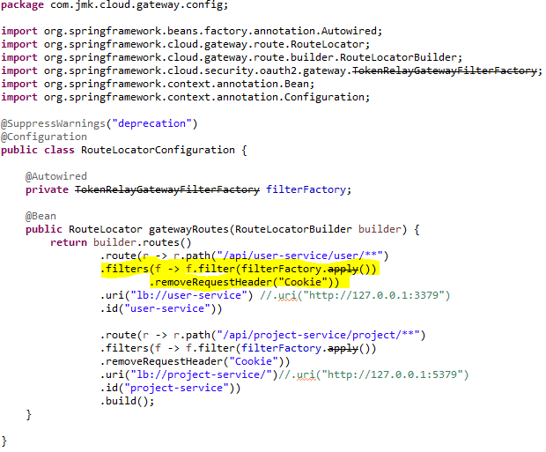

* Normal microservice forwarding the access token to another in the authorization request header using Feign Client.

Add authorization header to Feign Client

Since in Feign Client, you usually do everything in the interface, the same will be for the Authorization header. What you need to do is to simply pass your Authorization header in the declaration of your Feign Client method, as an @RequestHeader argument.

This is the code sample where we're getting items by name and we're passing Authorization header from the caller service:

@FeignClient(name="someService")

public interface ItemFeignClientService {

@RequestMapping(method = RequestMethod.GET, value = "/items/search/findByName?name={name}")

List<Item> findItemsByName(@RequestHeader(value = "Authorization", required = true) String authorizationHeader, @PathVariable("name") String name);

#### Client Credentials Grant

In this authorization pattern, the application requests an access token using only its own client credentials not require any user credentials. This flow is suitable for machine-to-machine (M2M) or service-to-service authorizations. It does not require login page for user credentials as we are not using the same.

* Used for Machine-to-machine authorization
* Usually clients are CLI application, Shell script on Remote Server or a microservice
* Clients make a post request directly to Token Endpoint to retrieve Access Token with Grant Types as Client Credentials.
* Crob job can invoke the microservice directly and this microservice will call another.

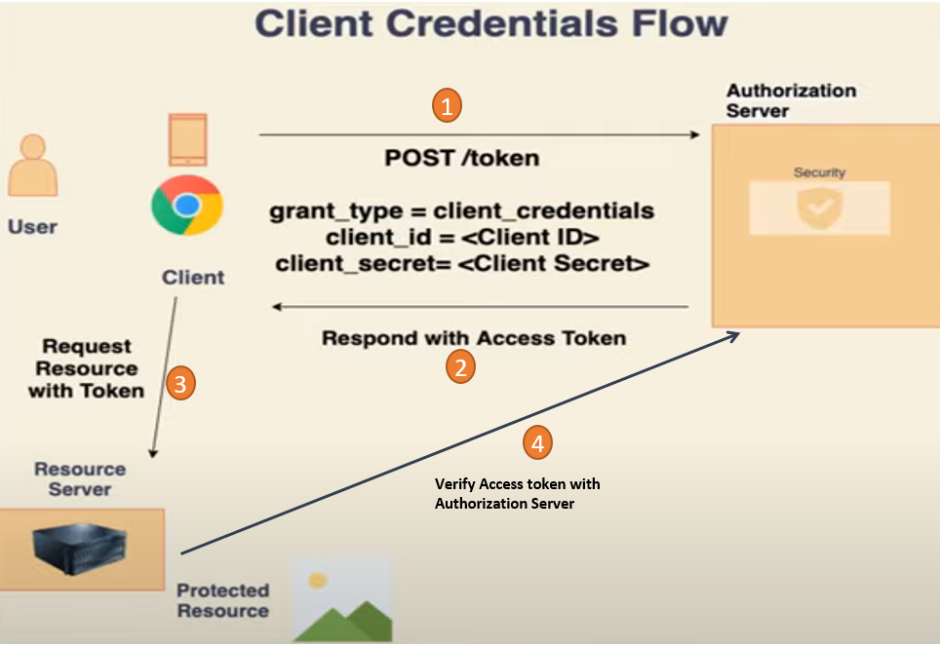

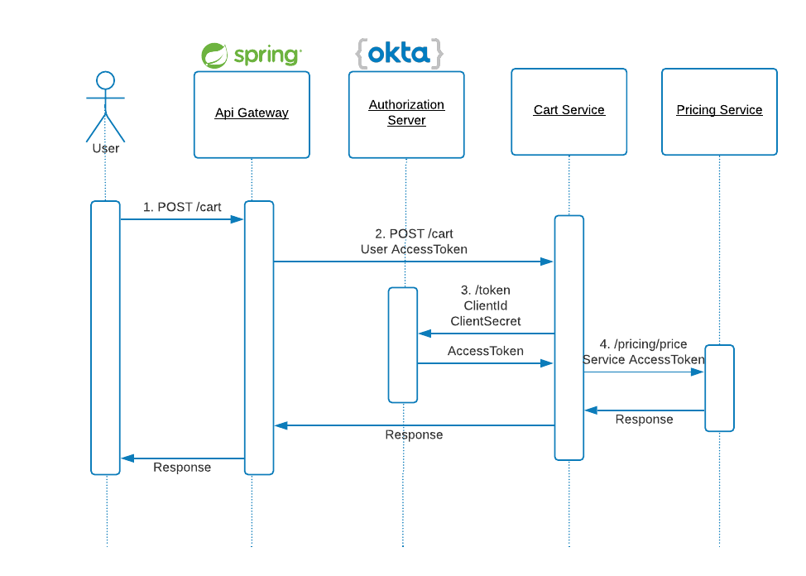

### Coding and Testing (**OpenID Connect end-user authentication**)

#### Keycloak Setup

We are using Keycloak for authentication and authorization in our gateway-service.

[Keycloak](https://www.keycloak.org/) is Open Source Identity and Access Management Server, which is a [OAuth2](https://oauth.net/2/) and [OpenID Connect](https://en.wikipedia.org/wiki/OpenID)(OIDC) protocol complaint for modern applications and services.

It is OIDC protocol built on the top of OAuth2 and it returns the both following information.

* + 1. Access token: Used to verify user is authorized to Access the resource.
    2. ID token: used to verify the User Information and Identity of User.

**We introduce the authentication and authorization layer only to the API gateway** and **all other services will be using infrastructure level authentication to avoid direct access**. So basically, our API gateway is the only place that is accessible to the public and other places are accessible only via the API gateway.

* Download the Keycloak for Setting Up.

Download the Keycloak using the URL: <https://www.keycloak.org/downloads>

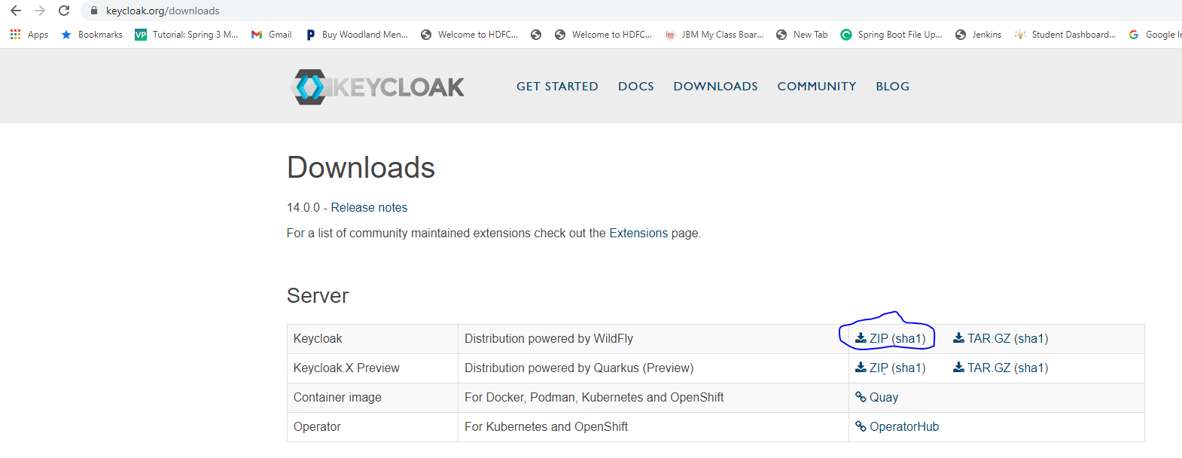

* Unzip the folder: keycloak-14.0.0 and go the bin folder. By default, Keycloak runs on 8080 ports and can be changed as well. We need to update the standalone.xml exists in F:\JAVA\keycloak-14.0.0\standalone\configuration. Suppose, we need to run the KeyCloak on 8100 (8080+100) then we need to add offset from 0 to 100.
  + In your standalone.xml file, look for this element:
    - <socket-binding-group name="standard-sockets" default-interface="public" port-offset="${jboss.socket.binding.port-offset:0}">
  + The port-offset attribute lets you modify all the ports wildfly uses, by adding the number you specify. For example, the default value is 0, which means that http port will be 8080. If you use ${jboss.socket.binding.port-offset:100}, http port will be 8180 (8080+100).
    - <socket-binding-group name="standard-sockets" default-interface="public" port-offset="${jboss.socket.binding.port-offset:100}">
* Run the Keycloak console
  + Cd F:\JAVA\keycloak-14.0.0\bin
  + .\standalone.bat
* Now we are ready with Keycloak instance and access the Keycloak dashboard for other changes. Here my local Keycloak instance is accessible via <http://127.0.0.1:8180/auth/>

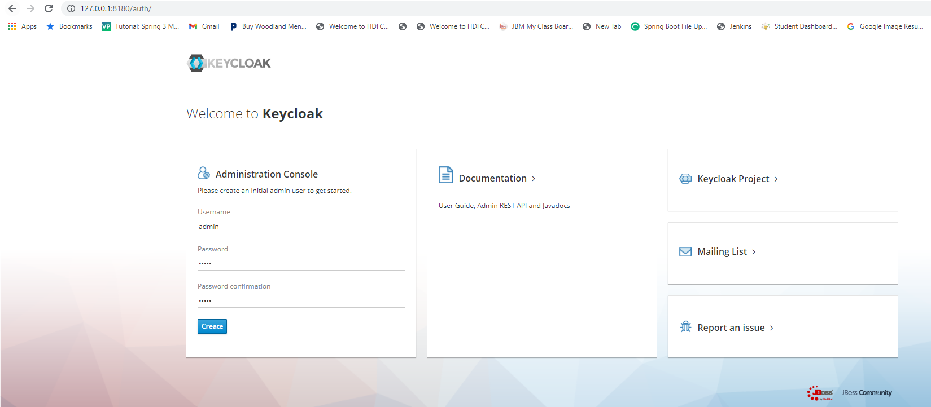

* After that login to the Administration Console using username and password
  + Username: admin
  + Password: admin
* Now we should create a new realm and client to use with our microservices project.

A *realm* is a security policy domain defined for a web or application server. A realm contains a collection of users, who may or may not be assigned to a group.

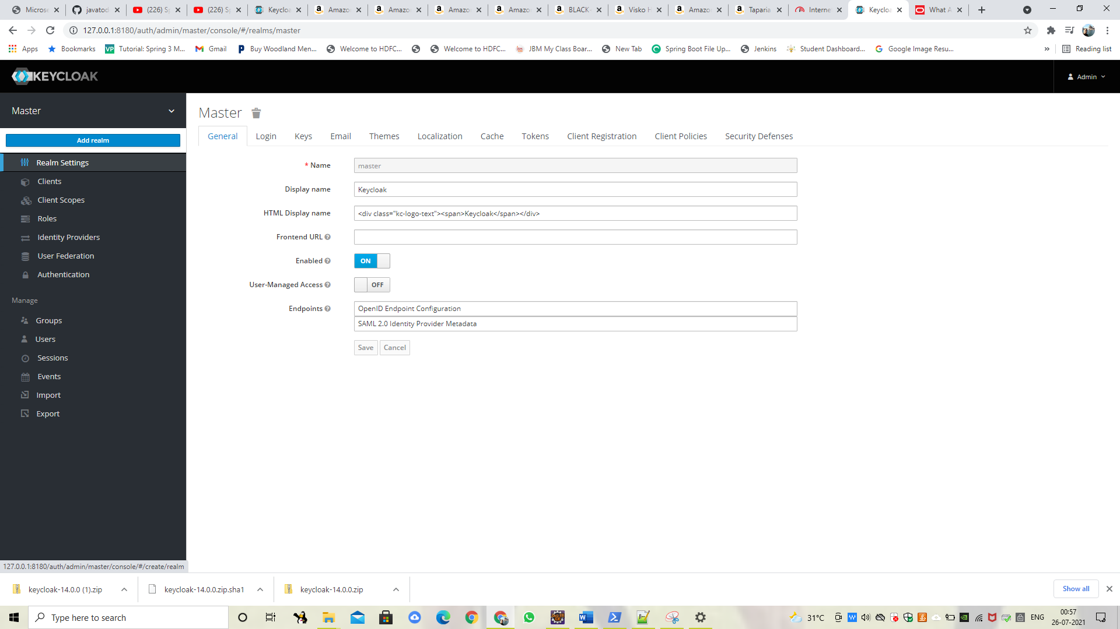

* Create Keycloak realm “**oauth2-bjjd-system-realm** “.

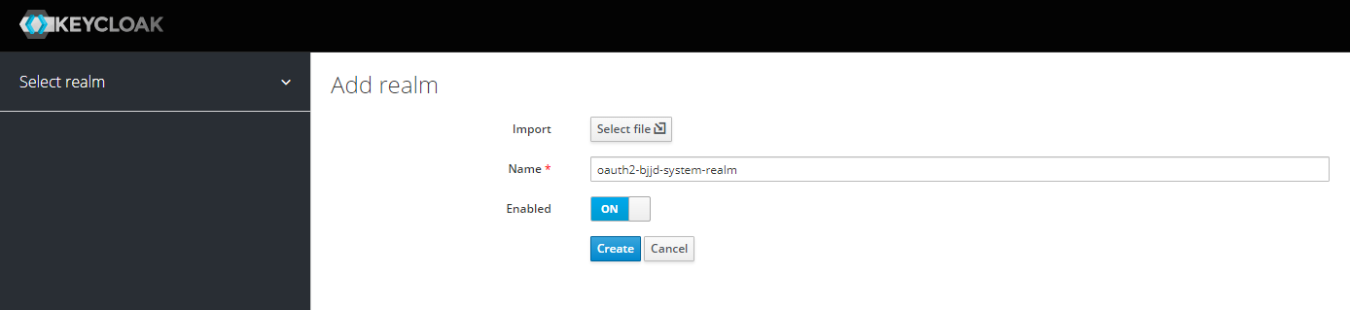

* Now we need to have a client, just access the client registration page and create client: oauth2-bjjd-system-client with Keycloak admin panel following details.

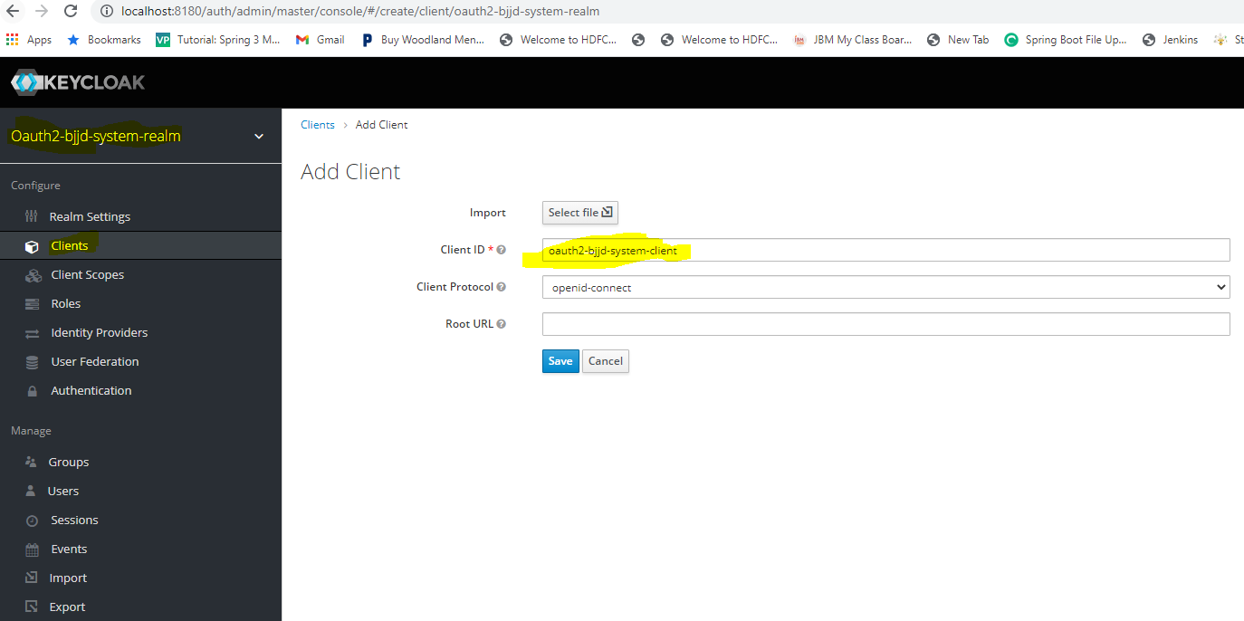

* Navigate to the Clients->oauth2-bjjd-system-client. By default, client access type is public, but here we **need to have a confidential client** to use with spring cloud gateway. So just change it as confidential then put redirect URL as \* for the moment.
  + There are following client access type
    - Public
    - Confidential (Here we are using this one.)
    - Bearer-only

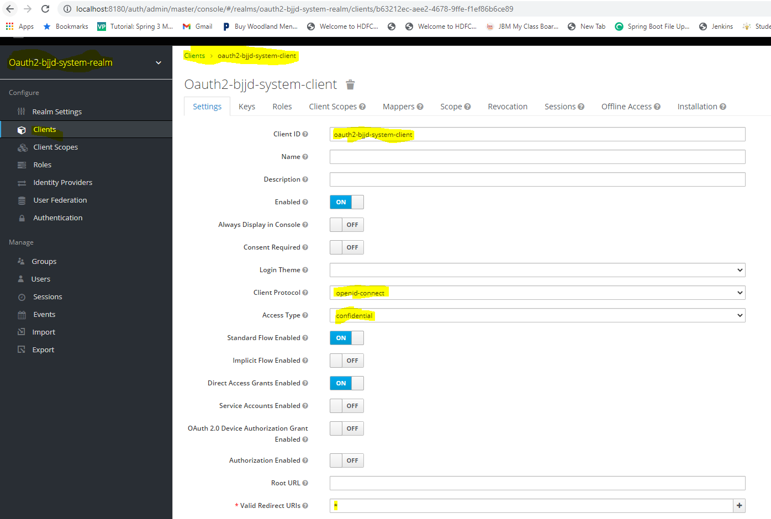

* **Copy the client id and secret from the credentials tab.**

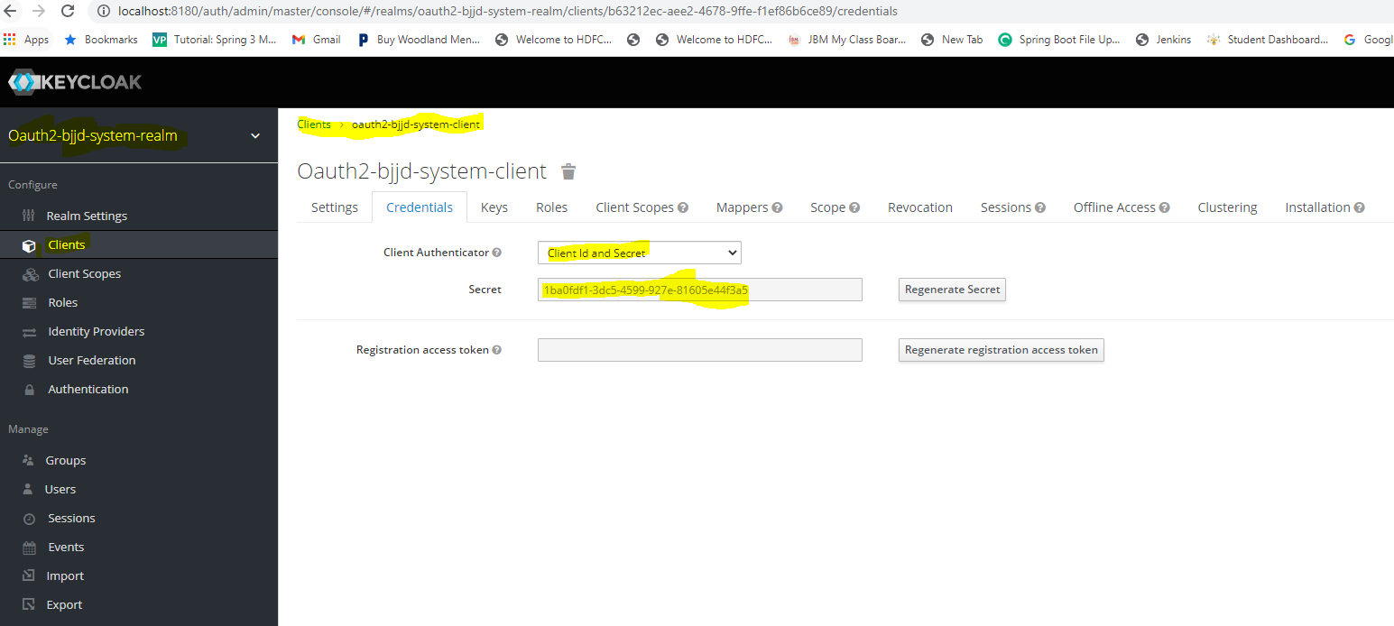

* Up to now, we have configured realm and client in Keycloak to use with our API gateway. Let’s create a user inside this realm to access the API. Basically, this user will be a super admin for this application. Navigate to User->Add User and provide the username: super-user.

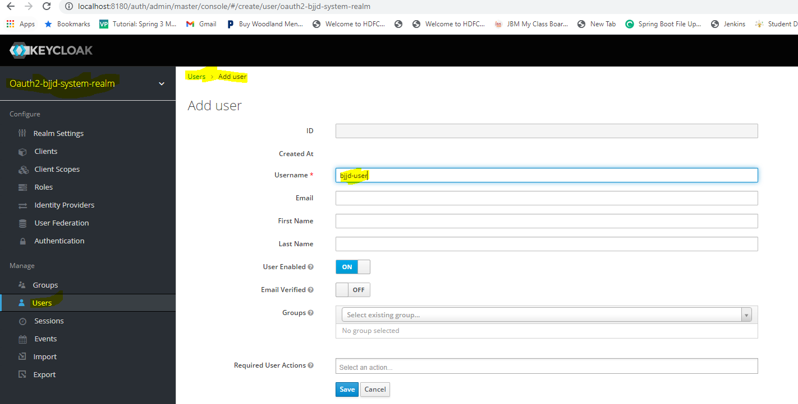

* After that just access the user related page and set a password for that user. Password: rajiv999.

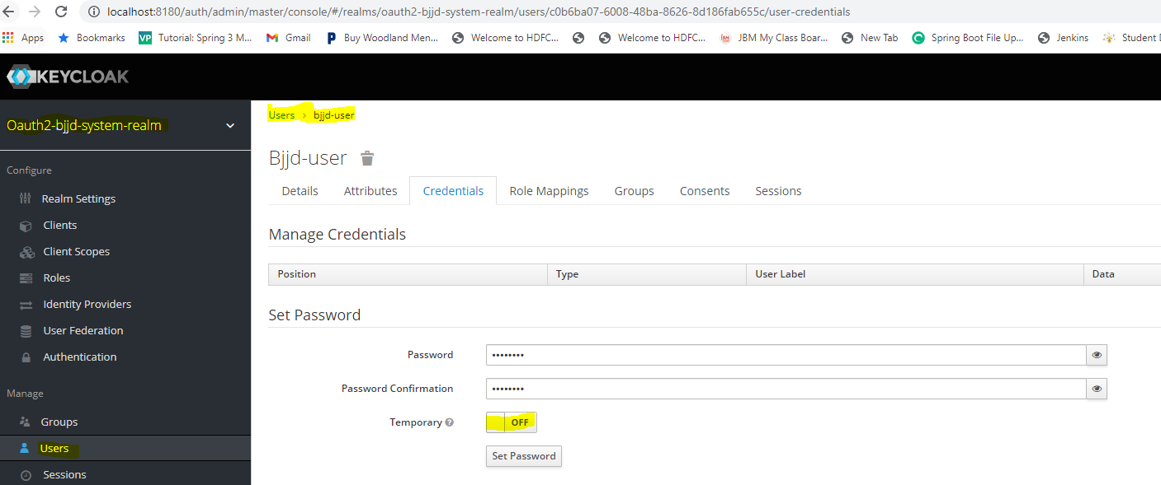

* Now we have all the configurations to work with Keycloak.

Keycloak Setup

#### Code changes

* Add the following dependencies to enable Oauth2.0 security with Keycloak in cloud-gateway-service microservice.
  + spring-boot-starter-oauth2-client: contains Spring Security’s client support for OAuth 2.0 Authorization Framework and OpenID Connect Core 1.0. It is required by applications that use OAuth 2.0 Login or OAuth Client support.
  + spring-boot-starter-oauth2-resource-server: contains Spring Security’s support for OAuth 2.0 Resource Servers. It is used to protect APIs via OAuth 2.0 Bearer Tokens.
  + spring-security-oauth2-jose: contains Spring Security’s support for the JOSE (JavaScript Object Signing and Encryption) framework. The JOSE framework is intended to provide a method to securely transfer claims between parties. It is built from a collection of specifications:
    - JSON Web Token (JWT)
    - JSON Web Signature (JWS)
    - JSON Web Encryption (JWE)
    - JSON Web Key (JWK)
  + spring-cloud-starter-security: It provides the core security entities you need to build a bulletproof app. To use the Token Relay pattern so that token can further forward to the routed microservice.

<!-- OAUTH2.0 CLIENT LIBRARIES: Start -->

<!-- Starter for using Spring Security's OAuth2/OpenID Connect client features -->

<dependency>

<groupId>org.springframework.boot</groupId>

<artifactId>spring-boot-starter-oauth2-client</artifactId>

</dependency>

<!-- Starter for using Spring Security's OAuth2 resource server features. -->

<dependency>

<groupId>org.springframework.boot</groupId>

<artifactId>spring-boot-starter-oauth2-resource-server</artifactId>

</dependency>

<!-- It contains Spring Security’s support for the JOSE (Javascript Object Signing and Encryption) framework. -->

<dependency>

<groupId>org.springframework.security</groupId>

<artifactId>spring-security-oauth2-jose</artifactId>

</dependency>

<dependency>

<groupId>org.springframework.cloud</groupId>

<artifactId>spring-cloud-starter-security</artifactId>

</dependency>

<!-- OAUTH2.0 CLIENT LIBRARIES: Ends -->

* Creating @configuration class basically the security configuration class to the API gateway application to complete the authentication setup. In this class, **I’m allowing our Registration API URL to access without any authentication**. This API will be written on our next steps to create API endpoints on user creation.

**package** com.jmk.cloud.gateway.config.security;

**import** org.springframework.context.annotation.Bean;

**import** org.springframework.security.config.annotation.method.configuration.EnableReactiveMethodSecurity;

**import** org.springframework.security.config.annotation.web.reactive.EnableWebFluxSecurity;

**import** org.springframework.security.config.web.server.ServerHttpSecurity;

**import** org.springframework.security.web.server.SecurityWebFilterChain;

@EnableWebFluxSecurity //To enable WebFlux support in Spring Security 5,

@EnableReactiveMethodSecurity //Indicate the ordering of the execution of the security advisor when multiple advices are applied at a specific joinpoint.

**public** **class** SecurityConfiguration {

@Bean

**public** SecurityWebFilterChain securityWebFilterChain(ServerHttpSecurity http) {

http

.authorizeExchange()

//ALLOWING REGISTER API FOR DIRECT ACCESS

.pathMatchers("/user/api/v1/register").permitAll()

//ALL OTHER APIS ARE AUTHENTICATED

.anyExchange().authenticated()

.and()

.csrf().disable()

.oauth2Login()

.and()

.oauth2ResourceServer() //**behave as a Resource Server and that we’ll be using JWT formatted Access Tokens using the methods oauth2ResourceServer() and jwt()**

.jwt();

**return** http.build();

}

}

* Updating RouteLocatorConfiguration which is used to handle requests by routing them to the corresponding microservice.
  + Adding TokenRelay so that we can carry forward the access token and id token to forwarded microservice.



Notice how we made use of the main building blocks of this API:

* *Route –*the primary API of the gateway. It is defined by a given identification (ID), a destination (URI) and set of predicates and filters
* *Predicate –* a Java 8's *Predicate –*which is used for matching HTTP requests using headers, methods or parameters
* *Filter –* a standard Spring's *WebFilter*
* Updating CloudGatewayServiceApplication to enable RestController so that verify session id, access id and token details.

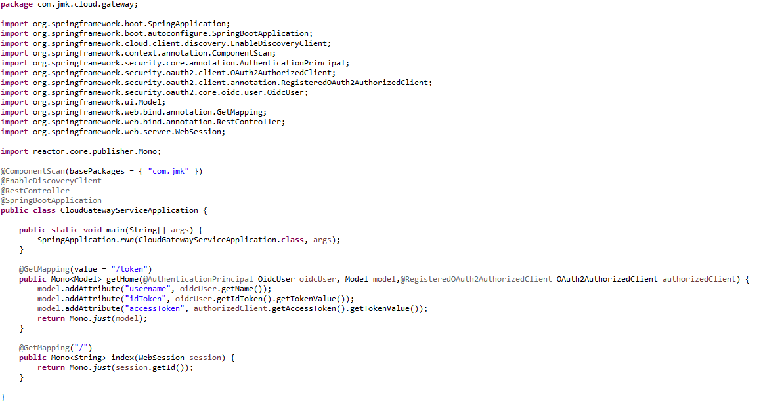

* Updating the application-dev.properties and application-prod.properties with the KeyCloak provider and KeyCloak client details.

application-dev.properties

#Name of the application

spring.application.name=cloud-gateway-service

#Port of the application

server.port=8080

#Spring profile

spring.profiles.active=dev

#It is worth mentioning that Zuul acts as a Eureka client. So, we give it a name, port, and link to Eureka server URL

eureka.client.service-url.default-zone=http://localhost:8761/eureka

eureka.client.fetch-registry=true

eureka.client.register-with-eureka=true

spring.sleuth.sampler.probability = 1.0

hystrix.command.default.execution.isolation.thread.timeoutInMilliseconds=5000000

ribbon.ReadTimeout=20000000

ribbon.ConnectTimeout=20000000

spring.cloud.gateway.default-filters=TokenRelay

app.config.keycloak.baseUrl=http://localhost:8180

app.config.keycloak.url=http://localhost:8180/auth

app.config.keycloak.realm=oauth2-bjjd-system-realm

## API SECURITY WITH KEYCLOAK PROVIDER

spring.security.oauth2.client.provider.keycloak.authorization-uri=${app.config.keycloak.url}/realms/${app.config.keycloak.realm}/protocol/openid-connect/auth

spring.security.oauth2.client.provider.keycloak.jwk-set-uri=${app.config.keycloak.url}/realms/${app.config.keycloak.realm}/protocol/openid-connect/certs

spring.security.oauth2.client.provider.keycloak.token-uri=${app.config.keycloak.url}/realms/${app.config.keycloak.realm}/protocol/openid-connect/token

spring.security.oauth2.client.provider.keycloak.user-info-authentication-method=header

spring.security.oauth2.client.provider.keycloak.user-info-uri=${app.config.keycloak.url}/realms/${app.config.keycloak.realm}/protocol/openid-connect/userinfo

spring.security.oauth2.client.provider.keycloak.issuer-uri=${app.config.keycloak.url}/realms/${app.config.keycloak.realm}

## API WITH KEYCLOAK : oauth2-bjjd-system-client This is the client we created in Keycloak server

spring.security.oauth2.client.registration.oauth2-bjjd-system-client.provider=keycloak

spring.security.oauth2.client.registration.oauth2-bjjd-system-client.client-id=oauth2-bjjd-system-client

spring.security.oauth2.client.registration.oauth2-bjjd-system-client.client-secret=1ba4b9c5-7dc1-41a7-aa9b-55ff144de886

spring.security.oauth2.client.registration.oauth2-bjjd-system-client.scope=openid, profile, roles

#spring.security.oauth2.client.registration.oauth2-bjjd-system-client.authorization-grant-type=authorization\_code

#spring.security.oauth2.client.registration.oauth2-bjjd-system-client.redirect-uri=${app.config.keycloak.baseUrl}/login/oauth2/code/keycloak

spring.security.oauth2.resourceserver.jwt.jwk-set-uri=${app.config.keycloak.url}/realms/${app.config.keycloak.realm}/protocol/openid-connect/certs

application-prod.properties

#Application Name

spring.application.name=cloud-gateway-service

#Port of the application

server.port=8080

#Spring profile

spring.profiles.active=${SPRING\_ACTIVE\_PROFILE:prod}

spring.cloud.kubernetes.discovery.all-namespaces=true

#It is worth mentioning that user-service acts as a Eureka client. So, we give it a name, port, and link to Eureka server

# eureka server url

#eureka.client.service-url.default-zone=http://localhost:8761/eureka

eureka.client.enabled=false

eureka.client.serviceUrl.registerWithEureka=false

spring.sleuth.sampler.probability = 1.0

hystrix.command.default.execution.isolation.thread.timeoutInMilliseconds=5000000

ribbon.ReadTimeout=20000000

ribbon.ConnectTimeout=20000000

spring.cloud.gateway.default-filters=TokenRelay

app.config.keycloak.baseUrl=http://localhost:8180

app.config.keycloak.url=http://localhost:8180/auth

app.config.keycloak.realm=oauth2-bjjd-system-realm

## API SECURITY WITH KEYCLOAK PROVIDER

spring.security.oauth2.client.provider.keycloak.authorization-uri=${app.config.keycloak.url}/realms/${app.config.keycloak.realm}/protocol/openid-connect/auth

spring.security.oauth2.client.provider.keycloak.jwk-set-uri=${app.config.keycloak.url}/realms/${app.config.keycloak.realm}/protocol/openid-connect/certs

spring.security.oauth2.client.provider.keycloak.token-uri=${app.config.keycloak.url}/realms/${app.config.keycloak.realm}/protocol/openid-connect/token

spring.security.oauth2.client.provider.keycloak.user-info-authentication-method=header

spring.security.oauth2.client.provider.keycloak.user-info-uri=${app.config.keycloak.url}/realms/${app.config.keycloak.realm}/protocol/openid-connect/userinfo

spring.security.oauth2.client.provider.keycloak.authorization-uri=${app.config.keycloak.url}/realms/${app.config.keycloak.realm}/protocol/openid-connect/auth

spring.security.oauth2.client.provider.keycloak.issuer-uri=${app.config.keycloak.url}/realms/${app.config.keycloak.realm}

## API WITH KEYCLOAK : oauth2-bjjd-system-client This is the client we created in Keycloak server

spring.security.oauth2.client.registration.oauth2-bjjd-system-client.provider=keycloak

spring.security.oauth2.client.registration.oauth2-bjjd-system-client.client-id=oauth2-bjjd-system-client

spring.security.oauth2.client.registration.oauth2-bjjd-system-client.client-secret=1ba4b9c5-7dc1-41a7-aa9b-55ff144de886

spring.security.oauth2.client.registration.oauth2-bjjd-system-client.scope=openid, profile, roles

#spring.security.oauth2.client.registration.oauth2-bjjd-system-client.authorization-grant-type=authorization\_code

#spring.security.oauth2.client.registration.oauth2-bjjd-system-client.redirect-uri=${app.config.keycloak.baseUrl}/login/oauth2/code/keycloak

spring.security.oauth2.resourceserver.jwt.jwk-set-uri=${app.config.keycloak.url}/realms/${app.config.keycloak.realm}/protocol/openid-connect/certs

#### Testing

##### Run in Dev Environment

* Run the application as **Spring Boot App** in the following order
  + EurekaServerApplication
  + ConfigServerApplication
  + CloudGatewayServiceApplication
  + ProjectServiceApplication
* Check the EurekaServer to verify the required microservices have been registered to it.

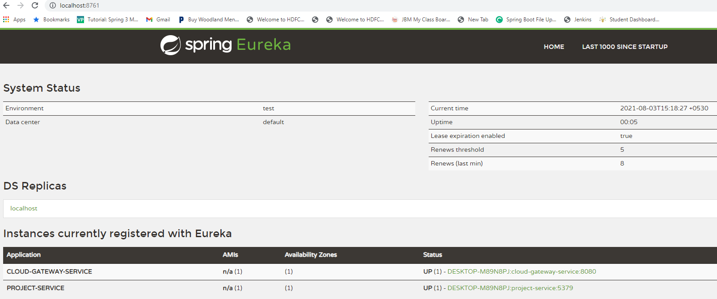

* When user will open the browser and access the Client Application to use microservices via the Gateway Api, Client Application can perform any of the following actions:
  + It will open its login page where user or resource owner will provide its username and password and then it redirects the request to the gateway api to get the access token and id token with the client application details from the KeyCloak server.

**OR**

* + Login request can be forwarded directly from client application to gateway api using the URL: <http://localhost:8080/login>

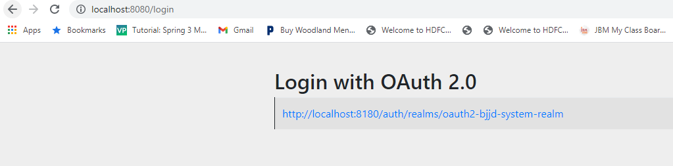

Then gateway api redirects this request on the URL: <http://localhost:8180/auth/realms/oauth2-bjjd-system-realm/protocol/openid-connect/auth> along with the client application details to the Keycloak server to get the access and id token where Keycloak server will open the Login page where the resource owner or user will provide the details.

Username: bjjd-user

Password: rajiv999

Client application Details (picked from application-dev.properties)

**Client Application Details**

spring.security.oauth2.client.registration.oauth2-bjjd-system-client.provider=keycloak

spring.security.oauth2.client.registration.oauth2-bjjd-system-client.client-id=oauth2-bjjd-system-client

spring.security.oauth2.client.registration.oauth2-bjjd-system-client.client-secret=1ba4b9c5-7dc1-41a7-aa9b-55ff144de886

spring.security.oauth2.client.registration.oauth2-bjjd-system-client.scope=openid, profile, roles

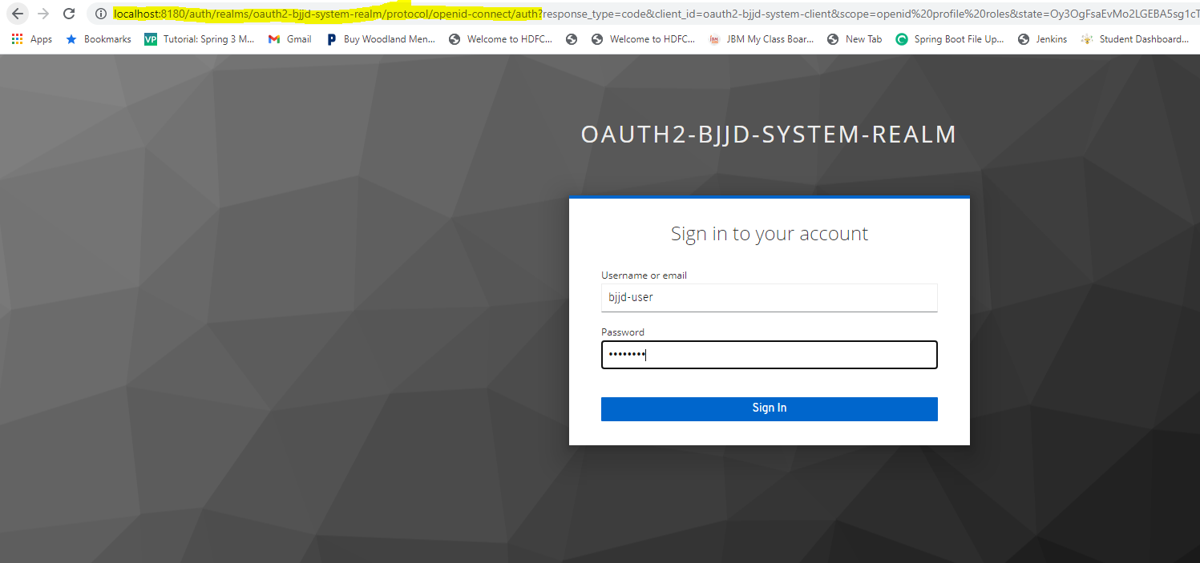

* After providing the credentials, Keycloak server authenticates the user credentials and provides the access token and id token to the client application via callback or redirects URL where we will set the access token and id token in the session of client application. So that going forward, with every request to the microservices, we can add the access token in the request header. It will be verified at Gateway API with the help of Keycloak server.
* If the access token is valid then gateway api will move forward the request to the routed microservice with the access token as well using the TokenRelay pattern. So that if any microservice is required to be accessed if it is secured then this access token can be passed and verified.
* If any redirect URL is not provided then it will be returned to the application URL (<http://localhost:8080/>) and will show the session id.

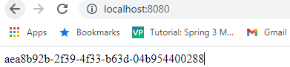

* Hit the URL of gateway api: <http://localhost:8080/token> to get the access token and id token

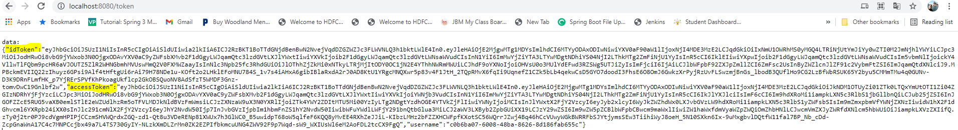

* **Using the Postman (or alternatively client application will send the request with the access token in the request header which is received from the Keycloak server)** 
  + Copy the access token using the gateway api URL <http://localhost:8080/token> which we have used earlier.
  + Hit the target microservice: project-service

<http://localhost:8080/api/project-service/project/findByStatus?status=A>

* + Copy the access token in the postman when sending the request, and it will be verified at gateway api service with the help of Keycloak server. And routed to the destination microservice and get the responds back from the targeted microservices.

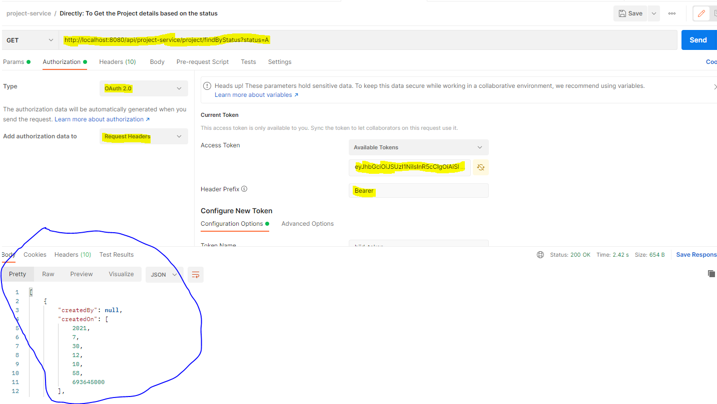

##### Run in Dev Environment Using Postman

* Let’s generate a token from our KeyCloak, so here following are the client application values that we should add in KeyCloak Oauth2.0 token generation window.
  + **Token Name:** bjjd-token (can be any name)
  + **Access token URL**: <http://localhost:8180/auth/realms/oauth2-bjjd-system-realm/protocol/openid-connect/token>
  + **Client ID**: oauth2-bjjd-system-client
  + **Client Secret**: 1ba4b9c5-7dc1-41a7-aa9b-55ff144de886
  + **Username**: bjjd-user
  + **Password**: rajiv999
  + **Scope**: openid, profile, roles
  + **Grant Type:** Password Credentials
* After providing all the details, click on the **Get New Access Token**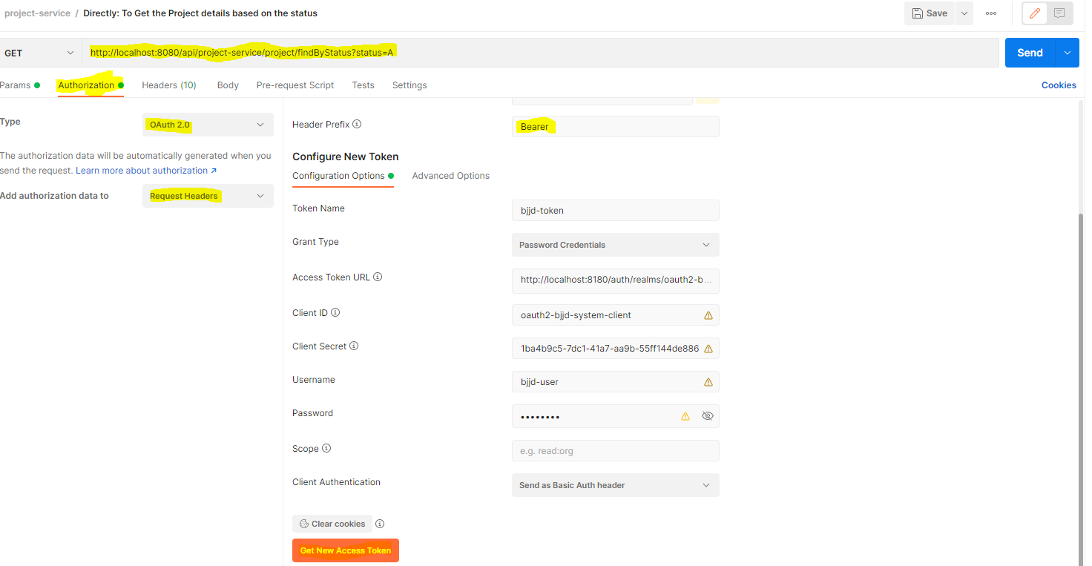
* Click on the **Use Token** Button, it will copy the access token into the request header with the request of the destination microservice URL and get the responds back from the targeted microservices.

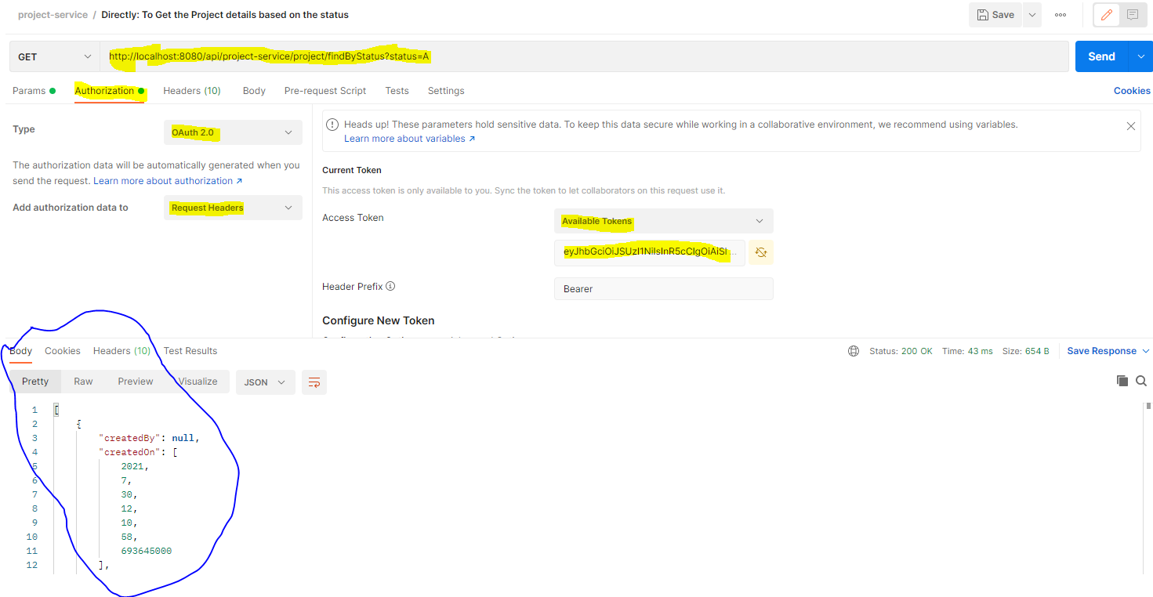

### Coding and Testing (**Client Credentials Flow**)

##### Code Changes Required

* Update the pom.xml with the following dependency

<!-- OAUTH2.0 CLIENT LIBRARIES: Start -->

<!-- Starter for using Spring Security's OAuth2/OpenID Connect client features -->

<dependency>

<groupId>org.springframework.boot</groupId>

<artifactId>spring-boot-starter-webflux</artifactId>

</dependency>

<dependency>

<groupId>org.springframework.boot</groupId>

<artifactId>spring-boot-starter-oauth2-client</artifactId>

</dependency>

<dependency>

<groupId>org.springframework.boot</groupId>

<artifactId>spring-boot-starter-oauth2-resource-server</artifactId>

</dependency>

<dependency>

<groupId>org.springframework.security</groupId>

<artifactId>spring-security-oauth2-jose</artifactId>

</dependency>

<dependency>

<groupId>org.springframework.boot</groupId>

<artifactId>spring-boot-starter-security</artifactId>

</dependency>

<!-- OAUTH2.0 CLIENT LIBRARIES: Ends -->

* Update the application.properties

server.port=8080

spring.security.oauth2.client.registration.oauth2-client-credentials.client-id=oauth2-client-credentials

spring.security.oauth2.client.registration.oauth2-client-credentials.client-secret=1b298cbb-d4b0-4b8e-8cef-8f370b1070d5

spring.security.oauth2.client.registration.oauth2-client-credentials.scope=openid, profile, roles

spring.security.oauth2.client.registration.oauth2-client-credentials.authorization-grant-type=client\_credentials

spring.security.oauth2.client.registration.oauth2-client-credentials.redirect-uri=http://localhost:8080/login/oauth2/code/oauth2-client-credentials

spring.security.oauth2.client.registration.oauth2-client-credentials.provider=keycloak

spring.security.oauth2.client.provider.keycloak.issuer-uri=http://localhost:8180/auth/realms/oauth2-demo-realm

spring.security.oauth2.resourceserver.jwt.issuer-uri=http://localhost:8180/auth/realms/oauth2-demo-realm

* Adding security configuration

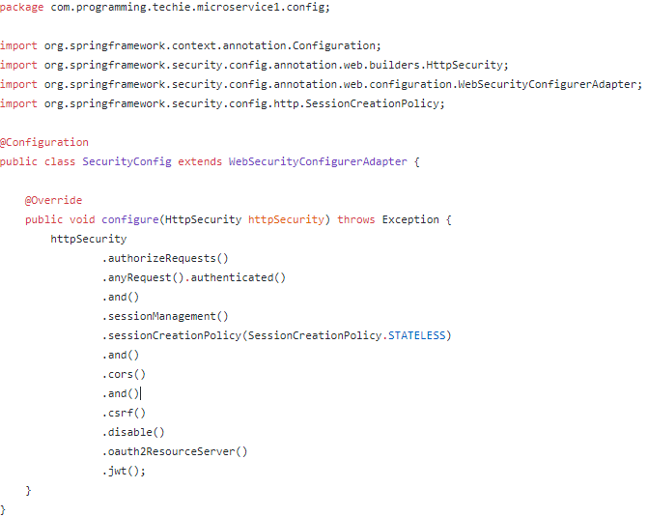

* Remaining changes are simple in the microservice 1 from where we are calling microservice 2.

##### Testing (Using Postman)

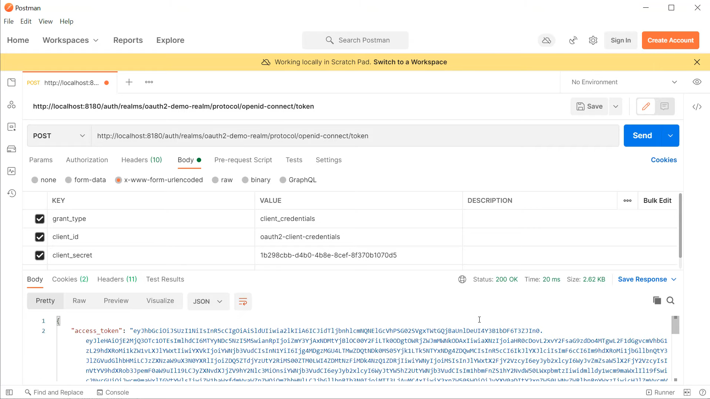

OR

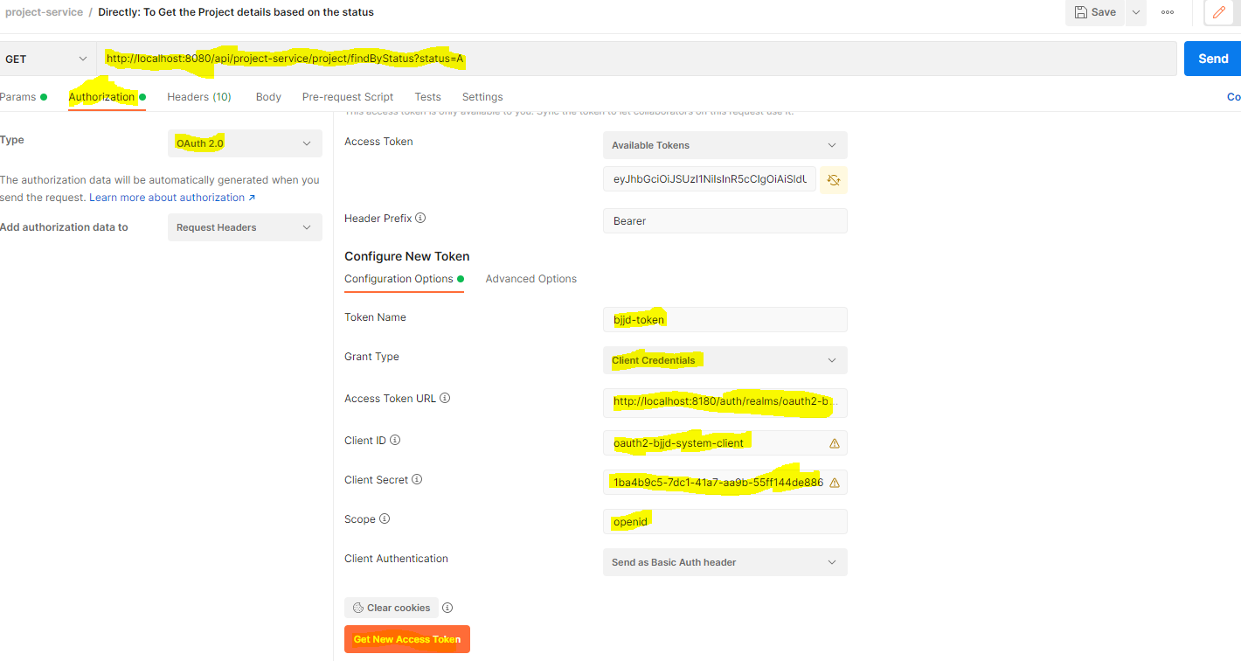

* Click on the **Use Token** Button, it will copy the access token into the request header with the request of the destination microservice URL and get the responds back from the targeted microservices.



# User Service

## Description

User Service is developed to manage the user profile and its role and authorized module can be accessed by user. User details can be cached for retrieval using Hazelcast Cache. It will have the following functions.

* Create the user:

Other microservices such as people-service will call dependent microservice: **user-service** to create the user credentials/information for every member so that member would be able to login into the BJJD application with his details)

* Update the user
* Get the list of all the user
* Delete the user
* Get the user details
* Find the user details based on the username (which can be used by auth-service).

## Entity Relationship Diagram

## Class Diagram

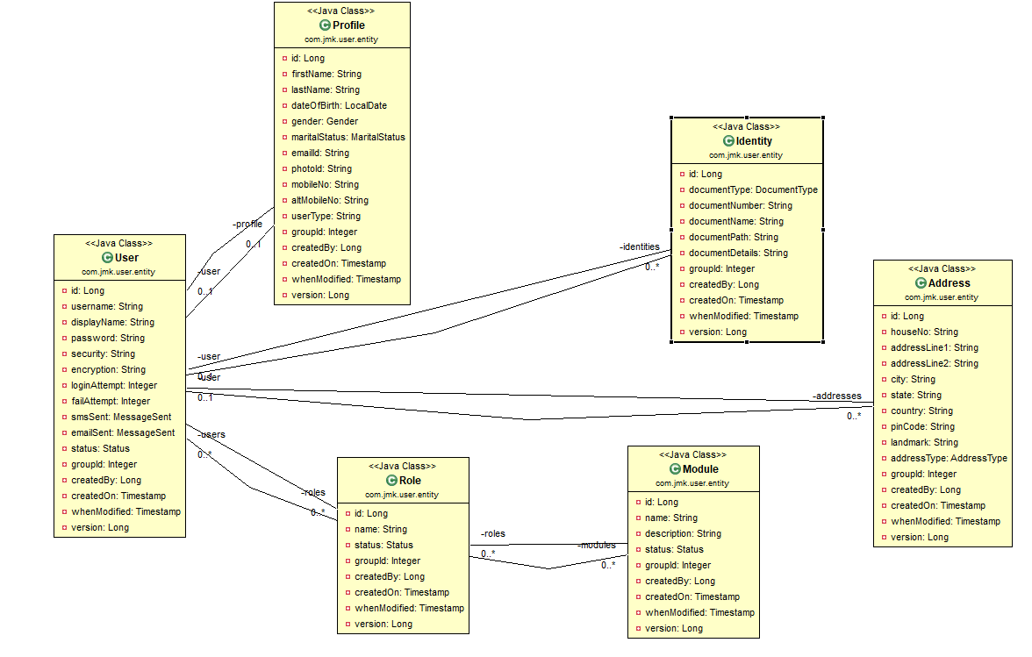

## Use Case Diagram

A use case diagram is a representation of user’s interaction with the system that shows the relationship between the user and the different use cases in which user is involved.

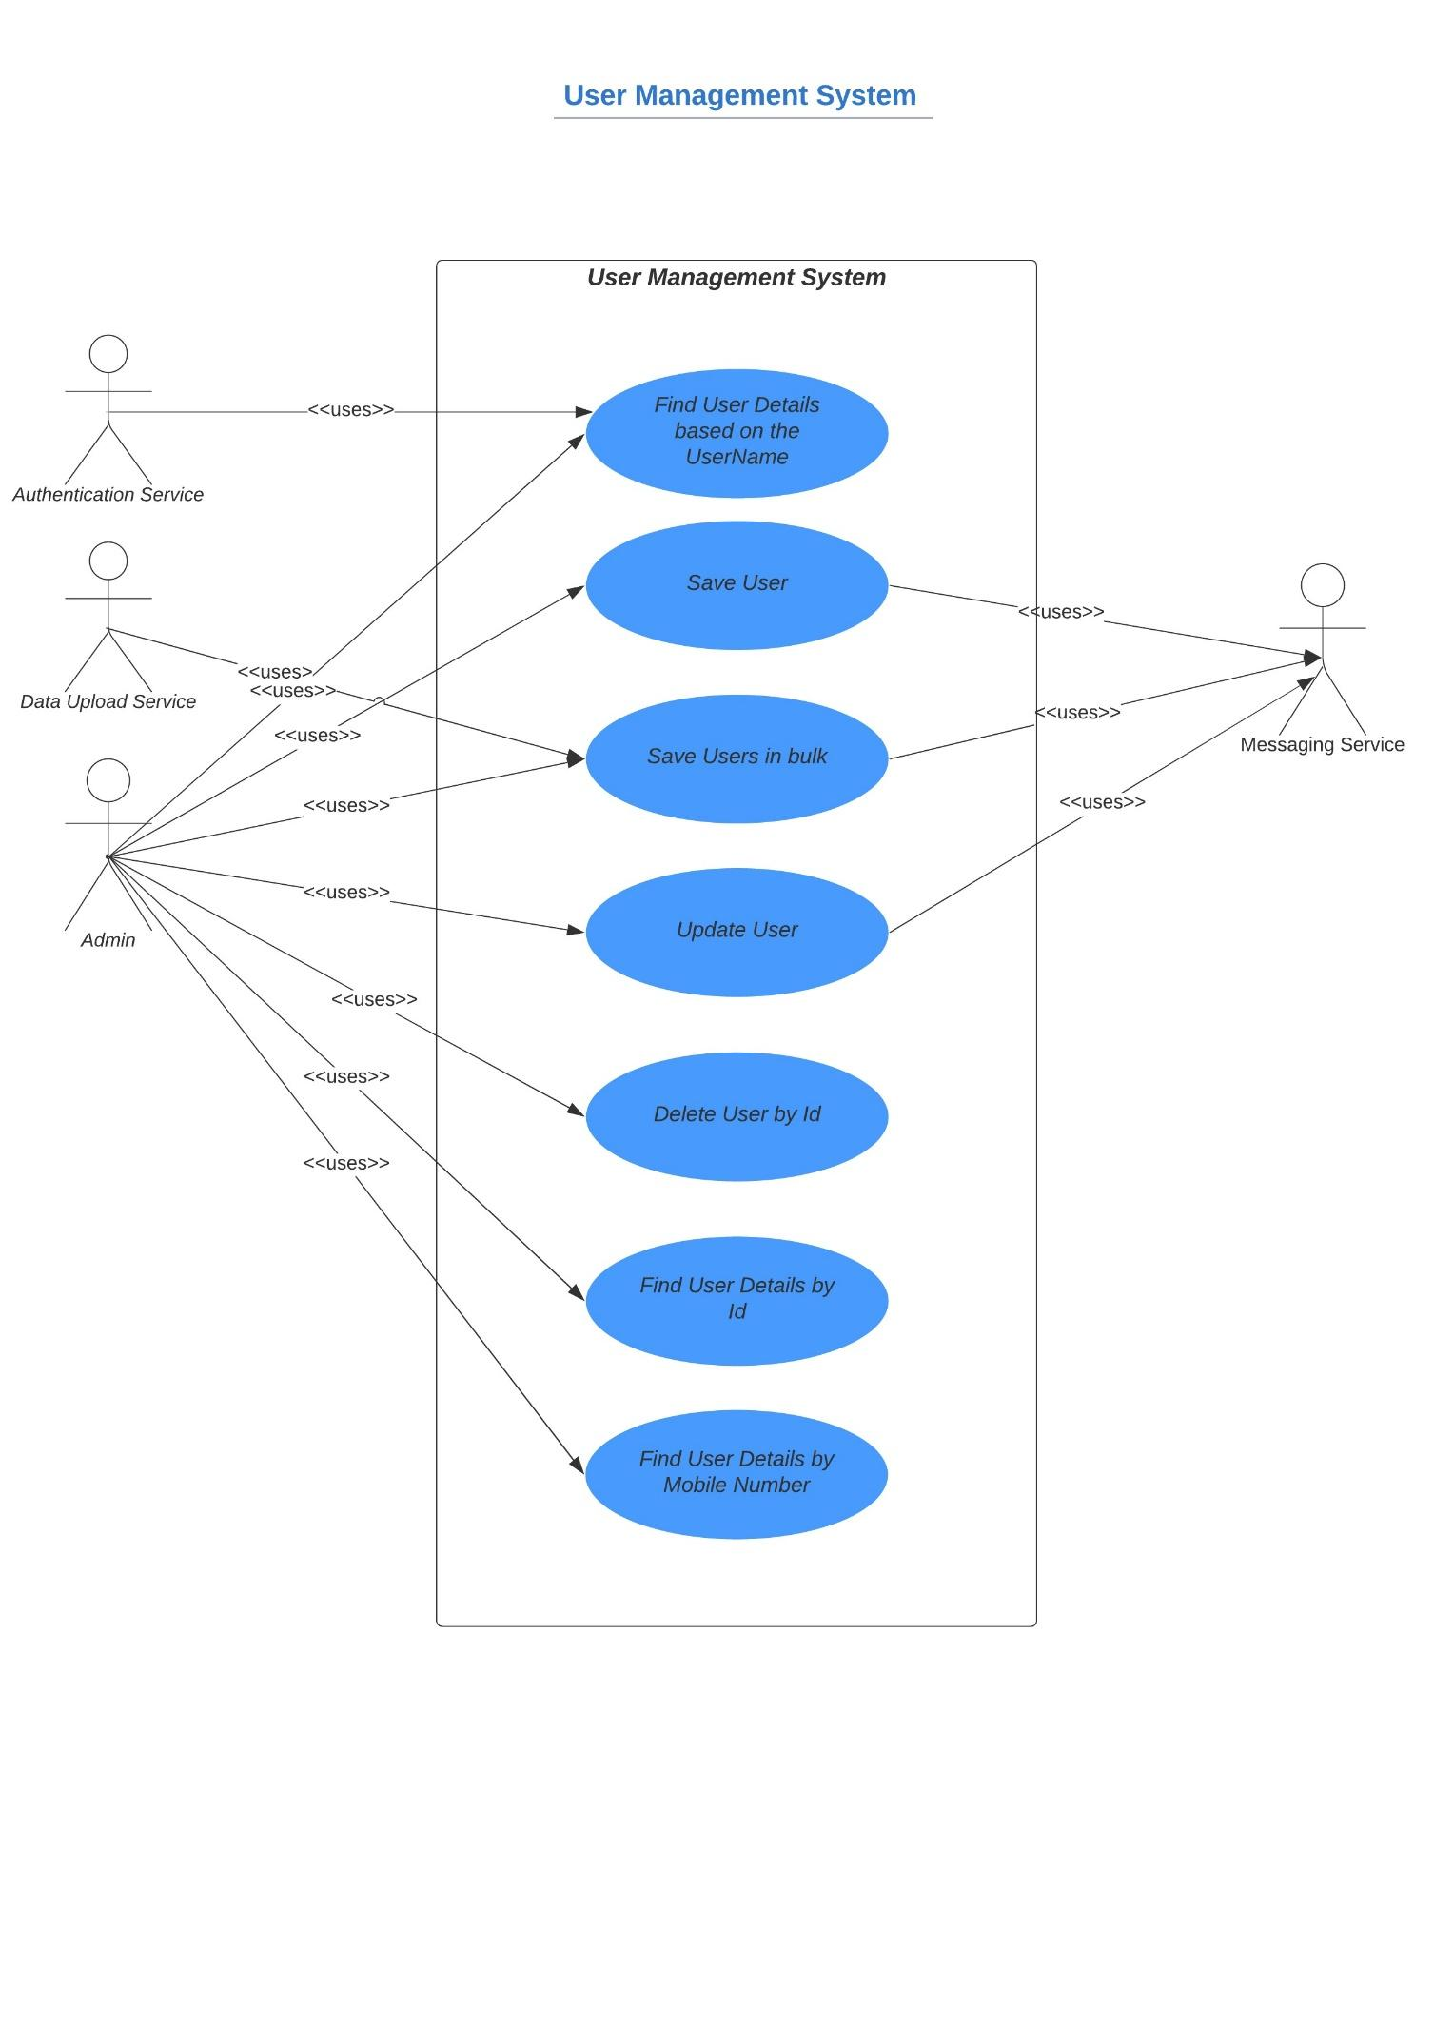

## Use Case Implementation

### Coding

1. Follow the document to implement user-service: **DemoProjectWork-member-mgmt-service.doc** along with the following changes:

|  |  |
| --- | --- |
| Database/Schema Name | users\_db |
| User name | bjjd |
| Password | bjjd\_379 |

**Commands:**

Connect with the root with the following credentials in MySQL database command line or UI

User Id: root

Password: bjjd

* create database users\_db;
* create user 'bjjd'@'%' identified by 'bjjd\_379';
* grant all on users\_db.\* to 'bjjd'@'%';
* grant SELECT,INSERT,UPDATE,DELETE,CREATE,index,drop,ALTER,create temporary tables,references ON users\_db.\* to 'bjjd'@'%';

1. Use the following document related to the swagger, database scripts, ER diagram of Users:



* mvn --encrypt-master-password rajiv379
* Add the following dependencies in the pom.xml with the following considerations:

1. bjjd-microservices Parent: It contains common dependencies of Spring Boot, Spring Cloud and kubeternetes etc.
2. Common-service: It will keep all the dto models, exception handling and common configurations.
3. Hazelcast: to be used for distributed embedded cache
4. Sql-connector: to connect with the MySQL database.
5. jib-maven-plugin:A Maven plugin for building docker container images for your Java applications and pushed to the docker hub.

<project xmlns=*"http://maven.apache.org/POM/4.0.0"*

xmlns:xsi=*"http://www.w3.org/2001/XMLSchema-instance"*

xsi:schemaLocation=*"http://maven.apache.org/POM/4.0.0 http://maven.apache.org/maven-v4\_0\_0.xsd"*>

<modelVersion>4.0.0</modelVersion>

<parent>

<groupId>com.jmk</groupId>

<artifactId>bjjd-microservices</artifactId>

<version>0.0.1.RELEASE</version>

</parent>

<artifactId>user-service</artifactId>

<packaging>jar</packaging>

<name>user-service</name>

<description>User Service</description>

<dependencies>

<!-- Cache dependencies -->

<!-- Spring Boot starter cache -->

<!--

<dependency>

<groupId>org.springframework.boot</groupId>

<artifactId>spring-boot-starter-cache</artifactId>

</dependency>

-->

<dependency>

<groupId>com.hazelcast</groupId>

<artifactId>hazelcast</artifactId>

<version>4.1</version>

</dependency>

<dependency>

<groupId>com.hazelcast</groupId>

<artifactId>hazelcast-spring</artifactId>

<version>4.1</version>

</dependency>

<!-- https://mvnrepository.com/artifact/com.hazelcast/hazelcast-kubernetes -->

<dependency>

<groupId>com.hazelcast</groupId>

<artifactId>hazelcast-kubernetes</artifactId>

<version>2.2.2</version>

</dependency>

<!-- Starter for using Spring Data JPA with Hibernate -->

<dependency>

<groupId>org.springframework.boot</groupId>

<artifactId>spring-boot-starter-data-jpa</artifactId>

</dependency>

<dependency>

<groupId>mysql</groupId>

<artifactId>mysql-connector-java</artifactId>

<version>8.0.25</version><!--$NO-MVN-MAN-VER$ -->

</dependency>

<dependency>

<groupId>javax.validation</groupId>

<artifactId>validation-api</artifactId>

</dependency>

<!-- Internal API Dependency -->

<dependency>

<groupId>com.jmk</groupId>

<artifactId>common-service</artifactId>

<version>${jmk-version}</version>

</dependency>

</dependencies>

<build>

<plugins>

<plugin>

<groupId>com.google.cloud.tools</groupId>

<artifactId>jib-maven-plugin</artifactId>

<version>${jib-maven-plugin.version}</version>

<configuration>

<to>

<image>registry.hub.docker.com/rajivbansal2981/user-service:${jmk-version}</image>

<auth>

<username>rajivbansal2981</username>

<password>rajiv379</password>

</auth>

</to>

</configuration>

</plugin>

</plugins>

</build>

</project>

* Main application.properties file which can further refer the following based on the selected maven profile.
  1. application-dev.properties
  2. application-prod.properties
* application.properties : @spring.profiles.active@ determines which properties file will be referred based on the maven profile: dev or prod

There will be an application.properties file but it will have the following minimum details:

* + - Name of the application
    - Active Default Profile
    - Cloud Config server URI with port

#Name of the application

spring.application.name=user-service

#Active Profile - will relate to development properties file in the server. If this property is absent

#Then, default profile will be activated which is the property file without any environment name at the end.

spring.profiles.active=@spring.profiles.active@

#Setting cloud config server uri with port

spring.cloud.config.uri=http://localhost:8888

* application-dev.properties moved to the git repository: **bjjd-config-server-git-repo** and will be selected if maven profile is dev

#Name to the application

spring.application.name=user-service

#Port of the application

server.port=3379

#It is worth mentioning that user-service acts as a Eureka client. So, we give it a name, port, and link to Eureka server

# eureka server url

eureka.client.service-url.default-zone=http://localhost:8761/eureka

#Spring profile

spring.profiles.active=dev

#To disable the Kubernetes Discovery client

#spring.cloud.kubernetes.enabled=false

#spring.cloud.kubernetes.discovery.include-not-ready-addresses=true

spring.sleuth.sampler.probability = 1.0

server.servlet.context-path=/api/user-service

spring.jackson.date-format=com.jmk.user.swagger.RFC3339DateFormat

spring.jackson.serialization.WRITE\_DATES\_AS\_TIMESTAMPS=false

#Define properties related to JPA

spring.jpa.hibernate.ddl-auto=create

spring.datasource.url=jdbc:mysql://localhost:3306/users\_db

spring.datasource.username=bjjd

spring.datasource.password=bjjd\_379

#Optional

spring.datasource.tomcat.max-wait=20000

spring.datasource.tomcat.max-active=50

spring.datasource.tomcat.max-idle=20

spring.datasource.tomcat.min-idle=15

#Below line is commented as it takes by default: org.hibernate.dialect.MySQL5Dialect

#spring.jpa.properties.hibernate.dialect = org.hibernate.dialect.MySQL5Dialect

spring.jpa.properties.hibernate.id.new\_generator\_mappings = false

spring.jpa.properties.hibernate.format\_sql = true

logging.level.org.hibernate.SQL=DEBUG

logging.level.org.hibernate.type.descriptor.sql.BasicBinder=TRACE

logstash.host=localhost

logstash.queue-size=1000

logstash.port=5000

* application-prod.properties: It will be selected if maven profile is prod.
  1. Eureka Clients registrations with Eureka server need to be disabled in Kubernetes.
  2. Add client option to your mysql-connector allowPublicKeyRetrieval=true to allow the client to automatically request the public key from the server. Note that AllowPublicKeyRetrieval=True could allow a malicious proxy to perform a MITM attack to get the plaintext password, so it is False by default and must be explicitly enabled.
  3. Adding useSSL=false when you use it for testing/develop purposes

#Name of the application

spring.application.name=user-service

#Port of the application

server.port=3379

#Spring profile

spring.profiles.active=${SPRING\_ACTIVE\_PROFILE:prod}

spring.cloud.kubernetes.discovery.all-namespaces=true

#It is worth mentioning that user-service acts as a Eureka client. So, we give it a name, port, and link to Eureka server

# eureka server url

#eureka.client.service-url.default-zone=http://localhost:8761/eureka

eureka.client.enabled=false

eureka.client.serviceUrl.registerWithEureka=false

server.servlet.context-path=/api/user-service

spring.jackson.date-format=com.jmk.user.swagger.RFC3339DateFormat

spring.jackson.serialization.WRITE\_DATES\_AS\_TIMESTAMPS=false

#Define properties related to JPA

spring.jpa.hibernate.ddl-auto=validate

spring.datasource.url=jdbc:mysql://${DB\_HOSTNAME:localhost}:${DB\_PORT:3306}/${DB\_NAME:users\_db}?allowPublicKeyRetrieval=true&useSSL=false

spring.datasource.username=${DB\_USERNAME:bjjd}

spring.datasource.password=${DB\_PASSWORD:bjjd\_379}

#Optional

spring.datasource.tomcat.max-wait=20000

spring.datasource.tomcat.max-active=50

spring.datasource.tomcat.max-idle=20

spring.datasource.tomcat.min-idle=15

#Below line is commented as it takes by default: org.hibernate.dialect.MySQL5Dialect

spring.jpa.properties.hibernate.dialect = org.hibernate.dialect.MySQL5Dialect

spring.jpa.properties.hibernate.id.new\_generator\_mappings = false

spring.jpa.properties.hibernate.format\_sql = true

logging.level.org.hibernate.SQL=DEBUG

logging.level.org.hibernate.type.descriptor.sql.BasicBinder=TRACE

1. Rename the package of io.swagger to com.jmk.user
2. Rename and refactor the Swagger2SpringBoot.java to UserServiceApplication.java with the following details:
   1. Enable Discovery Client so that it can register with Eureka Server and it supports Kubernetes Discovery System.
   2. Enable JpaRepositories

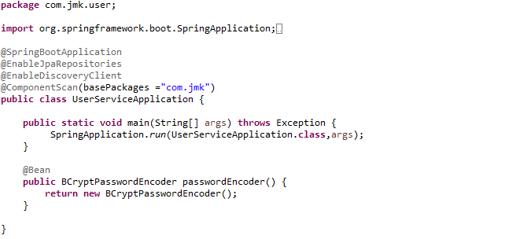

1. Rest UserApi with its implementation

UserApi.java

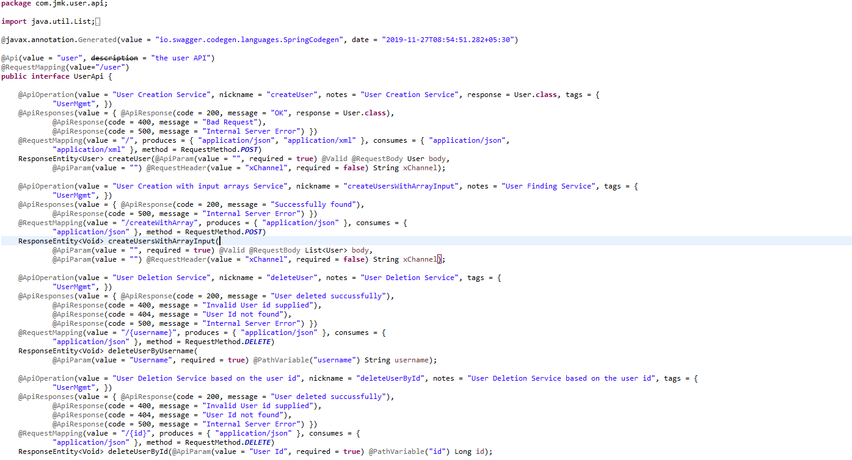

UserApiController.java

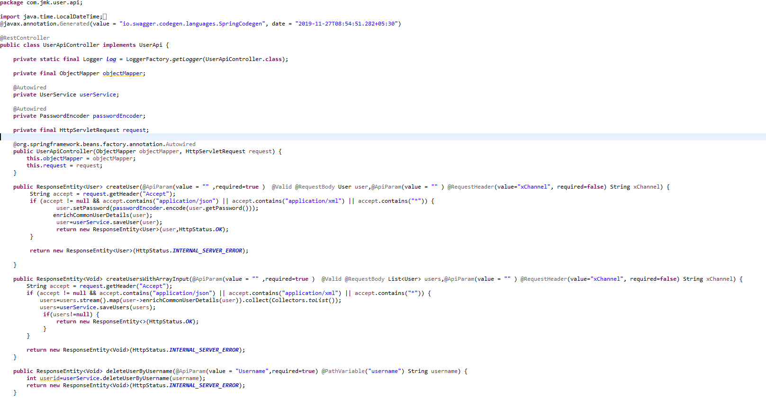

1. Configure the Hazelcast Cache (Embedded Distributed Cache)

* Configure the Hazelcast Cache in the two ways:
  1. If application is running in the Dev environment

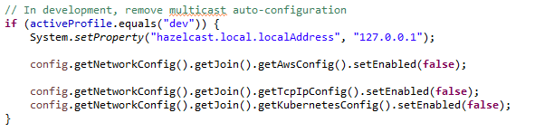

* 1. If application is running in the Kubernetes Environment (Prod)

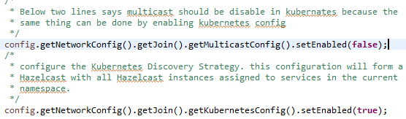

* HazelcastCacheConfiguration.java file to configure the Hazelcast Cache.

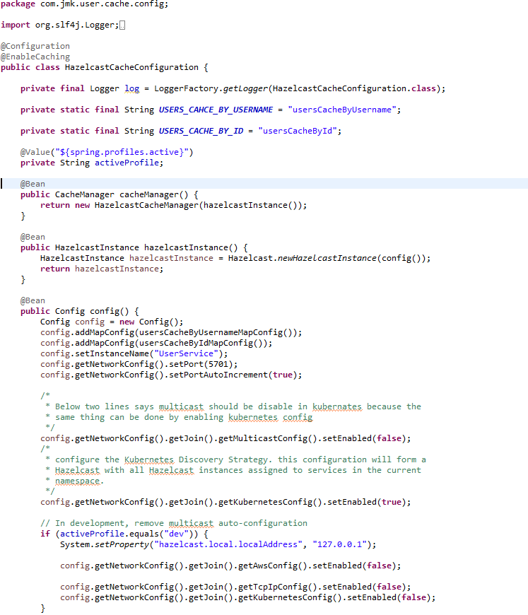

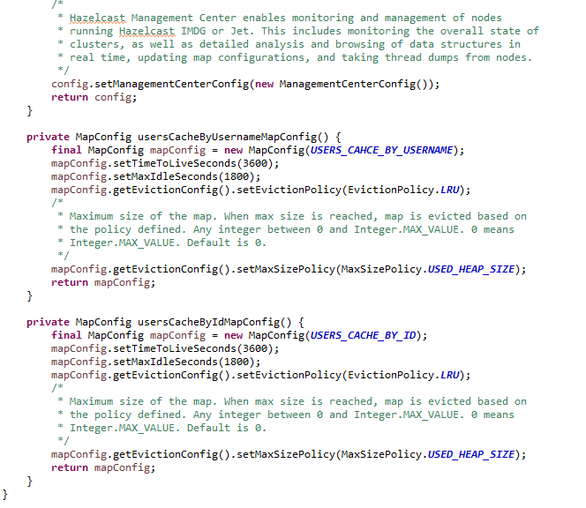

1. User Service should be exposed as following:

**public** **interface** UserService {

User saveUser(User user);

**void** deleteUserById(Long id);

User findUserDetailsByUserName(String userName);

User findUserDetailsById(Long id);

**int** deleteUserByUsername(String username);

List<User> saveUsers(List<User> users);

List<User> findAllUsers();

}

1. User Service Implementation should be exposed as following:
   1. Custom Exception Handling where EntityNotFoundException class (created in common-service) thrown if entity not present in database which is handled in RestExcceptionHandler(created in common-service), in this handler we are creating the appropriate error message in json and send back to client.
   2. Implementations of Hazelcast Cache.

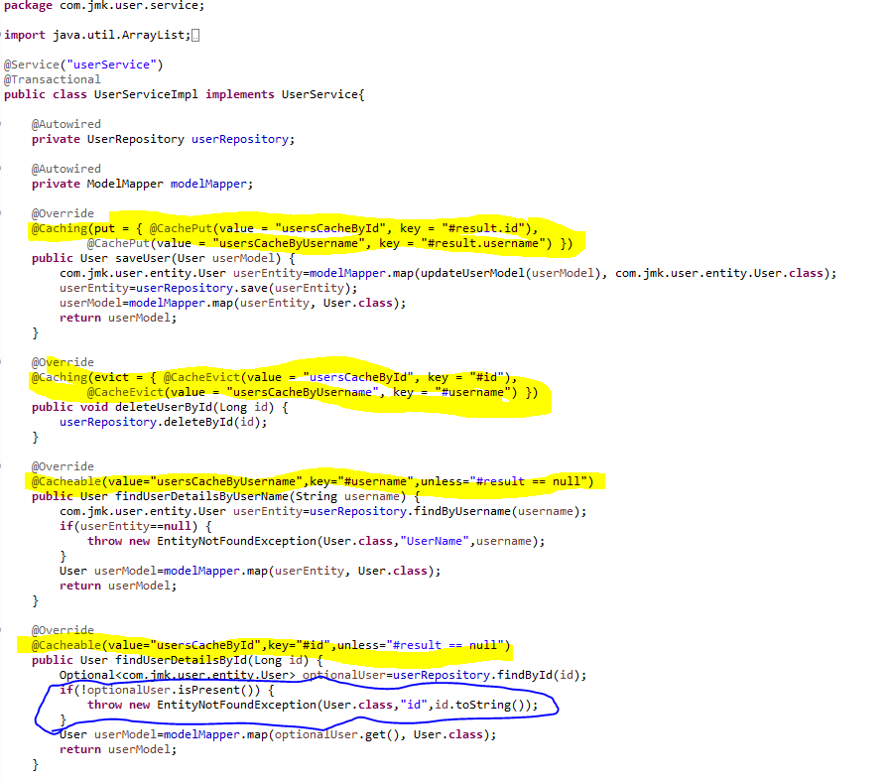

1. UserRepository.java

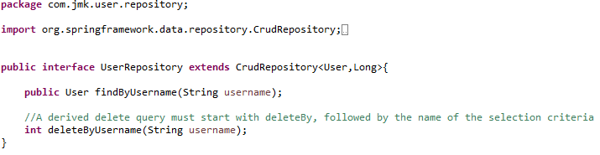

1. Create the model and entities using Lombok.

@**JsonProperty** is suitable for conversion during **serialization**.

@**ApiModelProperty** is **used** for interface document display.

**@Data //It is combination of @ToString, @EqualsAndHashCode ,@Getter,@Setter and @RequiredArgsConstructor**

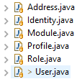

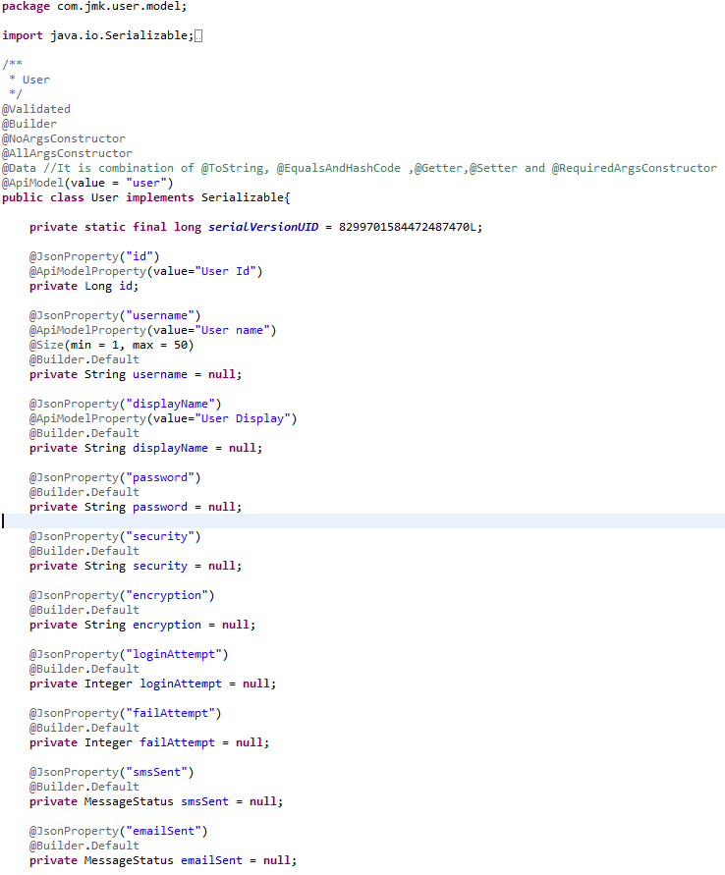

1. Made changes for swagger documentation
   1. in the SwaggerDocumentationConfig, @EnableSwagger2 - Annotation to Enable Swagger Documentation on the API

@EnableSwagger2

@Configuration

**public** **class** SwaggerDocumentationConfig {

ApiInfo apiInfo() {

**return** **new** ApiInfoBuilder()

.title("User Managerment Service API")

.description("User Managerment Service API for BJJD")

.license("")

.licenseUrl("http://unlicense.org")

.termsOfServiceUrl("")

.version("18.10.0")

.contact(**new** Contact("","", ""))

.build();

}

@Bean

**public** Docket customImplementation(){

**return** **new** Docket(DocumentationType.***SWAGGER\_2***)

.select()

.apis(RequestHandlerSelectors.*basePackage*("com.jmk.user.api")).paths(PathSelectors.*regex*("/user.\*"))

.build()

.directModelSubstitute(org.threeten.bp.LocalDate.**class**, java.sql.Date.**class**)

.directModelSubstitute(org.threeten.bp.OffsetDateTime.**class**, java.util.Date.**class**)

.apiInfo(apiInfo());

}

}

* 1. Made changes in the Swagger’s HomeController

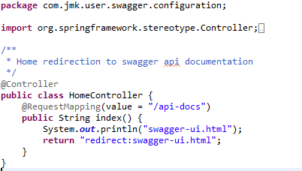

1. Run the application as **Spring Boot App** in the following order
   1. EurekaServerApplication
   2. UserMgmtRestApplication

Check Eureka Server is running and UserMgmtServiceApplication is registered with Eureka Server: <http://localhost:8761/>

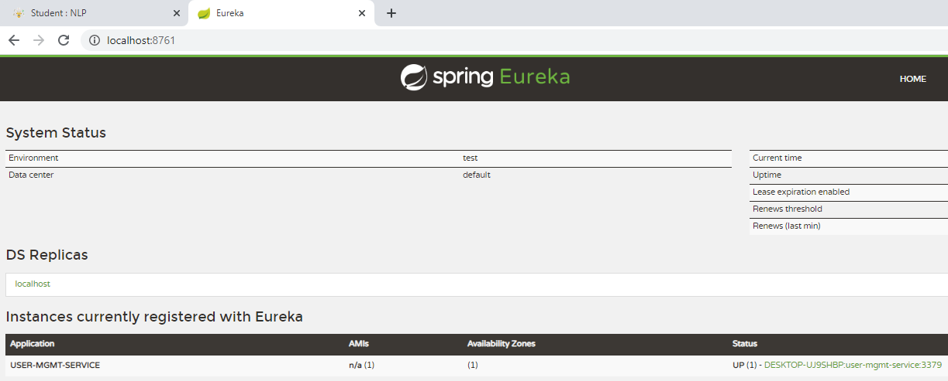

1. After running the application, should be visible following functions for the following url: <http://localhost:3379/api/user-mgmt-service/swagger-ui.html>

Or

<http://localhost:3379/api/user-mgmt-service/api-docs>

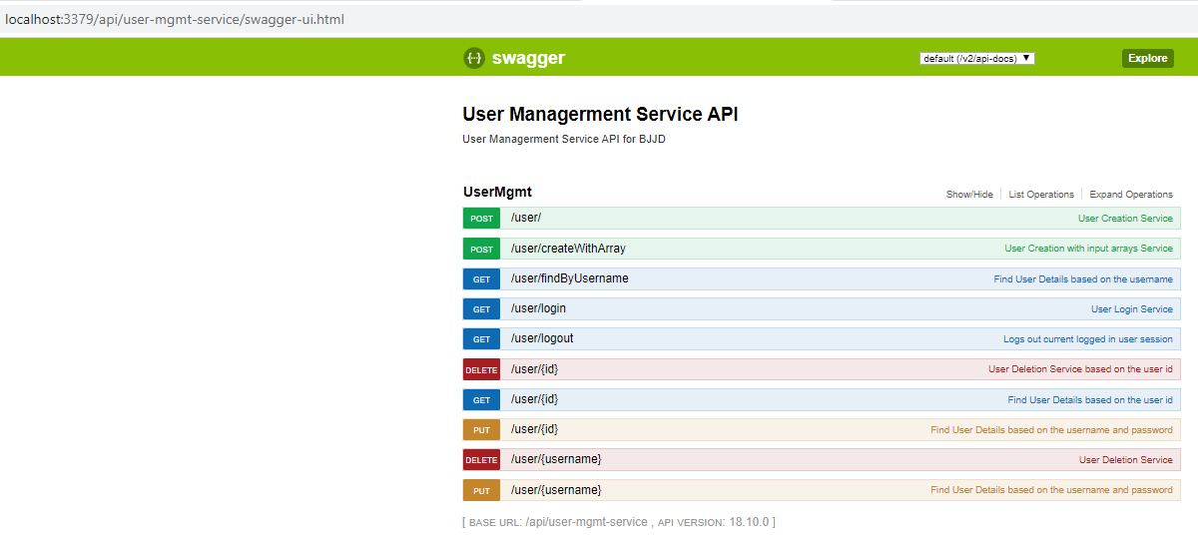

### Testing

#### Junit Testing

Test the User Api using JUnit

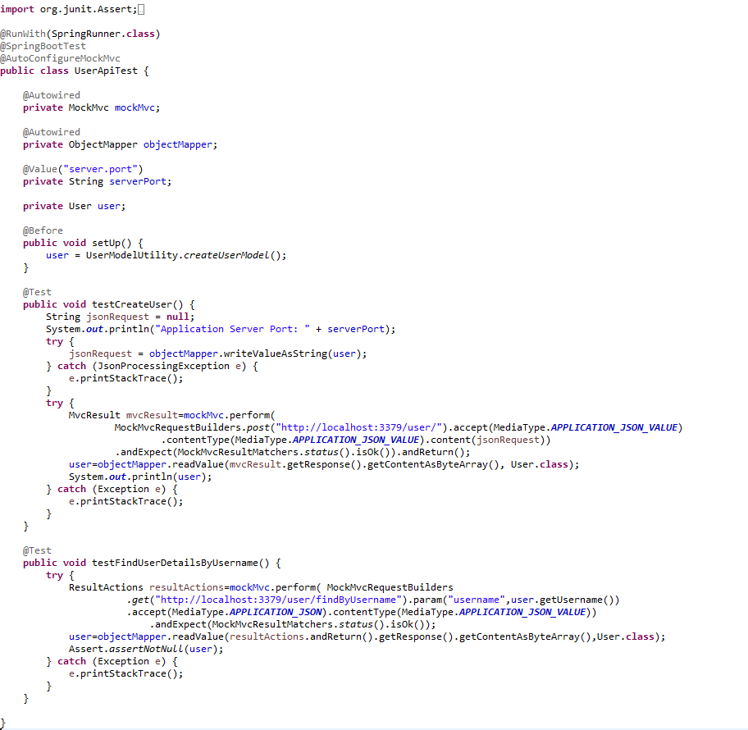

#### Testing in Dev Environment

* Getting user details based on the username using Postman

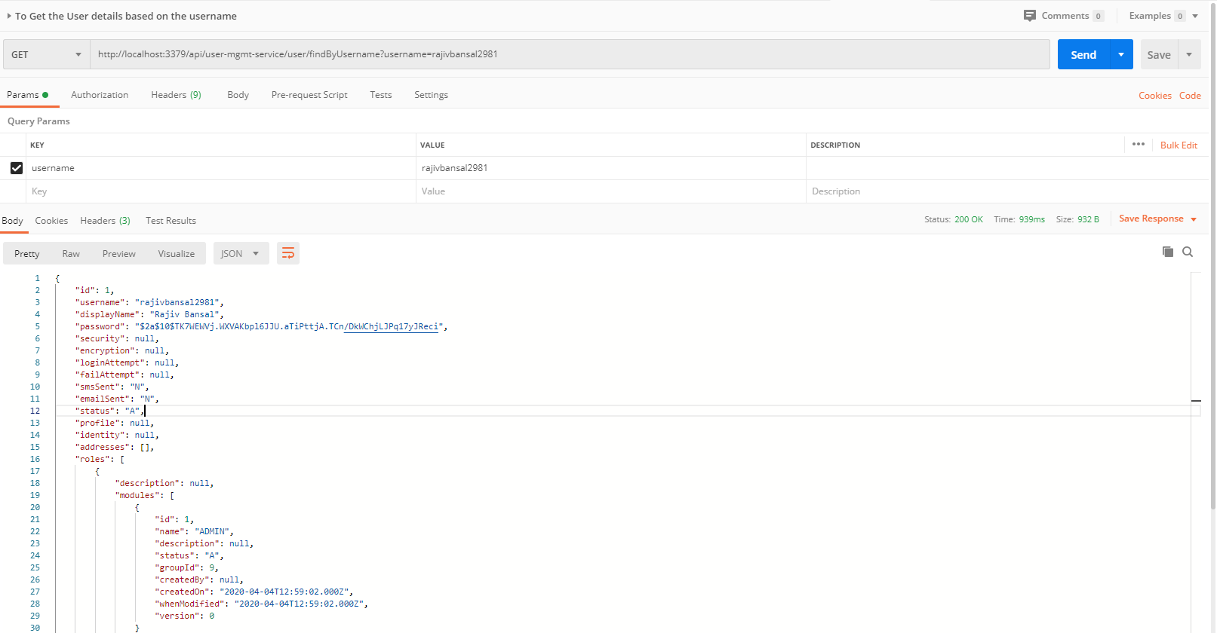

* Getting user details based on the username but not found, then custom ApiError message will be shown using Postman

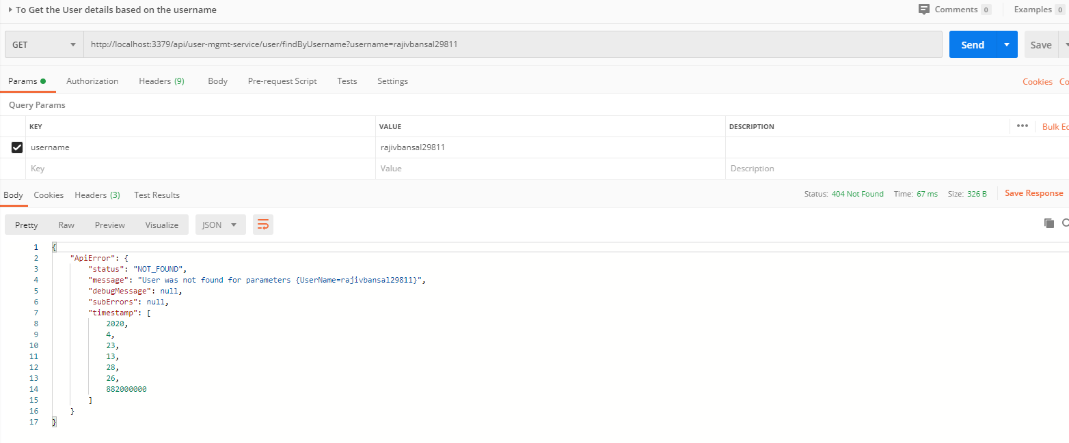

#### Testing in Kubernetes Environment

* Running the application in Kubernetes Environment

Following are the steps to run the application in the Kubernetes:

* 1. Create the docker image for the application jar file and pushed into the docker hub using the below command:

**Command**: mvn clean install -DskipTests -Pprod jib:build

* 1. Create the folder k8s which contains the following files:
     + namespace.yaml (Located in main K8s folder: bjjd-microservices\k8s\namespace.yaml)
     + rbac.yaml (Located in main K8s folder: bjjd-microservices\k8s\rbac.yaml)
     + deployment.yaml (Located in application’s K8s folder: bjjd-microservices\user-service\k8s\deployment.yaml)
     + kustomization.yaml (Located in application’s K8s folder: bjjd-microservices\user-service\k8s\kustomization.yaml)
  2. Connect to the kubernetes cluster
* **Command**: gcloud container clusters get-credentials jmk-cluster --zone us-central1-c --project logical-lock-315311
* **Output**
  1. Run the command to create the namespace: bjjd-system in the kubernetes environment:
     + **File:** Namespace.yaml

apiVersion: v1

kind: Namespace

metadata:

name: bjjd-system

* + - **Command**: kubectl apply -f namespace.yaml
    - **Output**:



* 1. Run the following command as we are using Hazelcast cache in this microservices. Hazelcast uses Kubernetes API for auto-discovery. That is why you need to grant certain roles to your service account. we can do it by creating the following “rbac.yaml” file.
     + **File**: rbac.yaml

apiVersion: rbac.authorization.k8s.io/v1

kind: ClusterRoleBinding

metadata:

name: default-cluster

roleRef:

apiGroup: rbac.authorization.k8s.io

kind: ClusterRole

name: view

subjects:

- kind: ServiceAccount

name: default

namespace: bjjd-system

* + - **Command**: kubectl apply -f rbac.yaml
    - **Output**



* 1. Create the kustomization file will be the central point of your base and it describes the resources you use. For example, configmaps, secrets, and it can refer to the resources file: deployment.yaml which is to create the deployment and service in the kubernetes.
* **File**: kustomization.yaml

apiVersion: kustomize.config.k8s.io/v1beta1

kind: Kustomization

namespace: bjjd-system

configMapGenerator:

- name: user-service-configmap

literals:

- database.hostname=db-server.cznoz9bpqnlj.ap-south-1.rds.amazonaws.com

- database.name=users\_db

- database.port=3306

- database.username=bjjd

- application.port=3379

- hazelcast.port=5701

- spring.active.profile=prod

secretGenerator:

- name: user-service-secrets

literals:

- database.root.password=server\_42\_123 #My sql root password:bjjd

- database.password=bjjd\_379

resources: #Adding the following yaml resources

- deployment.yaml

* + - **File**: deployment.yaml : to create the deployment and service in the kubernetes

apiVersion: apps/v1

kind: Deployment

metadata:

name: user-service

labels:

app: user-service

spec:

replicas: 1

minReadySeconds: 45

selector:

matchLabels:

app: user-service

strategy:

rollingUpdate:

maxSurge: 25%

maxUnavailable: 25%

type: RollingUpdate

template:

metadata:

labels:

app: user-service

spec:

containers:

- name: user-service

image: rajivbansal2981/user-service:0.0.1-RELEASE

imagePullPolicy: Always #IfNotPresent

ports:

- name: http

containerPort: 3379 # The port that the container exposes

- name: multicast

containerPort: 5701 # The port that Hazelcast exposes

env:

- name: DB\_HOSTNAME

valueFrom:

configMapKeyRef:

name: user-service-configmap

key: database.hostname #MySQL db host name

- name: DB\_NAME

valueFrom:

configMapKeyRef:

name: user-service-configmap

key: database.name

- name: DB\_USERNAME

valueFrom:

configMapKeyRef:

name: user-service-configmap

key: database.username

- name: DB\_PASSWORD

valueFrom:

secretKeyRef:

name: user-service-secrets

key: database.password

- name: DB\_PORT

valueFrom:

configMapKeyRef:

name: user-service-configmap

key: database.port

- name: SPRING\_ACTIVE\_PROFILE

valueFrom:

configMapKeyRef:

name: user-service-configmap

key: spring.active.profile

restartPolicy: Always

terminationGracePeriodSeconds: 60

---

apiVersion: v1

kind: Service

metadata:

name: user-service

labels: #PODS

app: user-service

spec:

type: ClusterIP #NodePort or LoadBalancer or ClusterIP

selector:

app: user-service

ports:

- name: hazelcast

port: 5701

- name: app

port: 3379

* + - Command: kubectl apply -k ./
    - Output:

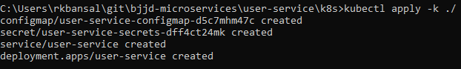

* 1. To check all the application running successfully.
* **Command**: kubectl get pods --namespace bjjd-system -o wide
* **Output**:
  1. If we do not specify in the service type, then by default, Cluster IP Service created which is only accessible from within the cluster.

NOTE: This is the Rest API which ideally we should exposed as Cluster IP only as it will be accessed through API Gateway (Single Entry Point) only.

* + - Command: kubectl get services --namespace bjjd-system -o wide
    - Output:



* 1. To access the user-service from outside the cluster, there are two ways: NodePort and LoadBalancer
     + Nodeport: Used to expose a service on the same port across all the nodes of a cluster. An internal routing mechanism ensures that the request is forwarded to the appropriate pods on each node. This is typically used for services with external consumers.
     + If we define service as Nodeport in the deployment.yaml

apiVersion: v1

kind: Service

metadata:

name: user-service

labels: #PODS

app: user-service

spec:

type: **NodePort** #NodePort or LoadBalancer or ClusterIP

selector:

app: user-service

ports:

- name: hazelcast

port: 5701

- name: app

port: 3379

* + - Run the following commands to access the user-service from outside:
      * **Apply the changes of deployment.yaml file**
        1. **Command**: kubectl apply -k ./
        2. **Output**:

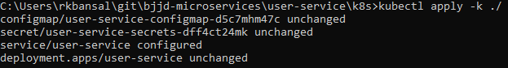

* + - * To check the services again:
        1. Command: kubectl get services --namespace bjjd-system -o wide
        2. Output:
      * To create the firewall rule for the Node’s TCP port:
        1. Command: gcloud compute firewall-rules create bjjd-node-port --project logical-lock-315311 --allow tcp:31924

Name: bjjd-node-port

Project Id: project logical-lock-315311

Allowed TCP Port: 31924

* + - * 1. Output
      * To access the user-service outside the kubernetes using Node’s TCP port:
        + To get the pod details to find the associated Node

Command: kubectl get pods --namespace bjjd-system -o wide

Output:



* + - * To get the Node IP Address

Command: kubectl get nodes --namespace bjjd-system -o wide

Output



Node IP with TCP Port

34.134.28.100:31924

* + - * To get the user details using postman after getting the details of node IP address and TCP port

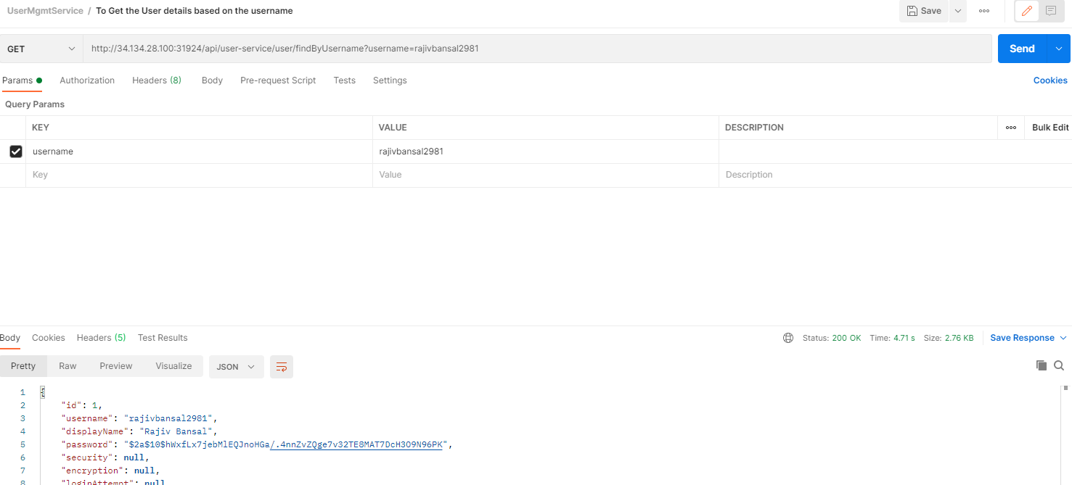

* 1. To access the user-service from outside the cluster, using LoadBalancer IP Service
     + If we define service as Nodeport in the deployment.yaml

apiVersion: v1

kind: Service

metadata:

name: user-service

labels: #PODS

app: user-service

spec:

type: LoadBalancer #NodePort or LoadBalancer or ClusterIP

selector:

app: user-service

ports:

- name: hazelcast

port: 5701

- name: app

port: 3379

* + - Run the following commands to access the user-service from outside:
      * **Apply the changes of deployment.yaml file**
        1. **Command**: kubectl apply -k ./
        2. **Output**:

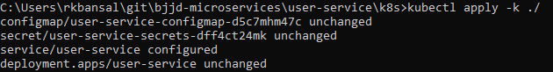

* + - * To check the services again:
        1. Command: kubectl get services --namespace bjjd-system -o wide
        2. Output:



* + - * To get the user details using postman

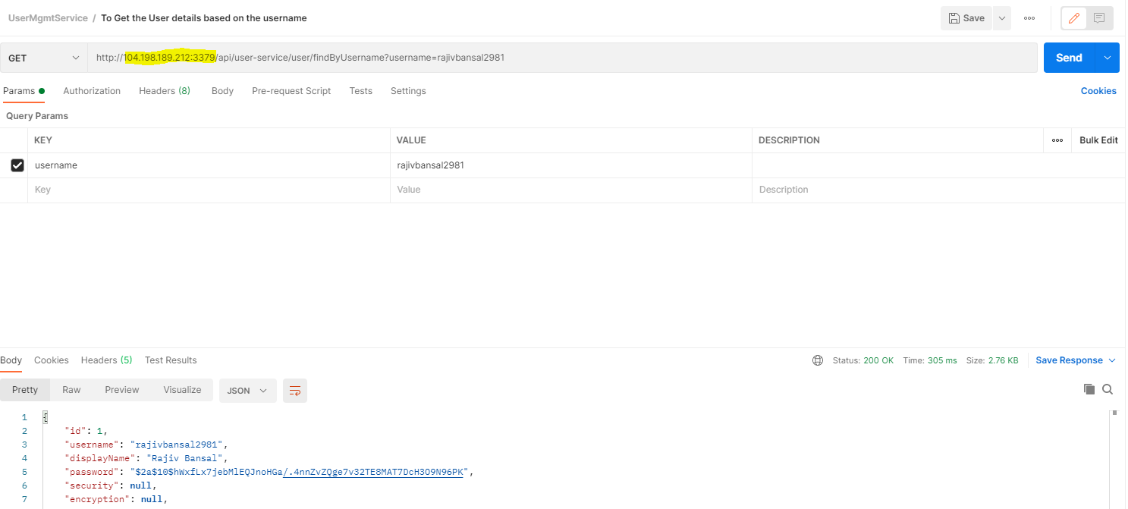

# Authentication Service

## Description

Authentication Service is used for validating user credentials, and issuing tokens.

The authentication flow is simple as:

* 1. The user sends a request to get a token passing his credentials.
  2. The server validates the credentials and sends back a token.
  3. With every request, the user has to provide the token, and server will validate that token.
* Validating the token in Authentication service for every request: Gateway Service has to call the auth service to validate user credentials and the issued token before allowing the requests to go to any service.

1. Authentication Service Tools
   1. Spring Cloud Security
   2. OAuth2
   3. JWT
2. Authentication service can call any user-mgmt-service to validate the user credentials with the DB or any other source.

We’ll introduce another service called ‘auth service’ for validating user credentials, and issuing tokens.

What about validating the token? Well, it can be implemented in the auth service itself, and the gateway has to call the auth service to validate the token before allowing the requests to go to any service.

Instead, we can validate the tokens at the gateway level, and let the auth service validate user credentials, and issue tokens. And that’s what we’re going to do here.

In both ways, we are blocking the requests unless it’s authenticated (except the requests for generating tokens).

**JSON Based Token (JWT)**

1. A token is an encoded string, generated by our application (after being authenticated) and sent by the user along each request to allow access to the resources exposed by our application.
2. JSON Based Web Token (JWT) is a JSON-based open standard for creating access tokens. It consists of three parts; header, payload, and signature.
3. The header contains the hashing algorithm

{type: “JWT”, hash: “HS256”}

1. The payload contains attributes (username, email, etc) and their values.

{username: "Omar", email: "omar@example.com", admin: true }

1. The signature is hashing of: Header + “.” + Payload + Secret key

## Coding

**To implement the Authentication Service there are two major steps :**

1. Need to change in the gateway-service(gateway-zuul) previously created project.
2. Create Authentication Service

**I. Need to change in the gateway-service(gateway-service) previously created project**

In the gateway, we need to do two things:

* 1. validate tokens with every request, and
  2. prevent all unauthenticated requests to our services. Fair enough?

**🡪Steps:**

* In the pom.xml add spring security and JWT dependencies.

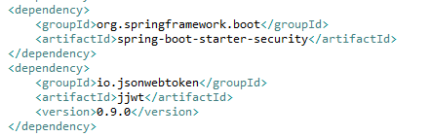

* Made changes in the application.properties

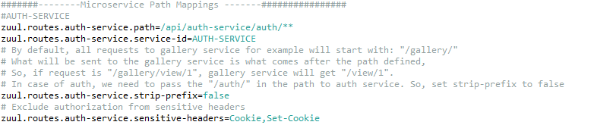

* Three Java classes need to be created
  + SecurityTokenConfig
  + JwtTokenAuthenticationFilter
  + JwtConfig
  + JwtAuthenticationEntryPoint – to handle an authorized attempt
  + CurrentUserAuthenticationFilter
* To define our security configurations, create a class, and annotated with @EnableWebSecurity, and extends WebSecurityConfigurerAdapter class to override and provide our own custom security configurations.

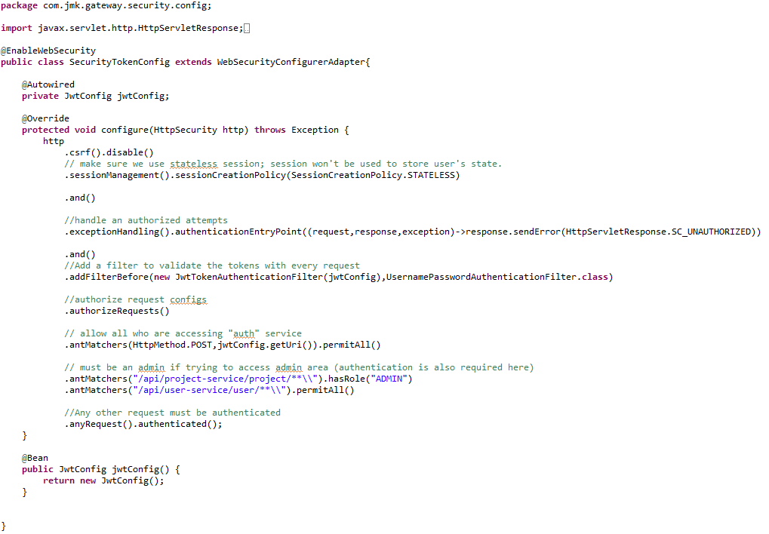

* Create the filter **JwtTokenAuthenticationFilter**

Spring has filters that will get executed within the life cycle of the request (filter chain). To enable and use these filters, we need to extend the class of any of these filters.

By default, spring will try to figure out when the filter should be executed. Otherwise, we can also define when should be executed (after or before another filter).

In this step, we implement our filter that validates the tokens. We’re using OncePerRequestFilter. It guarantees a single execution per request (since you can have a filter on the filter chain more than once).

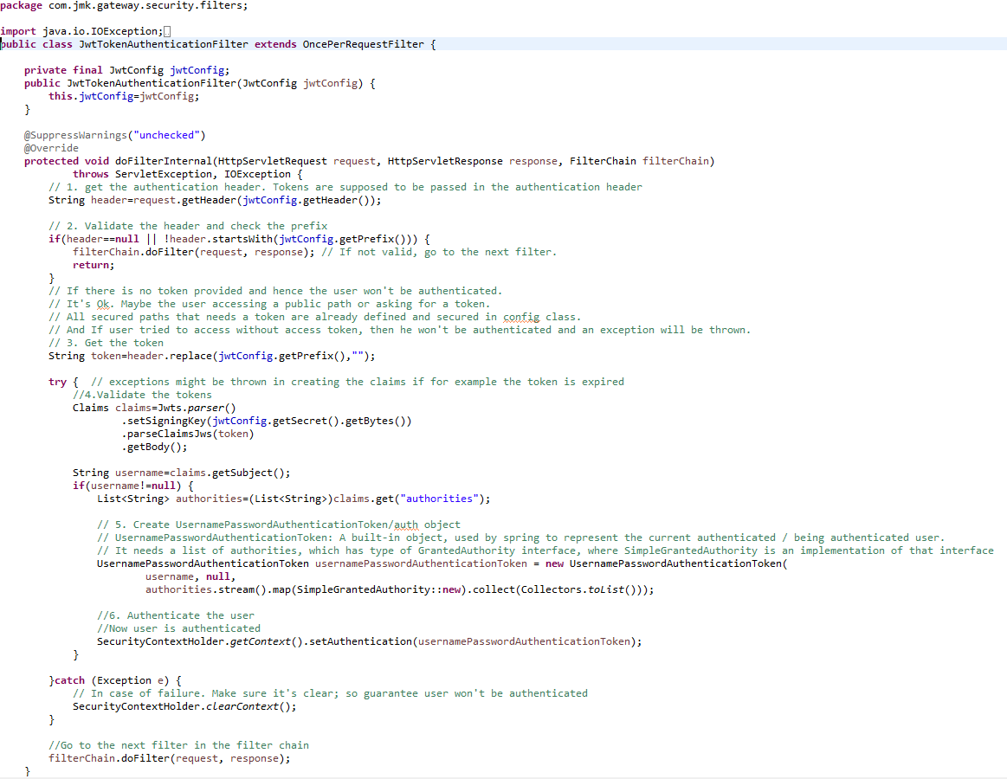

* Create **JwtConfig** Class first which contains configuration variables with getters and setters.

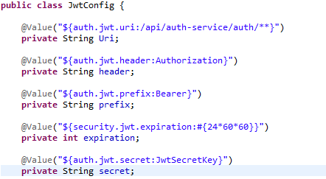

* Create **JwtAuthenticationEntryPoint** to handle the authorized attempt

This class is used to return a 401 unauthorized error to clients that try to access a protected resource without proper authentication. It implements Spring Security's AuthenticationEntryPoint interface.

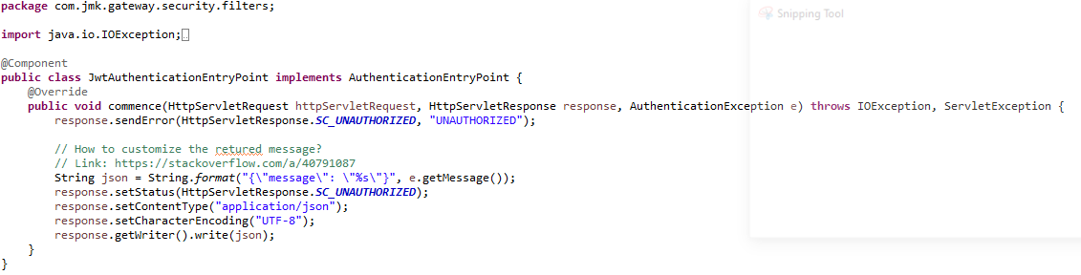

* **Use of existing UsernamePasswordAuthenticationFilter**

Processes and authentication form submission. Called AuthenticationProcessingFilter prior to Spring Security 3.0.

Login forms must present two parameters to this filter: a username and password. The default parameter names to use are contained in the static fields [SPRING\_SECURITY\_FORM\_USERNAME\_KEY](https://docs.spring.io/spring-security/site/docs/current/api/org/springframework/security/web/authentication/UsernamePasswordAuthenticationFilter.html#SPRING_SECURITY_FORM_USERNAME_KEY) and [SPRING\_SECURITY\_FORM\_PASSWORD\_KEY](https://docs.spring.io/spring-security/site/docs/current/api/org/springframework/security/web/authentication/UsernamePasswordAuthenticationFilter.html#SPRING_SECURITY_FORM_PASSWORD_KEY). The parameter names can also be changed by setting the usernameParameter and passwordParameter properties.

This filter by default responds to the URL /login.

* **Create Current User Authentication Filter**

Now you can see how to filter requests through your proxy service. Zuul has four standard filter types:

* pre filters run before the request is routed.
* route filters can handle the actual routing of the request.
* post filters run after the request has been routed.
* error filters run if an error occurs in the course of handling the request.

We are going to write a pre filter. Spring Cloud Netflix picks up, as a filter, any @Bean that extends com.netflix.zuul.ZuulFilter and is available in the application context.

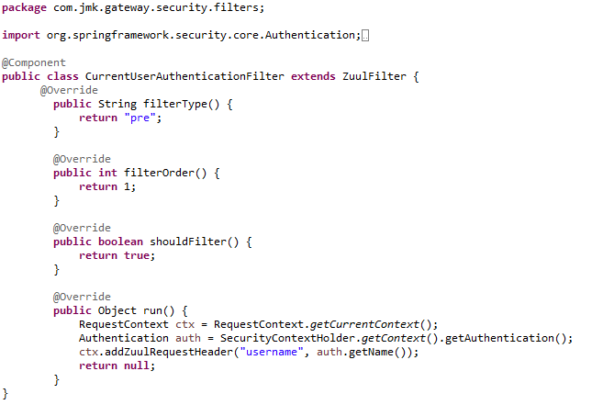

1. **Create Authentication Service**

In the auth service, we need to

* + 1. Validate the user credentials, and if valid: by calling user-service using Feign Client
    2. generate a token, otherwise, throw an exception.

**🡪Steps:**

* Create Spring Boot Project



* Click on next and fill the required details shown in the below screen:

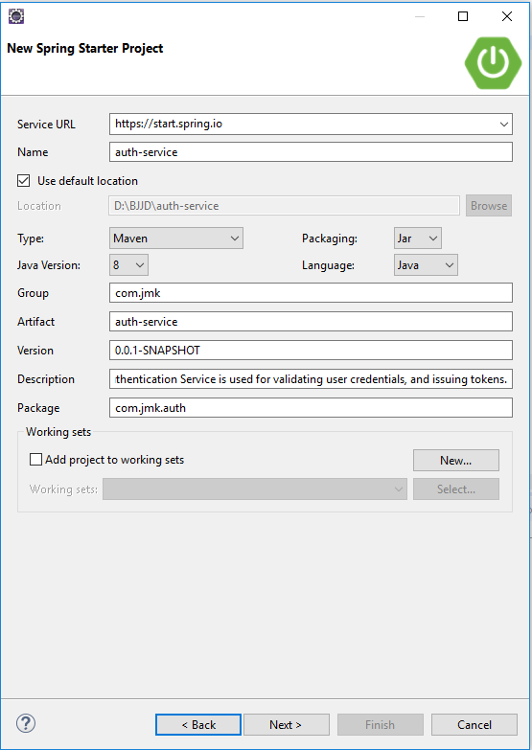

* Add the following dependencies in the pom.xml with the following considerations:

1. bjjd-microservices Parent: It contains common dependencies of Spring Boot, Spring Cloud and kubernetes etc.
2. common-service: It will keep all the dto models, exception handling and common configurations.
3. jib-maven-plugin: A Maven plugin for building docker container images for your Java applications and pushed to the docker hub.
4. JWT: Json Web Token

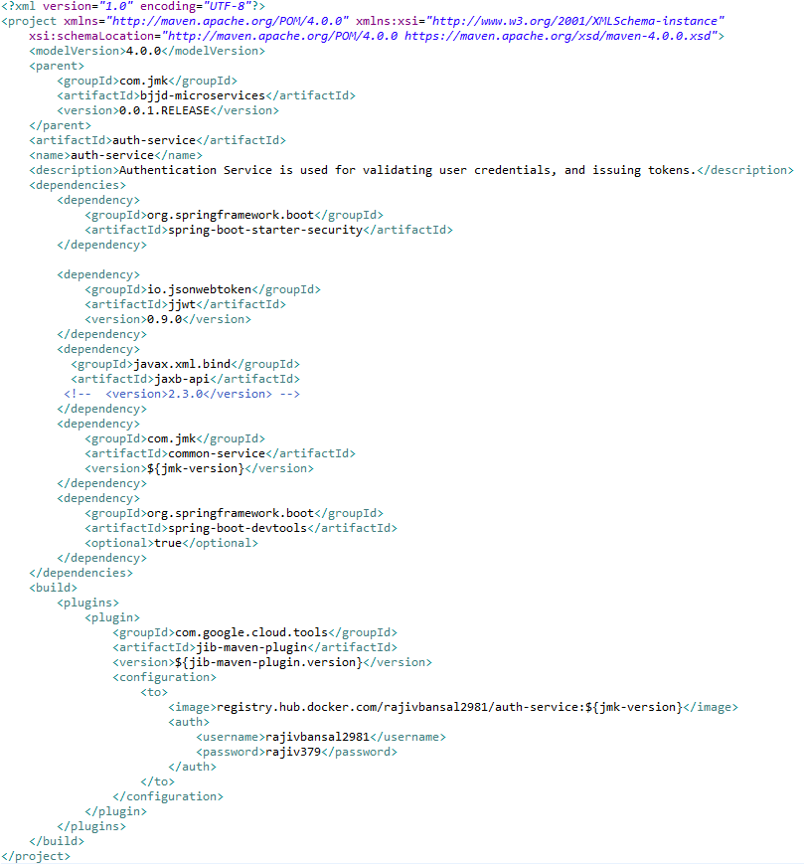

* Main application.properties file which can further refer the following based on the selected maven profile.
  1. application-dev.properties
  2. application-prod.properties
* application.properties : @spring.profiles.active@ determines which properties file will be referred based on the maven profile: dev or prod

There will be an application.properties file but it will have the following minimum details:

* + - Name of the application
    - Active Default Profile
    - Cloud Config server URI with port

#Name of the application

spring.application.name=auth-service

#Active Profile - will relate to development properties file in the server. If this property is absent

#then,default profile will be activated which is the property file without any environment name at the end.

spring.profiles.active=@spring.profiles.active@

#Setting cloud config server uri with port

spring.cloud.config.uri=http://localhost:8888

* application-dev.properties moved to the git repository: **bjjd-config-server-git-repo** and will be selected if maven profile is dev

#Name of the application

spring.application.name=auth-service

#Port of the application

server.port=2379

#Spring profile

spring.profiles.active=dev

#It is worth mentioning that user-service acts as a Eureka client. So, we give it a name, port, and link to Eureka server

# eureka server url

eureka.client.service-url.default-zone=http://localhost:8761/eureka

eureka.client.registerWithEureka=true

eureka.client.fetchRegistry=true

spring.sleuth.sampler.probability = 1.0

#To disable the Kubernetes Discovery client

spring.cloud.kubernetes.enabled=false

#Spring profile

spring.profiles.active=${SPRING\_ACTIVE\_PROFILE:dev}

spring.sleuth.sampler.probability = 1.0

#Feign client configuration

feign.client.config.default.connectTimeout: 16000000

feign.client.config.default.readTimeout: 16000000

logstash.host=localhost

logstash.queue-size=1000

logstash.port=5000

* application-prod.properties: It will be selected if maven profile is prod.
  1. Eureka Clients registrations with Eureka server need to be disabled in Kubernetes.

#Application Name

spring.application.name=auth-service

#Port of the application

server.port=2379

#Spring profile

spring.profiles.active=${SPRING\_ACTIVE\_PROFILE:prod}

spring.cloud.kubernetes.discovery.all-namespaces=true

#It is worth mentioning that user-service acts as a Eureka client. So, we give it a name, port, and link to Eureka server

# Eureka server url

#eureka.client.service-url.default-zone=http://localhost:8761/eureka

eureka.client.enabled=false

eureka.client.serviceUrl.registerWithEureka=false

spring.sleuth.sampler.probability = 1.0

#Feign client configuration

feign.client.config.default.connectTimeout: 16000000

feign.client.config.default.readTimeout: 16000000

#spring.jackson.date-format=com.jmk.user.swagger.RFC3339DateFormat

#spring.jackson.serialization.WRITE\_DATES\_AS\_TIMESTAMPS=false

hystrix.command.default.execution.isolation.thread.timeoutInMilliseconds=5000000

ribbon.ReadTimeout=20000000

ribbon.ConnectTimeout=20000000

* Update the main **AuthServiceApplication** application with the following details:
  + Enable Eureka Client so that it can register with Eureka Server
  + Enable FeignClient to interact with user--service
  + Enable JpaRepositories

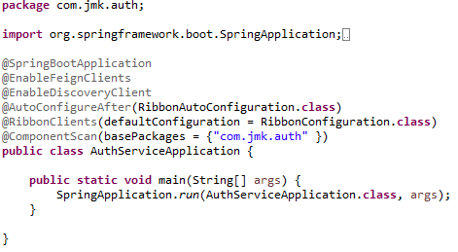

* Following Classes will be created in this class.
  + UserServiceClient.java – Feign Client for user-service
  + UserDetailsServiceImpl.java – It will call microservice: user-service to validate the credentials using feign client created above.
  + SecurityCredentialsConfig.java
  + JwtUsernameAndPasswordAuthenticationFilter.java
  + JwtConfig.java (same as already created in the above section)
  + RibbonConfiguration.java
* UserServiceClient- Feign Client for user-mgmt-service.
* Feign dynamically generates the implementation of the interface we created, so Feign has to know which service to call beforehand. That's why we need to give a name for the interface, which is the {Service-Id} of UserMgmtService. Now, Feign contacts the Eureka server with this Service Id, resolves the actual IP/hostname of the UserMgmtService, and calls the URL provided in Request Mapping.
* To send HTTP Request to a destination **user-mgmt-service** Microservice we will need to create a Feign Client interface. Please note the use of @FeignClient annotation which accepts the name user-mgmt-service under which the destination Microservice is registered with Eureka Discovery Service.

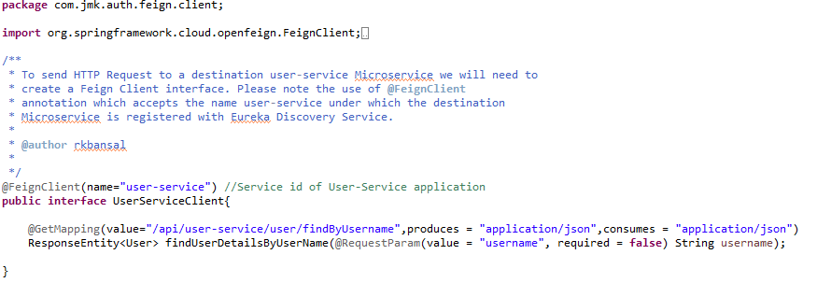

* UserDetailsServiceImpl –

It will implement UserDetailsService(Spring Security API) interface and will call microservice: user-mgmt-service to validate the credentials using feign client created above.

This class acts like a provider for the user; meaning it loads the user from the database (or any data source). It doesn’t do authentication. It just loads the user given his username.

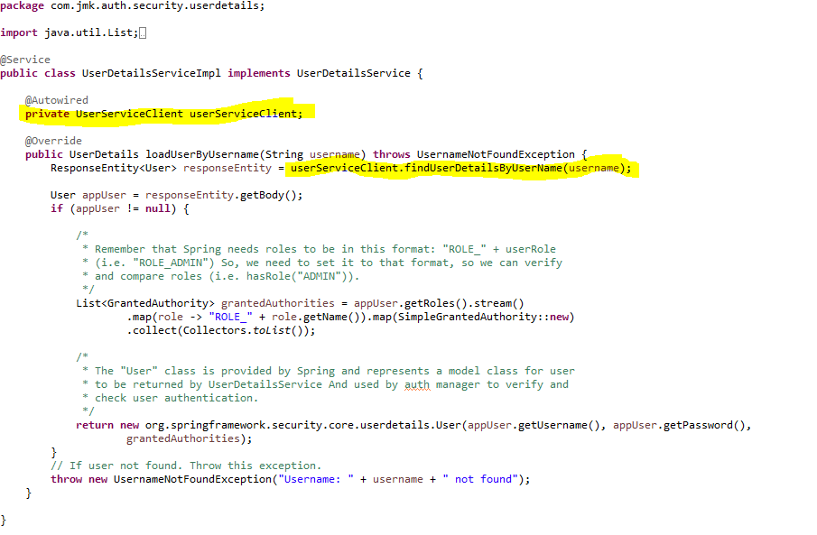

* SecurityCredentialsConfig :

As we did in the Gateway for security configurations, create a class: SecurityCredentialsConfig, annotated with @EnableWebSecurity, and extends WebSecurityConfigurerAdapter

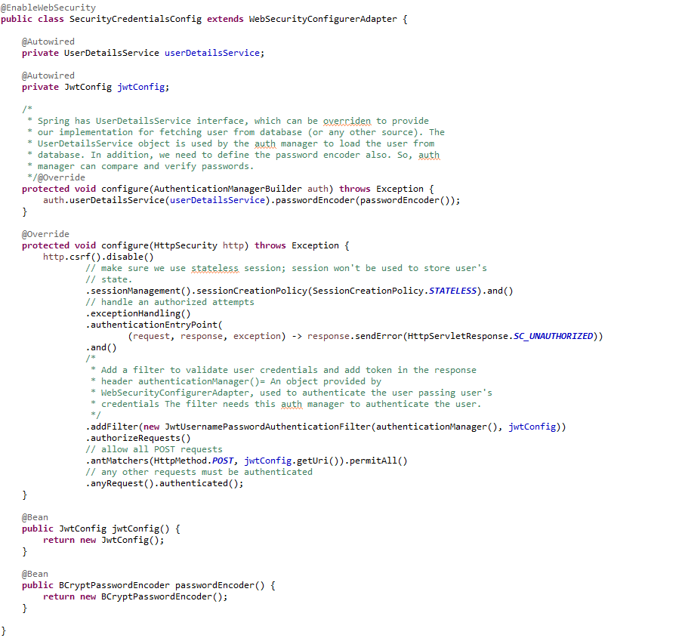

* JwtUsernameAndPasswordAuthenticationFilter

We’re using JwtUsernameAndPasswordAuthenticationFilter. It’s used to validate user credentials, and generate tokens. The username and password must be sent in a POST request.

NOTE: we can complete the following class with getter and setter of UserCredentials not showing in the below pic.

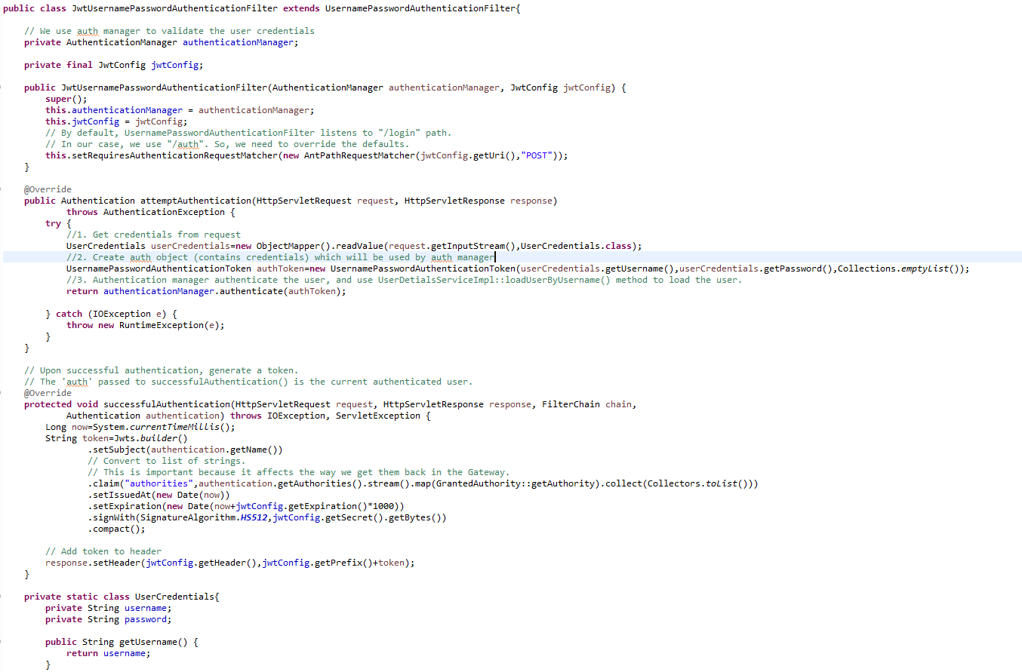

* Create **JwtConfig** Class first which contains configuration variables with getters and setters.



* If we get an unexpected surprise… The discovery across all namespaces does not work for the Ribbon client. It only works for DiscoveryClient. I think that Ribbon auto-configuration should respect the property spring.cloud.kubernetes.discovery.all-namespaces, but in that case we don’t have any other choice than prepare a workaround. Our workaround is to override Ribbon client auto-configuration provided within Spring Cloud Kubernetes. We are using DiscoveryClient directly for it as shown below.

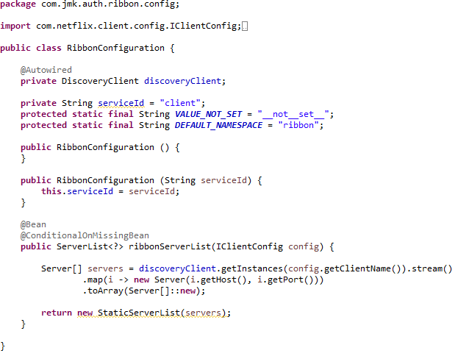

## Testing

### Testing in Dev Environment

* Run the application as **Spring Boot App** in the following order
  1. EurekaServerApplication
  2. UserServiceApplication
  3. AuthServiceApplication
  4. ZuulGatewayApplication
* Open the browser of Eureka Server at localhost:8761, you should see the all the microservices running and enter the url: <http://localhost:8761/>

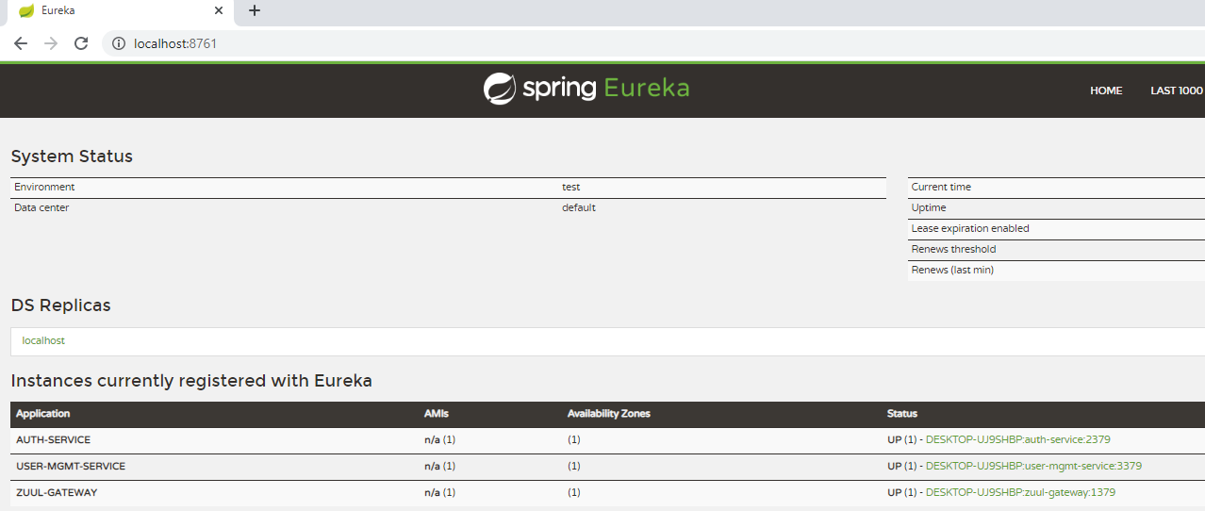

* To use any microservices, we have to go via zuul-gateway port: 1379.
  + To get the token, user will pass his credentials and call auth service via zuul-gateway service.
  + The Auth service validates the credentials and sends back a token.
  + With every request, the user has to provide the token, and server will validate that token.

**Request**

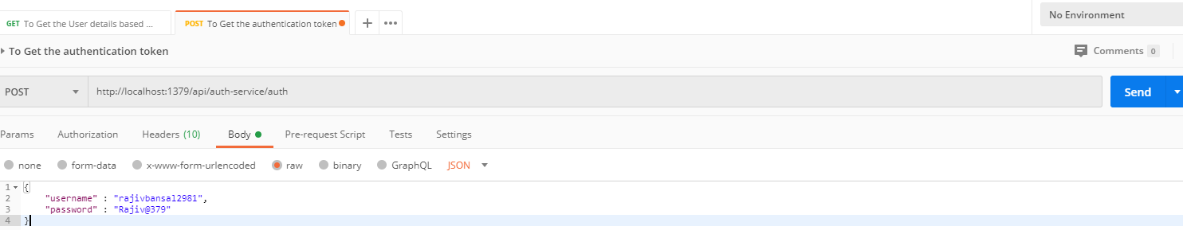

**Response –** see the response header containing the token in the Authorization attribute.

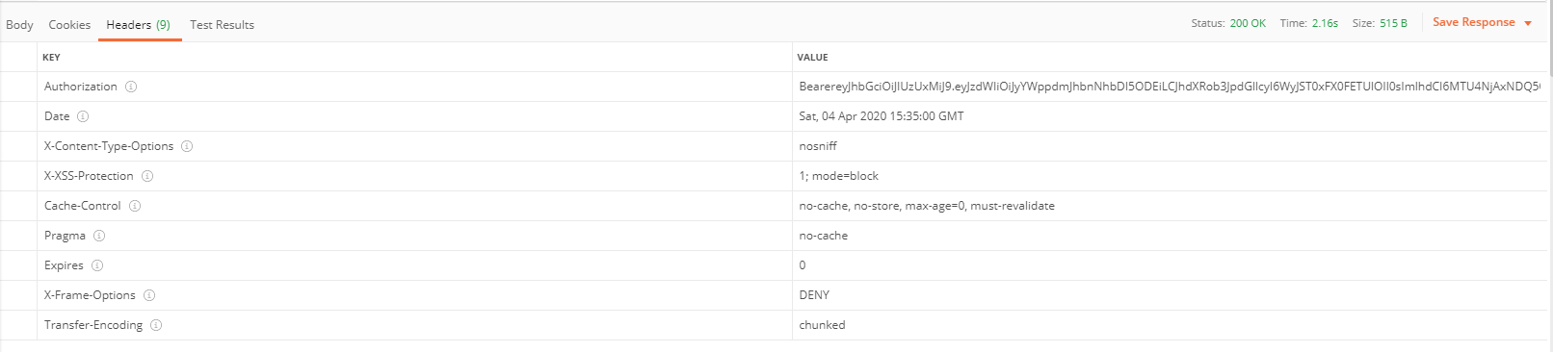

### Testing in Kubernetes Environment

* Perquisite:
  + Below services should be in running state in Kubernetes
    - Gateway-service: as NodePort or LoadBalancer so that can be accessed any service using this single-entry point.
    - User-service: Authenticate service will use user-service to authenticate the user credentials.

Following are the steps to run the application in the Kubernetes:

* 1. Create the docker image for the application jar file and pushed into the docker hub using the below command:

**Command**: mvn clean install -DskipTests -Pprod jib:build

* 1. Create the folder k8s which contains the following files:
     + namespace.yaml (Located in main K8s folder: bjjd-microservices\k8s\namespace.yaml)
     + deployment.yaml (Located in application’s K8s folder: bjjd-microservices\auth-service\k8s\deployment.yaml)
     + kustomization.yaml (Located in application’s K8s folder: bjjd-microservices\auth-service\k8s\kustomization.yaml)
  2. Connect to the kubernetes cluster
* **Command**: gcloud container clusters get-credentials jmk-cluster --zone us-central1-c --project logical-lock-315311
* **Output**
  1. Run the command to create the namespace: bjjd-system in the kubernetes environment:
     + **File:** Namespace.yaml

apiVersion: v1

kind: Namespace

metadata:

name: bjjd-system

* + - **Command**: kubectl apply -f namespace.yaml
    - **Output**:



* 1. Create the kustomization file will be the central point of your base and it describes the resources you use. For example, configmaps, secrets, and it can refer to the resources file: deployment.yaml which is to create the deployment and service in the kubernetes.
* **File**: kustomization.yaml

apiVersion: kustomize.config.k8s.io/v1beta1

kind: Kustomization

namespace: bjjd-system

configMapGenerator:

- name: auth-service-configmap

literals:

- application.port=2379

- spring.active.profile=prod

resources: #Adding the following yaml resources

- deployment.yaml

* + - **File**: deployment.yaml : to create the deployment and service in the kubernetes

apiVersion: apps/v1

kind: Deployment

metadata:

name: auth-service

labels:

app: auth-service

#namespace: default

spec:

replicas: 1

minReadySeconds: 45

selector:

matchLabels:

app: auth-service

strategy:

rollingUpdate:

maxSurge: 25%

maxUnavailable: 25%

type: RollingUpdate

template:

metadata:

labels:

app: auth-service

spec:

containers:

- name: auth-service

image: rajivbansal2981/auth-service:0.0.1-RELEASE

imagePullPolicy: Always #IfNotPresent

ports:

- name: http

containerPort: 2379 # The port that the container exposes

env:

- name: SPRING\_ACTIVE\_PROFILE

valueFrom:

configMapKeyRef:

name: auth-service-configmap

key: spring.active.profile

restartPolicy: Always

terminationGracePeriodSeconds: 60

---

apiVersion: v1

kind: Service

metadata:

name: auth-service

labels: #PODS

app: auth-service

namespace: default

spec:

type: ClusterIP #NodePort or LoadBalancer or ClusterIP

selector:

app: auth-service

ports:

- name: app

port: 2379

* + - Command: kubectl apply -k ./
    - Output:

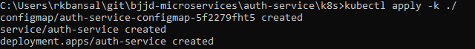

* 1. To check all the application running successfully.
* **Command**: kubectl get pods --namespace bjjd-system -o wide
* **Output**:
  1. If we do not specify in the service type, then by default, Cluster IP Service created which is only accessible from within the cluster.

NOTE: This is the Rest API which ideally, we should expose as Cluster IP only as it will be accessed through API Gateway (Single Entry Point) only.

* + - Command: kubectl get services --namespace bjjd-system -o wide
    - Output:



* 1. To access the auth-service from outside the cluster, we need gateway-service to be in running stage which will be exposed as Nodeport or LoadBalancer.
     + Go To the gateway-service section, and run the gateway-service.
     + If gateway-service is running as Nodeport, check the services are running.
       - To get the Node Name associated with the pod

Command: kubectl get pods –namespace bjjd-system -o wide

Output



* + - Check the service type should be as Nodeport, so that it can be accessible outside to the client.

Nodeport is used to expose a service on the same port across all the nodes of a cluster. An internal routing mechanism ensures that the request is forwarded to the appropriate pods on each node. This is typically used for services with external consumers.

* + - * Command: kubectl get services --namespace bjjd-system -o wide
      * Output:



* + - To create the firewall rule for the Node’s TCP port if not created:
      * 1. Command: gcloud compute firewall-rules create bjjd-node-port1 --project logical-lock-315311 --allow tcp:32021

Name: bjjd-node-port

Project Id: project logical-lock-315311

Allowed TCP Port: 31924

* + - * 1. Output
    - To access the gateway-service outside the kubernetes using Node’s TCP port:
      * To get the pod details to find the associated Node
        + Command: kubectl get pods --namespace bjjd-system -o wide
        + Output:
      * To get the Node IP Address

Command: kubectl get nodes --namespace bjjd-system -o wide

Output



Node IP with TCP Port

35.222.148.176:32021

* + - * Now gateway service is ready and if any microservice to be called then request will be processed through this API Gateway. For example, auth-service is validating the user credentials.



* 1. If gateway-service’s service type is exposed as LoadBalancer so the it be accessed from outside the cluster
     + - To check the services again:
         1. Command: kubectl get services --namespace bjjd-system -o wide
         2. Output:



* + - * Now gateway service is ready and if any microservice to be called then request will be processed through this API Gateway. For example, auth-service is validating the user credentials.



# Project Service

## Description

## Entity Relationship Diagram

## Class Diagram

## Use Case Diagram

## Use Case Implementation

### Coding

1. Follow the document to implement project-service: **DemoProjectWork-member-mgmt-service.doc** along with the following changes:

|  |  |
| --- | --- |
| Database/Schema Name | project\_db |
| User name | bjjd |
| Password | bjjd\_379 |

**Commands:**

Connect with the root with the following credentials in MySQL database command line or UI

User Id: root

Password: bjjd

* create database project\_db;
* create user 'bjjd'@'%' identified by 'bjjd\_379';
* grant all on project\_db.\* to 'bjjd'@'%';
* grant SELECT,INSERT,UPDATE,DELETE,CREATE,index,drop,ALTER,create temporary tables,references ON project\_db.\* to 'bjjd'@'%';

1. Use the following document related to the swagger, database scripts, ER diagram of Users:



* mvn --encrypt-master-password rajiv379
* Add the following dependencies in the pom.xml with the following considerations:

1. bjjd-microservices Parent: It contains common dependencies of Spring Boot, Spring Cloud and kubernetes etc.
2. Common-service: It will keep all the dto models, exception handling and common configurations.
3. Hazelcast: to be used for distributed embedded cache
4. Sql-connector: to connect with the MySQL database.
5. jib-maven-plugin: A Maven plugin for building docker container images for your Java applications and pushed to the docker hub.

<project xmlns=*"http://maven.apache.org/POM/4.0.0"*

xmlns:xsi=*"http://www.w3.org/2001/XMLSchema-instance"*

xsi:schemaLocation=*"http://maven.apache.org/POM/4.0.0 http://maven.apache.org/maven-v4\_0\_0.xsd"*>

<modelVersion>4.0.0</modelVersion>

<parent>

<groupId>com.jmk</groupId>

<artifactId>bjjd-microservices</artifactId>

<version>0.0.1.RELEASE</version>

</parent>

<artifactId>project-service</artifactId>

<packaging>jar</packaging>

<name>project-service</name>

<dependencies>

<!-- Cache dependencies -->

<dependency>

<groupId>com.hazelcast</groupId>

<artifactId>hazelcast</artifactId>

<version>4.1</version>

</dependency>

<dependency>

<groupId>com.hazelcast</groupId>

<artifactId>hazelcast-spring</artifactId>

<version>4.1</version>

</dependency>

<!-- https://mvnrepository.com/artifact/com.hazelcast/hazelcast-kubernetes -->

<dependency>

<groupId>com.hazelcast</groupId>

<artifactId>hazelcast-kubernetes</artifactId>

<version>2.2.2</version>

</dependency>

<dependency>

<groupId>com.github.joschi.jackson</groupId>

<artifactId>jackson-datatype-threetenbp</artifactId>

<version>2.6.4</version>

</dependency>

<!-- Bean Validation API support -->

<dependency>

<groupId>javax.validation</groupId>

<artifactId>validation-api</artifactId>

</dependency>

<dependency>

<groupId>com.jmk</groupId>

<artifactId>common-service</artifactId>

<version>${jmk-version}</version>

</dependency>

<!-- Starter for using Spring Data JPA with Hibernate to store and retrieve

data in a relational database. -->

<dependency>

<groupId>org.springframework.boot</groupId>

<artifactId>spring-boot-starter-data-jpa</artifactId>

</dependency>

<!--MySQL provides connectivity -->

<dependency>

<groupId>mysql</groupId>

<artifactId>mysql-connector-java</artifactId>

<version>8.0.25</version><!--$NO-MVN-MAN-VER$ -->

</dependency>

</dependencies>

<build>

<plugins>

<plugin>

<groupId>com.google.cloud.tools</groupId>

<artifactId>jib-maven-plugin</artifactId>

<version>${jib-maven-plugin.version}</version>

<configuration>

<to>

<image>registry.hub.docker.com/rajivbansal2981/project-service:${jmk-version}</image>

<auth>

<username>rajivbansal2981</username>

<password>rajiv379</password>

</auth>

</to>

</configuration>

</plugin>

</plugins>

</build>

</project>

* Main application.properties file which can further refer the following
  1. application-dev.properties
  2. application-prod.properties
* application.properties : @spring.profiles.active@ determines which properties file will be referred based on the maven profile: dev or prod

There will be an application.properties file but it will have the following minimum details:

* + - Name of the application
    - Active Default Profile
    - Cloud Config server URI with port

#Name of the application

spring.application.name=project-service

#Active Profile - will relate to development properties file in the server. If this property is absent

#Then, default profile will be activated which is the property file without any environment name at the end.

spring.profiles.active=@spring.profiles.active@

#Setting cloud config server uri with port

spring.cloud.config.uri=http://localhost:8888

* application-dev.properties moved to the git repository: **bjjd-config-server-git-repo** and will be selected if maven profile is dev

#Application Name

spring.application.name=project-service

#Port of the application

server.port=5379

server.servlet.context-path=/api/project-service

#It is worth mentioning that user-service acts as a Eureka client. So, we give it a name, port, and link to Eureka server

# eureka server url

eureka.client.service-url.default-zone=http://localhost:8761/eureka

#Spring profile

spring.profiles.active=dev

#To disable the Kubernetes Discovery client

spring.cloud.kubernetes.enabled=false

spring.cloud.kubernetes.discovery.include-not-ready-addresses=true

spring.sleuth.sampler.probability = 1.0

spring.jackson.date-format=com.jmk.project.swagger.RFC3339DateFormat

spring.jackson.serialization.WRITE\_DATES\_AS\_TIMESTAMPS=false

#FeignClient properties

feign.client.config.default.connectTimeout: 16000000

feign.client.config.default.readTimeout: 16000000

#Define properties related to JPA

spring.jpa.hibernate.ddl-auto=validate

spring.datasource.url=jdbc:mysql://localhost:3306/project\_db

spring.datasource.username=bjjd

spring.datasource.password=bjjd\_379

#Optional

spring.datasource.tomcat.max-wait=20000

spring.datasource.tomcat.max-active=50

spring.datasource.tomcat.max-idle=20

spring.datasource.tomcat.min-idle=15

#Below line is commented as it takes by default: org.hibernate.dialect.MySQL5Dialect

#spring.jpa.properties.hibernate.dialect = org.hibernate.dialect.MySQL5Dialect

spring.jpa.properties.hibernate.id.new\_generator\_mappings = false

spring.jpa.properties.hibernate.format\_sql = true

logging.level.org.hibernate.SQL=DEBUG

logging.level.org.hibernate.type.descriptor.sql.BasicBinder=TRACE

logstash.host=localhost

logstash.queue-size=1000

logstash.port=5000

* application-prod.properties: It will be selected if maven profile is prod.
  1. Eureka Clients registrations with Eureka server need to be disabled in Kubernetes.
  2. Add client option to your mysql-connector allowPublicKeyRetrieval=true to allow the client to automatically request the public key from the server. Note that AllowPublicKeyRetrieval=True could allow a malicious proxy to perform a MITM attack to get the plaintext password, so it is False by default and must be explicitly enabled.
  3. Adding useSSL=false when you use it for testing/develop purposes

#Application Name

spring.application.name=project-service

#Port of the application

server.port=5379

#URL Context of the application

server.servlet.context-path=/api/project-service

#Spring profile

spring.profiles.active=${SPRING\_ACTIVE\_PROFILE:prod}

spring.cloud.kubernetes.discovery.all-namespaces=true

#It is worth mentioning that user-service acts as a Eureka client. So, we give it a name, port, and link to Eureka server

# Eureka server url

#eureka.client.service-url.default-zone=http://localhost:8761/eureka

eureka.client.enabled=false

eureka.client.serviceUrl.registerWithEureka=false

spring.jackson.date-format=com.jmk.project.swagger.RFC3339DateFormat

spring.jackson.serialization.WRITE\_DATES\_AS\_TIMESTAMPS=false

#FeignClient properties

feign.client.config.default.connectTimeout: 16000000

feign.client.config.default.readTimeout: 16000000

#Define properties related to JPA

spring.jpa.hibernate.ddl-auto=create

spring.datasource.url=jdbc:mysql://${DB\_HOSTNAME:localhost}:${DB\_PORT:3306}/${DB\_NAME:project\_db}?allowPublicKeyRetrieval=true&useSSL=false

spring.datasource.username=${DB\_USERNAME:bjjd}

spring.datasource.password=${DB\_PASSWORD:bjjd\_379}

#Optional

spring.datasource.tomcat.max-wait=20000

spring.datasource.tomcat.max-active=50

spring.datasource.tomcat.max-idle=20

spring.datasource.tomcat.min-idle=15

#Below line is commented as it takes by default: org.hibernate.dialect.MySQL5Dialect

spring.jpa.properties.hibernate.dialect = org.hibernate.dialect.MySQL5Dialect

spring.jpa.properties.hibernate.id.new\_generator\_mappings = false

spring.jpa.properties.hibernate.format\_sql = true

logging.level.org.hibernate.SQL=DEBUG

logging.level.org.hibernate.type.descriptor.sql.BasicBinder=TRACE

1. Rename the package of io.swagger to com.jmk.project
2. Rename and refactor the Swagger2SpringBoot.java to ProjectServiceApplication.java with the following details:
   1. Enable Discovery Client so that it can register with Eureka Server and it supports Kubernetes Discovery System.
   2. Enable FeignClient to interact with user-mgmt-service
   3. Enable RibbonClient
   4. Enable JpaRepositories

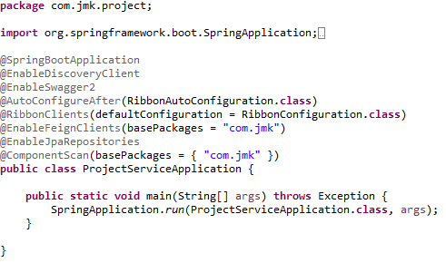

1. Rest ProjectApi with its implementation ProjectApiController

ProjectApi.java

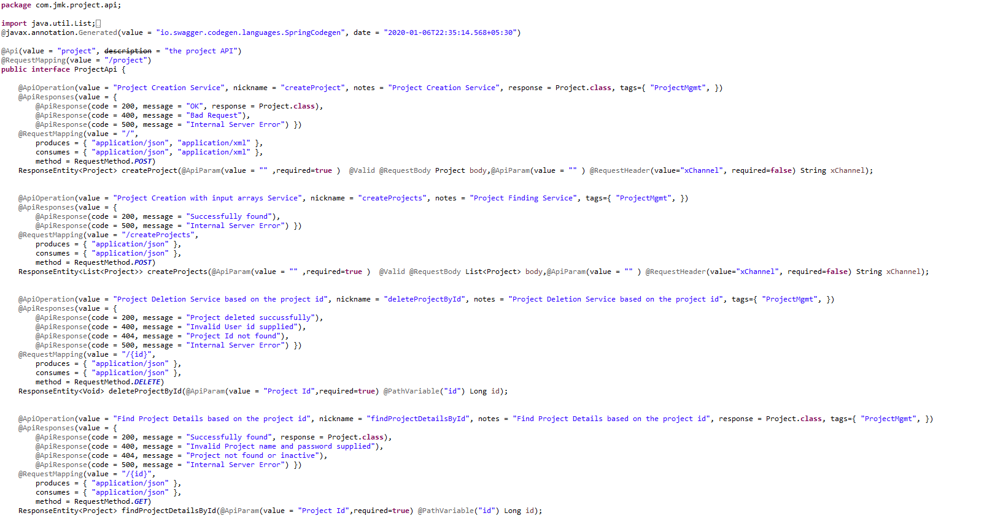

ProjectApiController.java

We can see the use of Feign Client in highlighted colour.

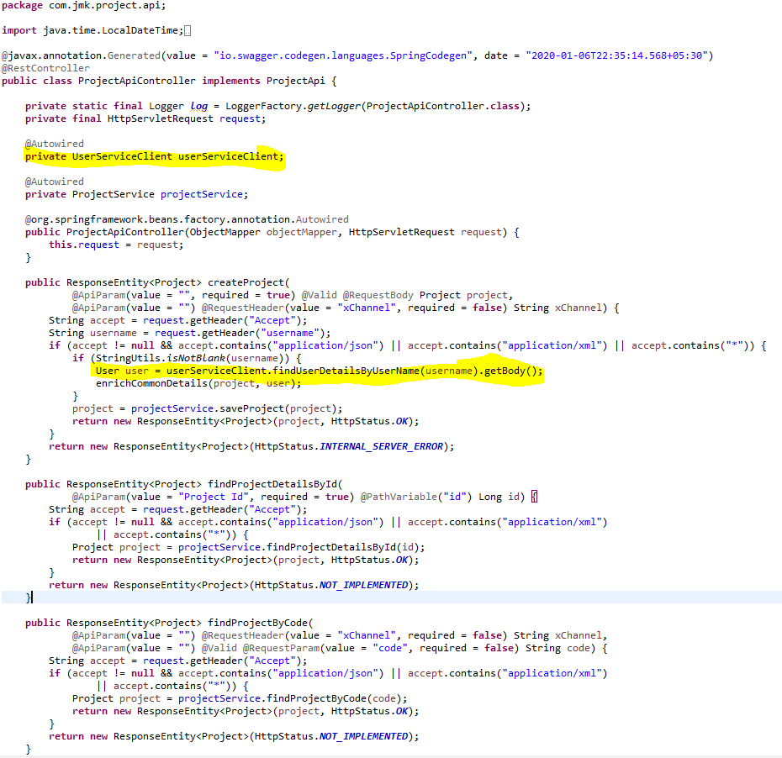

1. Configure the Hazelcast Cache (Embedded Distributed Cache)

* Configure the Hazelcast Cache in the two ways:
  1. If application is running in the Dev environment



* 1. If application is running in the Kubernetes Environment (Prod)



* HazelcastCacheConfiguration.java file to configure the Hazelcast Cache.

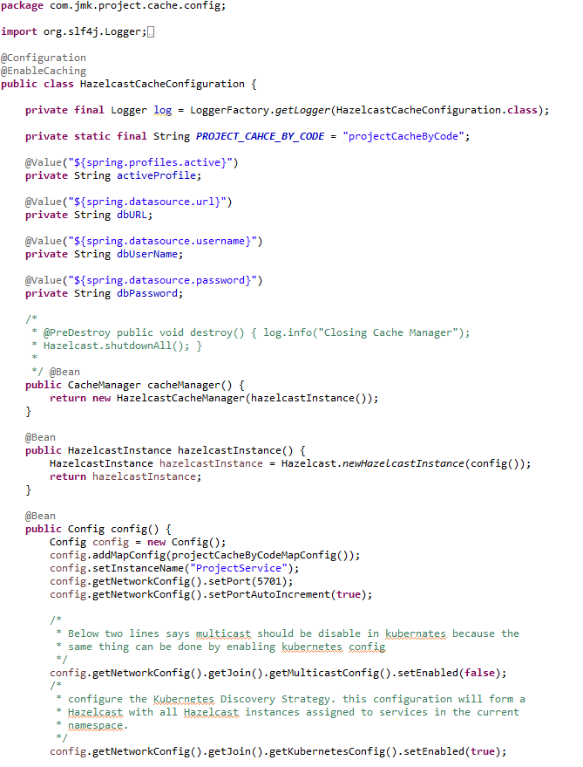

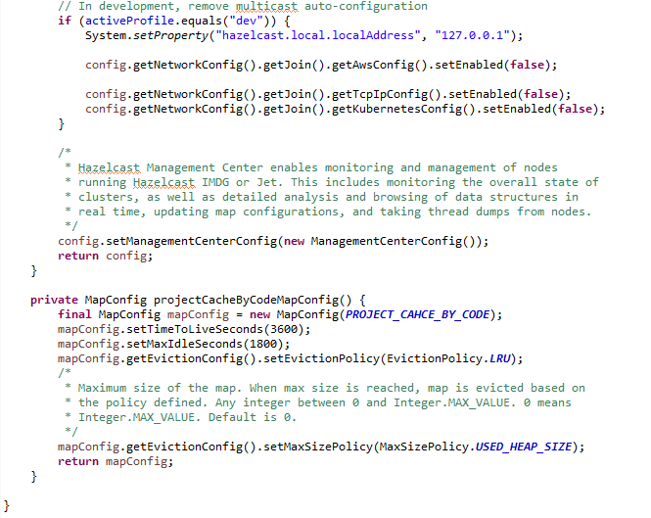

1. UserServiceClient – Feign Client for communicating user-service

Feign dynamically generates the implementation of the interface we created, so Feign has to know which service to call beforehand. That's why we need to give a name for the interface, which is the {Service-Id} of UserServiceClient. Now, Feign contacts the Eureka server with this Service Id, resolves the actual IP/hostname of the UserServiceClient, and calls the URL provided in Request Mapping.

To send HTTP Request to a destination **user-service** Microservice we will need to create a Feign Client interface. Please note the use of @FeignClient annotation which accepts the name user-mgmt-service under which the destination Microservice is registered with Eureka Discovery Service.

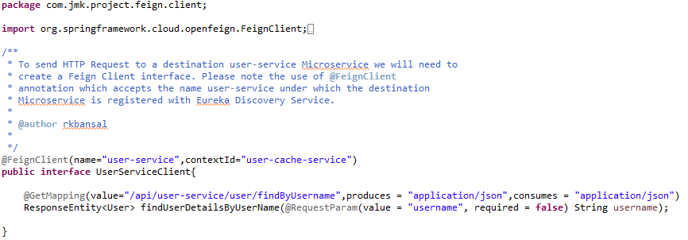

1. If we get an unexpected surprise… The discovery across all namespaces does not work for the Ribbon client. It only works for DiscoveryClient. I think that Ribbon auto-configuration should respect the property spring.cloud.kubernetes.discovery.all-namespaces, but in that case we don’t have any other choice than prepare a workaround. Our workaround is to override Ribbon client auto-configuration provided within Spring Cloud Kubernetes. We are using DiscoveryClient directly for it as shown below.

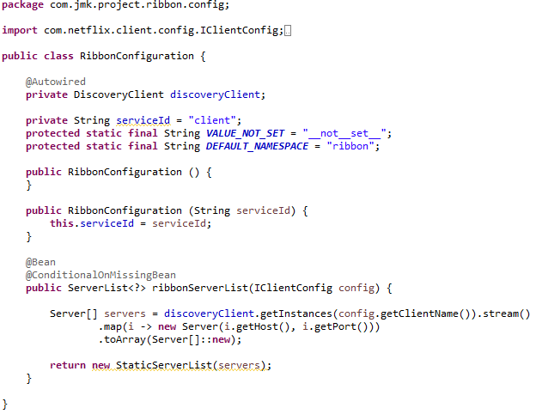

1. Project Service should be exposed as following:

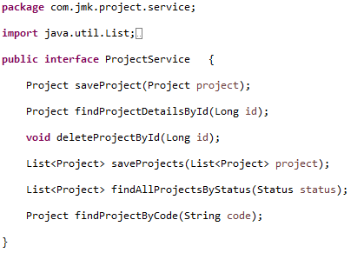

1. Project Service Implementation should be exposed as following:
   1. Custom Exception Handling where EntityNotFoundException class (created in common-service) thrown if entity not present in database which is handled in RestExcceptionHandler(created in common-service), in this handler we are creating the appropriate error message in json and send back to client.
   2. Implementations of Hazelcast Cache.

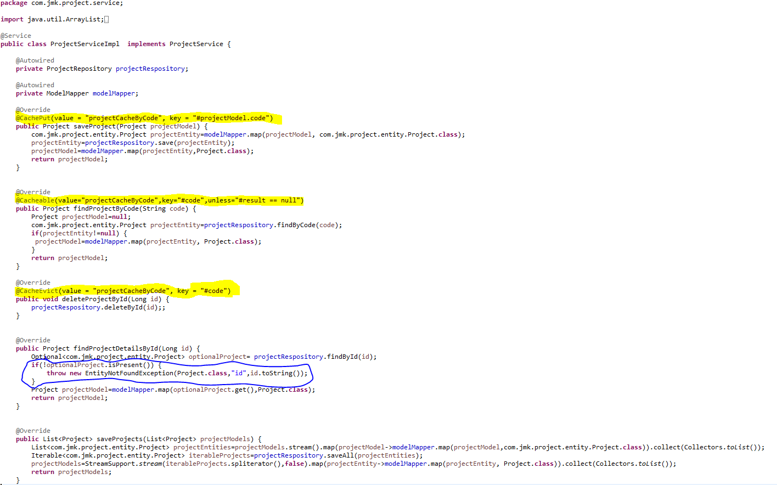

1. ProjectRepository.java

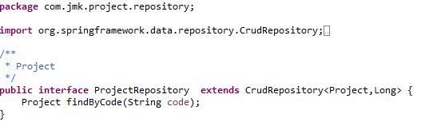

1. Create the model and entities using Lombok.

@**JsonProperty** is suitable for conversion during **serialization**.

@**ApiModelProperty** is **used** for interface document display.

**@Data //It is combination of @ToString, @EqualsAndHashCode ,@Getter,@Setter and @RequiredArgsConstructor**

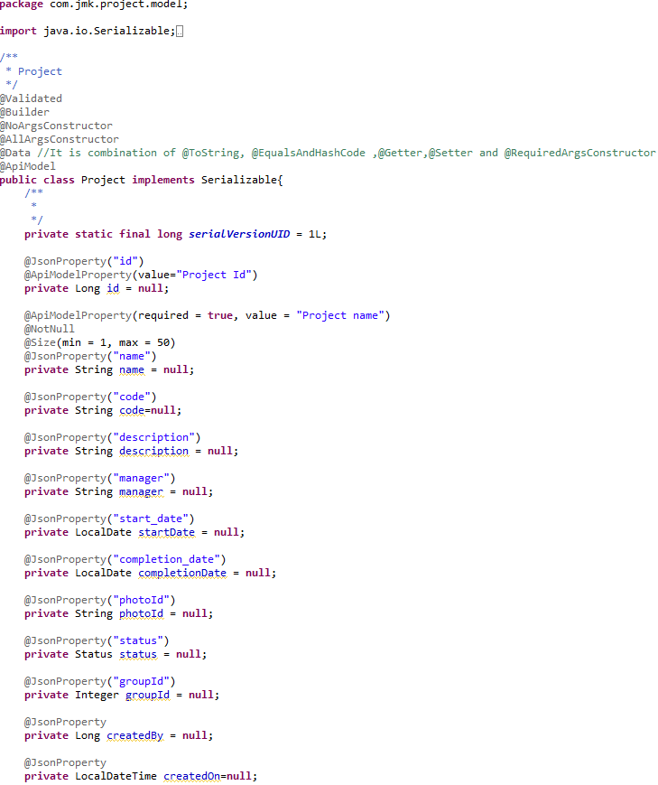

* Made changes in the SwaggerDocumentationConfig

@EnableSwagger2 - Annotation to Enable Swagger Documentation on the API

@EnableSwagger2

@Configuration

**public** **class** SwaggerDocumentationConfig {

ApiInfo apiInfo() {

**return** **new** ApiInfoBuilder()

.title("Project Management Service API")

.description("No description provided (generated by Swagger Codegen https://github.com/swagger-api/swagger-codegen)")

.license("")

.licenseUrl("http://unlicense.org")

.termsOfServiceUrl("")

.version("18.10.0")

.contact(**new** Contact("","", ""))

.build();

}

@Bean

**public** Docket customImplementation(){

**return** **new** Docket(DocumentationType.***SWAGGER\_2***)

.select()

.apis(RequestHandlerSelectors.*basePackage*("com.jmk.project.api")).paths(PathSelectors.*regex*("/project.\*"))

.build()

.directModelSubstitute(org.threeten.bp.LocalDate.**class**, java.sql.Date.**class**)

.directModelSubstitute(org.threeten.bp.OffsetDateTime.**class**, java.util.Date.**class**)

.apiInfo(apiInfo());

}

}

* Made changes in the Swagger’s HomeController

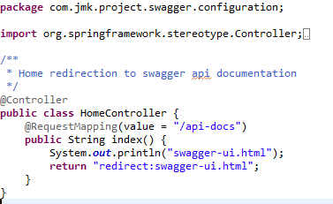

* After running the application, should be visible following functions for the following url: <http://localhost:5379/api/project-mgmt-service/swagger-ui.html>

Or

<http://localhost:5379/api/project-mgmt-service/api-docs>

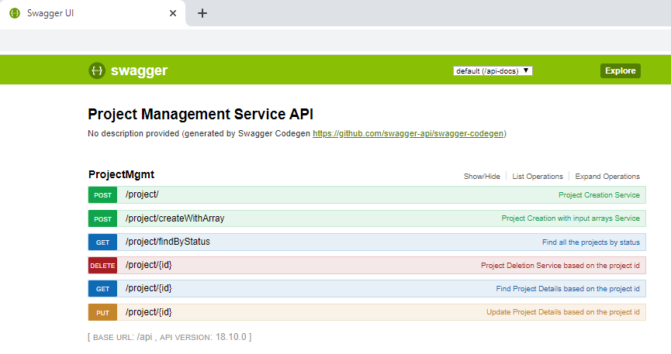

### Testing

#### Junit Testing

* Test the Project Api using JUnit

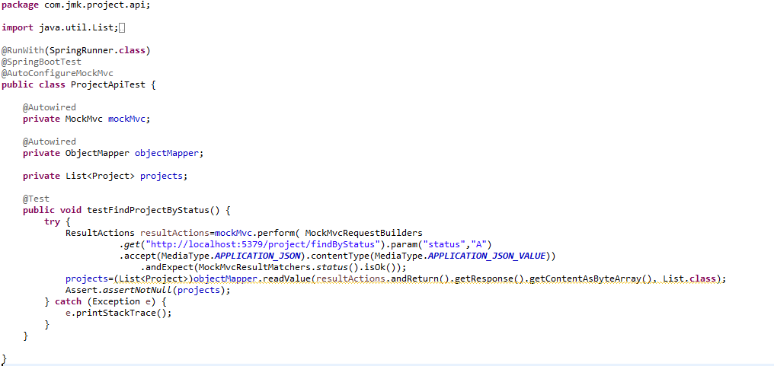

#### Testing in Dev Envrionment

* Run the application as **Spring Boot App** in the following order
  1. EurekaServerApplication
  2. UserServiceApplication
  3. AuthServiceApplication
  4. ZuulGatewayApplication
  5. ProjectMgmtRestApplication
* Open the browser of Eureka Server at localhost:8761, you should see the all the microservices running and enter the url: <http://localhost:8761/>

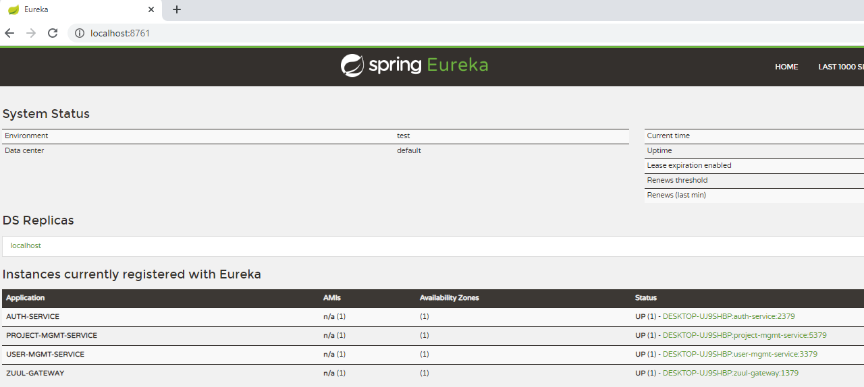

* Testing
  + Without authentication means directly hitting the project-mgmt-project running on 5379 and getting the details of project based on the status

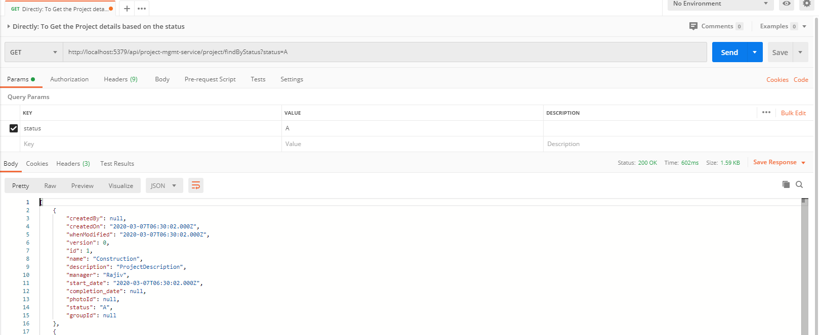

* + Without authentication means directly hitting the project-mgmt-project running on 5379 and getting the details of project based on the id but not found

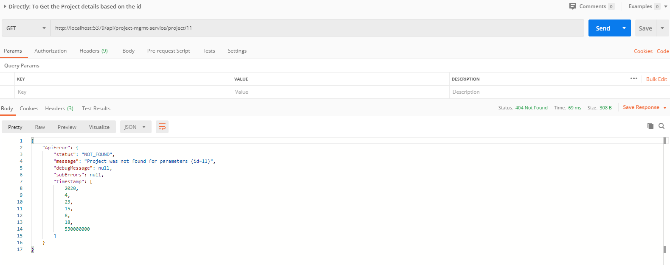

* + With authentication means every request to project-mgmt-service microservice will be hit via gateway running 1379
    - with authentication means every request to project-mgmt-service microservice will be hit via gateway running on 1379
      * getting project details with status “A” but without token means no authorization code(Bearer token) in the header will give the error.

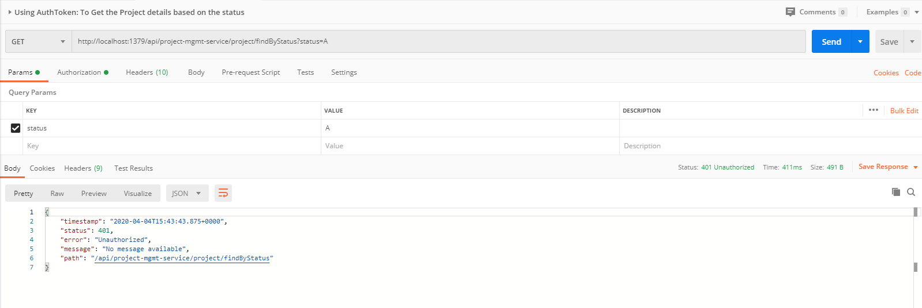

* getting project details with status “A” but with token means authorization code(Bearer token) in the header will be provided using authentication service

1. **To get authentication code in response header using authentication service**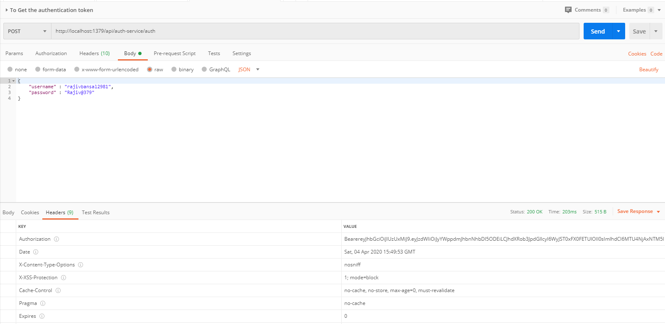
2. **Now hit the project-mgmt-service to** get project details with status “A” by providing the token means authorization code(Bearer token) in the header received in above step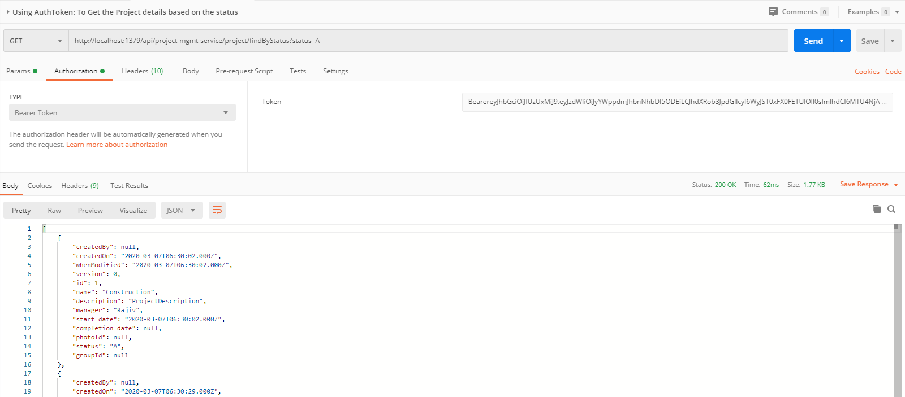

#### Testing in Kubernetes Environment

##### Apply Kubernetes Changes

* Running the application in Kubernetes Environment

Following are the steps to run the application in the Kubernetes:

* 1. Create the docker image for the application jar file and pushed into the docker hub using the below command:

**Command**: mvn clean install -DskipTests -Pprod jib:build

* 1. Create the folder k8s which contains the following files:
     + namespace.yaml (Located in main K8s folder: bjjd-microservices\k8s\namespace.yaml)
     + rbac.yaml (Located in main K8s folder: bjjd-microservices\k8s\rbac.yaml)
     + deployment.yaml (Located in application’s K8s folder: bjjd-microservices\project-service\k8s\deployment.yaml)
     + kustomization.yaml (Located in application’s K8s folder: bjjd-microservices\project-service\k8s\kustomization.yaml)
  2. Connect to the kubernetes cluster
* **Command**: gcloud container clusters get-credentials jmk-cluster --zone us-central1-c --project logical-lock-315311
* **Output**
  1. Run the command to create the namespace: bjjd-system in the kubernetes environment:
     + **File:** Namespace.yaml

apiVersion: v1

kind: Namespace

metadata:

name: bjjd-system

* + - **Command**: kubectl apply -f namespace.yaml
    - **Output**:



* 1. Run the following command as we are using Hazelcast cache in this microservices. Hazelcast uses Kubernetes API for auto-discovery. That is why you need to grant certain roles to your service account. we can do it by creating the following “rbac.yaml” file.
     + **File**: rbac.yaml

apiVersion: rbac.authorization.k8s.io/v1

kind: ClusterRoleBinding

metadata:

name: default-cluster

roleRef:

apiGroup: rbac.authorization.k8s.io

kind: ClusterRole

name: view

subjects:

- kind: ServiceAccount

name: default

namespace: bjjd-system

* + - **Command**: kubectl apply -f rbac.yaml
    - **Output**



* 1. Create the kustomization file will be the central point of your base and it describes the resources you use. For example, configmaps, secrets, and it can refer to the resources file: deployment.yaml which is to create the deployment and service in the kubernetes.
* **File**: kustomization.yaml

apiVersion: kustomize.config.k8s.io/v1beta1

kind: Kustomization

namespace: bjjd-system

configMapGenerator:

- name: project-service-configmap

literals:

- database.hostname=db-server.cznoz9bpqnlj.ap-south-1.rds.amazonaws.com

- database.name=project\_db

- database.port=3306

- database.username=bjjd

- application.port=5379

- hazelcast.port=5701

- spring.active.profile=prod

secretGenerator:

- name: project-service-secrets

literals:

- database.root.password=server\_42\_123 #My sql root password:bjjd

- database.password=bjjd\_379

resources: #Adding the following yaml resources

- deployment.yaml

* + - **File**: deployment.yaml : to create the deployment and service in the kubernetes

apiVersion: apps/v1

kind: Deployment

metadata:

name: project-service

labels:

app: project-service

#namespace: default

spec:

replicas: 1

minReadySeconds: 45

selector:

matchLabels:

app: project-service

strategy:

rollingUpdate:

maxSurge: 25%

maxUnavailable: 25%

type: RollingUpdate

template:

metadata:

labels:

app: project-service

spec:

containers:

- name: project-service

image: rajivbansal2981/project-service:0.0.1-RELEASE

imagePullPolicy: Always #IfNotPresent

ports:

- name: http

containerPort: 5379 # The port that the container exposes

- name: multicast

containerPort: 5701 # The port that Hazelcast exposes

env:

- name: DB\_HOSTNAME

valueFrom:

configMapKeyRef:

name: project-service-configmap

key: database.hostname #MySQL db host name

- name: DB\_NAME

valueFrom:

configMapKeyRef:

name: project-service-configmap

key: database.name

- name: DB\_USERNAME

valueFrom:

configMapKeyRef:

name: project-service-configmap

key: database.username

- name: DB\_PASSWORD

valueFrom:

secretKeyRef:

name: project-service-secrets

key: database.password

- name: DB\_PORT

valueFrom:

configMapKeyRef:

name: project-service-configmap

key: database.port

restartPolicy: Always

terminationGracePeriodSeconds: 60

---

apiVersion: v1

kind: Service

metadata:

name: project-service

labels: #PODS

app: project-service

namespace: default

spec:

type: ClusterIP #NodePort or LoadBalancer or ClusterIP

selector:

app: project-service

ports:

- name: hazelcast

port: 5701

- name: app

port: 5379

* + - Command: kubectl apply -k ./
    - Output:

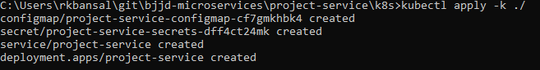

* 1. To check all the application running successfully.
* **Command**: kubectl get pods --namespace bjjd-system -o wide
* **Output**:
  1. If we do not specify in the service type, then by default, Cluster IP Service created which is only accessible from within the cluster.

NOTE: This is the Rest API which ideally, we should expose as Cluster IP only as it will be accessed through API Gateway (Single Entry Point) only.

* + - Command: kubectl get services --namespace bjjd-system -o wide
    - Output:



##### Testing without gateway-service(auth-service)

* 1. To access the project-service from outside the cluster, there are two ways: Nodeport and LoadBalancer
     + Nodeport: can refer the user-service section: Testing in Kubernetes Environment.
     + LoadBalancer: will discuss now.
  2. To access the user-service from outside the cluster, using LoadBalancer IP Service
     + If we define service as Nodeport in the deployment. yaml

apiVersion: v1

kind: Service

metadata:

name: project-service

labels: #PODS

app: project-service

namespace: default

spec:

type: LoadBalancer #NodePort or LoadBalancer or ClusterIP

selector:

app: project-service

ports:

- name: hazelcast

port: 5701

- name: app

port: 5379

* + - Run the following commands to access the user-service from outside:
      * **Apply the changes of deployment.yaml file**
        1. **Command**: kubectl apply -k ./
        2. **Output**:

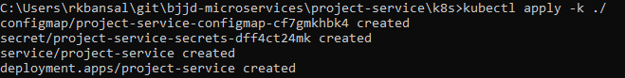

* + - * To check the services again:
        1. Command: kubectl get services --namespace bjjd-system -o wide
        2. Output:



* + - * To save the project details using postman

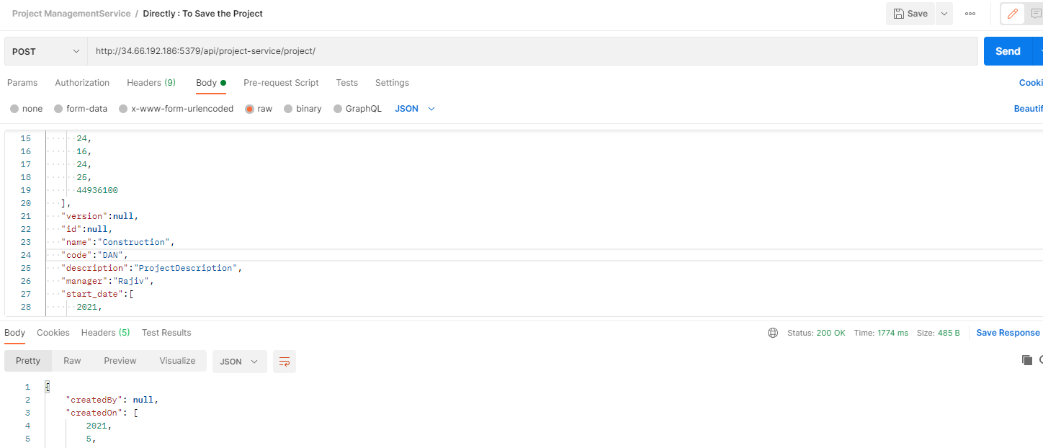

##### Testing with gateway-service and auth-service

**Perquisites:**

* Following services should be in running state
  + Gateway-service: It’s service should be exposed as Nodeport or LoadBalancer.
  + Auth-service: It’s service should be exposed as ClusterIP.
  + User-service: It’s service should be exposed as ClusterIP.
  + Project-service: should ideally be exposed as ClusterIP so that can be accessible through gateway-service (single entry point) only.
* Check all the microservices are running on the pods.
  + Command: kubectl get pods --namespace bjjd-system -o wide
  + Output:

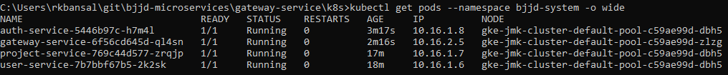

* Check all the type of the services are
  + Command: kubectl get services --namespace bjjd-system -o wide
  + Output:

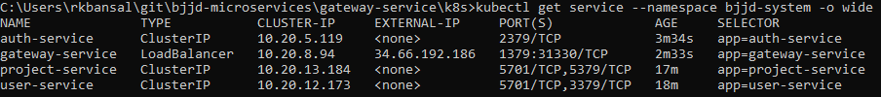

* + With authentication means every request to project-mgmt-service microservice will be hit via gateway running 1379
    - with authentication means every request to project-mgmt-service microservice will be hit via gateway running on 1379
      * saving the project details but without token means no authorization code (Bearer token) in the header will give the error.

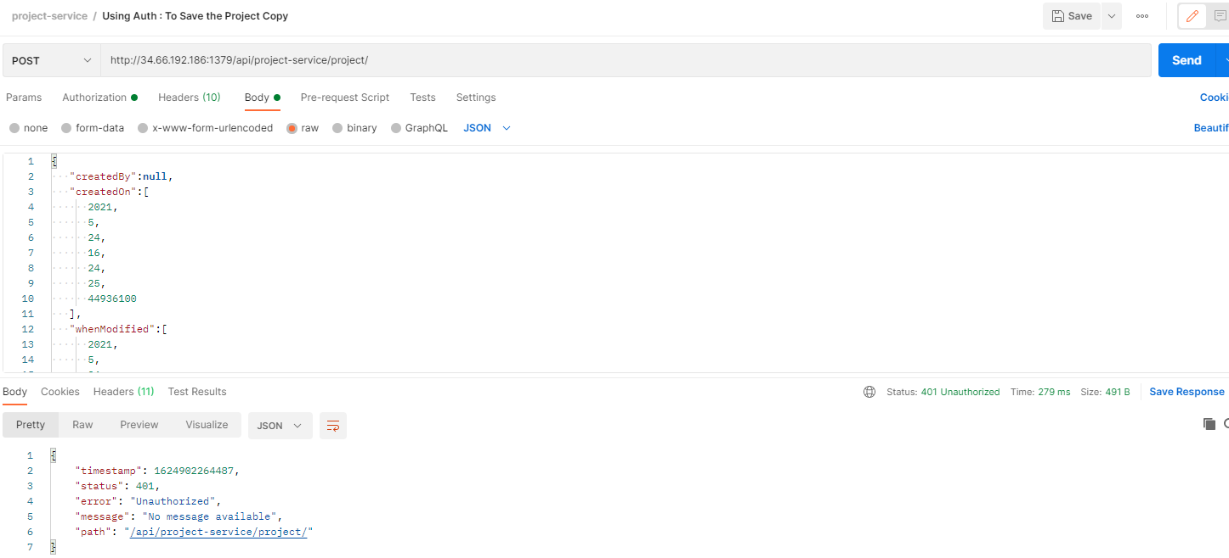

* saving the project details but with token means authorization code (Bearer token) in the header will be provided using authentication service

1. **To get authentication code in response header using authentication service**

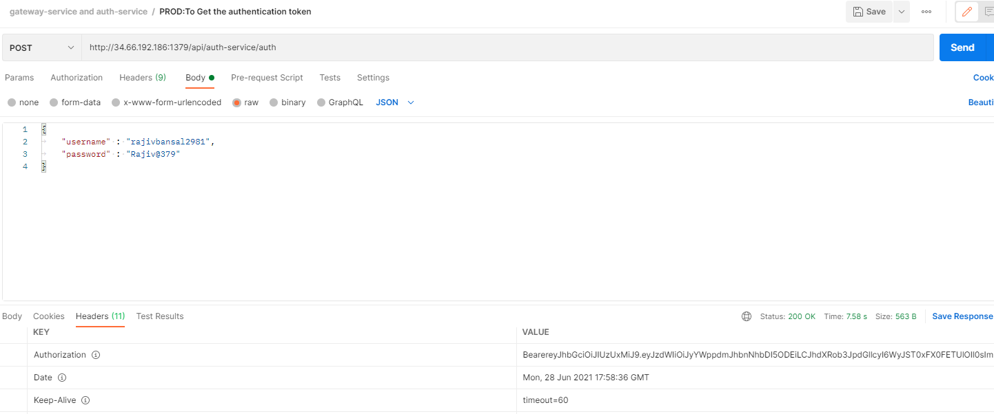

1. Now hit the project-service to save the project details by providing the project details and token means authorization code (Bearer token) in the header received in above step

* 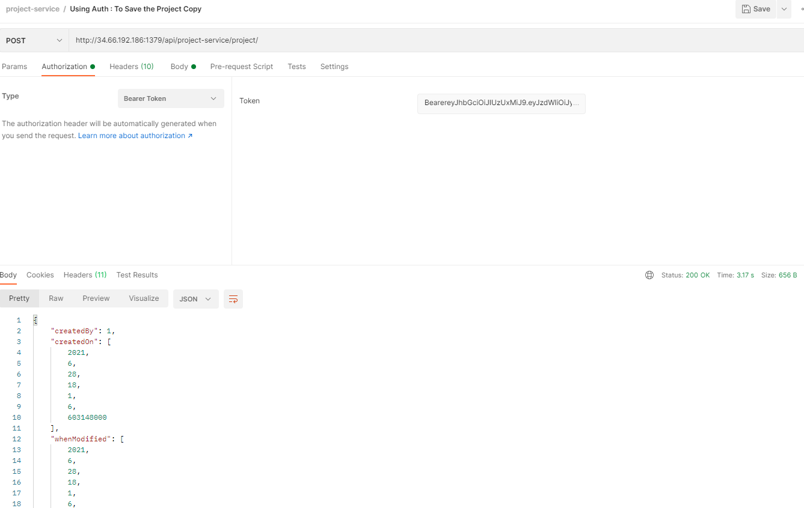

# People Service

## Description

Create the people-service application as microservice with the following functionalities:

In this microservice, we will create parent class Person having three subclasses Member, Sevadar and Devotee:

Create the member:

While creating member, it will call dependent microservice: **user-mgmt-service** to create the user credentials/information for every member so that member would be able to login into the BJJD application with his details)

2. Update the member

3. Get the list of all the members

4.Delete the member

5.Get the member details

1. Check the member exists:

this method would be invoked from **account-service** to check the member exists or not.

## Entity Relationship Diagram

Create parent class Person having three subclasses Member, Sevadar and Devotee

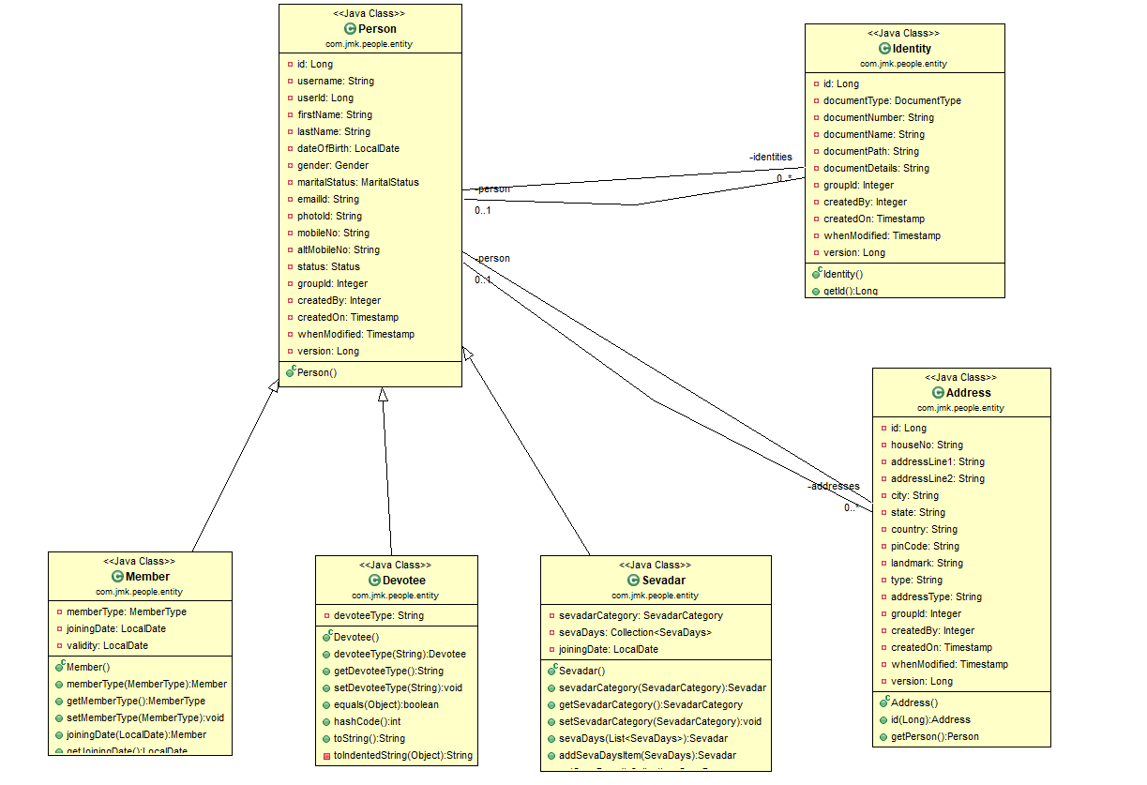

## Class Diagram

## Use Case Diagram

## Use Case Implementation

### Coding

1. Follow the document to implement project-service: **DemoProjectWork-member-mgmt-service.doc** along with the following changes:

|  |  |
| --- | --- |
| Database/Schema Name | person\_db |
| User name | bjjd |
| Password | bjjd\_379 |

**Commands:**

Connect with the root with the following credentials in MySQL database command line or UI

User Id: root

Password: bjjd

* create database person\_db;
* create user 'bjjd'@'%' identified by 'bjjd\_379';
* grant all on person\_db.\* to 'bjjd'@'%';
* grant SELECT,INSERT,UPDATE,DELETE,CREATE,index,drop,ALTER,create temporary tables,references ON person\_db.\* to 'bjjd'@'%';

1. Use the following document related to the swagger, database scripts, ER diagram of Users:
2. 

* mvn --encrypt-master-password rajiv379
* Add the following dependencies in the pom.xml with the following considerations:

1. bjjd-microservices Parent: It contains common dependencies of Spring Boot, Spring Cloud and kubernetes etc.
2. Common-service: It will keep all the dto models, exception handling and common configurations.
3. Hazelcast: to be used for distributed embedded cache
4. Sql-connector: to connect with the MySQL database.
5. jib-maven-plugin: A Maven plugin for building docker container images for your Java applications and pushed to the docker hub.

<?xml version=*"1.0"* encoding=*"UTF-8"*?>

<project xmlns=*"http://maven.apache.org/POM/4.0.0"*

xmlns:xsi=*"http://www.w3.org/2001/XMLSchema-instance"*

xsi:schemaLocation=*"http://maven.apache.org/POM/4.0.0 http://maven.apache.org/maven-v4\_0\_0.xsd"*>

<modelVersion>4.0.0</modelVersion>

<parent>

<groupId>com.jmk</groupId>

<artifactId>bjjd-microservices</artifactId>

<version>0.0.1.RELEASE</version>

</parent>

<artifactId>people-service</artifactId>

<packaging>jar</packaging>

<name>people-service</name>

<dependencies>

<!-- Cache dependencies -->

<dependency>

<groupId>com.hazelcast</groupId>

<artifactId>hazelcast</artifactId>

<version>4.1</version>

</dependency>

<dependency>

<groupId>com.hazelcast</groupId>

<artifactId>hazelcast-spring</artifactId>

<version>4.1</version>

</dependency>

<!-- https://mvnrepository.com/artifact/com.hazelcast/hazelcast-kubernetes -->

<dependency>

<groupId>com.hazelcast</groupId>

<artifactId>hazelcast-kubernetes</artifactId>

<version>2.2.2</version>

</dependency>

<dependency>

<groupId>com.github.joschi.jackson</groupId>

<artifactId>jackson-datatype-threetenbp</artifactId>

<version>2.6.4</version>

</dependency>

<!-- Bean Validation API support -->

<dependency>

<groupId>javax.validation</groupId>

<artifactId>validation-api</artifactId>

</dependency>

<dependency>

<groupId>com.jmk</groupId>

<artifactId>common-service</artifactId>

<version>${jmk-version}</version>

</dependency>

<!-- Starter for using Spring Data JPA with Hibernate to store and retrieve

data in a relational database. -->

<dependency>

<groupId>org.springframework.boot</groupId>

<artifactId>spring-boot-starter-data-jpa</artifactId>

</dependency>

<!--MySQL provides connectivity -->

<dependency>

<groupId>mysql</groupId>

<artifactId>mysql-connector-java</artifactId>

<version>8.0.25</version><!--$NO-MVN-MAN-VER$ -->

</dependency>

</dependencies>

<build>

<plugins>

<plugin>

<groupId>com.google.cloud.tools</groupId>

<artifactId>jib-maven-plugin</artifactId>

<version>${jib-maven-plugin.version}</version>

<configuration>

<to>

<image>registry.hub.docker.com/rajivbansal2981/people-service:${jmk-version}</image>

<auth>

<username>rajivbansal2981</username>

<password>rajiv379</password>

</auth>

</to>

</configuration>

</plugin>

</plugins>

</build>

</project>

* Main application.properties file which can further refer the following
  1. application-dev.properties
  2. application-prod.properties
* application.properties : @spring.profiles.active@ determines which properties file will be referred based on the maven profile: dev or prod

There will be an application.properties file but it will have the following minimum details:

* + - Name of the application
    - Active Default Profile
    - Cloud Config server URI with port

#Name of the application

spring.application.name=people-service

#Active Profile - will relate to development properties file in the server. If this property is absent

#then,default profile will be activated which is the property file without any environment name at the end.

spring.profiles.active=@spring.profiles.active@

#Setting cloud config server uri with port

spring.cloud.config.uri=http://localhost:8888

* application-dev.properties moved to the git repository: **bjjd-config-server-git-repo** and will be selected if maven profile is dev

#Given name to the application

spring.application.name=people-service

#Port of the application

server.port=6379

server.servlet.context-path=/api/people-service

#It is worth mentioning that user-service acts as a Eureka client. So, we give it a name, port, and link to Eureka server

# eureka server url

eureka.client.service-url.default-zone=http://localhost:8761/eureka

#Spring profile

spring.profiles.active=dev

#To disable the Kubernetes Discovery client

#spring.cloud.kubernetes.enabled=false

#spring.cloud.kubernetes.discovery.include-not-ready-addresses=true

spring.sleuth.sampler.probability = 1.0

spring.jackson.date-format=com.jmk.people.swagger.RFC3339DateFormat

spring.jackson.serialization.WRITE\_DATES\_AS\_TIMESTAMPS=false

#FeignClient properties

feign.client.config.default.connectTimeout: 16000000

feign.client.config.default.readTimeout: 16000000

#Define properties related to JPA

spring.jpa.hibernate.ddl-auto=create

spring.datasource.url=jdbc:mysql://localhost:3306/person\_db

spring.datasource.username=bjjd

spring.datasource.password=bjjd\_379

#Optional

spring.datasource.tomcat.max-wait=20000

spring.datasource.tomcat.max-active=50

spring.datasource.tomcat.max-idle=20

spring.datasource.tomcat.min-idle=15

#Below line is commented as it takes by default: org.hibernate.dialect.MySQL5Dialect

#spring.jpa.properties.hibernate.dialect = org.hibernate.dialect.MySQL5Dialect

spring.jpa.properties.hibernate.id.new\_generator\_mappings = false

spring.jpa.properties.hibernate.format\_sql = true

logging.level.org.hibernate.SQL=DEBUG

logging.level.org.hibernate.type.descriptor.sql.BasicBinder=TRACE

logstash.host=localhost

logstash.queue-size=1000

logstash.port=5000

* application-prod.properties: It will be selected if maven profile is prod.
  1. Eureka Clients registrations with Eureka server need to be disabled in Kubernetes.
  2. Add client option to your mysql-connector allowPublicKeyRetrieval=true to allow the client to automatically request the public key from the server. Note that AllowPublicKeyRetrieval=True could allow a malicious proxy to perform a MITM attack to get the plaintext password, so it is False by default and must be explicitly enabled.
  3. Adding useSSL=false when you use it for testing/develop purposes

#Name of the application

spring.application.name=people-service

#Port of the application

server.port=6379

server.servlet.context-path=/api/people-service

#Spring profile

spring.profiles.active=${SPRING\_ACTIVE\_PROFILE:prod}

spring.cloud.kubernetes.discovery.all-namespaces=true

#Disable eureka server

#eureka.client.service-url.default-zone=http://localhost:8761/eureka

eureka.client.enabled=false

eureka.client.serviceUrl.registerWithEureka=false

#Feign Client properties

feign.client.config.default.connectTimeout: 16000000

feign.client.config.default.readTimeout: 16000000

spring.jackson.date-format=com.jmk.user.swagger.RFC3339DateFormat

spring.jackson.serialization.WRITE\_DATES\_AS\_TIMESTAMPS=false

#Define properties related to JPA

spring.jpa.hibernate.ddl-auto=create

spring.datasource.url=jdbc:mysql://${DB\_HOSTNAME:localhost}:${DB\_PORT:3306}/${DB\_NAME:person\_db}?allowPublicKeyRetrieval=true&useSSL=false

spring.datasource.username=${DB\_USERNAME:bjjd}

spring.datasource.password=${DB\_PASSWORD:bjjd\_379}

#Optional

spring.datasource.tomcat.max-wait=20000

spring.datasource.tomcat.max-active=50

spring.datasource.tomcat.max-idle=20

spring.datasource.tomcat.min-idle=15

#Below line is commented as it takes by default: org.hibernate.dialect.MySQL5Dialect

spring.jpa.properties.hibernate.dialect = org.hibernate.dialect.MySQL5Dialect

spring.jpa.properties.hibernate.id.new\_generator\_mappings = false

spring.jpa.properties.hibernate.format\_sql = true

logging.level.org.hibernate.SQL=DEBUG

logging.level.org.hibernate.type.descriptor.sql.BasicBinder=TRACE

1. Rename the package of io.swagger to com.jmk.project
2. Rename and refactor the Swagger2SpringBoot.java to PeopleServiceApplication.java with the following details:
   * Enable Discovery Client so that it can register with Eureka Server and it supports Kubernetes Discovery System.
   * Enable FeignClient to interact with user-mgmt-service
   * Enable RibbonClient
   * Enable JpaRepositories

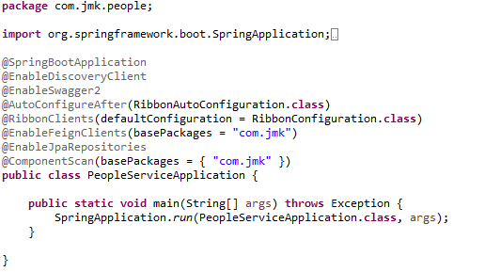

* People Mgmt Service APIS
  1. DevoteeApi and DevoteeApiController

DevoteeApi

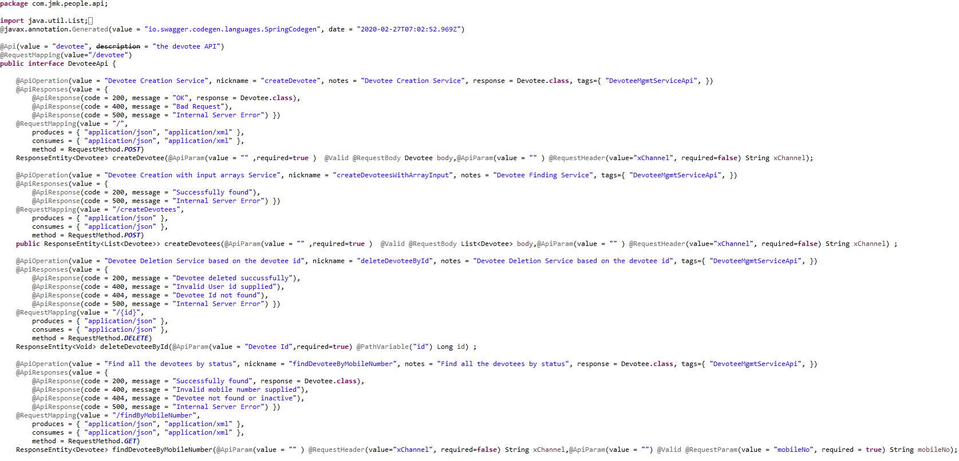

DevoteeApiController

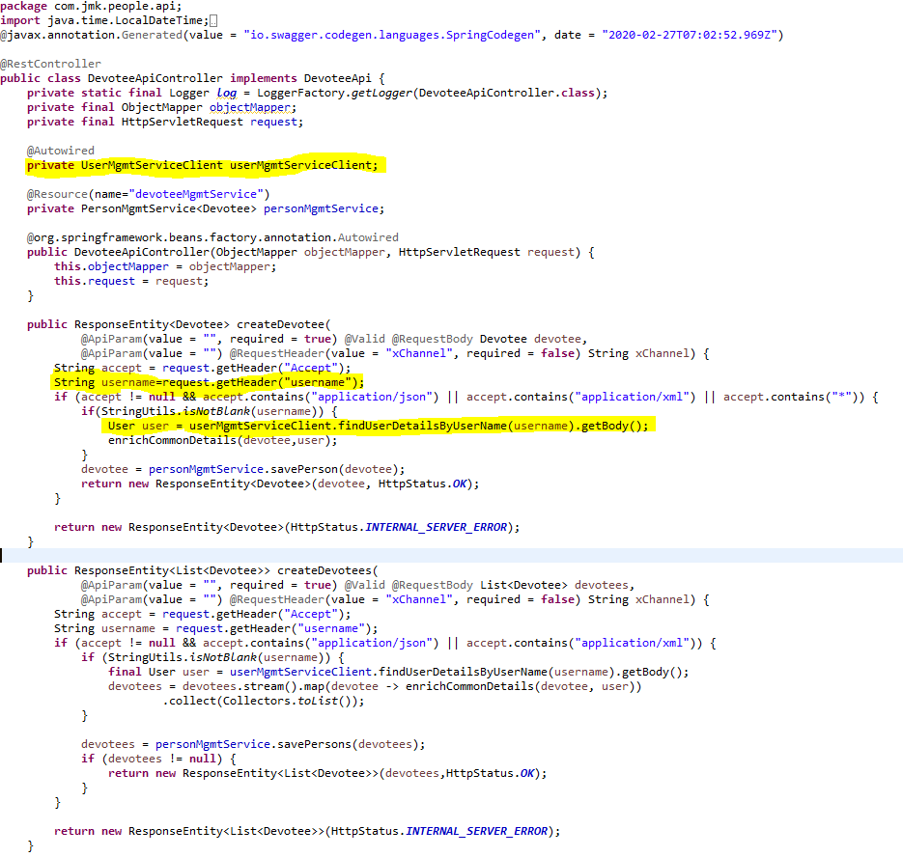

* 1. MemberApi and MemberApiController

MemberApi

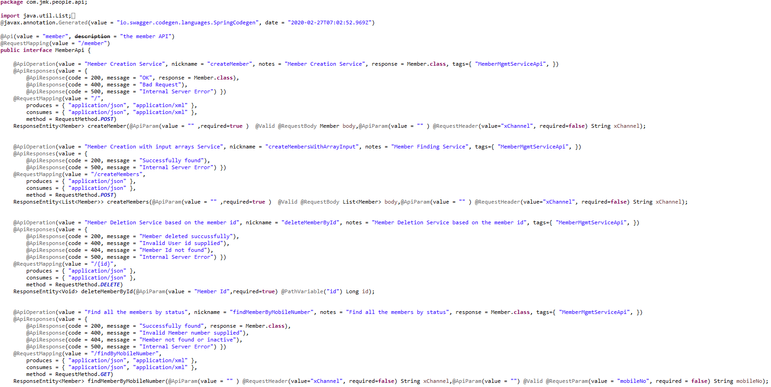

MemberApiController

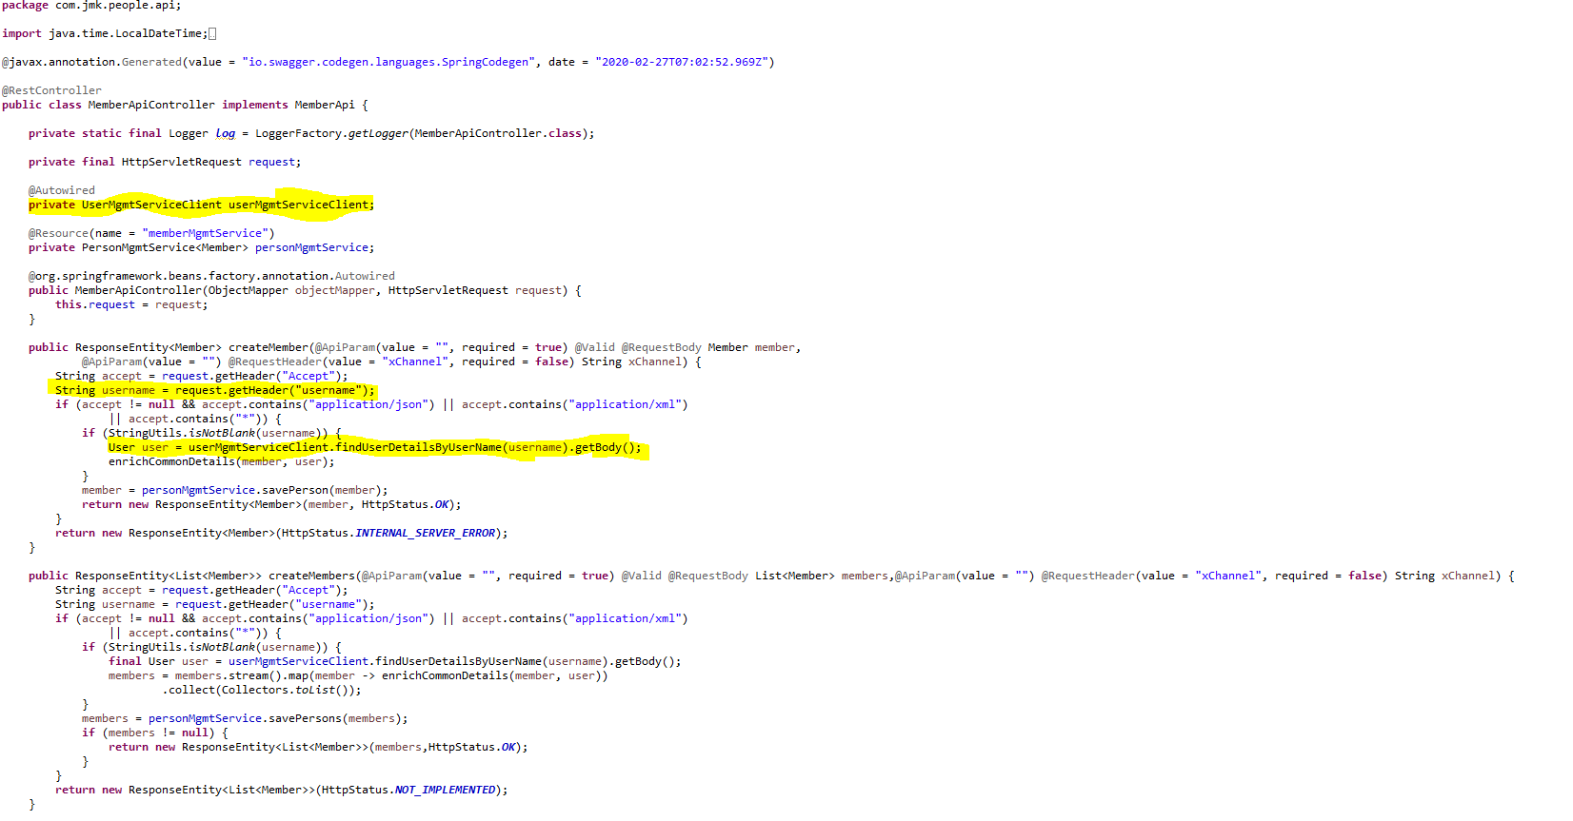

* 1. SevadarApi and SevadarApiController

SevadarApi

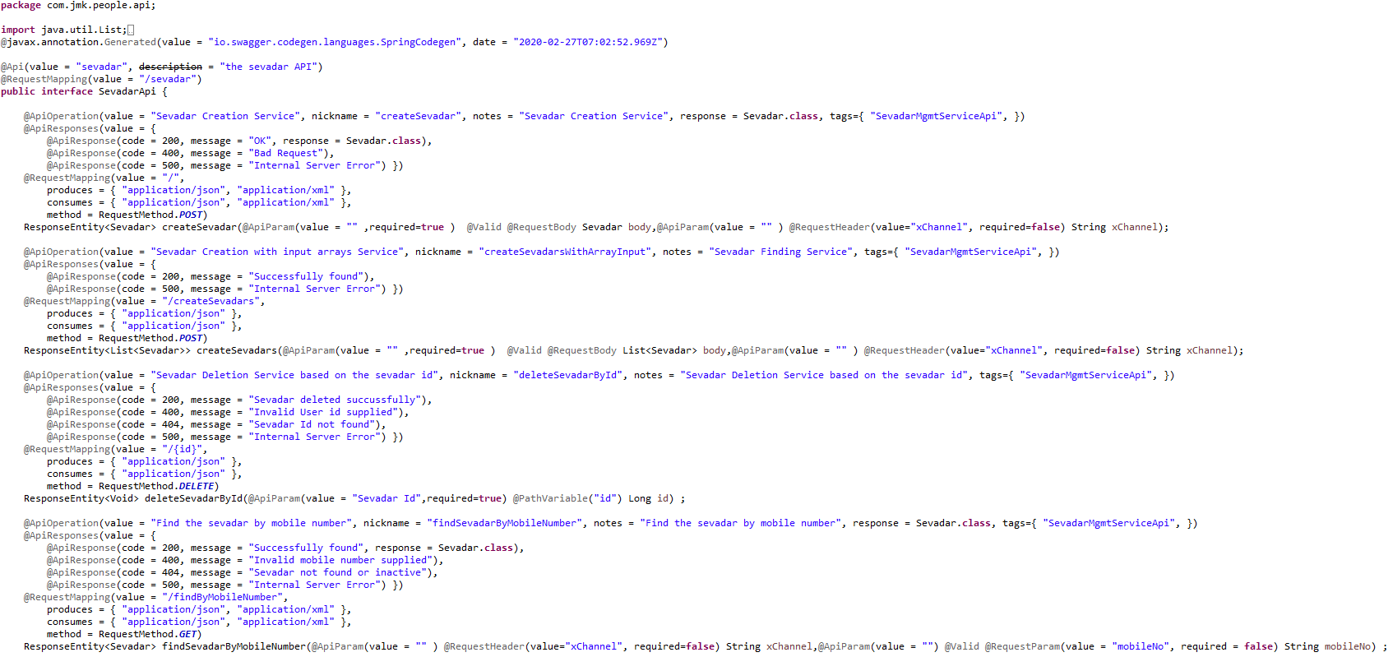

SevadarApiController

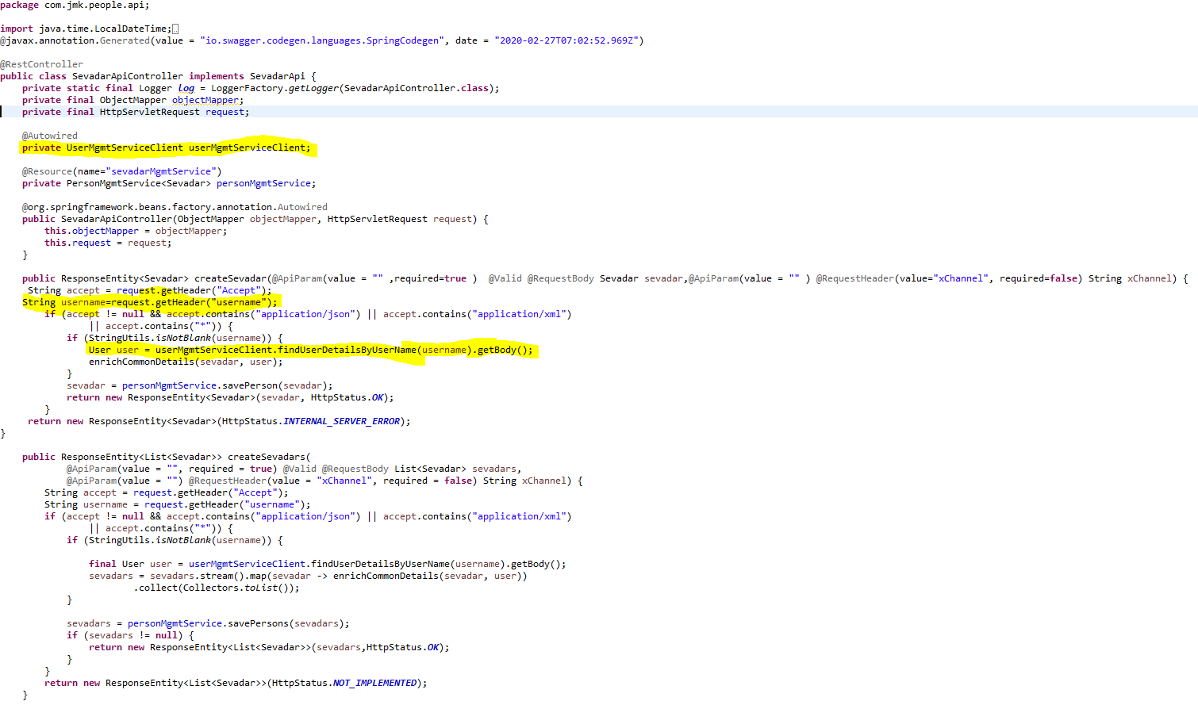

1. Configure the Hazelcast Cache (Embedded Distributed Cache)

* Configure the Hazelcast Cache in the two ways:
  1. If application is running in the Dev environment



* 1. If application is running in the Kubernetes Environment (Prod)



* HazelcastCacheConfiguration.java file to configure the Hazelcast Cache.

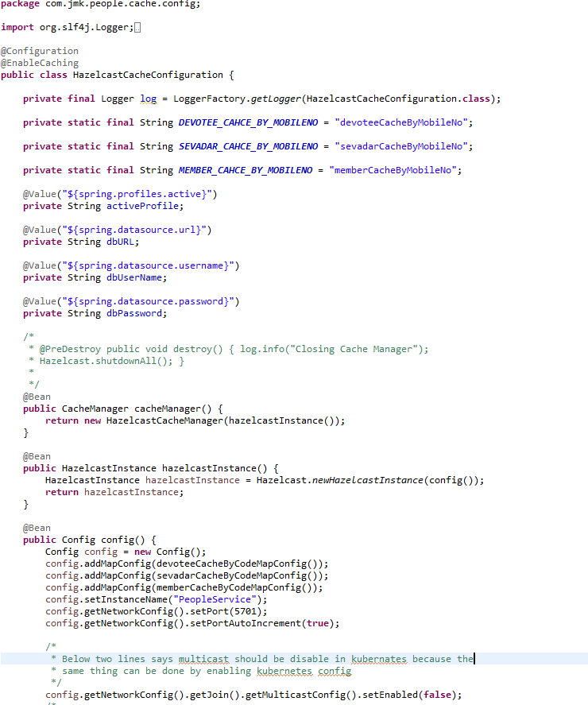

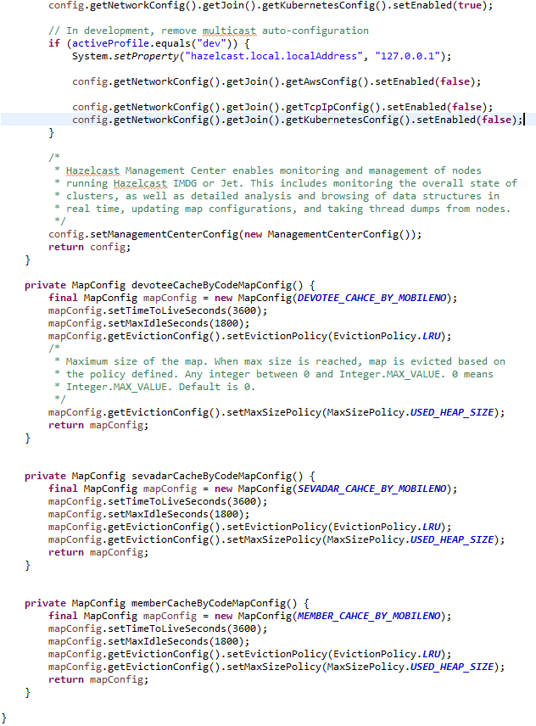

1. UserServiceClient – Feign Client for communicating user-service

Feign dynamically generates the implementation of the interface we created, so Feign has to know which service to call beforehand. That's why we need to give a name for the interface, which is the {Service-Id} of UserServiceClient. Now, Feign contacts the Eureka server with this Service Id, resolves the actual IP/hostname of the UserServiceClient, and calls the URL provided in Request Mapping.

To send HTTP Request to a destination **user-service** Microservice we will need to create a Feign Client interface. Please note the use of @FeignClient annotation which accepts the name user-mgmt-service under which the destination Microservice is registered with Eureka Discovery Service.

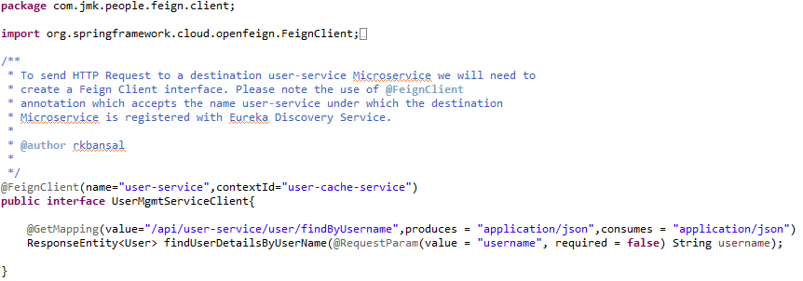

1. If we get an unexpected surprise… The discovery across all namespaces does not work for the Ribbon client. It only works for DiscoveryClient. I think that Ribbon auto-configuration should respect the property spring.cloud.kubernetes.discovery.all-namespaces, but in that case, we don’t have any other choice than prepare a workaround. Our workaround is to override Ribbon client auto-configuration provided within Spring Cloud Kubernetes. We are using DiscoveryClient directly for it as shown below.

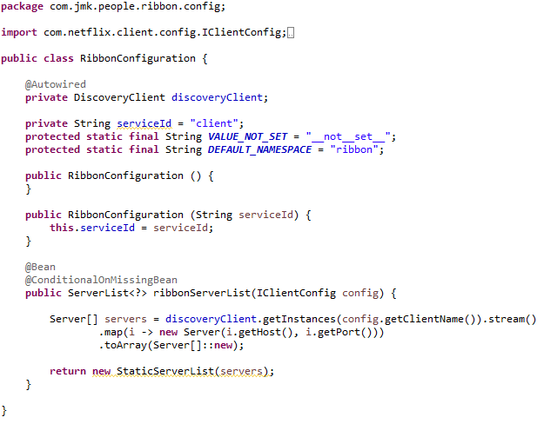

1. Person Service which is parent class for SevadarService,MemberService,should be exposed as following:

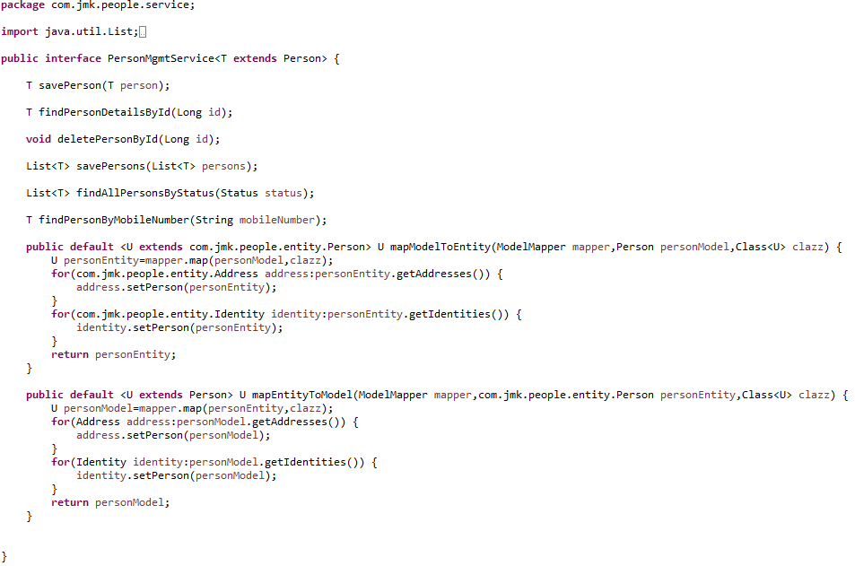

1. SevadarMgmtServiceImpl Service Implementation should be exposed as following:
   * Custom Exception Handling where EntityNotFoundException class (created in common-service) thrown if entity not present in database which is handled in RestExcceptionHandler(created in common-service), in this handler we are creating the appropriate error message in json and send back to client.
   * Implementations of Hazelcast Cache.

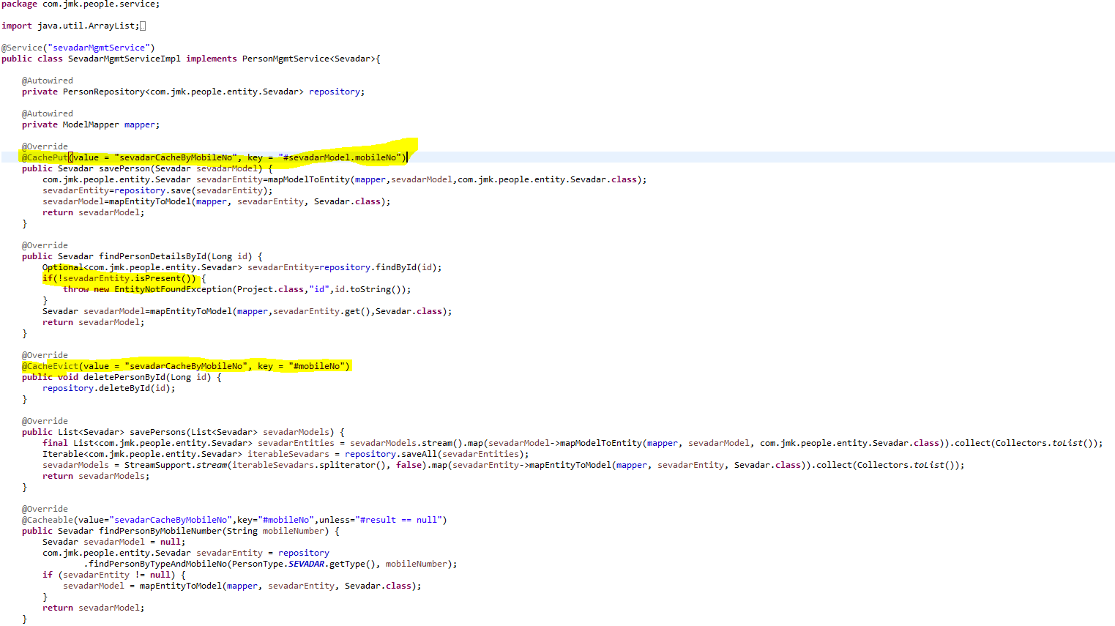

1. MemberMgmtServiceImpl Service Implementation should be exposed as following:

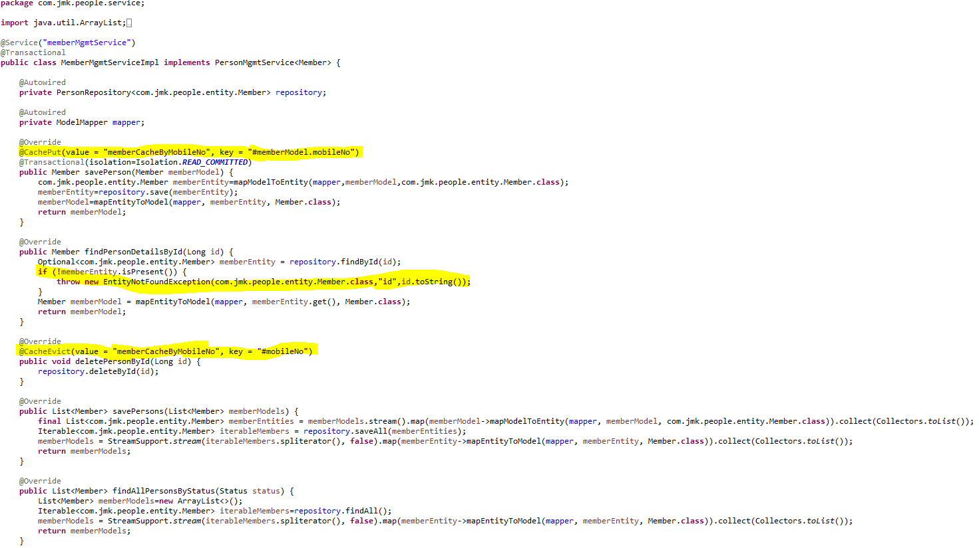

1. DevoteeMgmtServiceImpl Service Implementation should be exposed as following:

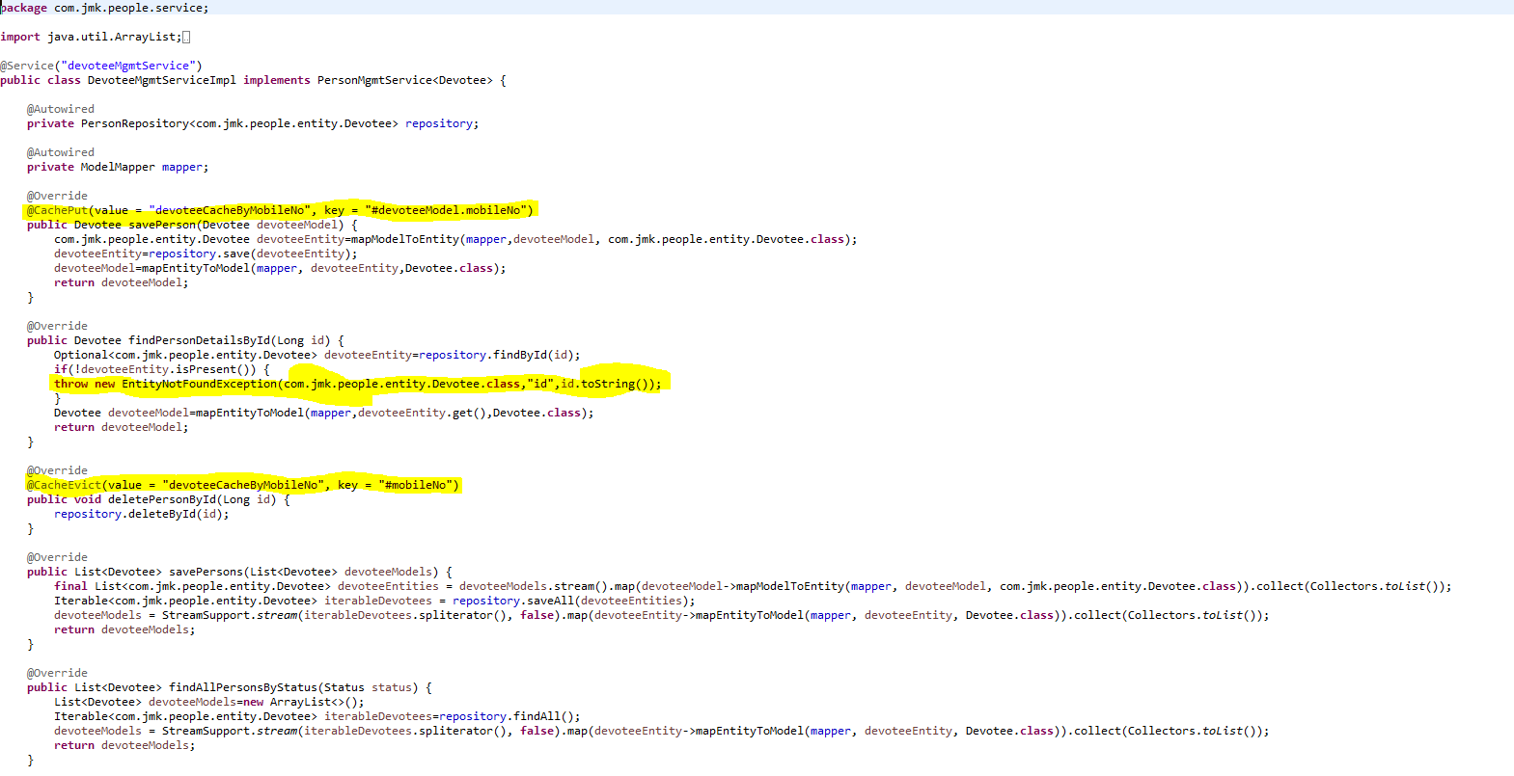

1. PersonRepository.java

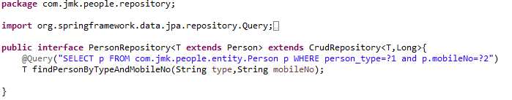

1. Create the model and entities using Lombok.

@**JsonProperty** is suitable for conversion during **serialization**.

@**ApiModelProperty** is **used** for interface document display.

**@Data //It is combination of @ToString, @EqualsAndHashCode ,@Getter,@Setter and @RequiredArgsConstructor**

* Person Entity Class

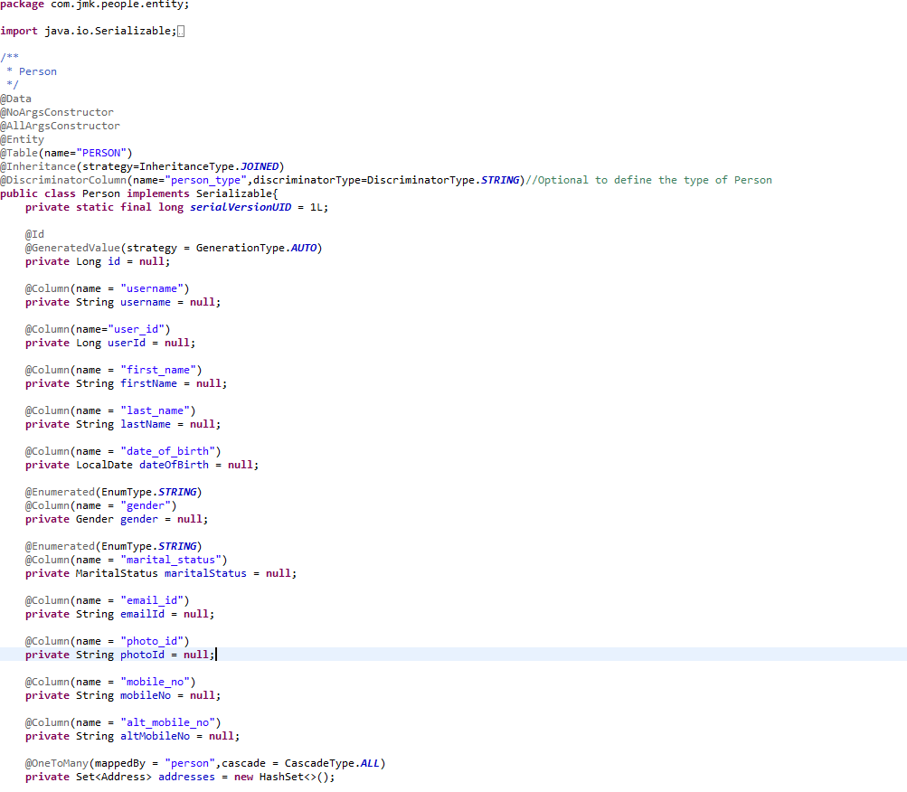

* Member Entity Class

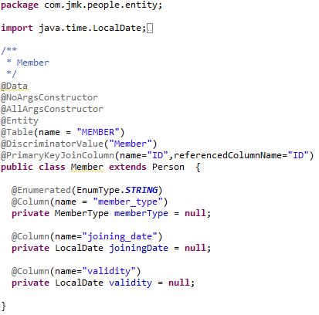

* Sevadar Entity Class

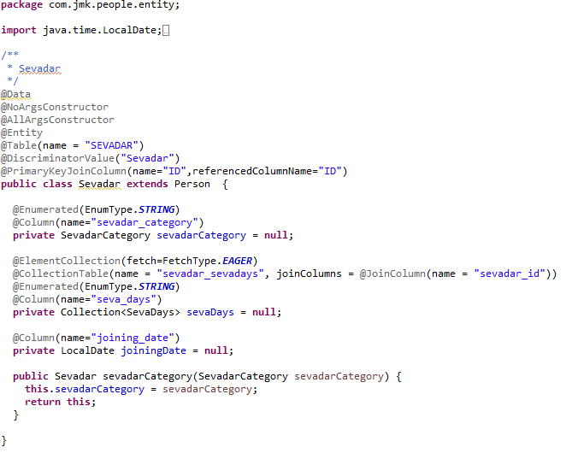

* Devotee Entity Class

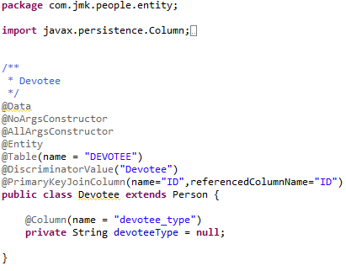

* Made changes in the SwaggerDocumentationConfig

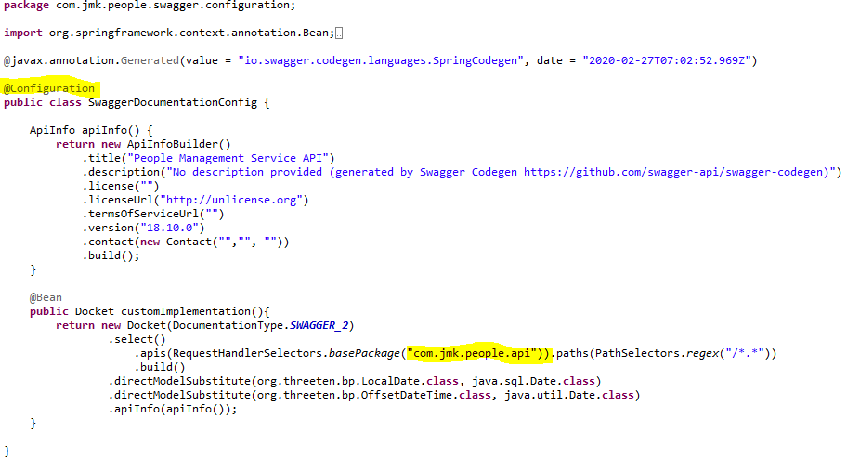

* Made changes in the Swagger’s HomeController

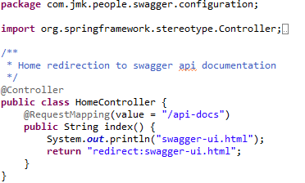

* After running the application, should be visible following functions for the following url: <http://localhost:6379/api/people-mgmt-service/swagger-ui.html>

Or

<http://localhost:6379/api/people-mgmt-service/api-docs>

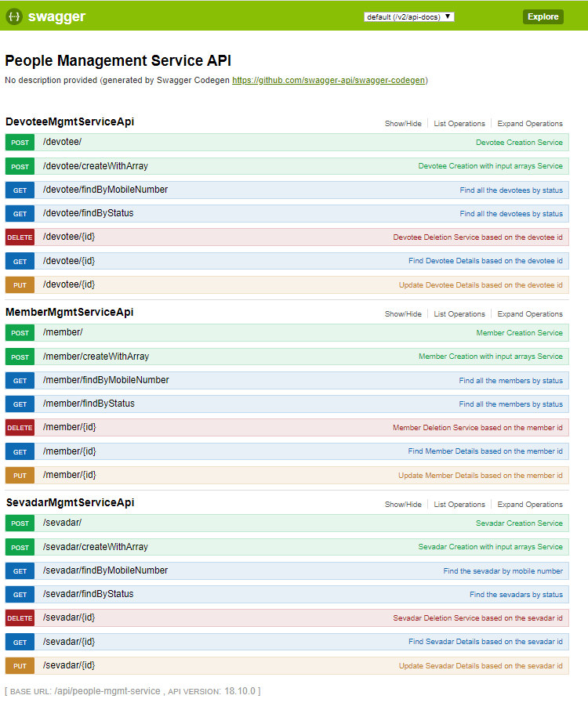

### Testing

#### Junit Testing

Test the People Api using JUnit

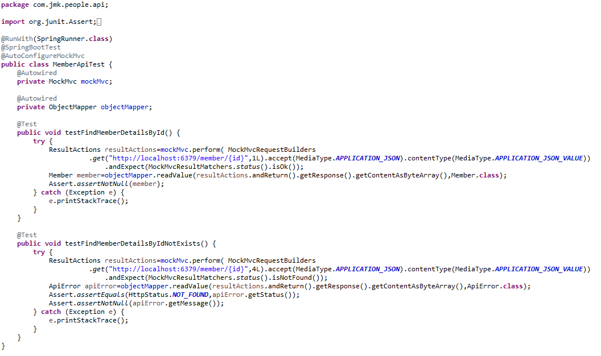

#### Testing in Dev Environment

* Run the application as **Spring Boot App** in the following order
  + EurekaServerApplication
  + UserMgmtRestApplication
  + AuthServiceApplication
  + ZuulGatewayApplication
  + PeopleMgmtRestApplication
* Open the browser of Eureka Server at localhost:8761, you should see the all the microservices running and enter the url: <http://localhost:8761/>

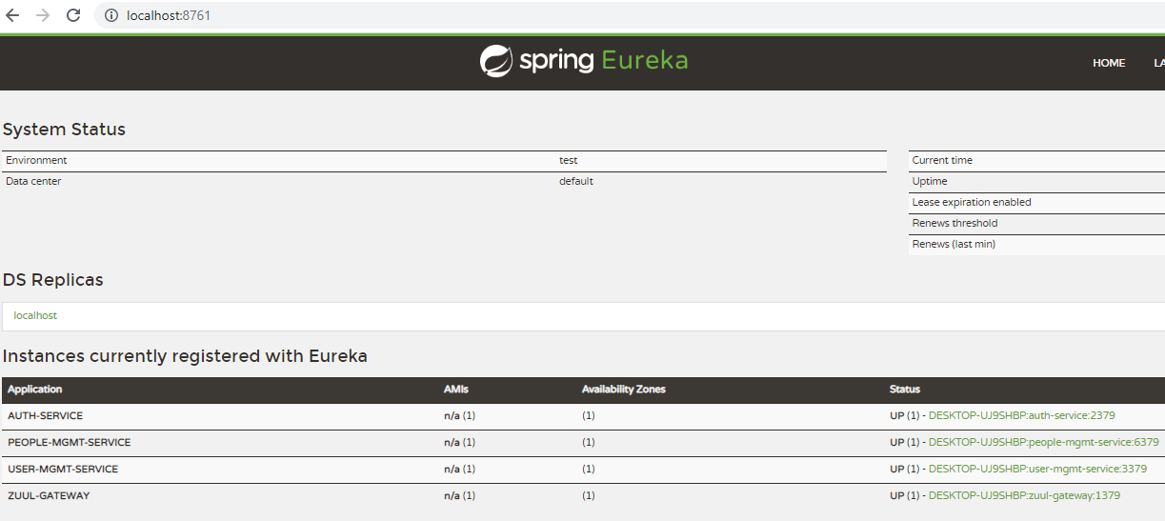

* Testing
  + Without authentication means directly hitting the people-mgmt-project running on 6379 and fetch the member details based on the id



* + Without authentication means directly hitting the people-mgmt-project running on 6379 but not able to get the member id because it does not exist

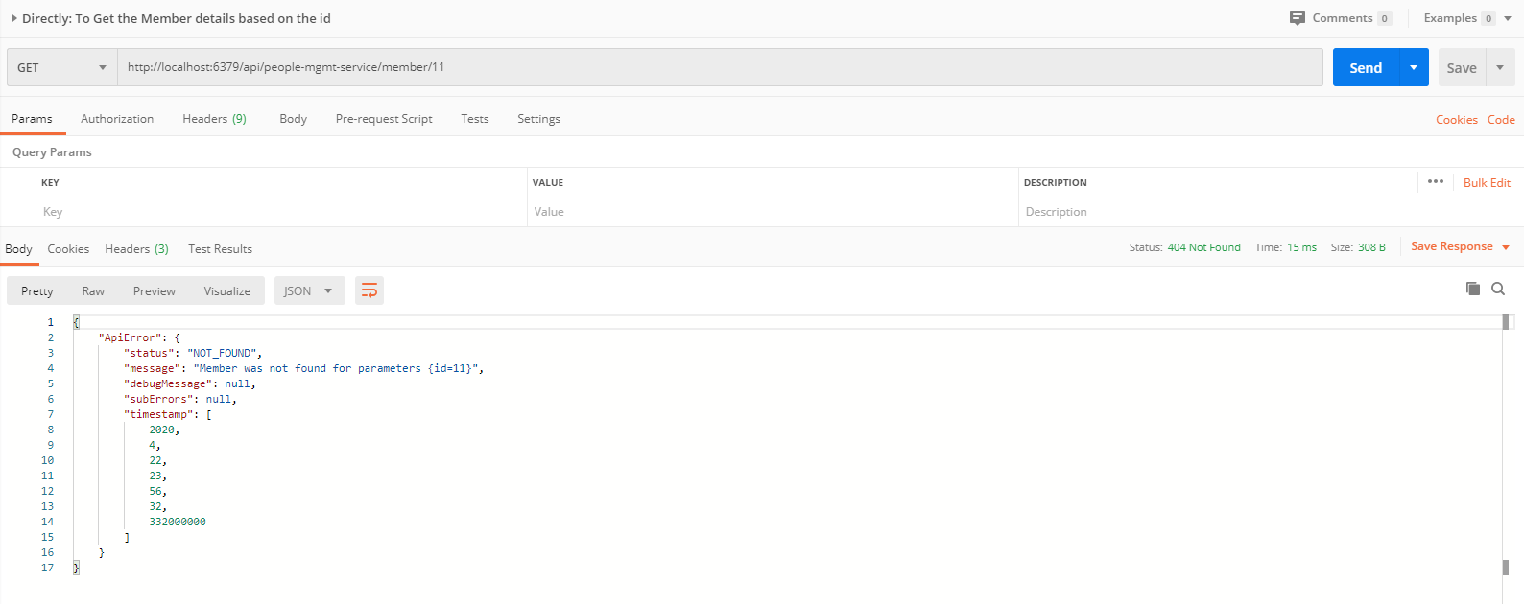

* + With authentication means every request to people-mgmt-service microservice will be hit via gateway running 1379
    - with authentication means every request to people-mgmt-service microservice will be hit via gateway running on 1379
      * getting member details based on the id but without token means no authorization code (Bearer token) in the header will give the error.

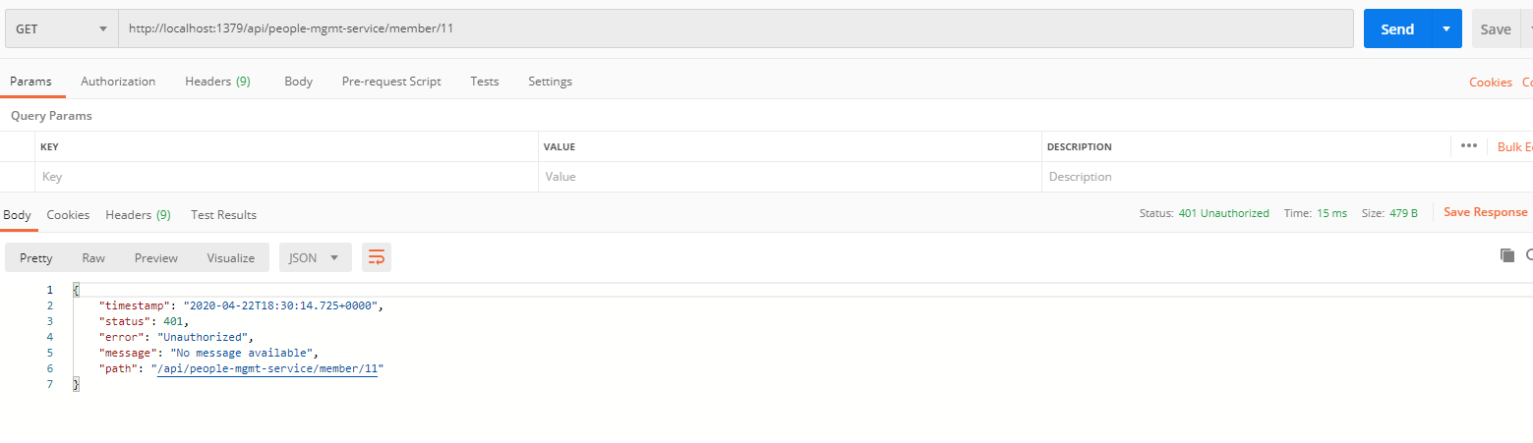

* getting member details based on the id with token means authorization code(Bearer token) in the header will be provided using authentication service
  + 1. **To get authentication code in response header using authentication service**

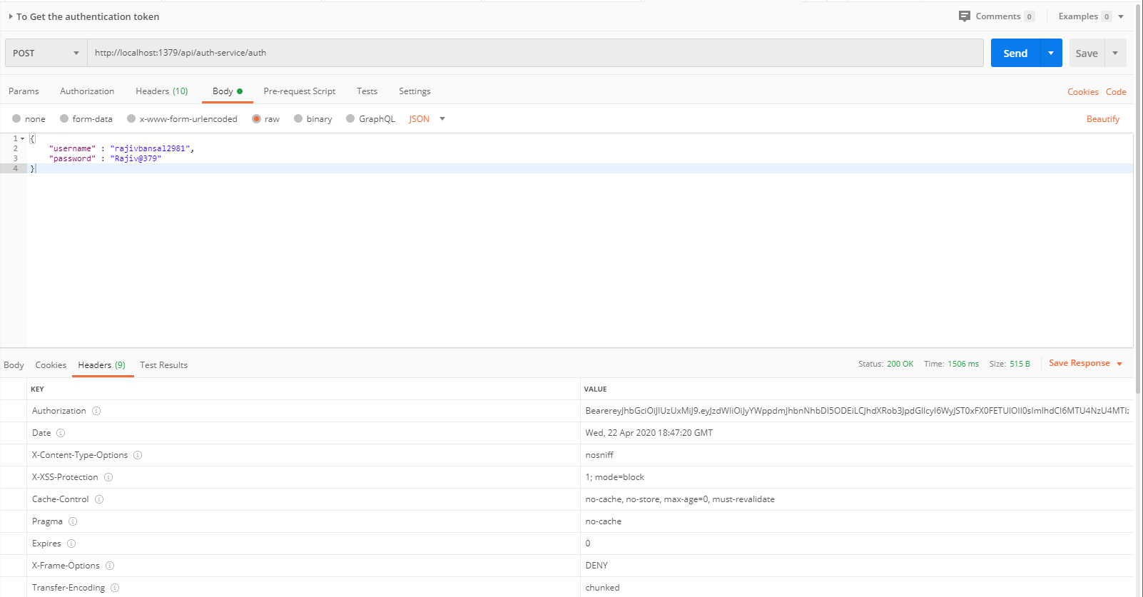

* + 1. **Now hit the people-mgmt-service to** get member details based on the id by providing the token means authorization code (Bearer token) in the header received in above step

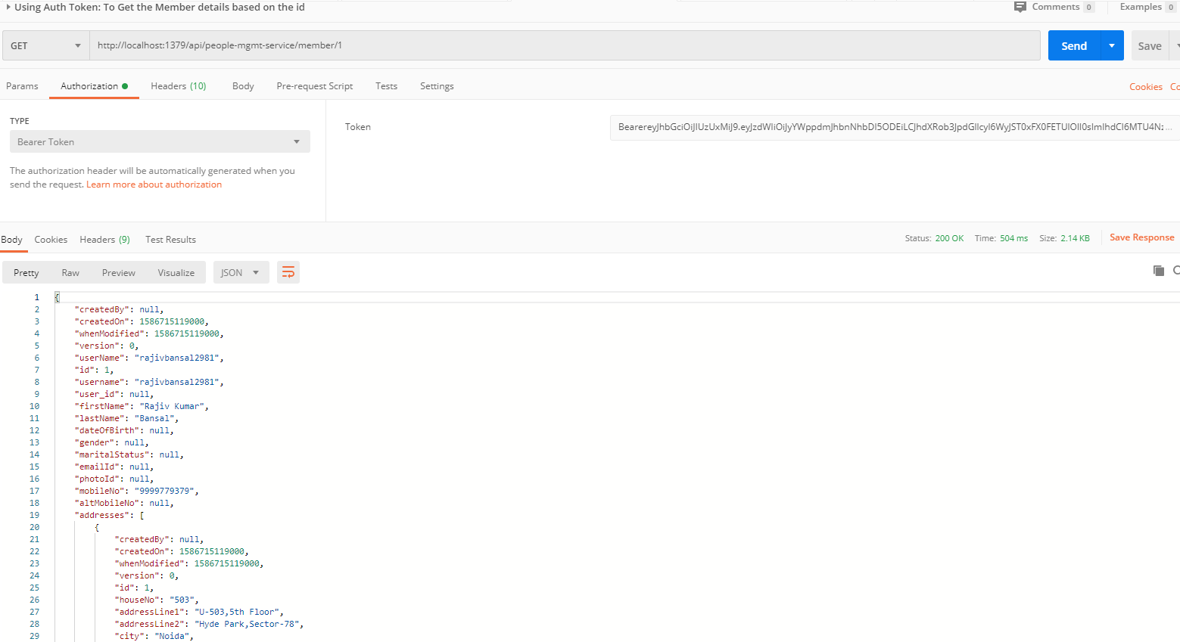

#### Testing in Kubernetes Environment

# Darshan Management Service

## Description

* Create the darshan-mgmt-service application as microservice with the following functionalities:
* Saving the details of darshan which includes the Darshan Date, Visitor Details, number of members with Visitor, number of times he visited
  + Validate the visitor if visitor id and donor type is provided in the request. Or If donor is Devotee and its id does not exist in the request.
  + Darshan request is valid otherwise error message should be triggered for the user.
  + Creating the visitor if required: If visitor is devotee and its id does not exist it means we need to create the devotee record first then will save the donation.
  + Saving the donation.
* Saving the details of darshan in bulk
* Updating the darshan details
* Delete the darshan
* Find the darshan by id

## Entity Relationship Diagram

## Class Diagram

## Use Case Diagram

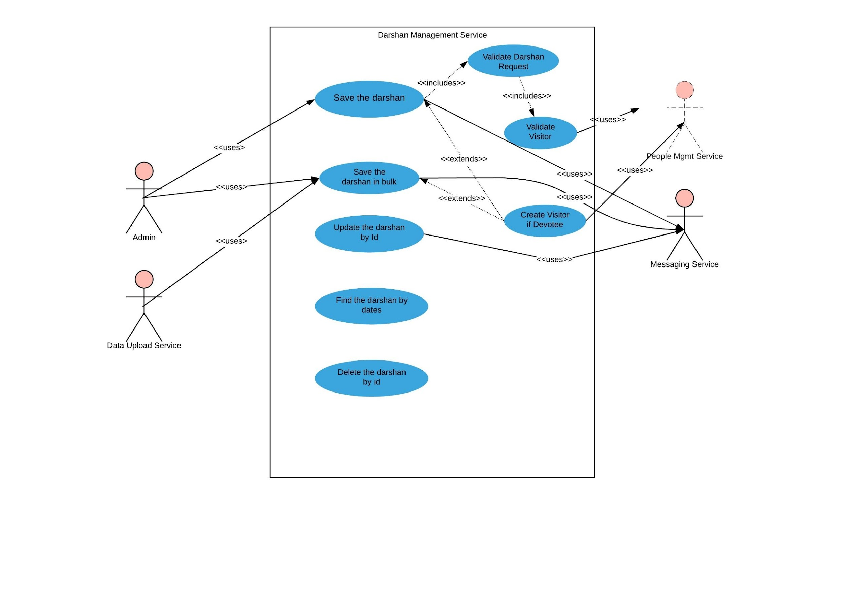

## Use Case Details

## Use Case Implementation

### Coding

1. Follow the document to implement project-service: **DemoProjectWork-member-mgmt-service.doc** along with the following changes:

|  |  |
| --- | --- |
| Database/Schema Name | darshan\_db |
| User name | bjjd |
| Password | bjjd\_379 |

**Commands:**

Connect with the root with the following credentials in MySQL database command line or UI

User Id: root

Password: bjjd

* create database darshan\_db;
* create user 'bjjd'@'%' identified by 'bjjd\_379';
* grant all on darshan\_db.\* to 'bjjd'@'%';
* grant SELECT,INSERT,UPDATE,DELETE,CREATE,index,drop,ALTER,create temporary tables,references ON darshan\_db.\* to 'bjjd'@'%';

1. Use the following document related to the swagger, database scripts, ER diagram of Users:



* mvn --encrypt-master-password rajiv379
* Add the following dependencies in the pom.xml with the following considerations:

1. bjjd-microservices Parent: It contains common dependencies of Spring Boot, Spring Cloud and kubernetes etc.
2. Common-service: It will keep all the dto models, exception handling and common configurations.
3. Sql-connector: to connect with the MySQL database.
4. jib-maven-plugin: A Maven plugin for building docker container images for your Java applications and pushed to the docker hub.

<project xmlns=*"http://maven.apache.org/POM/4.0.0"*

xmlns:xsi=*"http://www.w3.org/2001/XMLSchema-instance"*

xsi:schemaLocation=*"http://maven.apache.org/POM/4.0.0 http://maven.apache.org/maven-v4\_0\_0.xsd"*>

<modelVersion>4.0.0</modelVersion>

<parent>

<groupId>com.jmk</groupId>

<artifactId>bjjd-microservices</artifactId>

<version>0.0.1.RELEASE</version>

</parent>

<artifactId>darshan-service</artifactId>

<packaging>jar</packaging>

<name>darshan-service</name>

<dependencies>

<dependency>

<groupId>com.github.joschi.jackson</groupId>

<artifactId>jackson-datatype-threetenbp</artifactId>

<version>2.6.4</version>

</dependency>

<!-- Bean Validation API support -->

<dependency>

<groupId>javax.validation</groupId>

<artifactId>validation-api</artifactId>

</dependency>

<dependency>

<groupId>com.jmk</groupId>

<artifactId>common-service</artifactId>

<version>${jmk-version}</version>

</dependency>

<!-- Starter for using Spring Data JPA with Hibernate to store and retrieve

data in a relational database. -->

<dependency>

<groupId>org.springframework.boot</groupId>

<artifactId>spring-boot-starter-data-jpa</artifactId>

</dependency>

<!--MySQL provides connectivity -->

<dependency>

<groupId>mysql</groupId>

<artifactId>mysql-connector-java</artifactId>

<version>8.0.25</version><!--$NO-MVN-MAN-VER$ -->

</dependency>

</dependencies>

<build>

<plugins>

<plugin>

<groupId>com.google.cloud.tools</groupId>

<artifactId>jib-maven-plugin</artifactId>

<version>${jib-maven-plugin.version}</version>

<configuration>

<to>

<image>registry.hub.docker.com/rajivbansal2981/darshan-service:${jmk-version}</image>

<auth>

<username>rajivbansal2981</username>

<password>rajiv379</password>

</auth>

</to>

</configuration>

</plugin>

</plugins>

</build>

</project>

* Main application.properties file which can further refer the following
  1. application-dev.properties
  2. application-prod.properties
* application.properties : @spring.profiles.active@ determines which properties file will be referred based on the maven profile: dev or prod

There will be an application.properties file but it will have the following minimum details:

* + - Name of the application
    - Active Default Profile
    - Cloud Config server URI with port

#Name of the application

spring.application.name=darshan-service

#Active Profile - will relate to development properties file in the server. If this property is absent

#then,default profile will be activated which is the property file without any environment name at the end.

spring.profiles.active=@spring.profiles.active@

#Setting cloud config server uri with port

spring.cloud.config.uri=http://localhost:8888

* application-dev.properties moved to the git repository: **bjjd-config-server-git-repo** and will be selected if maven profile is dev

#Application Name

spring.application.name=darshan-service

#Application Context and its port

server.port=4379

server.servlet.context-path=/api/darshan-service

#It is worth mentioning that user-service acts as a Eureka client. So, we give it a name, port, and link to Eureka server

# eureka server url

eureka.client.service-url.default-zone=http://localhost:8761/eureka

#Spring profile

spring.profiles.active=dev

#To disable the Kubernetes Discovery client

#spring.cloud.kubernetes.enabled=false

#spring.cloud.kubernetes.discovery.include-not-ready-addresses=true

#Feign Client properties

feign.client.config.default.connectTimeout: 16000000

feign.client.config.default.readTimeout: 16000000

spring.sleuth.sampler.probability = 1.0

server.servlet.context-path=/api/user-service

spring.jackson.date-format=com.jmk.user.swagger.RFC3339DateFormat

spring.jackson.serialization.WRITE\_DATES\_AS\_TIMESTAMPS=false

#Define properties related to JPA

spring.jpa.hibernate.ddl-auto=create

spring.datasource.url=jdbc:mysql://localhost:3306/darshan\_db

spring.datasource.username=bjjd

spring.datasource.password=bjjd\_379

#Optional

spring.datasource.tomcat.max-wait=20000

spring.datasource.tomcat.max-active=50

spring.datasource.tomcat.max-idle=20

spring.datasource.tomcat.min-idle=15

#Below line is commented as it takes by default: org.hibernate.dialect.MySQL5Dialect

#spring.jpa.properties.hibernate.dialect = org.hibernate.dialect.MySQL5Dialect

spring.jpa.properties.hibernate.id.new\_generator\_mappings = false

spring.jpa.properties.hibernate.format\_sql = true

logging.level.org.hibernate.SQL=DEBUG

logging.level.org.hibernate.type.descriptor.sql.BasicBinder=TRACE

logstash.host=localhost

logstash.queue-size=1000

logstash.port=5000

* application-prod.properties: It will be selected if maven profile is prod.
  1. Eureka Clients registrations with Eureka server need to be disabled in Kubernetes.
  2. Add client option to your mysql-connector allowPublicKeyRetrieval=true to allow the client to automatically request the public key from the server. Note that AllowPublicKeyRetrieval=True could allow a malicious proxy to perform a MITM attack to get the plaintext password, so it is False by default and must be explicitly enabled.
  3. Adding useSSL=false when you use it for testing/develop purposes

#Name of the application

spring.application.name=darshan-service

#Port of the application

server.port=4379

#Spring profile

spring.profiles.active=${SPRING\_ACTIVE\_PROFILE:prod}

spring.cloud.kubernetes.discovery.all-namespaces=true

#It is worth mentioning that user-service acts as a Eureka client. So, we give it a name, port, and link to Eureka server

# eureka server url

#eureka.client.service-url.default-zone=http://localhost:8761/eureka

eureka.client.enabled=false

eureka.client.serviceUrl.registerWithEureka=false

spring.sleuth.sampler.probability = 1.0

server.servlet.context-path=/api/darshan-service

spring.jackson.date-format=com.jmk.user.swagger.RFC3339DateFormat

spring.jackson.serialization.WRITE\_DATES\_AS\_TIMESTAMPS=false

feign.client.config.default.connectTimeout: 160000000

feign.client.config.default.readTimeout: 160000000

#Define properties related to JPA

spring.jpa.hibernate.ddl-auto=create

spring.datasource.url=jdbc:mysql://${DB\_HOSTNAME:localhost}:${DB\_PORT:3306}/${DB\_NAME:darshan\_db}?allowPublicKeyRetrieval=true&useSSL=false

spring.datasource.username=${DB\_USERNAME:bjjd}

spring.datasource.password=${DB\_PASSWORD:bjjd\_379}

#Optional

spring.datasource.tomcat.max-wait=20000

spring.datasource.tomcat.max-active=50

spring.datasource.tomcat.max-idle=20

spring.datasource.tomcat.min-idle=15

#Below line is commented as it takes by default: org.hibernate.dialect.MySQL5Dialect

spring.jpa.properties.hibernate.dialect = org.hibernate.dialect.MySQL5Dialect

spring.jpa.properties.hibernate.id.new\_generator\_mappings = false

spring.jpa.properties.hibernate.format\_sql = true

logging.level.org.hibernate.SQL=DEBUG

logging.level.org.hibernate.type.descriptor.sql.BasicBinder=TRACE

1. Rename the package of io.swagger to com.jmk.project
2. Rename and refactor the Swagger2SpringBoot.java to DarshanServiceApplication.java with the following details:
   * Enable Discovery Client so that it can register with Eureka Server and it supports Kubernetes Discovery System.
   * Enable FeignClient to interact with user-mgmt-service
   * Enable RibbonClient
   * Enable JpaRepositories

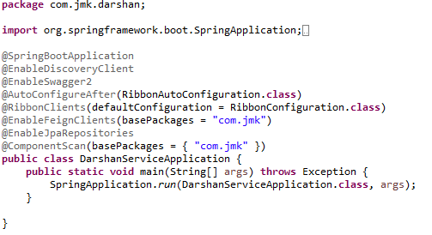

* DarshanAPI and DarshanApiController APIS
  1. DarshanAPI and DevoteeApiController

DarshanAPI

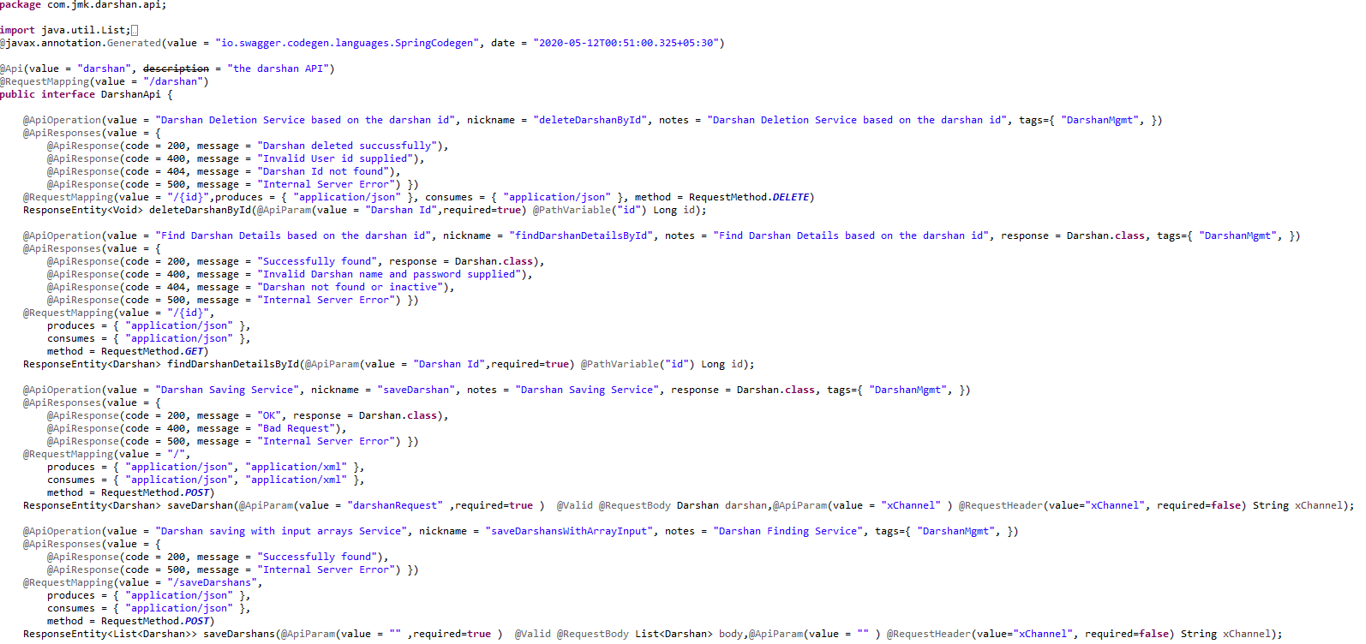

DarshanApiController

* + - Validating the visitor details and check if the visitor is new then create the devotee details by calling people-mgmt-service
    - Saving the user details and saving the user details who save the visiting details
    - MessageSenderClient used to send the message to the visitors after saving the details

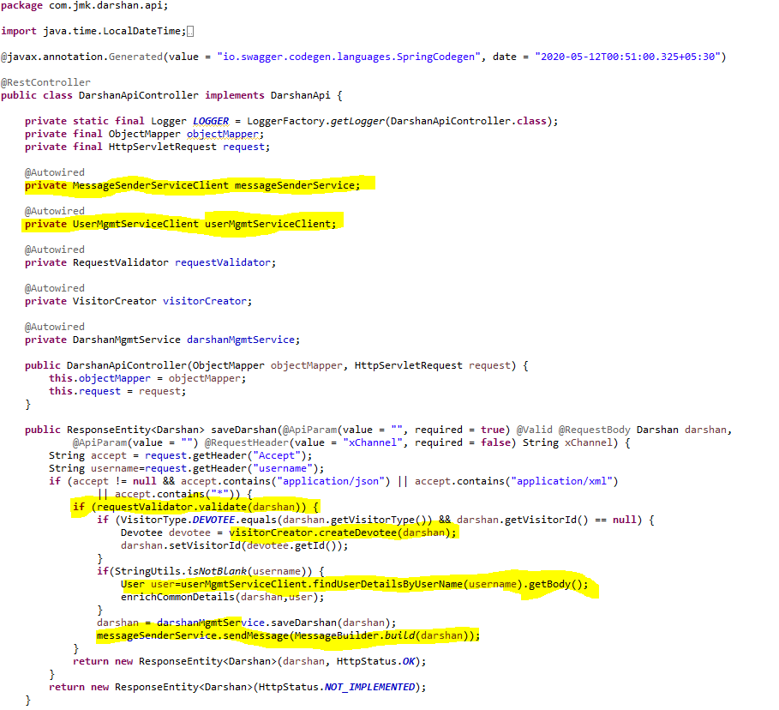

1. Feign Clients
   * **UserServiceClient** – Feign Client for communicating user-service

Feign dynamically generates the implementation of the interface we created, so Feign has to know which service to call beforehand. That's why we need to give a name for the interface, which is the {Service-Id} of UserServiceClient. Now, feign contacts the Eureka server with this Service Id, resolves the actual IP/hostname of the UserServiceClient, and calls the URL provided in Request Mapping.

To send HTTP Request to a destination **user-service** Microservice we will need to create a Feign Client interface. Please note the use of @FeignClient annotation which accepts the name user-mgmt-service under which the destination Microservice is registered with Eureka Discovery Service.



* **MessageSenderServiceClient**: to interact with message-sender-service to send the message to visitor.

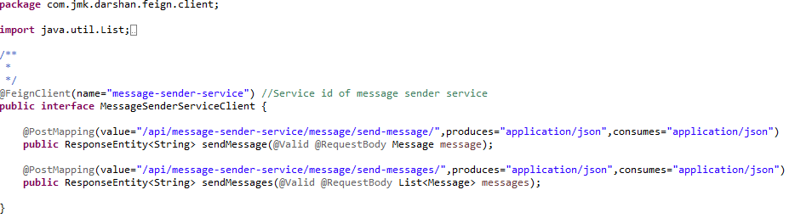

* + **PeopleMgmtServiceClient**: to interact with people-mgmt-service to get the details of devotee, member and sevadar.

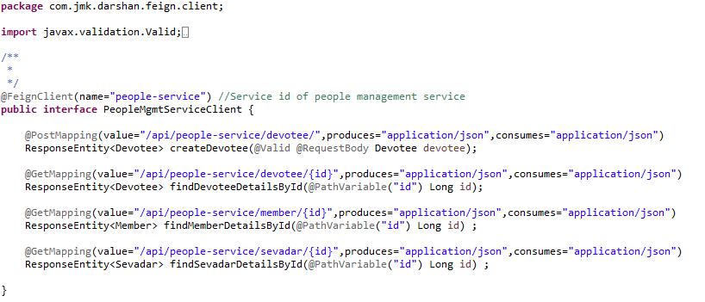

* + RequestValidator and DarshanRequestValidator: Create the **RequestValidator** to validate the darshan request where we will validate the visitor by invoking the people-mgmt-service using feign client.

RequestValidator

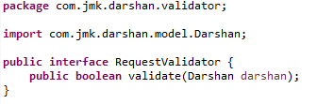

DarshanRequestValidator

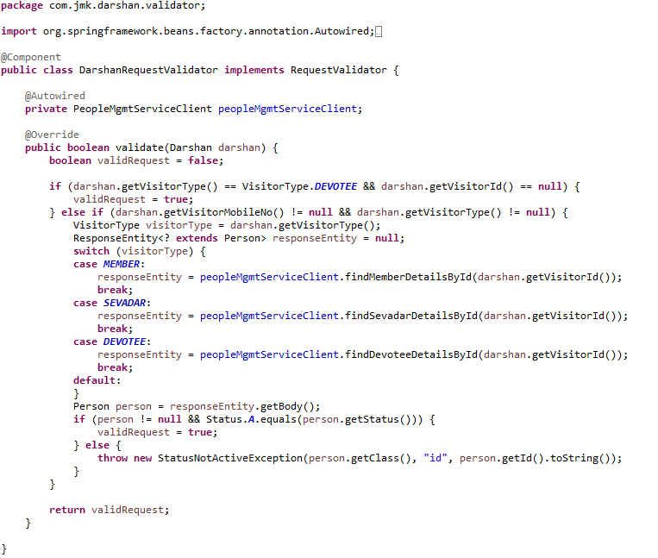

1. Create VisitorCreator class to create the donor by invoking the people-mgmt-service using feign client.

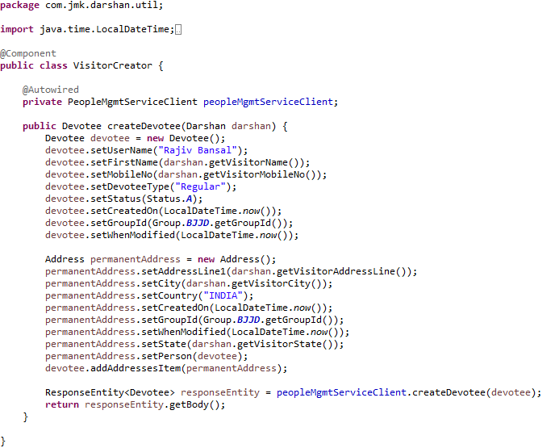

1. If we get an unexpected surprise… The discovery across all namespaces does not work for the Ribbon client. It only works for DiscoveryClient. I think that Ribbon auto-configuration should respect the property spring.cloud.kubernetes.discovery.all-namespaces, but in that case, we don’t have any other choice than prepare a workaround. Our workaround is to override Ribbon client auto-configuration provided within Spring Cloud Kubernetes. We are using DiscoveryClient directly for it as shown below.

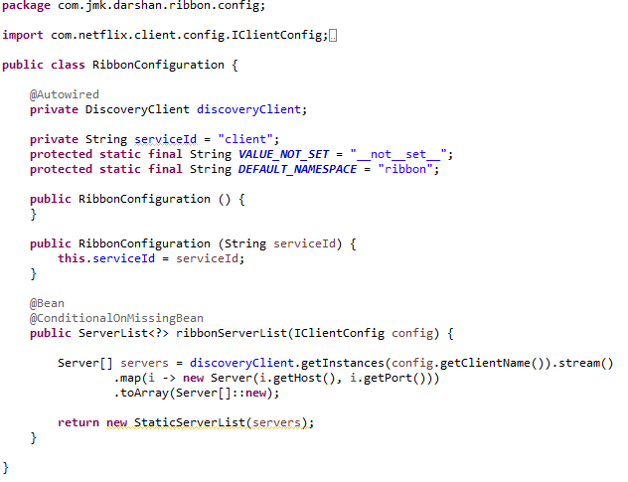

1. DarshanService and DarshanServiceImpl:

* DarshanMgmtService

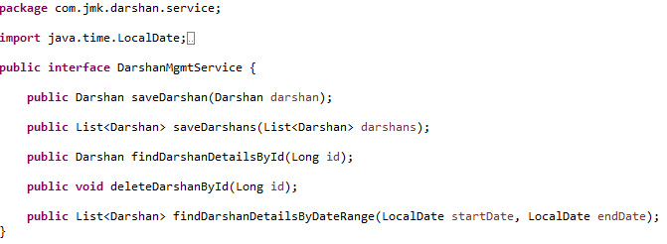

DarshanMgmtServiceImpl

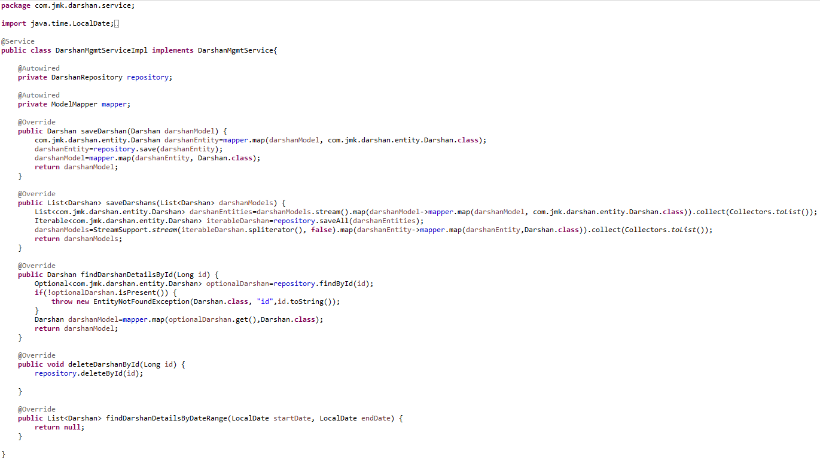

1. DarshanRepository.java

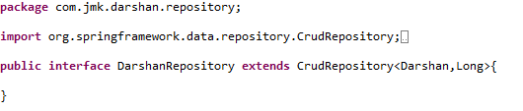

1. Create the model and entities using Lombok.

@**JsonProperty** is suitable for conversion during **serialization**.

@**ApiModelProperty** is **used** for interface document display.

**@Data //It is combination of @ToString, @EqualsAndHashCode ,@Getter,@Setter and @RequiredArgsConstructor**

* Person Entity Class

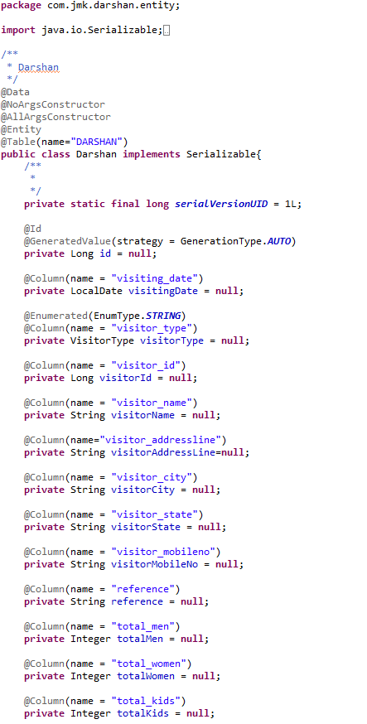

* Made changes in the SwaggerDocumentationConfig

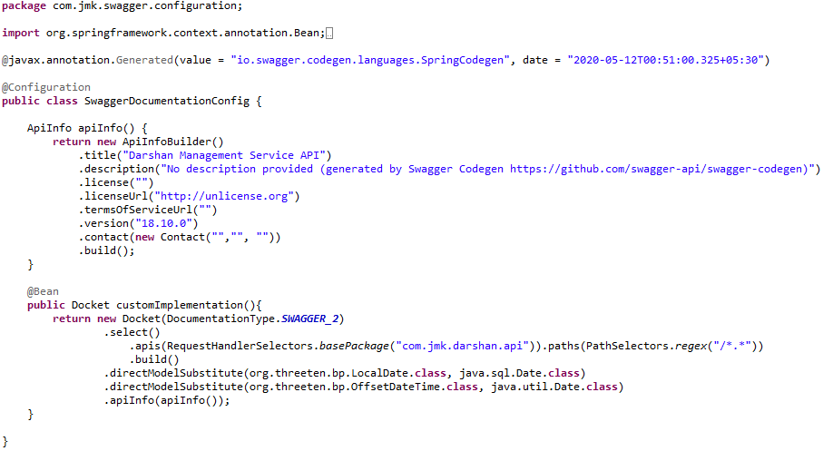

* Made changes in the Swagger’s HomeController

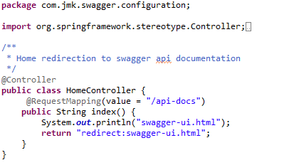

* After running the application, should be visible following functions for the following url: <http://localhost:4379/api/darshan-mgmt-service/swagger-ui.html>

Or

<http://localhost:4379/api/darshan-mgmt-service/api-docs>

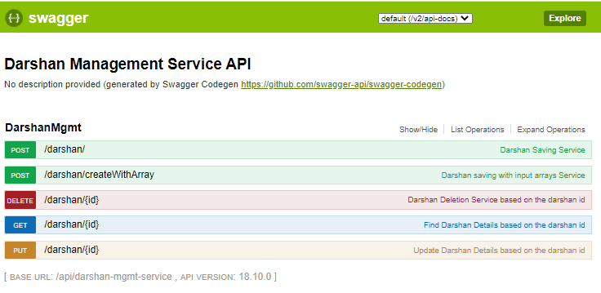

### Testing

#### Junit Testing

Test the Darshan Api using JUnit

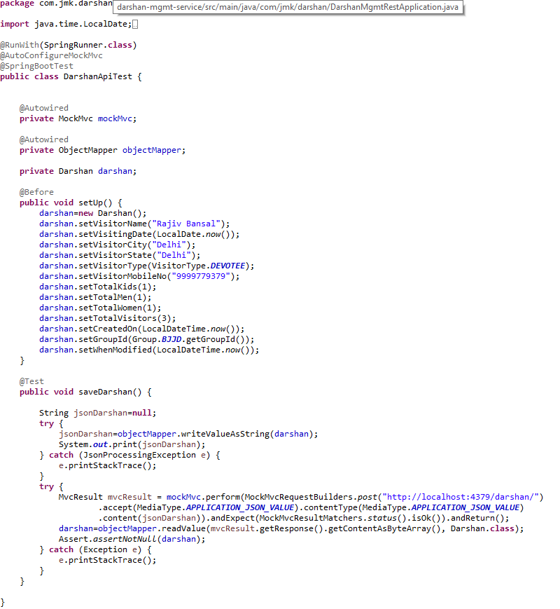

#### Testing in Dev Environment

* Run the application as **Spring Boot App** in the following order
  + ConfigServerApplication
  + EurekaServerApplication
  + UserServiceApplication
  + AuthServiceApplication
  + ZuulGatewayApplication
  + PeopleServiceApplication
  + DarshanServiceApplication
* Open the browser of Eureka Server at localhost:8761, you should see the all the microservices running and enter the url: <http://localhost:8761/>

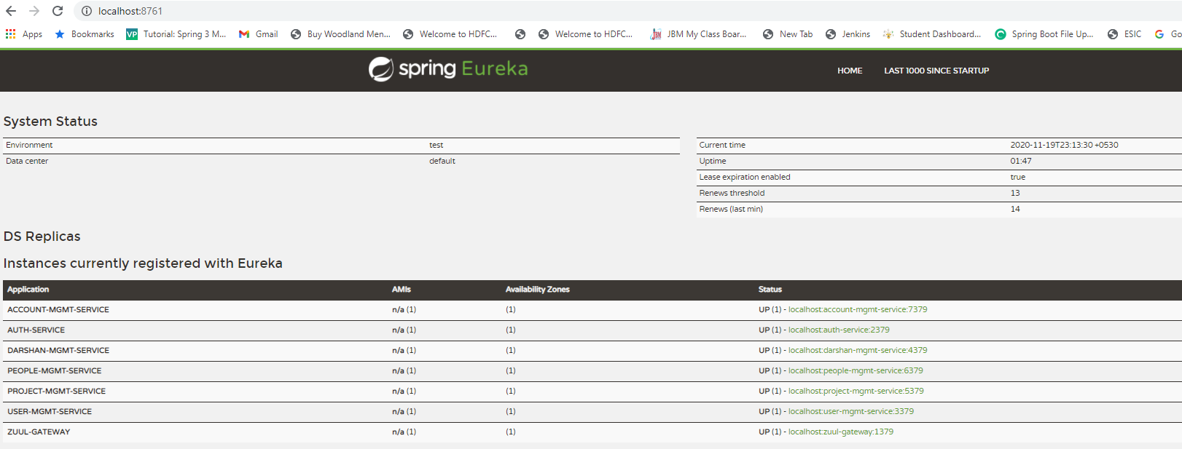

* Testing
  + Without authentication means directly hitting the darshan-mgmt-service running on 4379 and save the darshan details

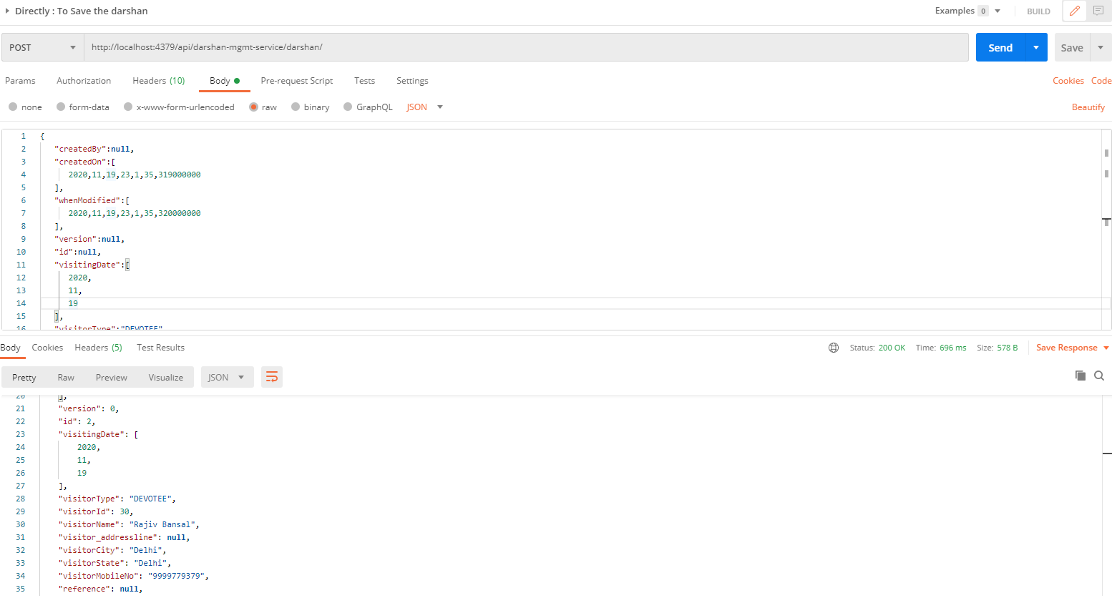

* + With authentication means every request to darshan-mgmt-service microservice will be hit via gateway running 1379
    - with authentication means every request to darshan-mgmt-service microservice will be hit via gateway running on 1379
      * saving darshan details based on the id but without token means no authorization code (Bearer token) in the header will give the error.

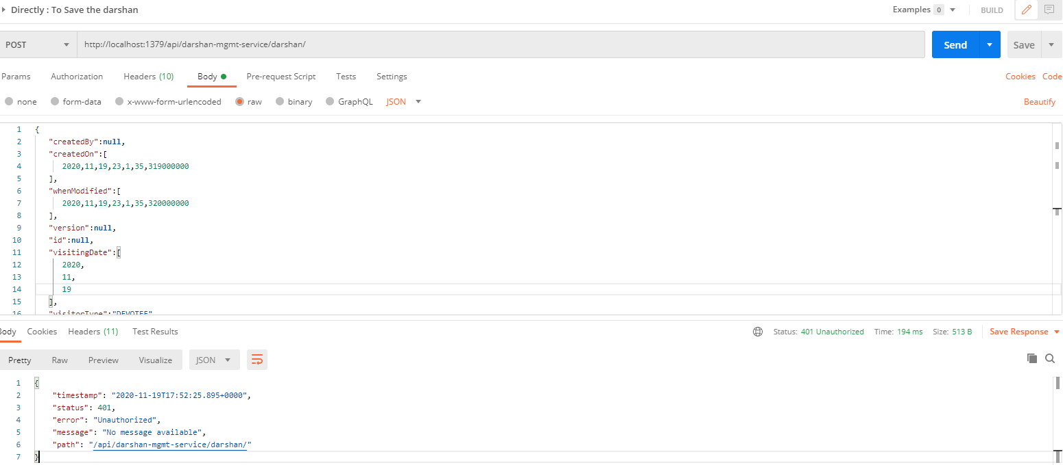

* Saving darshan with token means authorization code (Bearer token) in the header will be provided using authentication service
  + 1. **To get authentication code in response header using authentication service**

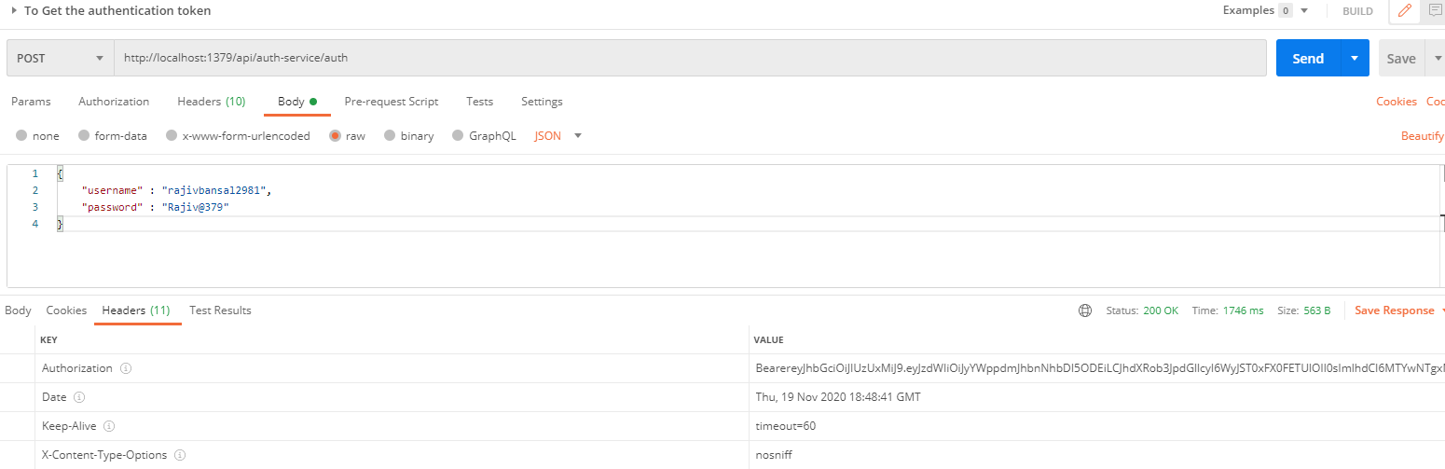

* + 1. **Now hit the darshan-mgmt-service to** save the donation by providing the token means authorization code (Bearer token) in the header received in above step
  + See the **Authorization** tab in the darshan request

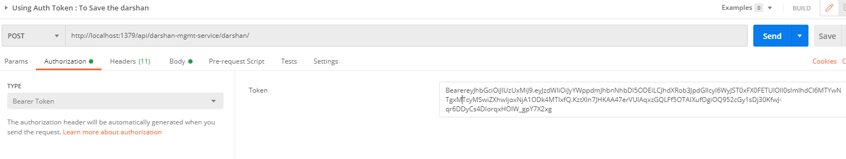

* + See the **Body** tab in the darshan request and response can be seen.

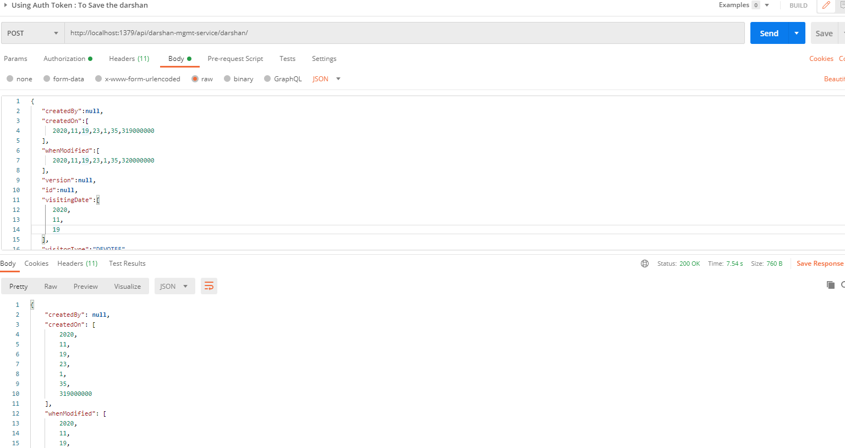

#### Testing in Kubernetes Environment

# Account Management Service

## Description

An Account Management Service is developed as microservice with the following functionalities:

* Manage the donations
  + Saving the donation

1. Validate the donor if donor id and donor type is provided in the request. Or If donor is Devotee and its id does not exist in the request.
2. Validate the project exists.
3. Donation request is valid otherwise error message should be triggered for the user.
4. Creating the donor if required: If donor is devotee and its id does not exist it means we need to create the devotee record first then will save the donation.
5. Saving the donation.
   * Updating the donation
   * Find the donation based on the id
   * Delete the donation
   * Saving the donation in bulk

* Manage the expenses:
  + Saving the expense
    1. Validate the project exists.
  + Saving the expense in bulk
  + Updating the expense
  + Delete the expense
  + Find the expense by id

## Entity Relationship Diagram

## Class Diagram

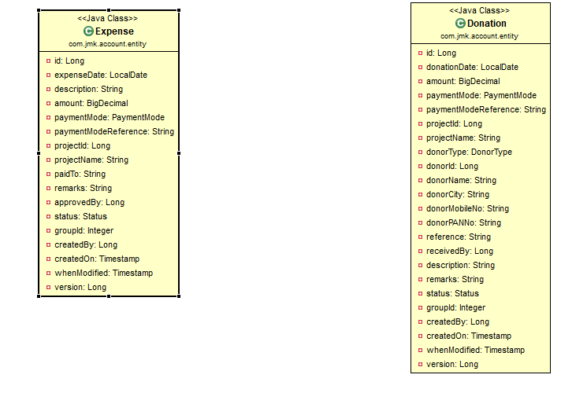

## Use Case Diagram

A use case diagram is a representation of user’s interaction with the system that shows the relationship between the user and the different use cases in which user is involved.

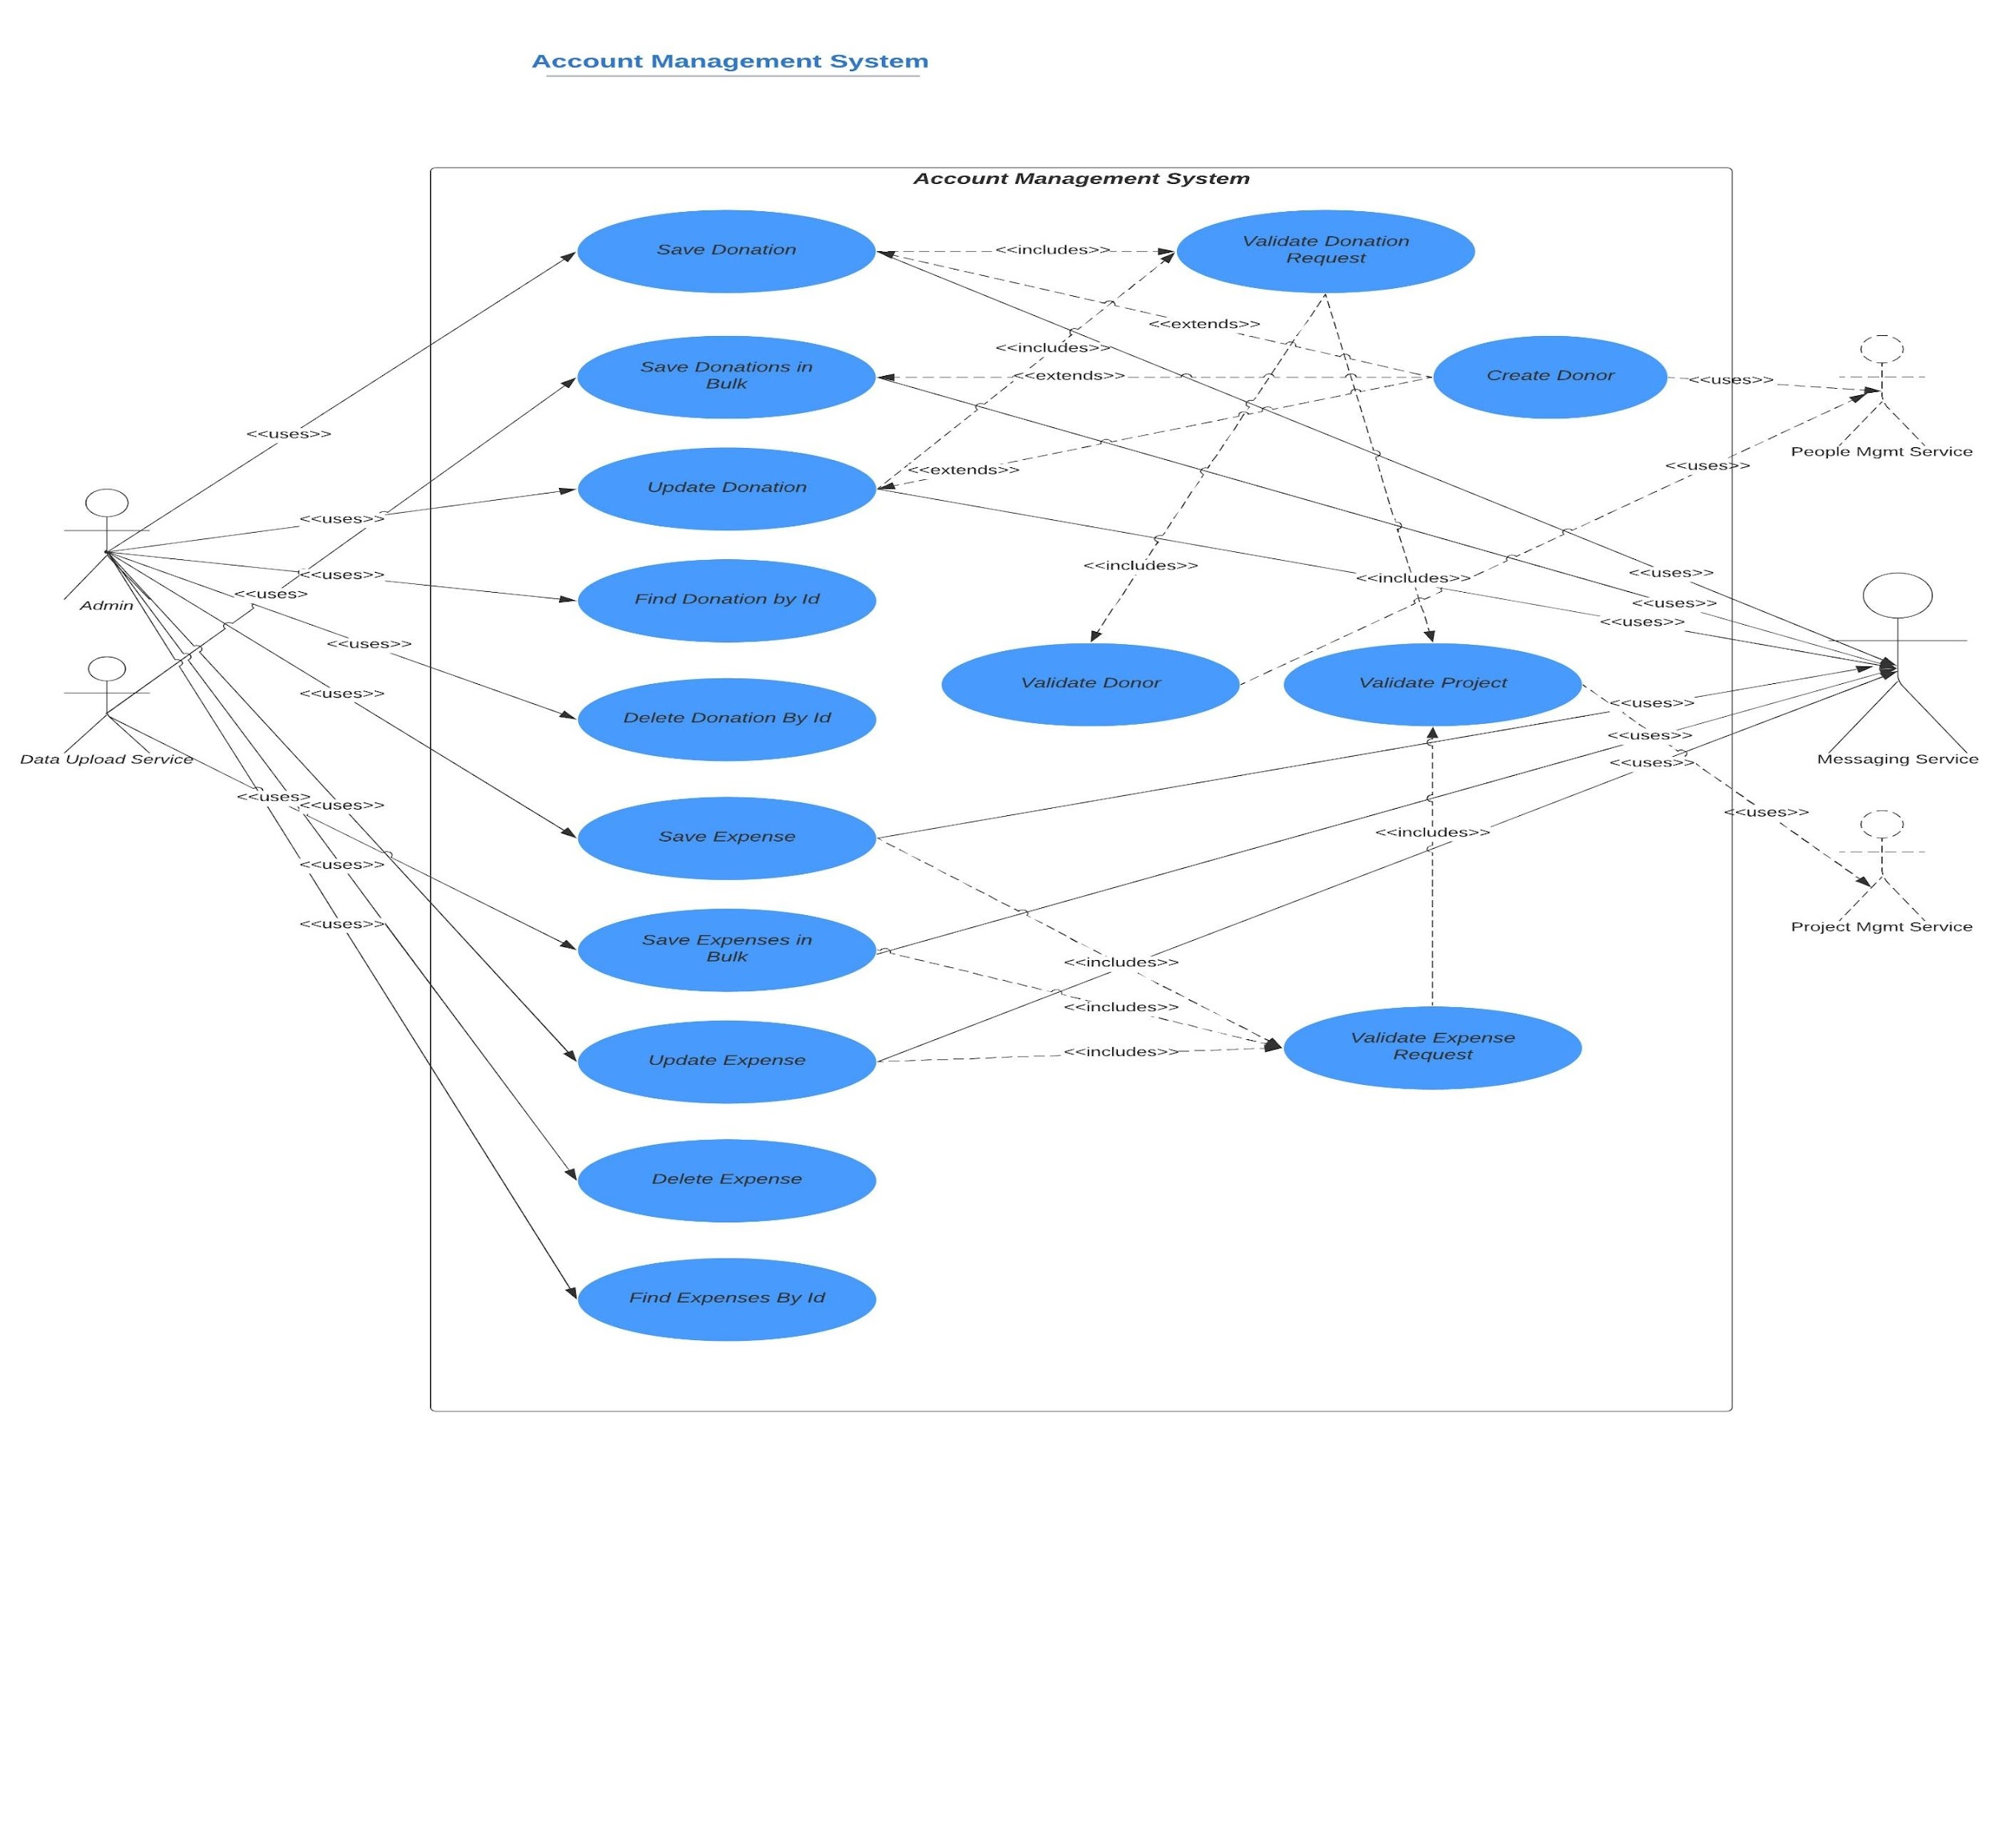

## Microservices Communication



Synch REST Request

Synch REST Request



Synch REST Request

Account Management System



Asynch REST Request



Asynch Kafka/RabbitMQ Request



## Use Case Details

### **Manage the donations**

#### Saving the donation

* Donation Request must be valid.
* If donation Request is valid
* Validate the donor if either of the following conditions met:
  + donor id and donor type are provided in the request and the donor should exists in the system. To check the donor existence, it will interact with **microservice**: people-mgmt-service.
  + If donor is Devotee and its id does not exist in the request.
* Validate the project exists. To check the project existence, it will interact with **microservice**: project-mgmt-service.
* Else If Donation Request Not Valid
* Error message should be triggered for the user.
* Creating the donor if required. If donor is devotee and its id does not exist it means Devotee is new and we need to create the devotee by interacting **microservice**: people-mgmt-service.
* Save the donation and return the saved Donation result.

#### Saving the donations in bulk

* Donation Request must be valid.
* If donation Request is valid
* Validate the donor if either of the following conditions met:
  + donor id and donor type are provided in the request and the donor should exists in the system. To check the donor existence, it will interact with **microservice**: people-mgmt-service.
  + If donor is Devotee and its id does not exist in the request.
* Validate the project exists. To check the project existence, it will interact with **microservice**: project-mgmt-service.
* Else If Donation Request Not Valid
* Error message should be triggered for the user.
* Creating the donor if required. If donor is devotee and its id does not exist it means Devotee is new and we need to create the devotee by interacting **microservice**: people-mgmt-service.
* Save the donation and return the saved Donation result.

#### Update the donation

* Donation Request must be valid.
* If donation Request is valid
* Validate the donor existence:
  + donor id and donor type are provided in the request and the donor should exists in the system. To check the donor existence, it will interact with **microservice**: people-mgmt-service.
* Validate the project exists. To check the project existence, it will interact with **microservice**: project-mgmt-service.
* Else If Donation Request Not Valid
* Error message should be triggered for the user.
* Update the donation request and return the updated Donation result.

#### Find the donation results based on the Id

To get the donation results by providing donation id.

#### Delete the donation based on the Id

To delete the donation by providing the donation id.

### **Manage the expenses**

#### Saving the expense

* Expense Request must be valid.
* If expense Request is valid
* Validate the donor if either of the following conditions met:
  + donor id and donor type are provided in the request and the donor should exists in the system. To check the donor existence, it will interact with **microservice**: people-mgmt-service.
  + If donor is Devotee and its id does not exist in the request.
* Validate the project exists. To check the project existence, it will interact with **microservice**: project-mgmt-service.
* Else If Donation Request Not Valid
* Error message should be triggered for the user.
* Creating the donor if required. If donor is devotee and its id does not exist it means Devotee is new and we need to create the devotee by interacting **microservice**: people-mgmt-service.
* Save the donation and return the saved Donation result.

#### Saving the expenses in bulk

* Donation Request must be valid.
* If donation Request is valid
* Validate the donor if either of the following conditions met:
  + donor id and donor type are provided in the request and the donor should exists in the system. To check the donor existence, it will interact with **microservice**: people-mgmt-service.
  + If donor is Devotee and its id does not exist in the request.
* Validate the project exists. To check the project existence, it will interact with **microservice**: project-mgmt-service.
* Else If Donation Request Not Valid
* Error message should be triggered for the user.
* Creating the donor if required. If donor is devotee and its id does not exist it means Devotee is new and we need to create the devotee by interacting **microservice**: people-mgmt-service.
* Save the donation and return the saved Donation result.

#### Update the expense

* Donation Request must be valid.
* If donation Request is valid
* Validate the donor existence:
  + donor id and donor type are provided in the request and the donor should exists in the system. To check the donor existence, it will interact with **microservice**: people-mgmt-service.
* Validate the project exists. To check the project existence, it will interact with **microservice**: project-mgmt-service.
* Else If Donation Request Not Valid
* Error message should be triggered for the user.
* Update the donation request and return the updated Donation result.

#### Find the expense results based on the Id

#### Delete the expense based on the Id

## Use Case Implementation

### Coding

1. Follow the document to implement account-service: **DemoProjectWork-member-mgmt-service.doc** along with the following changes:

|  |  |
| --- | --- |
| Database/Schema Name | account\_db |
| User name | bjjd |
| Password | bjjd\_379 |

**Commands:**

Connect with the root with the following credentials in MySQL database command line or UI

User Id: root

Password: bjjd

* create database account\_db;
* create user 'bjjd'@'%' identified by 'bjjd\_379';
* grant all on account\_db.\* to 'bjjd'@'%';
* grant SELECT,INSERT,UPDATE,DELETE,CREATE,index,drop,ALTER,create temporary tables,references ON darshan\_db.\* to 'bjjd'@'%';
* Use the following document related to the swagger, database scripts, ER diagram of Users:

  

* mvn --encrypt-master-password rajiv379
* Add the following dependencies in the pom.xml with the following considerations:

1. bjjd-microservices Parent: It contains common dependencies of Spring Boot, Spring Cloud and kubernetes etc.
2. Common-service: It will keep all the dto models, exception handling and common configurations.
3. Sql-connector: to connect with the MySQL database.
4. jib-maven-plugin: A Maven plugin for building docker container images for your Java applications and pushed to the docker hub.

<project xmlns=*"http://maven.apache.org/POM/4.0.0"*

xmlns:xsi=*"http://www.w3.org/2001/XMLSchema-instance"*

xsi:schemaLocation=*"http://maven.apache.org/POM/4.0.0 http://maven.apache.org/maven-v4\_0\_0.xsd"*>

<modelVersion>4.0.0</modelVersion>

<parent>

<groupId>com.jmk</groupId>

<artifactId>bjjd-microservices</artifactId>

<version>0.0.1.RELEASE</version>

</parent>

<artifactId>account-service</artifactId>

<packaging>jar</packaging>

<name>account-service</name>

<dependencies>

<dependency>

<groupId>com.github.joschi.jackson</groupId>

<artifactId>jackson-datatype-threetenbp</artifactId>

<version>2.6.4</version>

</dependency>

<!-- Bean Validation API support -->

<dependency>

<groupId>javax.validation</groupId>

<artifactId>validation-api</artifactId>

</dependency>

<dependency>

<groupId>com.jmk</groupId>

<artifactId>common-service</artifactId>

<version>${jmk-version}</version>

</dependency>

<!-- Starter for using Spring Data JPA with Hibernate to store and retrieve

data in a relational database. -->

<dependency>

<groupId>org.springframework.boot</groupId>

<artifactId>spring-boot-starter-data-jpa</artifactId>

</dependency>

<!--MySQL provides connectivity -->

<dependency>

<groupId>mysql</groupId>

<artifactId>mysql-connector-java</artifactId>

<version>8.0.25</version><!--$NO-MVN-MAN-VER$ -->

</dependency>

</dependencies>

<build>

<plugins>

<plugin>

<groupId>com.google.cloud.tools</groupId>

<artifactId>jib-maven-plugin</artifactId>

<version>${jib-maven-plugin.version}</version>

<configuration>

<to>

<image>registry.hub.docker.com/rajivbansal2981/account-service:${jmk-version}</image>

<auth>

<username>rajivbansal2981</username>

<password>rajiv379</password>

</auth>

</to>

</configuration>

</plugin>

</plugins>

</build>

</project>

* Main application.properties file which can further refer the following
  1. application-dev.properties
  2. application-prod.properties
* application.properties : @spring.profiles.active@ determines which properties file will be referred based on the maven profile: dev or prod

There will be an application.properties file but it will have the following minimum details:

* + - Name of the application
    - Active Default Profile
    - Cloud Config server URI with port

#Application Name

spring.application.name=account-service

#Active Profile - will relate to development properties file in the server. If this property is absent

#then,default profile will be activated which is the property file without any environment name at the end.

spring.profiles.active=@spring.profiles.active@

#Setting cloud config server uri with port

spring.cloud.config.uri=http://localhost:8888

* application-dev.properties moved to the git repository: **bjjd-config-server-git-repo** and will be selected if maven profile is dev

#Application Name

spring.application.name=account-service

#Port of the application

server.port=7379

server.servlet.context-path=/api/account-service

#It is worth mentioning that user-service acts as a Eureka client. So, we give it a name, port, and link to Eureka server

# eureka server url

eureka.client.service-url.default-zone=http://localhost:8761/eureka

#Spring profile

spring.profiles.active=dev

#Feign Client properties

feign.client.config.default.connectTimeout: 16000000

feign.client.config.default.readTimeout: 16000000

#To disable the Kubernetes Discovery client

#spring.cloud.kubernetes.enabled=false

#spring.cloud.kubernetes.discovery.include-not-ready-addresses=true

spring.sleuth.sampler.probability = 1.0

spring.jackson.date-format=com.jmk.user.swagger.RFC3339DateFormat

spring.jackson.serialization.WRITE\_DATES\_AS\_TIMESTAMPS=false

#Define properties related to JPA

spring.jpa.hibernate.ddl-auto=create

spring.datasource.url=jdbc:mysql://localhost:3306/account\_db

spring.datasource.username=bjjd

spring.datasource.password=bjjd\_379

#Optional

spring.datasource.tomcat.max-wait=20000

spring.datasource.tomcat.max-active=50

spring.datasource.tomcat.max-idle=20

spring.datasource.tomcat.min-idle=15

#Below line is commented as it takes by default: org.hibernate.dialect.MySQL5Dialect

#spring.jpa.properties.hibernate.dialect = org.hibernate.dialect.MySQL5Dialect

spring.jpa.properties.hibernate.id.new\_generator\_mappings = false

spring.jpa.properties.hibernate.format\_sql = true

logging.level.org.hibernate.SQL=DEBUG

logging.level.org.hibernate.type.descriptor.sql.BasicBinder=TRACE

logstash.host=localhost

logstash.queue-size=1000

logstash.port=5000

* application-prod.properties: It will be selected if maven profile is prod.
  1. Eureka Clients registrations with Eureka server need to be disabled in Kubernetes.
  2. Add client option to your mysql-connector allowPublicKeyRetrieval=true to allow the client to automatically request the public key from the server. Note that AllowPublicKeyRetrieval=True could allow a malicious proxy to perform a MITM attack to get the plaintext password, so it is False by default and must be explicitly enabled.
  3. Adding useSSL=false when you use it for testing/develop purposes

#Name of the application

spring.application.name=account-service

#Port of the application

server.port=7379

#Spring profile

spring.profiles.active=${SPRING\_ACTIVE\_PROFILE:prod}

spring.cloud.kubernetes.discovery.all-namespaces=true

#It is worth mentioning that user-service acts as a Eureka client. So, we give it a name, port, and link to Eureka server

# eureka server url

#eureka.client.service-url.default-zone=http://localhost:8761/eureka

eureka.client.enabled=false

eureka.client.serviceUrl.registerWithEureka=false

#Feign Client properties

feign.client.config.default.connectTimeout: 16000000

feign.client.config.default.readTimeout: 16000000

spring.sleuth.sampler.probability = 1.0

server.servlet.context-path=/api/account-service

spring.jackson.date-format=com.jmk.user.swagger.RFC3339DateFormat

spring.jackson.serialization.WRITE\_DATES\_AS\_TIMESTAMPS=false

#Define properties related to JPA

spring.jpa.hibernate.ddl-auto=create

spring.datasource.url=jdbc:mysql://${DB\_HOSTNAME:localhost}:${DB\_PORT:3306}/${DB\_NAME:account\_db}?allowPublicKeyRetrieval=true&useSSL=false

spring.datasource.username=${DB\_USERNAME:bjjd}

spring.datasource.password=${DB\_PASSWORD:bjjd\_379}

#Optional

spring.datasource.tomcat.max-wait=20000

spring.datasource.tomcat.max-active=50

spring.datasource.tomcat.max-idle=20

spring.datasource.tomcat.min-idle=15

#Below line is commented as it takes by default: org.hibernate.dialect.MySQL5Dialect

spring.jpa.properties.hibernate.dialect = org.hibernate.dialect.MySQL5Dialect

spring.jpa.properties.hibernate.id.new\_generator\_mappings = false

spring.jpa.properties.hibernate.format\_sql = true

logging.level.org.hibernate.SQL=DEBUG

logging.level.org.hibernate.type.descriptor.sql.BasicBinder=TRACE

1. Rename the package of io.swagger to com.jmk.account
2. Rename and refactor the Swagger2SpringBoot.java to DarshanServiceApplication.java with the following details:
   * Enable Discovery Client so that it can register with Eureka Server and it supports Kubernetes Discovery System.
   * Enable FeignClient to interact with user-mgmt-service
   * Enable RibbonClient
   * Enable JpaRepositories

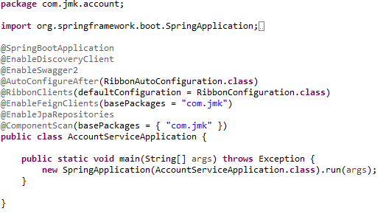

* DonationAPI and DonationAPIController API
  1. DonationAPI

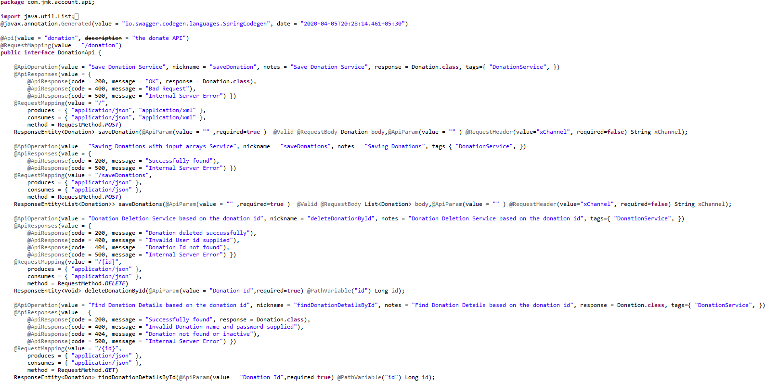

* 1. DonationAPIController

DonationApiController Class: In this class, when saving donation, we will perform the following activities:

* Validate the donor if donor id and donor type is provided in the request. Or If donor is Devotee and its id does not exist in the request.
* Validate the project exists.
* Donation request is valid otherwise error message should be triggered for the user.
* Creating the donor if required: If donor is devotee and its id does not exist it means we need to create the devotee record first then will save the donation.
* Saving the donation.

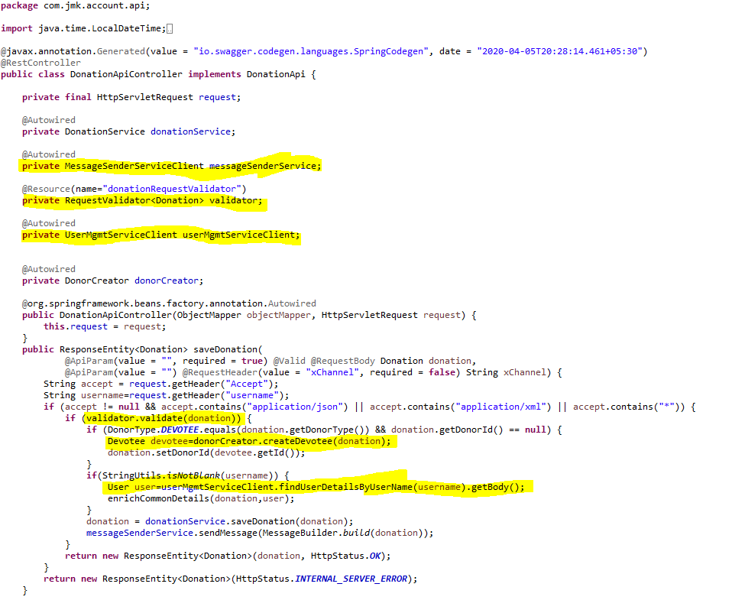

* ExpenseApi and ExpenseApiController API
  1. ExpenseApi

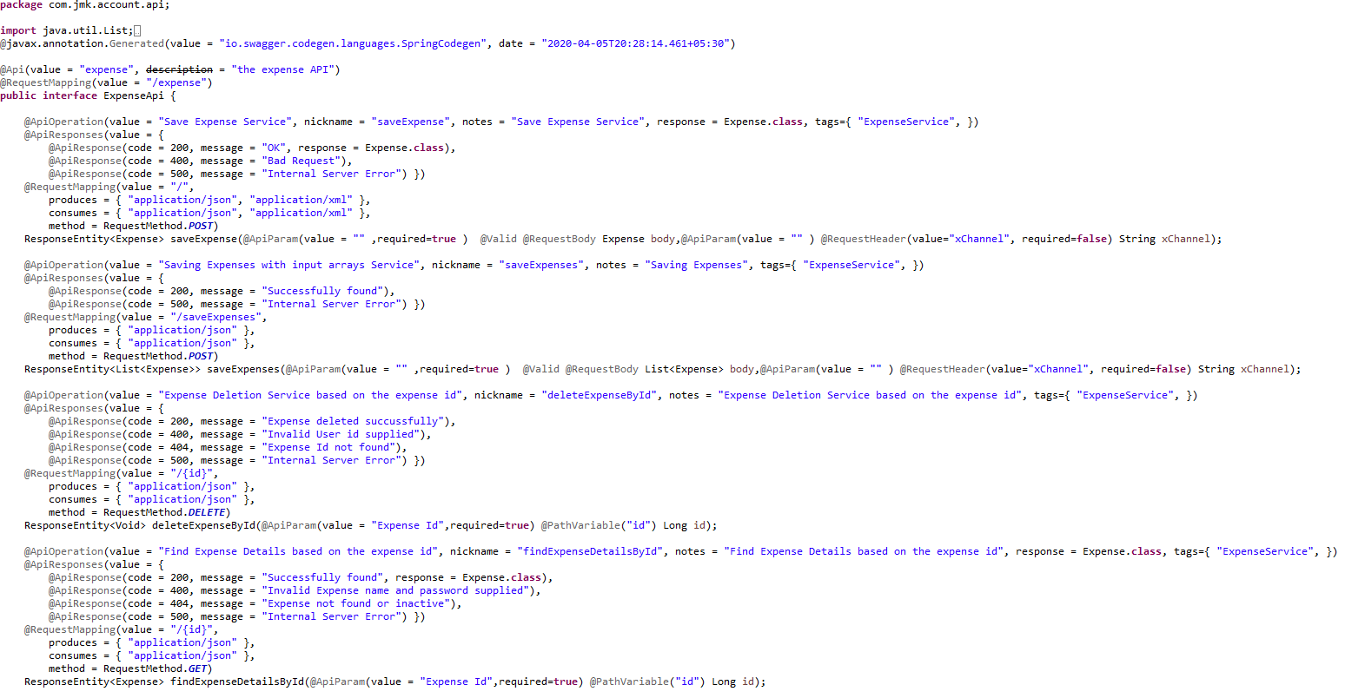

* 1. ExpenseApiController: while saving expense, validating the project

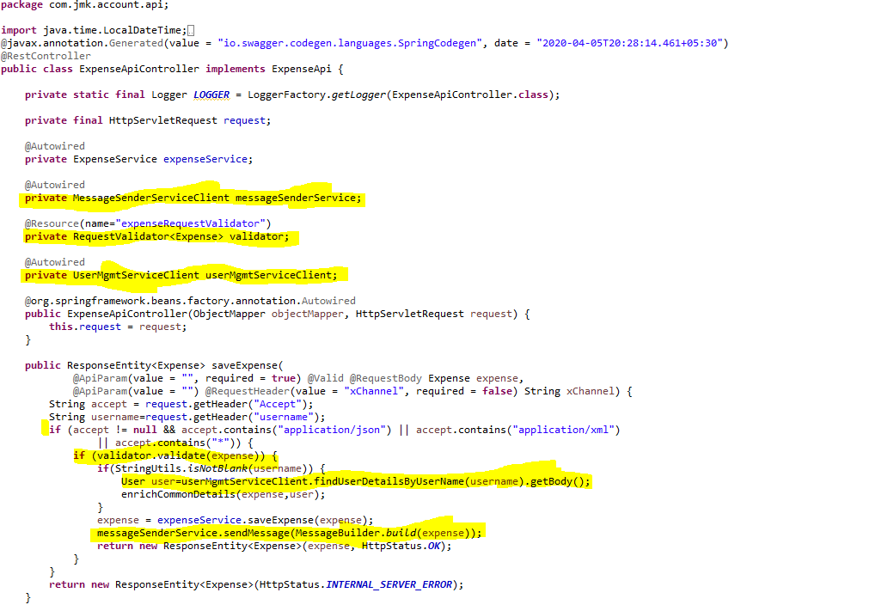

1. Feign Clients
   * UserServiceClient – Feign Client for communicating user-service

Feign dynamically generates the implementation of the interface we created, so Feign has to know which service to call beforehand. That's why we need to give a name for the interface, which is the {Service-Id} of UserServiceClient. Now, Feign contacts the Eureka server with this Service Id, resolves the actual IP/hostname of the UserServiceClient, and calls the URL provided in Request Mapping.

To send HTTP Request to a destination **user-service** Microservice we will need to create a Feign Client interface. Please note the use of @FeignClient annotation which accepts the name user-mgmt-service under which the destination Microservice is registered with Eureka Discovery Service.

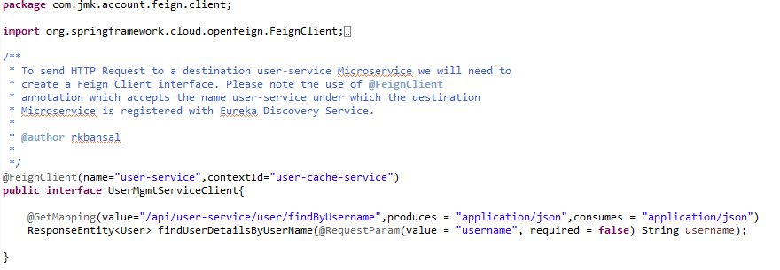

* **MessageSenderServiceClient**: to interact with message-sender-service to send the message to visitor.

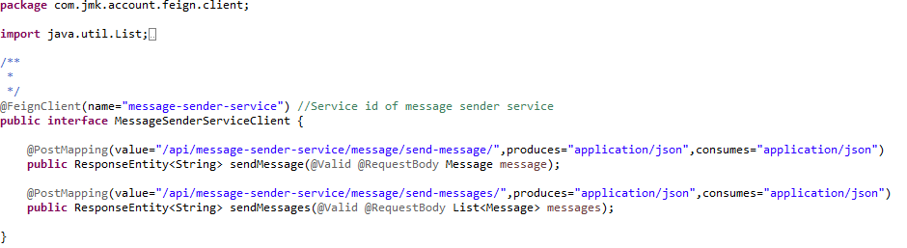

* + **PeopleMgmtServiceClient**: to interact with people-mgmt-service to get the details of devotee, member and sevadar.

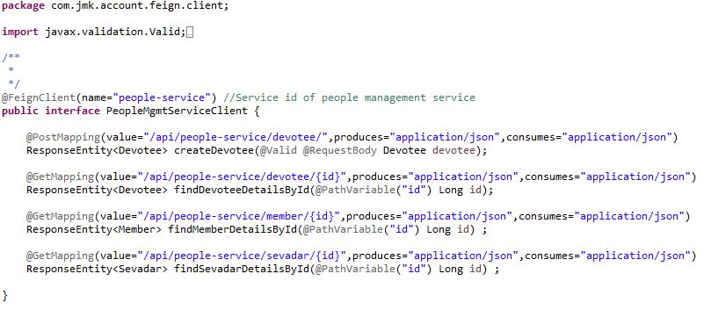

* + **ProjectMgmtServiceClient**: to validate the project exists or not.

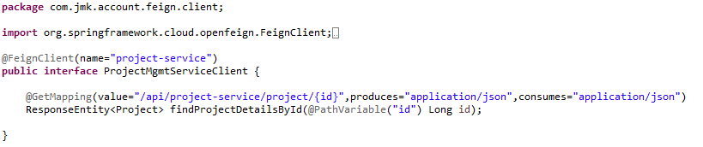

* + RequestValidator and DarshanRequestValidator: Create the **RequestValidator** to validate the donation request where we will validate the visitor by invoking the people-mgmt-service using feign client.
  + RequestValidator

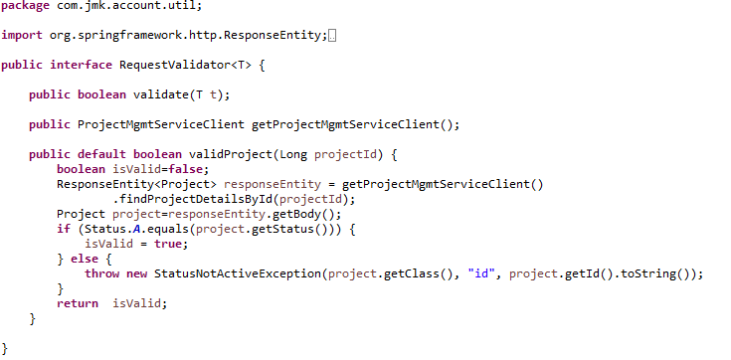

DonationRequestValidator

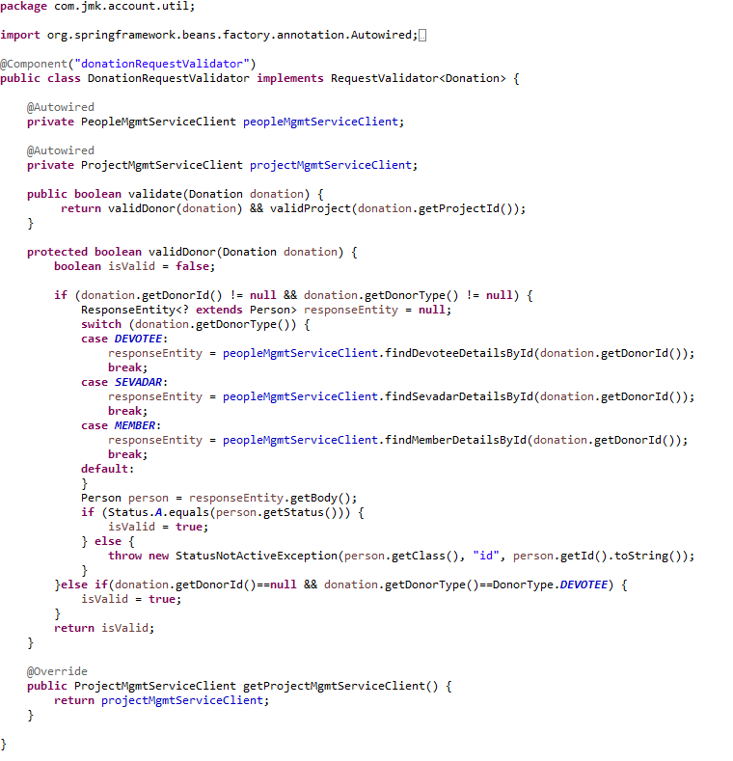

1. Create VisitorCreator class to create the donor by invoking the people-mgmt-service using feign client.



1. If we get an unexpected surprise… The discovery across all namespaces does not work for the Ribbon client. It only works for DiscoveryClient. I think that Ribbon auto-configuration should respect the property spring.cloud.kubernetes.discovery.all-namespaces, but in that case we don’t have any other choice than prepare a workaround. Our workaround is to override Ribbon client auto-configuration provided within Spring Cloud Kubernetes. We are using DiscoveryClient directly for it as shown below.



1. DarshanService and DarshanServiceImpl:

DarshanMgmtService



DarshanMgmtServiceImpl



1. DarshanRepository.java



1. Create the model and entities using Lombok.

@**JsonProperty** is suitable for conversion during **serialization**.

@**ApiModelProperty** is **used** for interface document display.

**@Data //It is combination of @ToString, @EqualsAndHashCode ,@Getter,@Setter and @RequiredArgsConstructor**

* Person Entity Class



* Made changes in the SwaggerDocumentationConfig



* Made changes in the Swagger’s HomeController



* After running the application, should be visible following functions for the following url: <http://localhost:4379/api/darshan-mgmt-service/swagger-ui.html>

Or

<http://localhost:4379/api/darshan-mgmt-service/api-docs>



### Testing

#### Junit Testing

Test the Darshan Api using JUnit



#### Testing in Dev Environment

* Run the application as **Spring Boot App** in the following order
  + ConfigServerApplication
  + EurekaServerApplication
  + UserServiceApplication
  + AuthServiceApplication
  + ZuulGatewayApplication
  + PeopleServiceApplication
  + DarshanServiceApplication
* Open the browser of Eureka Server at localhost:8761, you should see the all the microservices running and enter the url: <http://localhost:8761/>



* Testing
  + Without authentication means directly hitting the darshan-mgmt-service running on 4379 and save the darshan details



* + With authentication means every request to darshan-mgmt-service microservice will be hit via gateway running 1379
    - with authentication means every request to darshan-mgmt-service microservice will be hit via gateway running on 1379
      * saving darshan details based on the id but without token means no authorization code (Bearer token) in the header will give the error.



* Saving darshan with token means authorization code (Bearer token) in the header will be provided using authentication service
  + 1. **To get authentication code in response header using authentication service**



* + 1. **Now hit the darshan-mgmt-service to** save the donation by providing the token means authorization code (Bearer token) in the header received in above step
  + See the **Authorization** tab in the darshan request



* + See the **Body** tab in the darshan request and response can be seen.



#### Testing in Kubernetes Environment

# Data Upload Service

## Description

## Entity Relationship Diagram

## Class Diagram

## Use Case Diagram

## Use Case Details

# Messaging Sender Service

## Description

## Entity Relationship Diagram

## Class Diagram

## Use Case Diagram

## Use Case Details

# Kafka Producer Service

## Description

## Entity Relationship Diagram

## Class Diagram

## Use Case Diagram

## Use Case Details

# Kafka Consumer Service

## Description

## Entity Relationship Diagram

## Class Diagram

## Use Case Diagram

## Use Case Details

# Other

## Get LoggedInUser Details in other microservices

Please follow the steps to get the user details in other microservices:

* Add pre type Filter in Zuul-gateway application: CurrentUserAuthenticationFilter

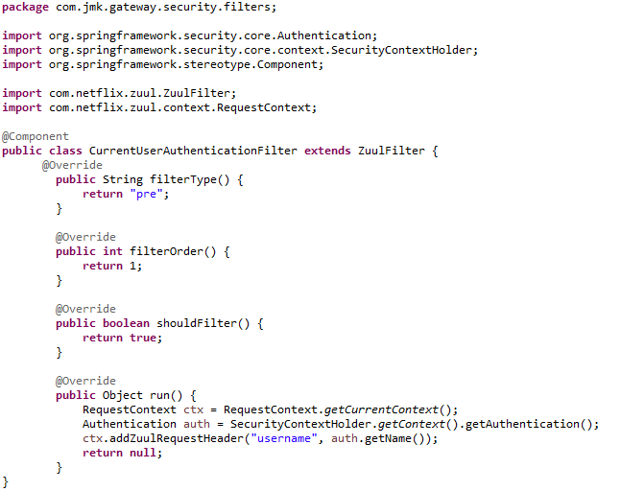

* Now we can retrieve the username by fetching the request header details in any other microservice. And based on the username, we can retrieve the details of user anytime by communicating user-mgmt-service using feign client implemented by cache-service. Please refer cache-service to see the implementation of UserCache and its communication with user-mgmt-service using feign client.

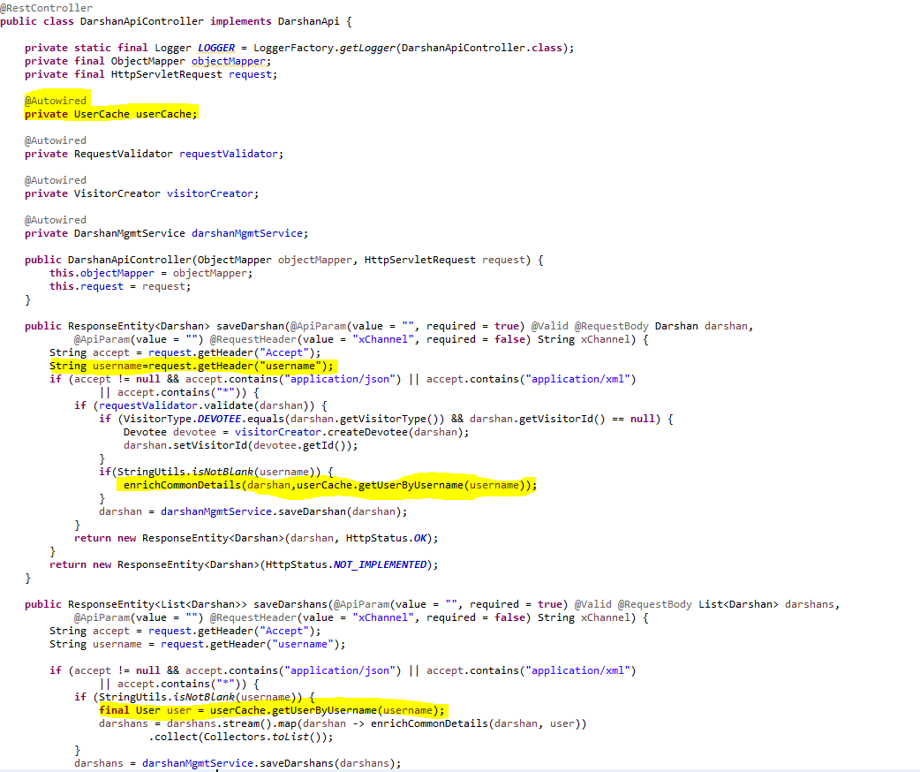

## Cache using Hazelcast (Embedded Distributed Cache)

We have used Hazelcast for the embedded distributed cache in our project.

Hazelcast IMDG is a perfect fit for your (micro)services running on Kubernetes since it can be used in the embedded mode and therefore scale in and out together with your service replicas. This blog post presents a step-by-step description of how to embed Hazelcast into a Spring Boot application and deploy it in the Kubernetes cluster.

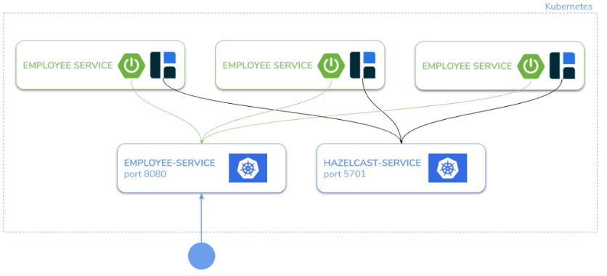

#### **Step 1: Configure Hazelcast to work on Kubernetes**

Make sure you have the following Maven dependencies:

<dependency>

<groupId>com.hazelcast</groupId>

<artifactId>hazelcast-all</artifactId>

<version>4.1</version>

</dependency>

#### **Step 2: Configure the Hazelcast Cache Configuration**

* Configure the Hazelcast Cache in the two ways:
  1. If application is running in the Dev environment



* 1. If application is running in the Kubernetes Environment (Prod)



* HazelcastCacheConfiguration.java file to configure the Hazelcast Cache.





#### **Step 3: Use of Hazelcast Cache:**

1. User Service Implementation should be exposed as following:
   1. Implementations of Hazelcast Cache.



#### **Step 4: Grant access to Kubernetes API**

Hazelcast uses Kubernetes API for auto-discovery. That is why you need to grant certain roles to your service account. You can do it by creating the following “rbac.yaml” file.

apiVersion: rbac.authorization.k8s.io/v1

kind: ClusterRoleBinding

metadata:

name: default-cluster

roleRef:

apiGroup: rbac.authorization.k8s.io

kind: ClusterRole

name: view

subjects:

- kind: ServiceAccount

name: default

namespace: bjjd-system

Then, apply it into your Kubernetes cluster.

kubectl apply -f rbac.yaml

#### **Step 5: Deploy the application**

Create “deployment.yaml” with Deployment and Service which will use the image you pushed to Docker Hub.

apiVersion: apps/v1

kind: Deployment

metadata:

name: user-service

labels:

app: user-service

spec:

replicas: 1

minReadySeconds: 45

selector:

matchLabels:

app: user-service

strategy:

rollingUpdate:

maxSurge: 25%

maxUnavailable: 25%

type: RollingUpdate

template:

metadata:

labels:

app: user-service

spec:

containers:

- name: user-service

image: rajivbansal2981/user-service:0.0.1.RELEASE

imagePullPolicy: Always #IfNotPresent

ports:

- name: http

containerPort: 3379 # The port that the container exposes

- name: multicast

containerPort: 5701 # The port that Hazelcast exposes

env:

- name: DB\_HOSTNAME

valueFrom:

configMapKeyRef:

name: user-service-configmap

key: database.hostname #MySQL db host name

- name: DB\_NAME

valueFrom:

configMapKeyRef:

name: user-service-configmap

key: database.name

- name: DB\_USERNAME

valueFrom:

configMapKeyRef:

name: user-service-configmap

key: database.username

- name: DB\_PASSWORD

valueFrom:

secretKeyRef:

name: user-service-secrets

key: database.password

- name: DB\_PORT

valueFrom:

configMapKeyRef:

name: user-service-configmap

key: database.port

- name: SPRING\_ACTIVE\_PROFILE

valueFrom:

configMapKeyRef:

name: user-service-configmap

key: spring.active.profile

restartPolicy: Always

terminationGracePeriodSeconds: 60

---

apiVersion: v1

kind: Service

metadata:

name: user-service

labels: #PODS

app: user-service

spec:

type: ClusterIP #NodePort or LoadBalancer or ClusterIP

selector:

app: user-service

ports:

- name: hazelcast

port: 5701

- name: app

port: 3379

Then, to deploy an application, run the following command:

kubectl apply -f deployment.yaml

#### **Step 6: Verify that the application works correctly**

You can check that the Deployment and Service were created.

$ kubectl get all

NAME READY STATUS RESTARTS AGE

pod/hazelcast-embedded-57f84c545b-64tnk 1/1 Running 0 2m

pod/hazelcast-embedded-57f84c545b-jjhcs 1/1 Running 0 45s

NAME TYPE CLUSTER-IP EXTERNAL-IP PORT(S) AGE

service/hazelcast-embedded LoadBalancer 10.19.251.145 104.154.43.142 5701:32302/TCP,8080:31613/TCP 2m

NAME DESIRED CURRENT UP-TO-DATE AVAILABLE AGE

deployment.extensions/hazelcast-embedded 2 2 2 2 2m

NAME DESIRED CURRENT READY AGE

replicaset.extensions/hazelcast-embedded-57f84c545b 2 2 2 2m

NAME DESIRED CURRENT UP-TO-DATE AVAILABLE AGE

deployment.apps/hazelcast-embedded 2 2 2 2 2m

NAME DESIRED CURRENT READY AGE

replicaset.apps/hazelcast-embedded-57f84c545b 2 2 2 2m

In the logs for PODs, you should see that the Hazelcast members formed a cluster.

$ kubectl logs pod/hazelcast-embedded-57f84c545b-jjhcs

...

Members {size:2, ver:4} [

Member [10.16.2.6]:5701 - 33076b61-e99d-46f2-b5c1-35e0e75f2311

Member [10.16.2.8]:5701 - 9ba9bb61-6e34-460a-9208-c5a644490107 this

]

...

Then, you can access the application, by its EXTERNAL-IP.

## Sleuth, Zipkin and ELK Stack with Filebeat

There are challenges in related to the creation of microservices based architecture is monitoring. Each microservice should be run on an environment isolated from the other microservices, so it does not share resources such as databases or log files with them.

Debugging becomes challenging in the microservices architecture. A request may go through a lot of microservices in its life cycle and hence, it becomes very difficult to keep a track of it: where it spent the most of its time, where some error occurred, etc.

The essential requirement for microservices architecture is relatively easy to access the call history, including the ability to look through the request propagation between multiple microservices.

There are some helpful third-party tools that can be used when creating microservices using such frameworks like Spring Boot and Spring Cloud libraries.

* **Spring Cloud Sleuth.** A library available as a part of the Spring Cloud project. It lets you track the progress of subsequent microservices by adding the appropriate headers to the HTTP requests. The library is based on the MDC (Mapped Diagnostic Context) concept, where you can easily extract values put to context and display them in the logs.
* **Zipkin.** A distributed tracing system that helps gather timing data for every request propagated between independent services. It has a simple management console where we can find a visualization of the time statistics generated by subsequent services.
* **Elastic Stack (ELK).** Elasticsearch, Logstash, and Kibana - three different tools usually used together. They are used for searching, analysing, and visualizing log data in real-time.

### **Distributed Tracing: Spring Cloud Sleuth and Zipkin**

**Spring Cloud Sleuth** and **Zipkin** are useful tools when one microservice talks to another microservice hosted in a different location (i.e., each service has its log). This approach requires the extensive use of correlation id which helps to map the request chaining.

Cloud Sleuth generates the attach the trace id, span id to the logs so that it can be used by tools like Zipkin and ELK for storage and analysis.

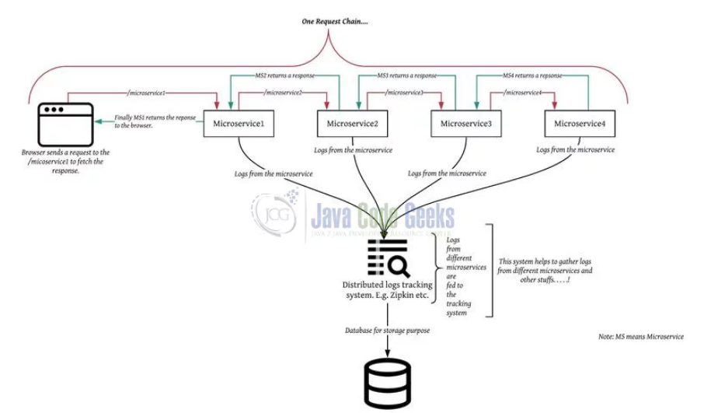

#### Spring Cloud Sleuth

Spring Cloud Sleuth provides the functionality of distributed tracing in Spring microservices. It assigns a **unique Id** to each request which remains the same throughout the life cycle of that request as it propagates to multiple microservices. It is known as **traceId**.

It automatically creates a trace id corresponding to each request and as soon as it moves from one microservice to another, **a new span id is created**.

It is used to generate the *trace id*, *span id* and add these information to the service calls in the headers and MDC, so that It can be used by tools like Zipkin and [ELK](https://howtodoinjava.com/microservices/elk-stack-tutorial-example/) etc. to store, index and process log files.

**Some Important Terminologies:**

Sleuth borrows its terminologies from [Dapper](https://research.google/pubs/pub36356/). Dapper is Google’s large scale distributed systems tracing infrastructure. It is an **annotation-based distributed tracing** tool. It was originally created to understand the system behaviour from a search request.

* **Trace:**It is a collection/set of spans in a tree-like structure. There is one trace per request. Each **trace is identified with a 64-bit unique ID**.
* **Span:**It represents a basic unit of work. It has a **name and time attributes** associated with it. It can also be said that it represents a single operation performed on the request within a trace. Each span is identified with a 64-bit unique ID. In addition to it, a **span also consists of tags and logs**.
  + **Tags** are key-value pairs that **store information** corresponding to the whole span.
  + **Logs** are key-value pairs that correspond to any **event within that span**. The initial span that starts a trace is known as the **root span**. The value of span id of that span is equal to trace id.

The diagram below shows how Spring Cloud Sleuth appends information to requests and the flow of the request.

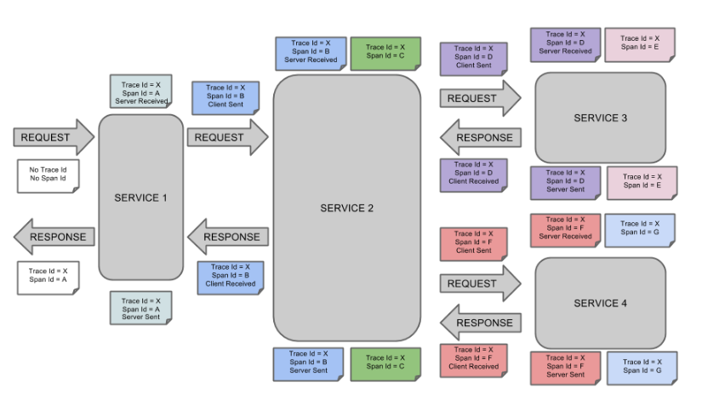

It adds **application-name**, **traceId**, **spanId** and **exportable** into Slf4J MDC. We can see it whenever we log anything on the console. Here is an example of a log:

2020-03-29 12:33:24.829 INFO [micro1,c08a0a7dc3d1046c,c08a0a7dc3d1046c,true] 1044 --- [nio-8080-exec-2] ...

Following are the entries from the MDC:

* **appname:**It represents the name of the microservice, the log belongs to.
* **traceId:**It is a unique Id assigned to the request and is the same across all the microservices.
* **spanId:**It is a unique Id assigned to each operation.
* **exportable:**It is a boolean value and represents whether the log should be exported to **Zipkin** or not.

It also automatically injects and extracts trace related information into the request's header using **SpanInjector**and **SpanExtractor**and propagates context between the services so that **traceId**remains the same across the services. It also provides a way to create or continue spans and add tags and logs through annotations.

**Implementation:**

In order to use Sleuth, we just need to add this dependency in the **pom.xml** file of our application and it **will start creating spans for us**. We can see tracing related info in our logs. We have added this dependency in our parent pom.xml

<dependency>

    <groupId>org.springframework.cloud</groupId>

    <artifactId>spring-cloud-starter-sleuth</artifactId>

</dependency>

As it is from spring cloud family, once added to the CLASSPATH, it automatically integrated to the common communication channels like –

* requests made with the [RestTemplate](https://howtodoinjava.com/spring-boot2/resttemplate/spring-restful-client-resttemplate-example/) etc.
* requests that pass through a [Netflix Zuul](https://howtodoinjava.com/spring/spring-cloud/spring-cloud-api-gateway-zuul/) micro proxy
* HTTP headers received at [Spring MVC](https://howtodoinjava.com/spring-mvc-tutorial/) controllers
* requests over messaging technologies like Apache Kafka or RabbitMQ etc.

Now Spring Cloud Sleuth Setup is done. If anywhere we will log into the application. It can be shown in the logs.

**AOP Logger**

In order to generate logs, we are using Spring AOP. It will be used to generate logs around each method execution stating that the method has started and ended.

In our microservices, we have used Spring AOP Logger implemented in the common-service, so that it can be reused in the other microservices.

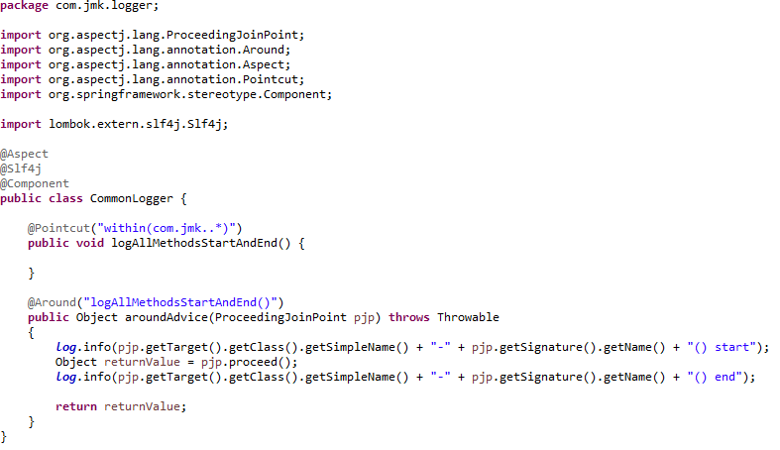

After running the application, can see the logs in the following format:



#### Zipkin

It is a distributed tracing system which provides a UI to see the traces and also allows to search traces using the **traceId**. It also shows the dependency graph of our microservices. By default, it uses in-memory storage for storing traces so as soon as we close it, the data will be lost.

##### Detail

Zipkin was originally developed at Twitter, based on a concept of a Google paper that described Google’s internally-built distributed app debugger – [dapper](https://research.google/pubs/pub36356/). It manages both the collection and lookup of this data. To use Zipkin, applications are instrumented to report timing data to it.

If you are troubleshooting latency problems or errors in ecosystem, you can filter or sort all traces based on the application, length of trace, annotation, or timestamp. By analysing these traces, you can decide which components are not performing as per expectations, and you can fix them.

Internally it has 4 modules –

1. **Collector** – Once any component sends the trace data arrives to Zipkin collector daemon, it is validated, stored, and indexed for lookups by the Zipkin collector.
2. **Storage** – This module store and index the lookup data in backend. [Cassandra](https://cassandra.apache.org/), [ElasticSearch](https://www.elastic.co/) and [MySQL](https://howtodoinjava.com/mysql/how-to-installuninstallexecute-mysql-as-windows-service/) are supported.
3. **Search** – This module provides a simple JSON API for finding and retrieving traces stored in backend. The primary consumer of this API is the Web UI.
4. **Web UI** – A very nice UI interface for viewing traces.

##### Zipkin Architecture

Every operation performed in the application that is being traced is usually generated on the client-side and starts with an outgoing http request. Several headers are added to this request in order to create unique IDs that are traceable along with the application. The Reporter is the component that is implemented inside each host of the tracked application and is in charge of sending the data to Zipkin. Reporters then send all traces to Zipkin collectors. The collector writes data to a data store(database). A query system provides an API for the UI component.

You can use either Cassandra or Elasticsearch for a scalable storage backend, as Zipkin supports them both. This storage is queried by the API used by the Zipkin UI.

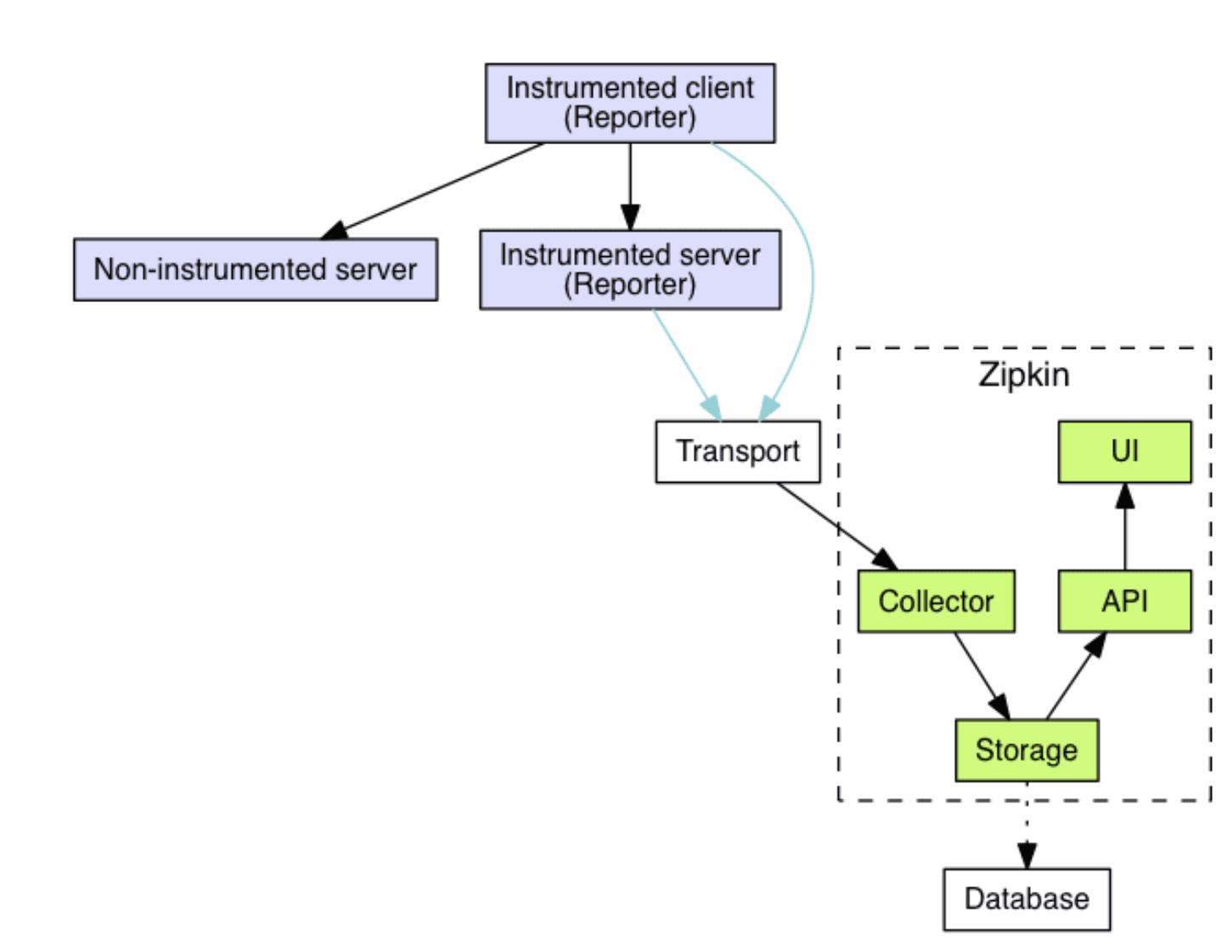

##### Implementation

Following are the steps to configure and run the Zipkin server:

1. Download Zipkin's jar file from the internet. Double click in order to run it. Go to **localhost:9411** which is the default port of Zipkin, you can see the Zipkin UI.



Open the command prompt and run the following command to run the Zipkin Server.

java -jar zipkin-server-2.23.2-exec.jar

Once Zipkin is started, we can see the Web UI at <http://localhost:9411/zipkin/>.

1. Add the dependency in parent pom.xml in dev profile and set the related property in application.properties

NOTE: in prod profile, we will not use below dependency as we will be using ISTIOS sidecar container for the same.

<dependency>

<groupId>org.springframework.cloud</groupId>

<artifactId>spring-cloud-starter-zipkin</artifactId>

<version>2.2.0.RELEASE</version>

</dependency>

Now again try running the microservices. Do you see any traces in Zipkin? I guess no. See the logs, **exportable is still false**. By default **Spring Cloud Sleuth sets all spans to non-exportable**. That means that traces appear in logs but not in any remote store. There's a property that we need to configure in the **application.properties** of our microservices: spring.sleuth.sampler.probability or spring.sleuth.sampler.percentage in previous versions whose values can be from **0.0** to **1.0** representing **how much percentage of spans must be exported**.

Let’s add this property in each microservice's **application.properties** file:

spring.sleuth.sampler.probability = 1.0

We can also configure the Zipkin's base URL if it is not running on the default port. Put this in the application.propertiesof our microservices:

spring.zipkin.baseUrl: https://192.168.99.100:9411/

Now, we can see a trace on Zipkin. You can explore it.

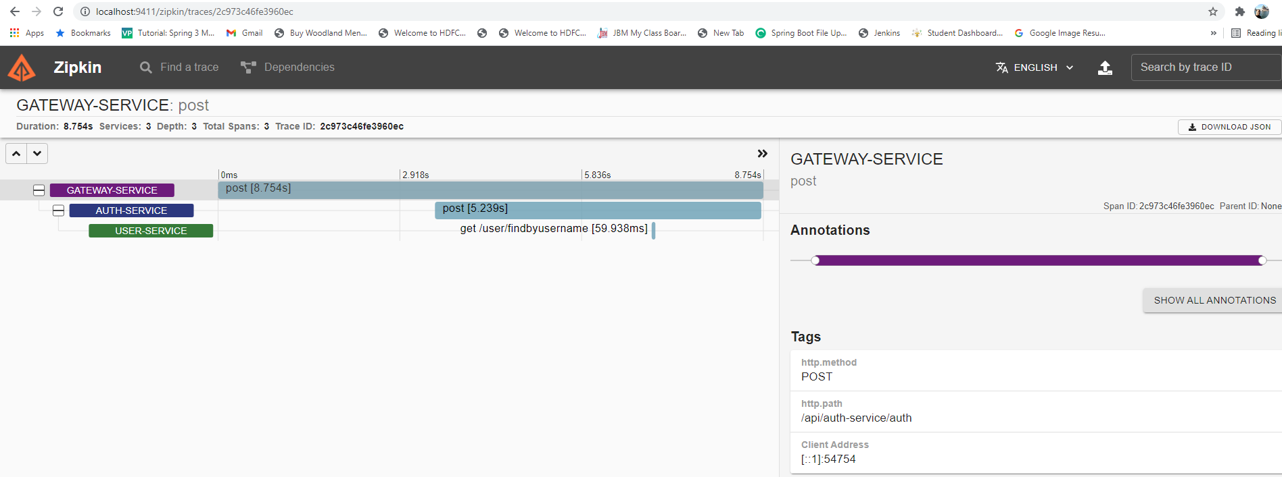

### **Centralized Logging: ELK Stack with File Beat**

The ELK Stack consists of three open-source products - Elasticsearch, Logstash, and Kibana from Elastic.

* **Elasticsearch**: is a NoSQL database that is based on the Lucene search engine. It is a distributed, JSON-based *search and analytics engine* designed for horizontal scalability, maximum reliability, and easy management. By default, it run on 9200 ports
* **Logstash**: It has been used to process logs from applications and send them to Elasticsearch. Logstash is a log pipeline tool that accepts inputs from various sources, executes different transformations, and exports the data to various targets. It is a dynamic data collection pipeline with an extensible plugin ecosystem and strong Elasticsearch synergy. By default, it run on 5000 ports.
* **Kibana**: is a visualization UI layer that works on top of Elasticsearch. It visualizes, Query and Filter the data stored in ElasticSearch store. By default, it run on 5601 ports.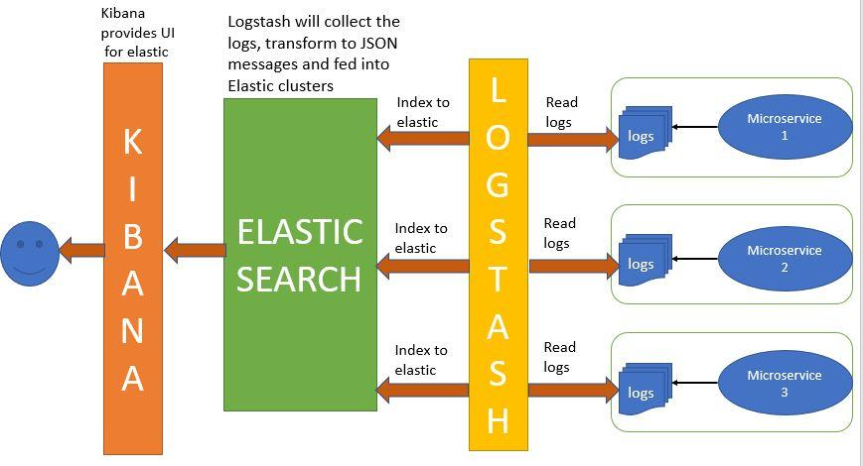

These three projects are used together for log analysis in various environments. So Logstash collects and parses logs, Elastic search indexes and store this information while Kibana provides a UI layer that provide actionable insights.

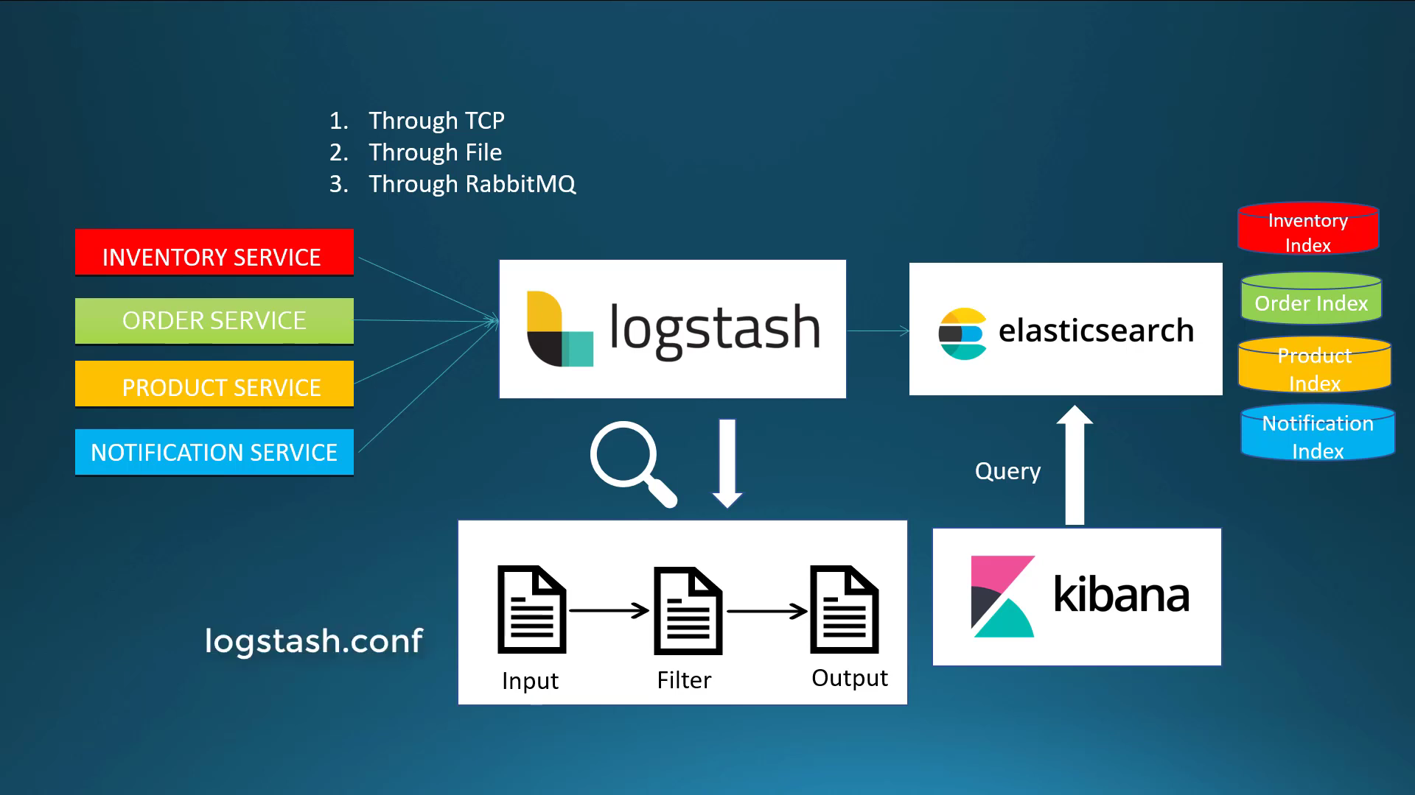

#### Logstash

Logstash is a log pipeline tool that accepts inputs from various sources, executes different transformations, and exports the data to various targets. It is a dynamic data collection pipeline with an extensible plugin ecosystem and strong Elasticsearch synergy.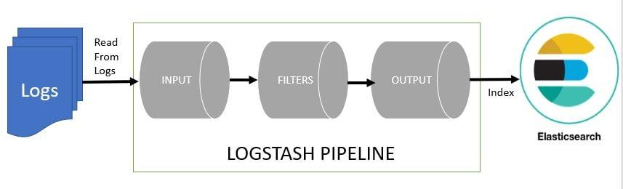

By default, it runs on 5000 ports.

A logstash configuration consists mainly on 3 stages:

* **Input**
  + The input section in the configuration file defines the input plugin to use. Each plugin has its own configuration options, which you should research before using. In our case it will be a json flow fetched from the logback of our microservices and we will be using the tcp plugin which will listen to any logs sent.
* **Filter**
  + The filter section in the configuration file defines what filter plugins we want to use, or in other words, what processing we want to apply to the logs. Each plugin has its own configuration options, which you should research before using.
* **Output**
  + The output section in the configuration file defines the destination to which we want to send the logs to (ElasticSearch for example). As before, each plugin has its own configuration options, which you should research before using.
* Download the latest version of logstash from [Logstash downloads](https://www.elastic.co/downloads/logstash).

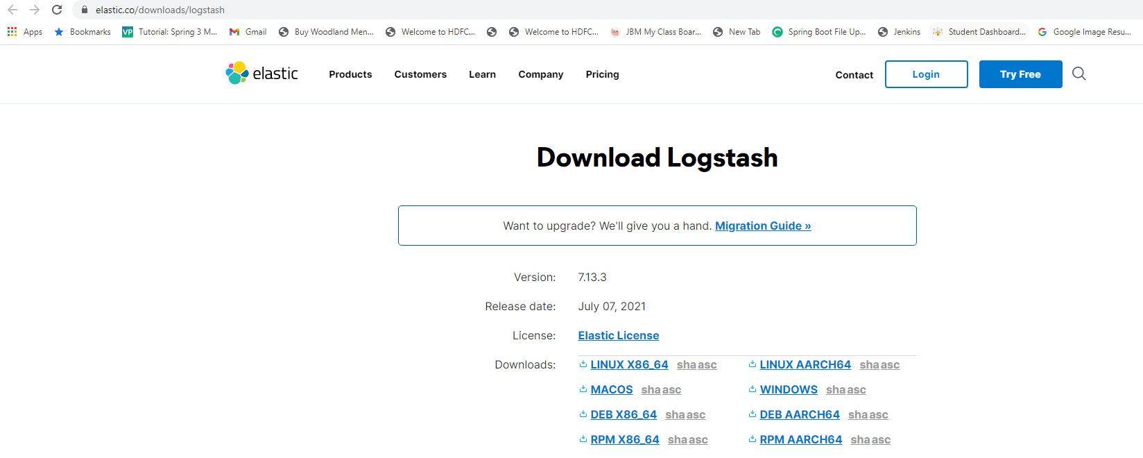

* Unzip it any folder. It will look as below:

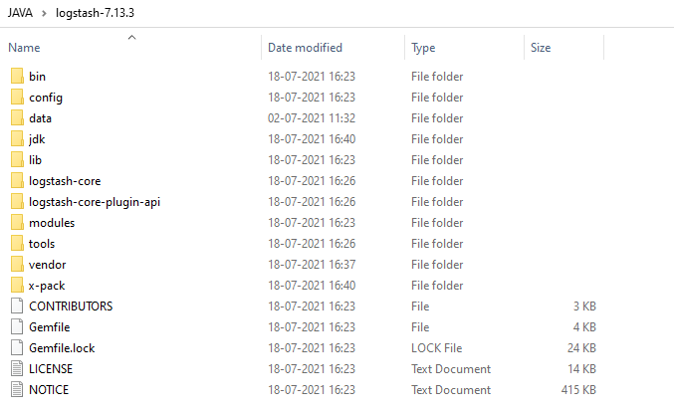

* Create one file logstash.conf as per [configuration instructions](https://www.elastic.co/guide/en/logstash/current/configuration.html) in F:\JAVA\logstash-7.13.3\config.

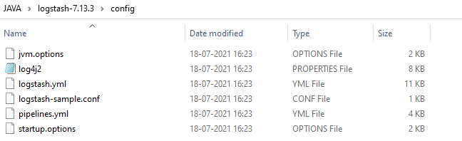

* Possible input types in logstash.conf. Logstash can read the log files over TCP, rabbit mq or log files.
  1. If we are reading the logs over TCP. Here we have deleted the filter part.

input {

tcp {

port => 5000

codec => "json"

}

}

output {

elasticsearch {

hosts => ["http://localhost:9200"]

index => "micro-%{appName}"

}

}

* 1. If we are reading the logs from log files (Not using in our microservices]

input {

file {

type => "java"

path => "C:/elk/spring-boot-elk.log"

codec => multiline {

pattern => "^%{YEAR}-%{MONTHNUM}-%{MONTHDAY} %{TIME}.\*"

negate => "true"

what => "previous"

}

}

}

filter {

#If log line contains tab character followed by 'at' then we will tag that entry as stacktrace

if [message] =~ "\tat" {

grok {

match => ["message", "^(\tat)"]

add\_tag => ["stacktrace"]

}

}

}

output {

stdout {

codec => rubydebug

}

# Sending properly parsed log events to elasticsearch

elasticsearch {

hosts => ["localhost:9200"]

}

}

* Run the logstash using the below command:
  + - Cd F:\JAVA\logstash-7.13.3\bin
    - .\logstash.bat -f ../config/logstash.conf

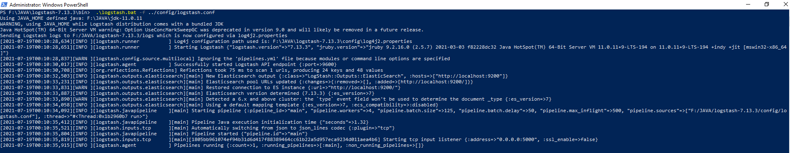

* It can be accessed at localhost:5000
* When using in microservices:
  1. Use logging Libraries like Log4J or Logback.
  2. We will use Logback as a logging framework in our microservices. Logback offers a faster implementation, provides more options for configuration, and more flexibility in archiving old log files.

To configure the logback, add the following dependency in parent pom.xml in dev profile.

NOTE: in prod profile, we will not use below dependency as we will be using ISTIOS sidecar container for the same.

<dependency>

<groupId>net.logstash.logback</groupId>

<artifactId>logstash-logback-encoder</artifactId>

<version>6.6</version>

</dependency>

* 1. Create the Logback configuration class: LogbackConfiguration OR logback-spring.xml in the resource folder.
     + Logback configuration class: LogbackConfiguration and it can be put in the common-service so that it can be referred by other microservices.

package com.jmk.common.logback.config;

import java.net.InetSocketAddress;

import org.slf4j.Logger;

import org.slf4j.LoggerFactory;

import org.springframework.beans.factory.annotation.Value;

import org.springframework.boot.context.properties.EnableConfigurationProperties;

import org.springframework.cloud.context.config.annotation.RefreshScope;

import org.springframework.context.annotation.Configuration;

import ch.qos.logback.classic.AsyncAppender;

import ch.qos.logback.classic.LoggerContext;

import ch.qos.logback.classic.spi.ILoggingEvent;

import ch.qos.logback.core.spi.DeferredProcessingAware;

import net.logstash.logback.appender.LogstashTcpSocketAppender;

import net.logstash.logback.composite.AbstractFieldJsonProvider;

import net.logstash.logback.composite.AbstractPatternJsonProvider;

import net.logstash.logback.composite.loggingevent.LogLevelJsonProvider;

import net.logstash.logback.composite.loggingevent.LoggingEventFormattedTimestampJsonProvider;

import net.logstash.logback.composite.loggingevent.LoggingEventPatternJsonProvider;

import net.logstash.logback.composite.loggingevent.MessageJsonProvider;

import net.logstash.logback.encoder.LoggingEventCompositeJsonEncoder;

@Configuration

@EnableConfigurationProperties

@RefreshScope

public class LogbackConfiguration {

private static final String LOGSTASH\_APPENDER\_NAME = "LOGSTASH";

private static final String ASYNC\_LOGSTASH\_APPENDER\_NAME = "ASYNC\_LOGSTASH";

private final Logger LOG = LoggerFactory.getLogger(LogbackConfiguration.class);

private final LoggerContext CONTEXT = (LoggerContext) LoggerFactory.getILoggerFactory();

private final String appName;

private final String logstashHost;

private final Integer logstashPort;

private final Integer logstashQueueSize;

public LogbackConfiguration(@Value("${spring.application.name}") String appName,

@Value("${logstash.host}") String logstashHost, @Value("${logstash.port}") Integer logstashPort,

@Value("${logstash.queue-size}") Integer logstashQueueSize) {

this.appName = appName;

this.logstashHost = logstashHost;

this.logstashPort = logstashPort;

this.logstashQueueSize = logstashQueueSize;

addLogstashAppender(CONTEXT);

}

private void addLogstashAppender(LoggerContext context) {

LOG.info("Initializing Logstash logging");

LogstashTcpSocketAppender logstashAppender = new LogstashTcpSocketAppender();

logstashAppender.setName(LOGSTASH\_APPENDER\_NAME);

logstashAppender.setContext(context);

logstashAppender.addDestinations(new InetSocketAddress(this.logstashHost, this.logstashPort));

LoggingEventCompositeJsonEncoder logstashJsonEncoder = new LoggingEventCompositeJsonEncoder();

logstashJsonEncoder.getProviders().addProvider(new LogLevelJsonProvider());

logstashJsonEncoder.getProviders().addProvider(new MessageJsonProvider());

logstashJsonEncoder.getProviders().addProvider(

withPattern(String.format("{ \"loglevel\": \"%s\" }", "INFO"), new LoggingEventPatternJsonProvider()));

logstashJsonEncoder.getProviders().addProvider(

withPattern(String.format("{ \"appName\": \"%s\" }", appName), new LoggingEventPatternJsonProvider()));

logstashJsonEncoder.getProviders()

.addProvider(withName("timestamp", new LoggingEventFormattedTimestampJsonProvider()));

logstashAppender.setEncoder(logstashJsonEncoder);

logstashAppender.start();

// Wrap the appender in an Async appender for performance

AsyncAppender asyncLogstashAppender = new AsyncAppender();

asyncLogstashAppender.setContext(context);

asyncLogstashAppender.setName(ASYNC\_LOGSTASH\_APPENDER\_NAME);

asyncLogstashAppender.setQueueSize(this.logstashQueueSize);

asyncLogstashAppender.addAppender(logstashAppender);

asyncLogstashAppender.start();

context.getLogger("ROOT").addAppender(asyncLogstashAppender);

}

private AbstractPatternJsonProvider<ILoggingEvent> withPattern(String pattern,

AbstractPatternJsonProvider<ILoggingEvent> provider) {

provider.setPattern(pattern);

return provider;

}

private <T extends DeferredProcessingAware> AbstractFieldJsonProvider<T> withName(String name,

AbstractFieldJsonProvider<T> provider) {

provider.setFieldName(name);

return provider;

}

}

* + - Logback-spring.xml can be put in the every microservice’s resource folder with the change in appName.

<?xml version=*"1.0"* encoding=*"UTF-8"*?>

<configuration>

<include resource=*"org/springframework/boot/logging/logback/base.xml"*/>

<appender name=*"logstash"* class=*"net.logstash.logback.appender.LogstashTcpSocketAppender"*>

<destination>localhost:5000</destination>

<encoder class=*"net.logstash.logback.encoder.LoggingEventCompositeJsonEncoder"*>

<providers>

<mdc />

<context />

<logLevel />

<loggerName />

<pattern>

<pattern>

{

"appName": "user-service"

}

</pattern>

</pattern>

<threadName />

<message />

<logstashMarkers />

<stackTrace />

</providers>

</encoder>

</appender>

<root level=*"info"*>

<appender-ref ref=*"logstash"* />

</root>

</configuration>

#### Elasticsearch

Elasticsearch is a real-time distributed and open source full-text search and analytics engine. It is accessible from RESTful web service interface and uses JSON documents to store data. It is built on Java programming language and hence Elasticsearch can run on different platforms. It enables users to explore very large amount of data at very high speed.

By default, it runs on 9200 port.

* Download the latest version of ElasticSearch from [Elasticsearch downloads](https://www.elastic.co/downloads/elasticsearch).

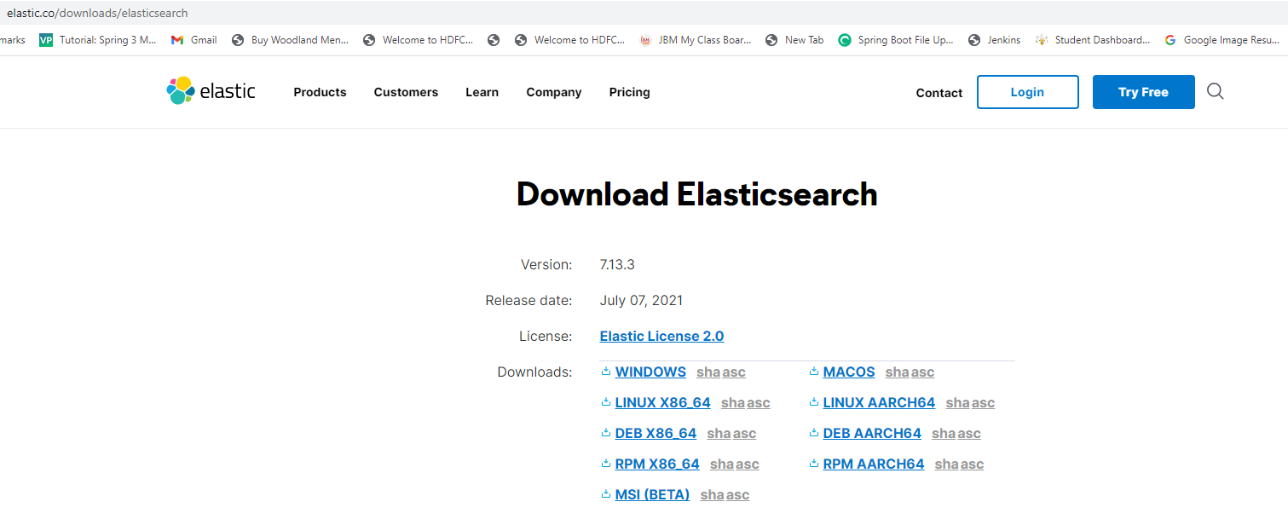

* Run the elasticsearch.bat using the command prompt. Elasticsearch can then be accessed at localhost:9200
  + cd F:\JAVA\elasticsearch-7.13.3\bin
  + elasticsearch.bat

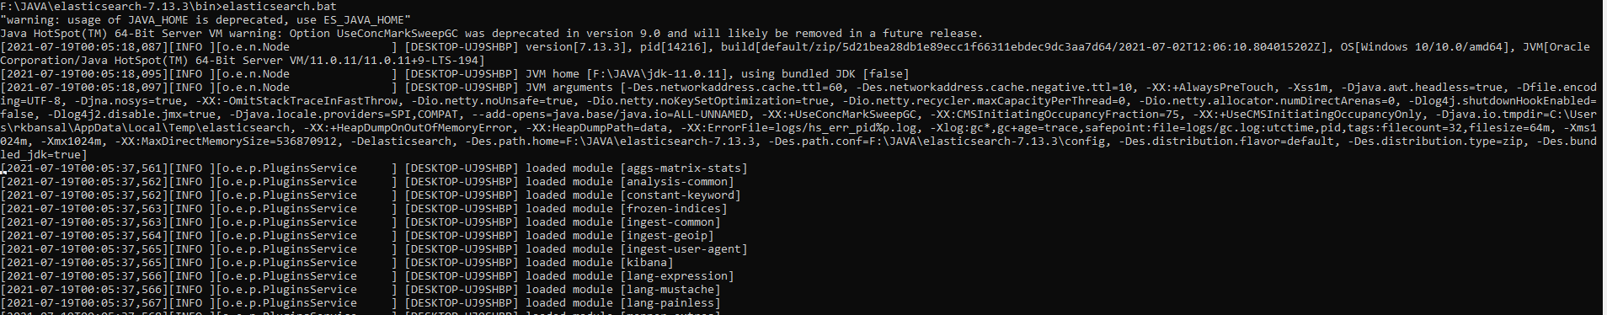

* Elasticsearch can then be accessed at localhost:9200

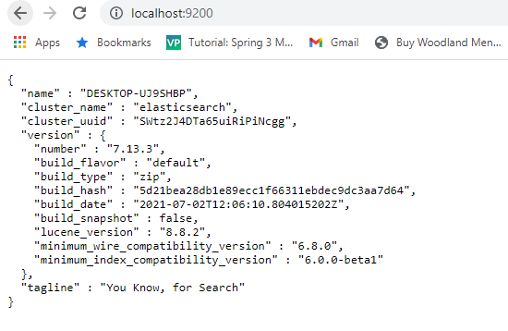

* To check the indices:
  + <http://localhost:9200/_cat/indices>

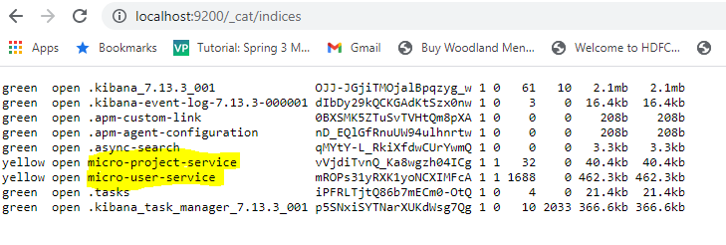

#### Kibana

Kibana is a data visualization and exploration tool used for **log and time-series analytics, application monitoring, and operational intelligence use cases**. It offers powerful and easy-to-use features such as histograms, line graphs, pie charts, heat maps, and built-in geospatial support.

It visualizes, Query and Filter the data stored in ElasticSearch store. Kibana is basically an analytics and visualization platform, which lets you easily visualize data from Elasticsearch and analyse it to make sense of it. You can assume Kibana as an Elasticsearch dashboard where you can create visualizations such as pie charts, line charts, and many others.

To build a dashboard in Kibana, users **must have data indexed in Elasticsearch** and have already built a search, visualization, or map.

By default, it run on 5601 ports.

* Download Elasticsearch zip file from <https://www.elastic.co/downloads/kibana>

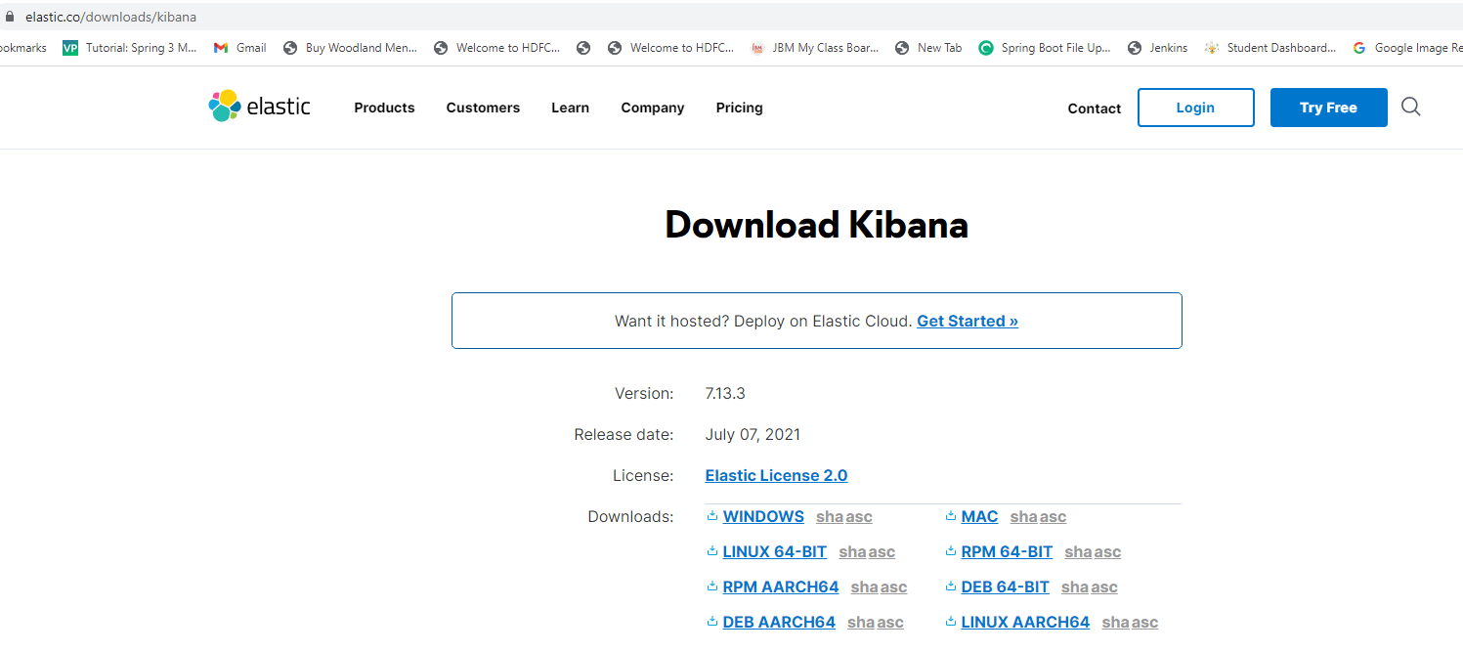

* Unzip it then run it.
  + cd F:\JAVA\kibana-7.13.3\bin
  + kibana.bat

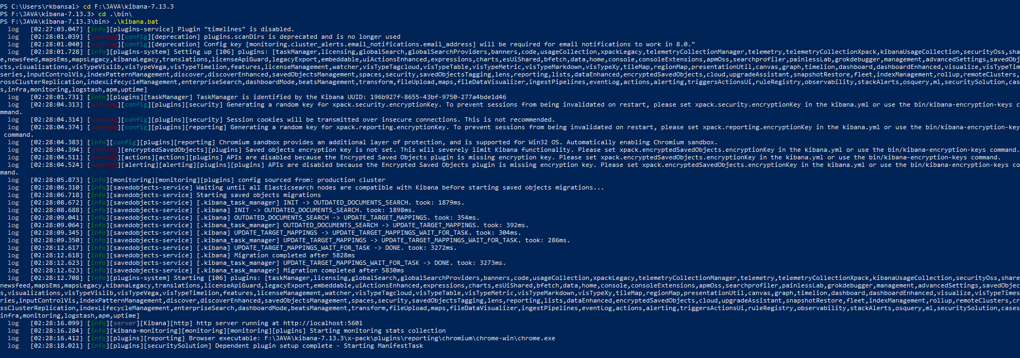

* Open up Kibana in your browser with: [http://localhost:5601.](about:blank) You will be presented with the Kibana home page.
* Go to the Dev Tools and run GET /micro-user-service
* 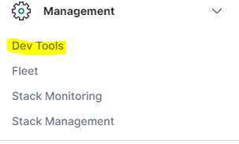

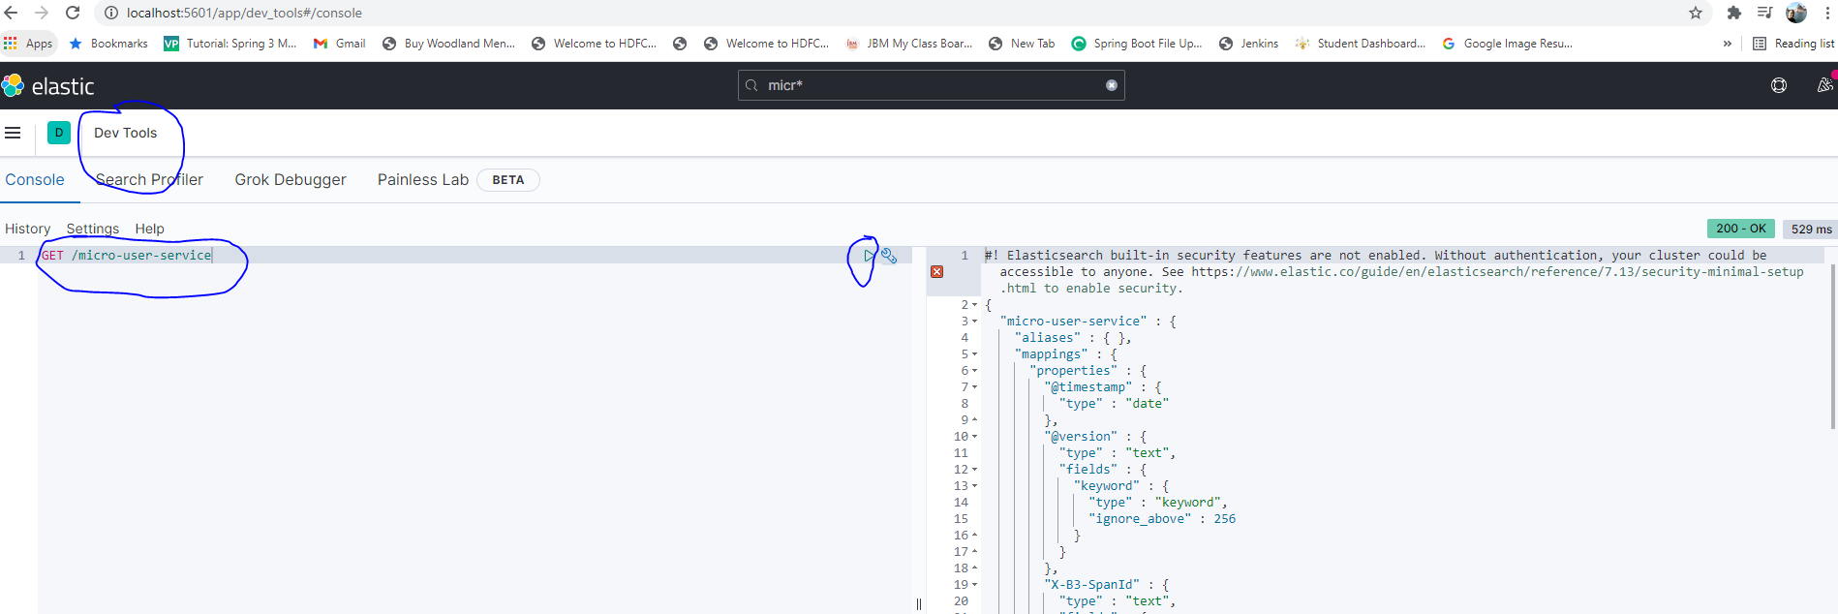

* Go to the Stack Management Section and click on Before viewing the logs in Kibana, we need to configure the Index Patterns. We can configure logstash-\* or micro-\* as default configuration.

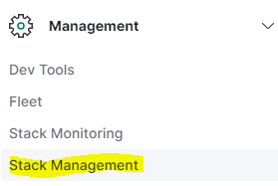

* + Create the following indexes

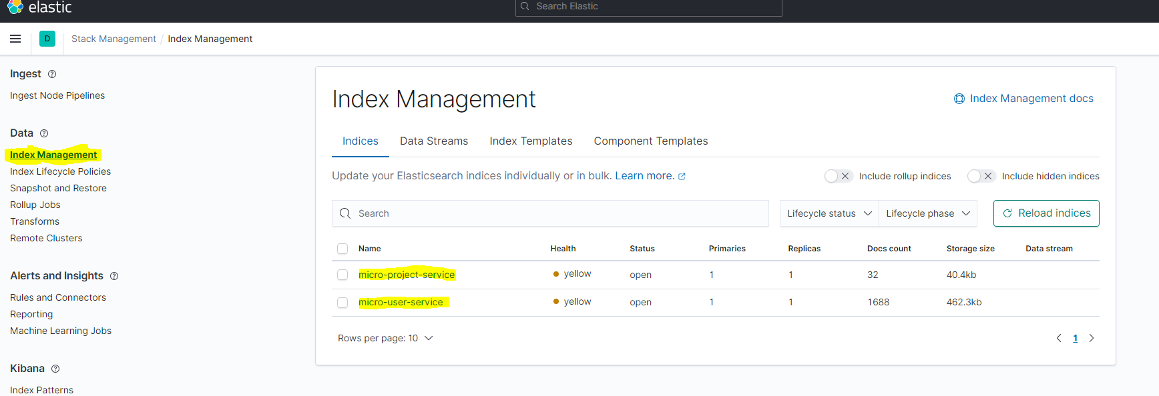

* Click on Discover under Analytics to analyse the logs.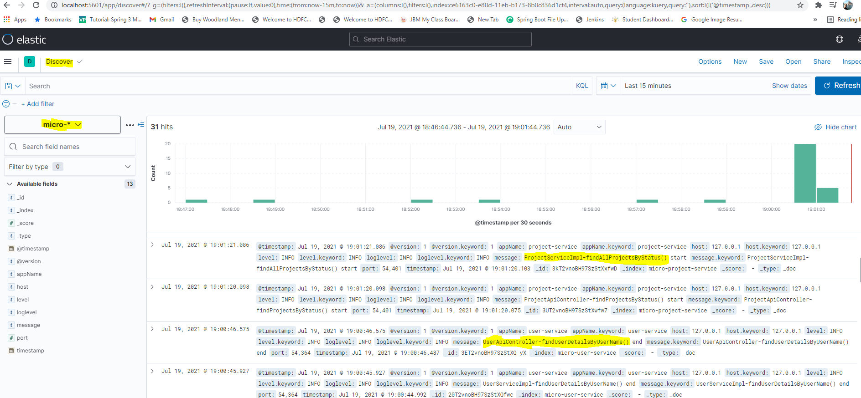

## **Helm 3 with Kubernetes**

Helm is the package manager for Kubernetes. Helm is the best way to find, share and use software for Kubernetes.

To make Helm working, need to install the Helm on two sides:

* Helm Client: It should be installed on the machine from where we will connect to the Kubernetes Cluster.
* Helm Tiller: It should be installed in the Google Kubernetes Cluster.

### Installing Kubernetes Helm Client on Windows (Using Chocolatey Package Manager)

To install Helm on your Windows operating system we would recommend you to install Chocolatey package manager on your Windows OS.

#### Steps for Chocolatey Installation

* Open **PowerShell** in administrator mode.
* With PowerShell, make sure that the property Get-ExecutionPolicy is not **Restricted**. We would recommend using the value Bypass to bypass the policy to get things installed or AllSigned for quite a bit more security.

Run Get-ExecutionPolicy. If it returns **Restricted**, then run Set-ExecutionPolicy AllSigned or Set-ExecutionPolicy Bypass -Scope Process. To do all things, run the following command:

Set-ExecutionPolicy Bypass -Scope Process -Force; [System.Net.ServicePointManager]::SecurityProtocol = [System.Net.ServicePointManager]::SecurityProtocol -bor 3072; iex ((New-Object System.Net.WebClient).DownloadString('https://chocolatey.org/install.ps1'))

* This will start the installation. Once it is installed, you can verify it by running the command:

choco -?

Once you have installed Chocolatey, it's just a matter of running a single command to install Helm.

#### To install Helm client in Open PowerShell

* If we have already installed Chocolatey, run choco in shell and you will see the following output:

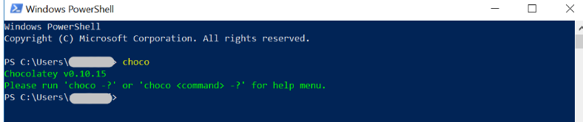

* To install Helm, we have to run the following command:

choco install kubernetes-helm

This will download and install the Helm package to your Windows OS.

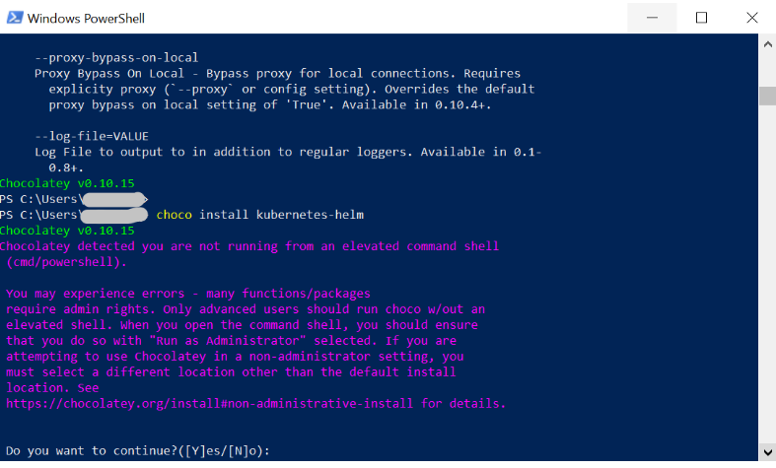

You may see the above message if you are using PowerShell to install Helm, but don't worry, press Y and hit Enter to proceed with the installation.

This will install the Helm package on your machine.

#### Verify Helm installation

To verify the Helm installation, type helm and hit enter:

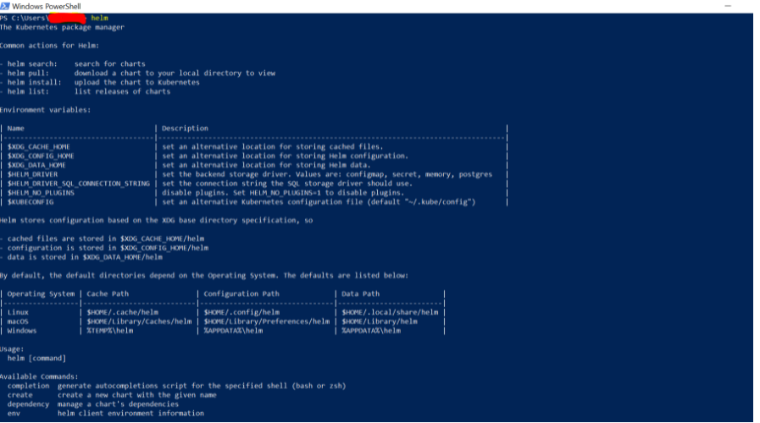

### Installing Helm Tiller in Google Kubernetes Cluster [It may not be required if using Helm 3]

Following are the steps to install Helm Tiller in Google Kubernetes Cluster or may refer the shell script: helm-tiller.sh



* Connect to the Kubernetes Cluster

gcloud container clusters get-credentials jmk-cluster --zone us-central1-c --project logical-lock-315311

* Installs helm with bash commands for easier command line integration

curl https://raw.githubusercontent.com/kubernetes/helm/master/scripts/get | bash

* Add a service account within a namespace to segregate tiller

kubectl --namespace kube-system create sa tiller

* create a cluster role binding for tiller

kubectl create clusterrolebinding tiller --clusterrole cluster-admin --serviceaccount=kube-system:tiller

* initialized helm within the tiller service account

helm init --service-account tiller

* updates the repos for Helm repo integration

helm repo update

* verify that helm is installed in the cluster

kubectl get deploy, svc tiller-deploy -n kube-system

### Creating Helm Chart

Helm Chart is a form of packaging that uses a collection of Kubernetes resources to define an application.

It uses a template approach to deploy applications. Templates give structure to projects and are suitable for any type of application.

Creating a Helm chart involves creating the chart itself, configuring the image pull policy, and specifying additional details in the *values.yaml* file.

* create the helm chart:

**Command:** helm create <chart\_name>

**Example:** helm create user-service

* To list the chart structure

**Command**: ls <chart\_name>

**Example**: ls user-service

**Output**:



The Helm chart directory contains:

* 1. ***charts*** – Used for adding dependent charts. Empty by default.
  2. ***templates***– Configuration files that deploy in the cluster.
  3. **Chart.yaml** – Outline of the Helm chart structure.
  4. ***Values.yaml***– Formatting information for configuring the chart.
* To see the structure in the eclipse

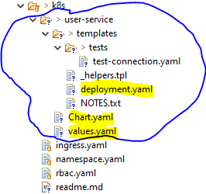

* Update the following files to install the helm chart
  1. Deployment.yaml : need to configurable those attributes which can be changed frequently.
  2. Values.yaml: provides the values for the attributes configured in the deployment.yaml.
  3. Chart.yaml: It defines the name of the chart, application version etc.

1. Deployment.yaml

apiVersion: v1

kind: ConfigMap

metadata:

name: {{ .Values.configmap}}

namespace: {{ .Values.namespace}}

data:

"spring.active.profile": "prod"

"database.hostname": "db-server.cznoz9bpqnlj.ap-south-1.rds.amazonaws.com"

"database.name": "users\_db"

"database.port": "3306"

"database.username": "bjjd"

---

apiVersion: v1

kind: Secret

metadata:

name: {{ .Values.secret}}

namespace: {{ .Values.namespace}}

type: Opaque

stringData:

database.root.password: server\_42\_123 #My sql root password:bjjd

database.password: bjjd\_379

---

apiVersion: apps/v1

kind: Deployment

metadata:

name: {{ .Values.name}}

namespace: {{ .Values.namespace}}

labels:

app: {{ .Values.name}}

spec:

replicas: {{ .Values.replicas}}

minReadySeconds: 45

selector:

matchLabels:

app: {{ .Values.name}}

strategy:

rollingUpdate:

maxSurge: 25%

maxUnavailable: 25%

type: RollingUpdate

template:

metadata:

labels:

app: {{ .Values.name}}

spec:

hostname: busybox-1

subdomain: default-subdomain

containers:

- name: {{ .Values.name}}

image: {{ .Values.image}}

imagePullPolicy: Always #IfNotPresent

ports:

- name: http

containerPort: {{ .Values.port}} # The port that the container exposes

- name: multicast

containerPort: 5701 # The port that Hazelcast exposes

env:

- name: DB\_HOSTNAME

valueFrom:

configMapKeyRef:

name: {{ .Values.configmap}}

key: database.hostname #MySQL db host name

- name: DB\_NAME

valueFrom:

configMapKeyRef:

name: {{ .Values.configmap}}

key: database.name

- name: DB\_USERNAME

valueFrom:

configMapKeyRef:

name: {{ .Values.configmap}}

key: database.username

- name: DB\_PASSWORD

valueFrom:

secretKeyRef:

name: {{ .Values.secret}}

key: database.password

- name: DB\_PORT

valueFrom:

configMapKeyRef:

name: {{ .Values.configmap}}

key: database.port

- name: SPRING\_ACTIVE\_PROFILE

valueFrom:

configMapKeyRef:

name: {{ .Values.configmap}}

key: spring.active.profile

restartPolicy: Always

terminationGracePeriodSeconds: 60

---

apiVersion: v1

kind: Service

metadata:

name: {{ .Values.name}}

namespace: {{ .Values.namespace}}

labels: #PODS

app: {{ .Values.name}}

spec:

type: {{ .Values.servicetype}} #NodePort or LoadBalancer or ClusterIP

selector:

app: {{ .Values.name}}

ports:

- name: hazelcast

port: 5701

- name: app

port: {{ .Values.port}}

1. Values.yaml

name: user-service

namespace: bjjd-system

configmap: user-service-configmap

secret: user-service-secrets

image: rajivbansal2981/user-service:0.0.1.RELEASE

port: 3379

servicetype: ClusterIP

replicas: 1

1. Chart.yaml

apiVersion: v1

# This is the version number of the application being deployed.

appVersion: 1.0.0.RELEASE

name: user-service

description: A Helm chart for Kubernetes

# This is the chart version. This version number should be incremented each time you make changes

version: 0.1.0

### Deploy and run the kubernetes application using Helm Chart

* Connect to the Kubernetes Cluster

gcloud container clusters get-credentials jmk-cluster --zone us-central1-c --project logical-lock-315311

* Create the namespace

**Command**: kubectl apply -f .\namespace.yaml

* Create the role-based access control

kubectl apply -f .\rbac.yaml



* Install the helm chart to deploy the docker based application in kubernetes
  1. Basic command

helm install -n bjjd-system user-service .\user-service\

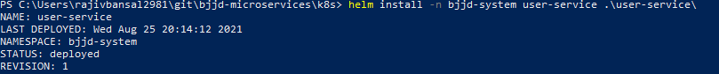

* 1. Command includes: If want to specify the location of values.yaml

helm install -f .\user-service\values.yaml -n bjjd-system user-service .\user-service\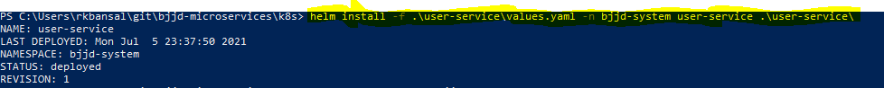

* Verify the deployment in Kubernetes:

**Command**: kubectl get pods -n bjjd-system -o wide

**Command** : kubectl get services -n bjjd-system -o wide



* Run the application: to get the user details based on the username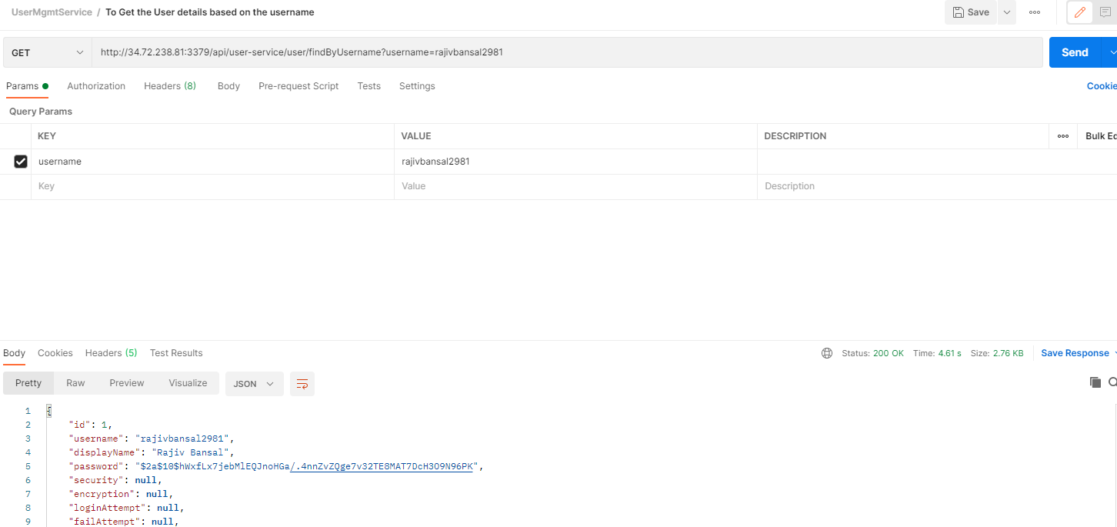

### Upgrade the Helm Chart

Upgrading the helm chart required when we make changes in the chart such as updating the image version, number of replicas in the values.yaml or if we any change in the deployment.yaml, chart.yaml file.

* 1. Basic Command

helm upgrade --install -n bjjd-system user-service .\user-service\

* 1. Command if want to specify the location of values.yaml file

helm upgrade --install -f .\user-service\values.yaml -n bjjd-system user-service .\user-service\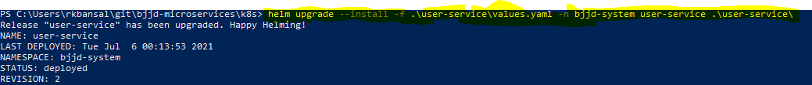

### Uninstall the Helm Chart

* Command: helm uninstall -n bjjd-system user-service



## **Istio with Helm 3 in Kubernetes**

Istio is an open-source service mesh that helps organizations run distributed microservices application anywhere. we deploy Istio container in every pod where our microservice is deployed to provide the common features such as distribute tracing, universal traffic management, telemetry, and security to complex deployments that’s why we call it sidecar container.

Following are the steps to install Istio using Helm 3.

* 1. Helm client should be installed
  2. [Download and install Istio](https://istio.io/latest/docs/setup/getting-started/#download)
  3. [Deploy the sample application](https://istio.io/latest/docs/setup/getting-started/#bookinfo)
  4. [Open the application to outside traffic](https://istio.io/latest/docs/setup/getting-started/#ip)
  5. [View the dashboard](https://istio.io/latest/docs/setup/getting-started/#dashboard)
* Open Google Cloud Shell and connect to the kubernetes cluster

gcloud container clusters get-credentials jmk-cluster --zone us-central1-c --project logical-lock-315311

* Download and extract the latest release automatically (Linux or macOS):

curl -L https://istio.io/downloadIstio | sh -

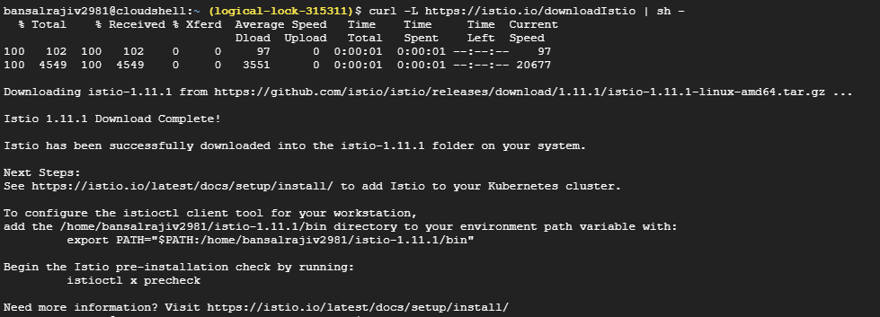

* Istios will be downloaded at

/home/bansalrajiv2981/istio-1.11.1

* Move to the Istio package directory. For example, if the package is istio-1.11.1:

cd istio-1.11.1

* Verify the installation directory contains:
  1. Sample applications in samples/
  2. The [istioctl](https://istio.io/latest/docs/reference/commands/istioctl) client binary in the bin/ directory.

ls -ltr

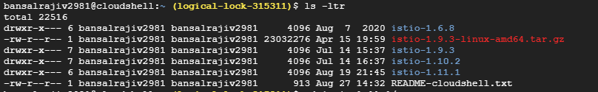

* Add the istioctl client to your path so that istioctl command can be run from anywhere.

export PATH=$PWD/bin:$PATH

* Verify helm installed so that we can install Istios feature

helm version

* Move to the Istio package directory. For example, if the package is istio-1.11.1:

cd istio-1.11.1

* Create a namespace istio-system for Istio components:

$ kubectl create namespace istio-system



* Install the Istio base chart which contains cluster-wide resources used by the Istio control plane:

$ helm install istio-base manifests/charts/base -n istio-system

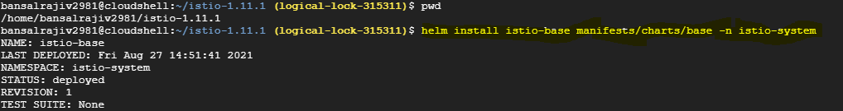

* Install the Istio discovery chart which deploys the istiod service:

helm install istiod manifests/charts/istio-control/istio-discovery -n istio-system



* (Optional) Install the Istio ingress gateway chart which contains the ingress gateway components:

helm install istio-ingress manifests/charts/gateways/istio-ingress -n istio-system



* (Optional) Install the Istio egress gateway chart which contains the egress gateway components:

helm install istio-egress manifests/charts/gateways/istio-egress -n istio-system



* (Optional) View the dashboard

Istio integrates with [several](https://istio.io/latest/docs/ops/integrations) different telemetry applications. These can help you gain an understanding of the structure of your service mesh, display the topology of the mesh, and analyze the health of your mesh.

Use the following instructions to deploy the following dashboard

* 1. [Kiali](https://istio.io/latest/docs/ops/integrations/kiali/) dashboard
  2. [Prometheus](https://istio.io/latest/docs/ops/integrations/prometheus/)
  3. [Grafana](https://istio.io/latest/docs/ops/integrations/grafana)
  4. [Jaeger](https://istio.io/latest/docs/ops/integrations/jaeger/)
  5. Zipkin

Command: Install all the above dashboard applications:

kubectl apply -f samples/addons

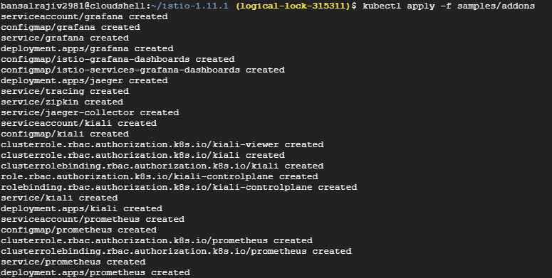

* Verify Istio Installation
  1. Verify Istio pods

kubectl get pods -n istio-system

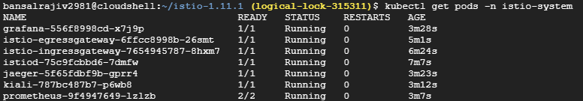

* 1. Verify Istios Services

Kubectl get services -n istio-system

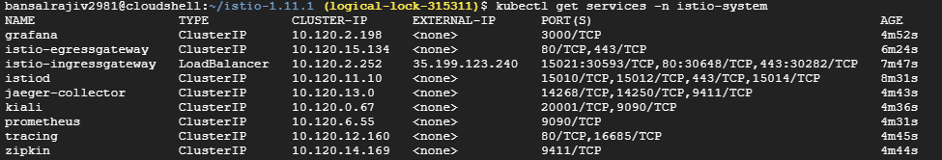

### **Injecting Istio Container in other Namespace**

* Injecting the Istios container into the other namespace where our microservices are deployed.

kubectl label namespace bjjd-system istio-injection=enabled



* Deploy the microservices in bjjd-system namespace, and check the pods details, you will find two containers deployed in every pods.

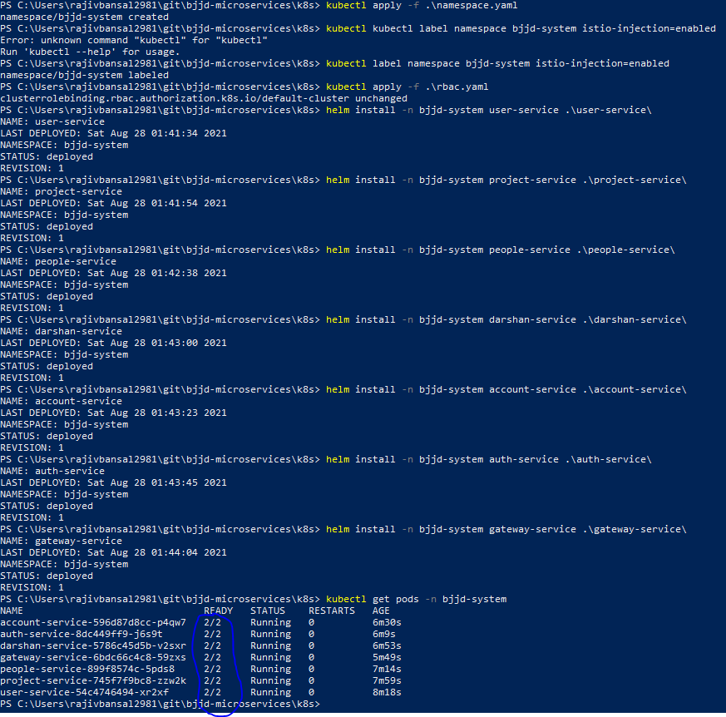

### **Istio Dashboard Tools**

* + [Kiali](https://istio.io/latest/docs/ops/integrations/kiali/) dashboard
  + [Prometheus](https://istio.io/latest/docs/ops/integrations/prometheus/)
  + [Grafana](https://istio.io/latest/docs/ops/integrations/grafana)
  + [Jaeger](https://istio.io/latest/docs/ops/integrations/jaeger/)
  + Zipkin

#### **Kiali**

Kiali is a management console for an Istio-based service mesh. It provides dashboards, observability, and lets you operate your mesh with robust configuration and validation capabilities. It shows the structure of your service mesh by inferring traffic topology and displays the health of your mesh. Kiali provides detailed metrics, powerful validation, Grafana access, and strong integration for distributed tracing with Jaeger.

* Setup access to the Kiali dashboard URL using port-forwarding so that it can be accessed locally.

kubectl port-forward $(kubectl get pod -n istio-system -l app=kiali -o jsonpath='{.items[0].metadata.name}') -n istio-system 20001



* Access Kiali Dashboard <http://localhost:20001>

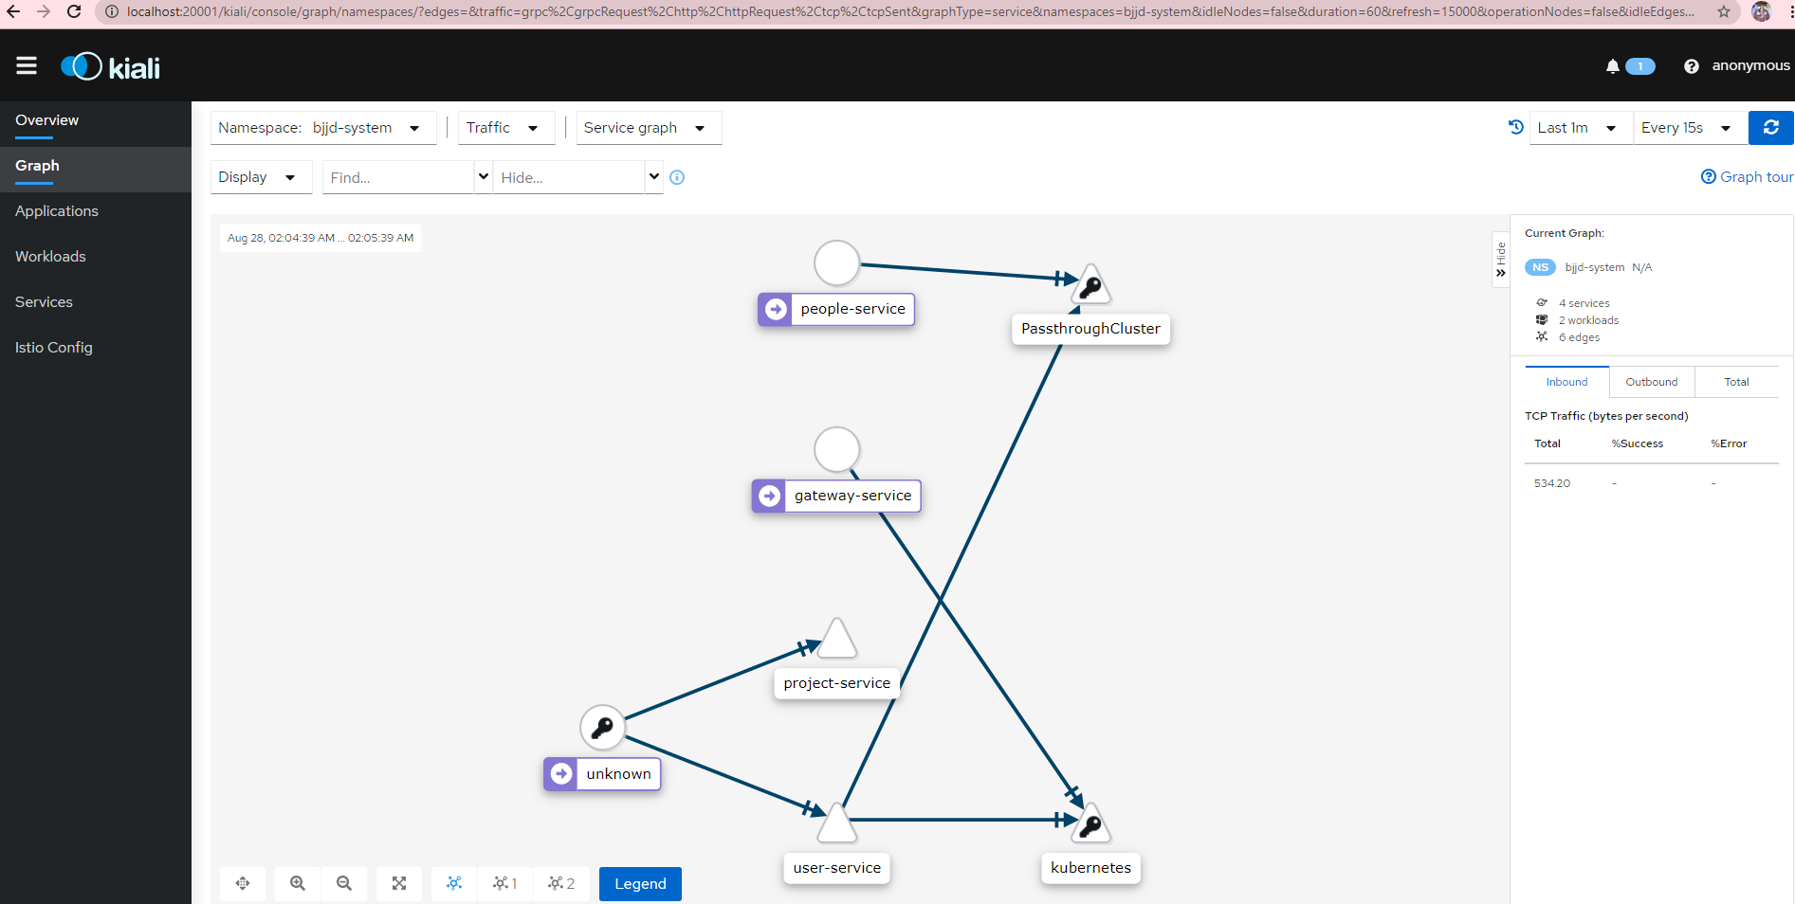

* Click on the applications to see the status of all the applications

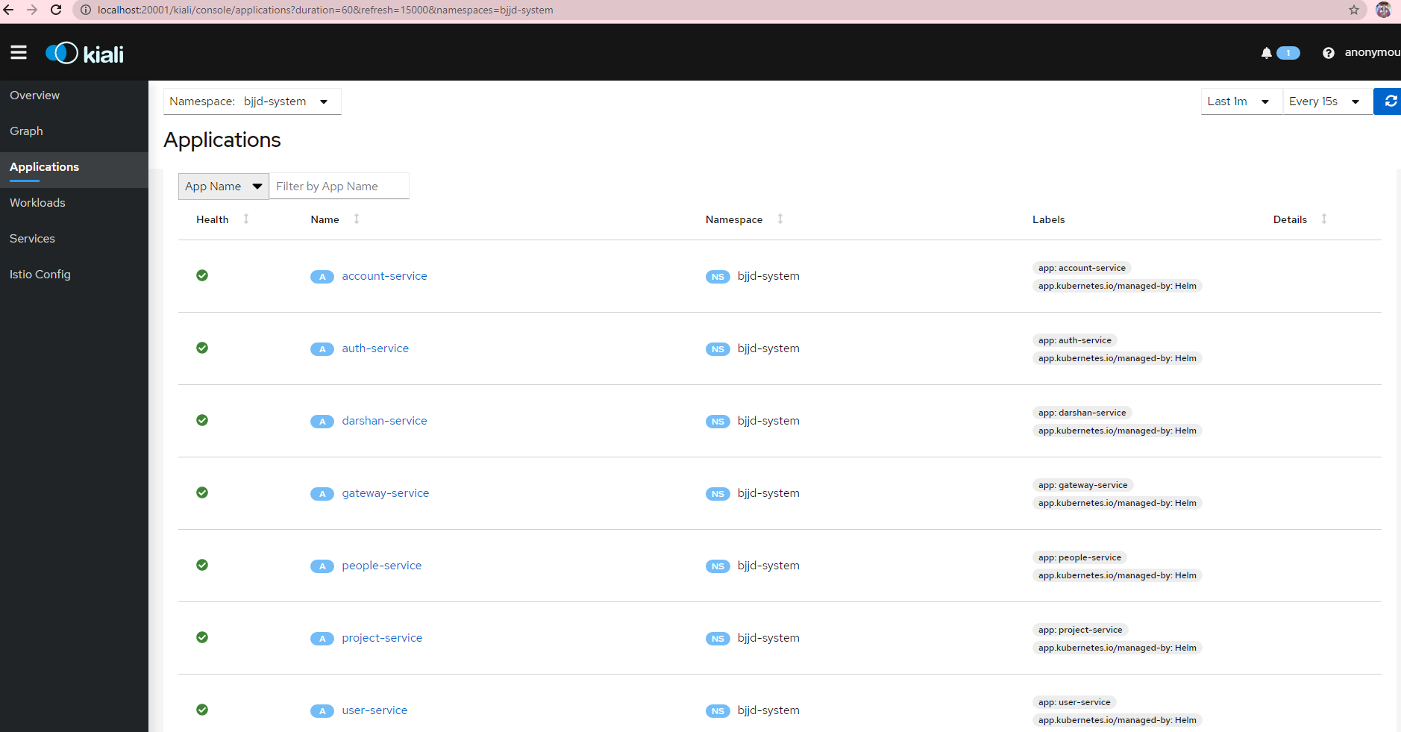

* (Optional)Create a secret `

kubectl get secret -n istio-system kiali kubectl create secret generic kiali -n istio-system --from-literal=username=admin --from-literal=passphrase=admin

#### **Grafana and Prometheus**

##### Grafana

Grafana is a multi-platform open-source analytics and interactive visualization web application.

Grafana is a web application which provides to display the performance metrics using charts, graphs, and alerts for the web when connected to supported data sources (InfluxDB or Prometheus).

The purpose of Grafana dashboards is **to bring data together in a way that is both efficient and organized**. It allows users to better understand the metrics of their data through queries, informative visualizations and alerts.

**Telegraf and InfluxDB:**

Telegraf is **a very light agent that is in charge of collecting, processing and sending** the metrics of a machine that we want to monitor to our database, InfluxDB. InfluxDB is the database in which we will store the metrics sent from the agent. This database is designed to withstand high write and read loads.

##### Prometheus (Performance metrics DB)

Prometheus is **a monitoring solution for storing time series data like metrics**. Grafana allows to visualize the data stored in Prometheus (and other sources).

**For monitoring particular instance which are running bunch of microservice following metrics are critically important:**

1. CPU Usage
2. Memory Usage and Swap
3. Bytes transferred across the network.
4. Disk read write speed.

**For monitoring particular microservice following metrics become critically important:**

1. CPU usage by the container.
2. Free and used memory statistics in the terms of heap memory.
3. Garbage Collection performance.
4. Class Loaded and threads
5. API Response time.

**All above statistics can be easily monitored, alerted and visualized using the following tools:**

1. [cAdvisor](https://github.com/google/cadvisor) — Monitoring the Docker Container and System.
2. [Spring Actuator](https://docs.spring.io/spring-boot/docs/current/reference/htmlsingle/)  –  Getting application performance metrics.
3. [Prometheus](https://prometheus.io/) — Time Series DB
4. [Grafana](https://grafana.com/) —  Graphs and Monitoring Dashboards.

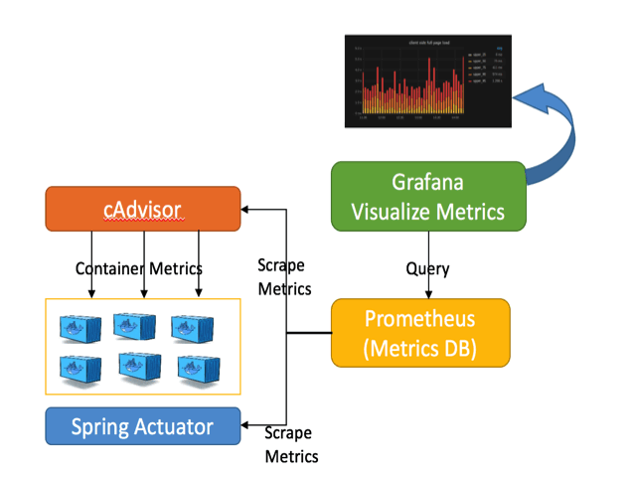

##### Setup Grafana to See Prometheus metrics

* Setup access to the Grafana dashboard URL using port-forwarding so that it can be accessed locally.

kubectl -n istio-system port-forward $(kubectl -n istio-system get pod -l app=grafana -o jsonpath='{.items[0].metadata.name}') 3000

* Access Grafana Dashboard: <http://localhost:3000>

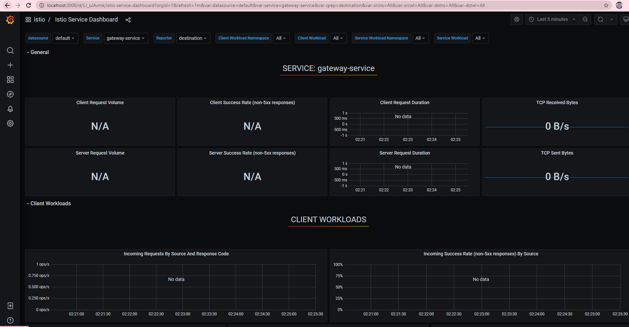

#### **Jaeger**

Jaeger is a distributed tracing system inspired by Dapper and OpenZipkin as open source by Uber Technologies. It is used for monitoring and troubleshooting microservices-based distributed applications.

##### Jaeger Architecture

Jaeger implements the OpenTracing specification to the last API, and its preferred deployment method is actually [Kubernetes](https://github.com/jaegertracing/jaeger-kubernetes). Jaeger is built with components that resemble other tracing systems, with collectors, a query service, and a UI. Jaeger also deploys an agent on every host that locally aggregates the data and sends it to the collector. The collector writes data to a data store(database) such as Elasticsearch or Cassandra and even ScyllaDB. A query system provides an API for the UI component.

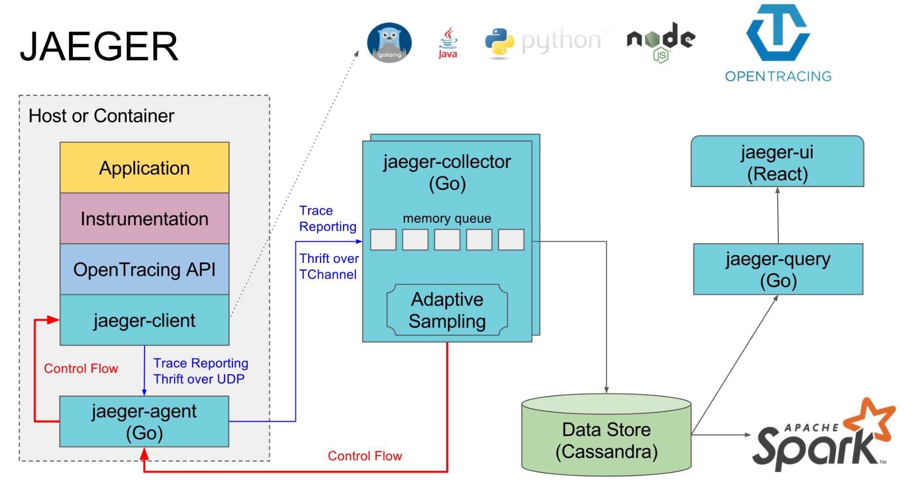

##### Jaeger Integration in Kiali

[Kiali](https://www.kiali.io/) has the ability to show traces obtained from [Istio](https://istio.io/). [Jaeger](https://www.jaegertracing.io/) collects traces for monitoring and troubleshooting microservices-based distributed systems, and both Istio and Kiali use the data that Jaeger provides.

##### Jaeger vs Zipkin

Zipkin and Jaeger both are the distributed tracing system. If Kubernetes is running in production, then adopt Jaeger. If there's no existing container infrastructure than Zipkin, it makes for a better fit because there are fewer moving pieces. Also, consider a self-hosted solution for the data layer. Unfortunately, there's no complete hosted Jaeger or Zipkin solutions, so accept the responsibility that comes with understanding and operating new production systems.

Here's a simple recommendation. Evaluate Jaeger first and see how it fits into your existing solution. If Jaeger doesn't fit, then go with Zipkin.

##### Jaeger Setup in Istio in Kubernetes

* Setup access to the Jaeger dashboard URL using port-forwarding so that it can be accessed locally.

kubectl port-forward -n istio-system $(kubectl get pod -n istio-system -l app=jaeger -o jsonpath='{.items[0].metadata.name}') 16686

* Access Jaeger Dashboard: <http://localhost:16686>

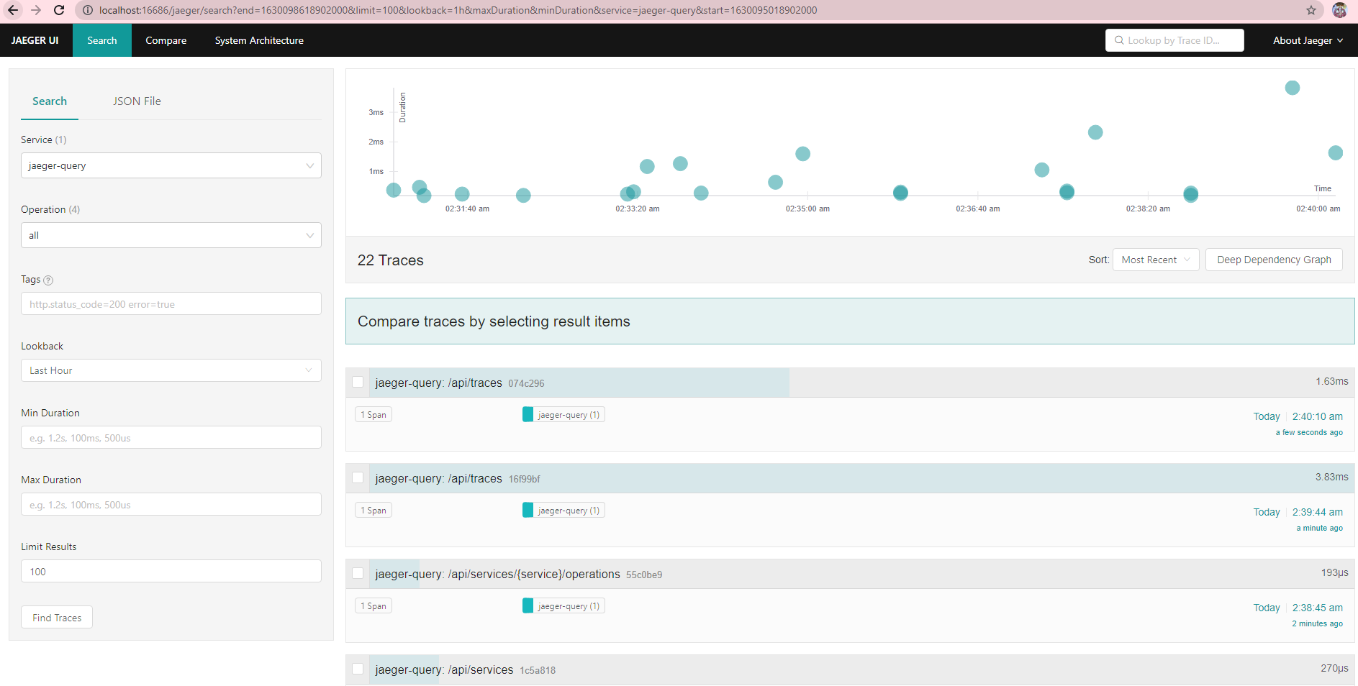

#### **Zipkin**

##### Details and Architecture

Refer Section 15.3.1.2.

##### Zipkin Setup with Istios in Kubernetes

* Open Google Cloud Shell and connect to the kubernetes cluster

gcloud container clusters get-credentials jmk-cluster --zone us-central1-c --project logical-lock-315311

* Go to the istio directory where Zipkin.yaml file is present.

Cd /home/bansalrajiv2981/istio-1.11.1/samples/addons/extras

* Deploy the Zipkin container in istio-system namespace in Kubernetes

kubectl apply -f zipkin.yaml



* Verify the Zipkin container deployment successfully.

kubectl get pods -n istio-system

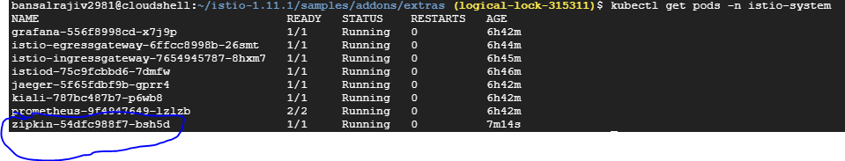

* Setup access to the Zipkin dashboard URL using port-forwarding so that it can be accessed locally.

kubectl -n istio-system port-forward $(kubectl -n istio-system get pod -l app=zipkin -o jsonpath='{.items[0].metadata.name}') 9411



* Access Zipkin Dashboard: <http://localhost:9411>

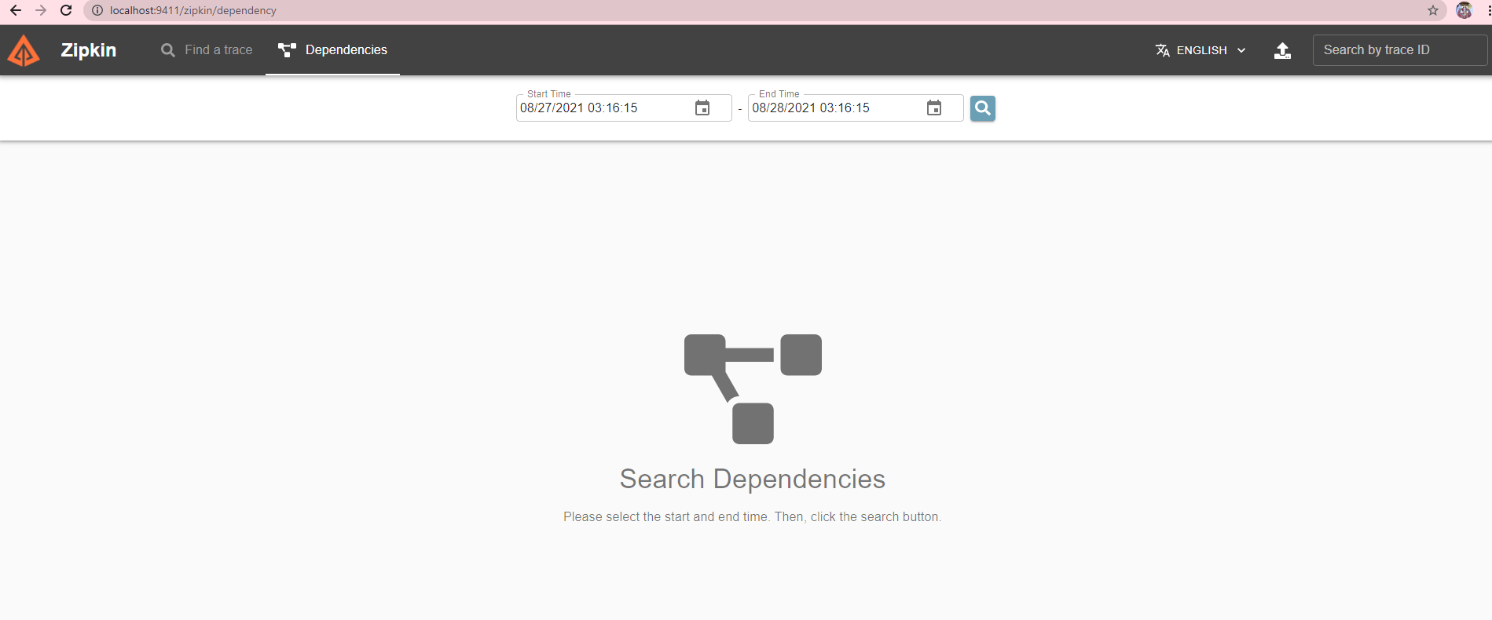

## Ribbon as LoadBalancer

Now we have learnt how to communicate with other microservices using [Feign as a REST client](http://javaonfly.blogspot.in/2017/07/microservices-communication-feign-as.html) and [Eureka server](http://javaonfly.blogspot.in/2017/07/microservicespring-cloud-eureka-server.html)as a service discovery.

In all cases, we consider only one instance of a microservice, which calls another instance of a dependent microservice (EmployeeDashBoard service call to EmployeeSearch service).

This is good for demo purposes, or when you are practicing how to develop microservices.

In production, it is certainly not the case- we break monolithic applications into microservice applications because we can scale each service based on the payload. A single instance of a service is unimaginable in production- so what we generally do is use a load balancer, which balances the payload among multiple instances of a service.

Before digging into Ribbon, the client-side load balancer for microservice architecture., let's discuss how our old fashioned Java EE services, AKA monolith, maintain load balancing.

### Server-Side Load Balancing

In Java EE architecture, we deploy our war/ear files into multiple application servers, then we create a pool of server and put a load balancer (Netscaler) in front of it, which has a public IP. The client makes a request using that public IP, and Netscaler decides in which internal application server it forwards the request by round robin or sticky session algorithm. We call it server side load balancing.

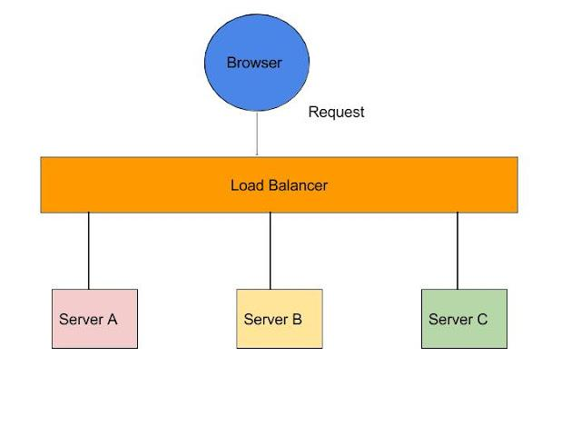

**Problem:** The problem of server-side load balancing is if one or more servers stop responding, we have to manually remove those servers from the load balancer by updating the IP table of the load balancer.

Another problem is that we have to implement a failover policy to provide the client with a seamless experience.

But microservices don't use server-side load balancing. They use client-side load balancing.

### Client-Side Load Balancing

To understand client-side load balancing, let's recap microservices architecture. We generally create a service discovery like Eureka or Consul, where each service instance registers when bootstrapped. Eureka server maintains a service registry; it maintains all the instances of the service as a key/value map, where the {service id} of your microservice serves as the key and instances serve as the value. Now, if one microservice wants to communicate with another microservice, it generally looks up the service registry using DiscoveryClient and Eureka server returns all the instances of the calling microservice to the caller service. Then it was a caller service headache which instance it calls. Here, client-side load balancing stepped in. Client-side load balancing maintains an algorithm like round robin or zone specific, by which it can invoke instances of calling services. The advantage is s service registry always updates itself; if one instance goes down, it removes it from its registry, so when the client-side load balancer talks to the Eureka server, it always updates itself, so there is no manual intervention- unlike server side load balancing- to remove an instance.

Another advantage is, as the load balancer is in the client side, you can control its load balancing algorithm programmatically. Ribbon provides this facility, so we will use Ribbon for client-side load balancing.

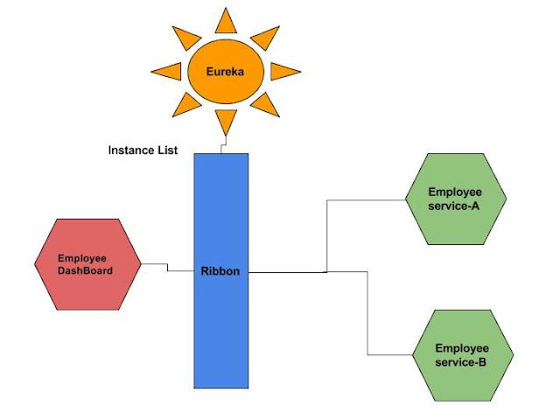

### Coding Time

We will configure Ribbon in our EmployeeDashBoardService, which will communicate with Eureka to fetch EmployeeSearchservice instances.

**Step 1:** To enable Ribbon in EmployeeDashBoard, we have to add the following dependency in pom.xml:

<dependency>

<groupId>org.springframework.cloud</groupId>

<artifactId>spring-cloud-starter-ribbon</artifactId>

</dependency>

**Step 2:** Now we have to Enable Ribbon so it can load balance the EmployeeSearch application. For that, we need to put @RibbonClient(name="EmployeeSearch") on top of the EmployeeServiceProxy interface. By doing this, we instruct Spring Boot to communicate with Eureka server and get the list of instances for service id EmployeeSearch. Please note that this is the {service-id} for the EmployeeSearch application.

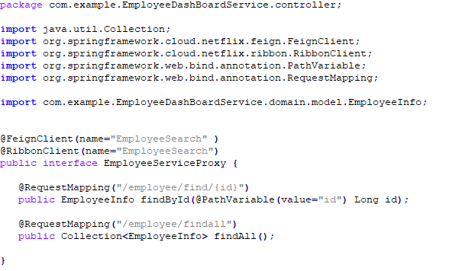

Our Ribbon Client is ready now.

### Testing Time

* Start Configserver and Eureka server first.
* Then start EmployeeService; it will be on port 8080, as we mentioned in bootstrap.preoperties.
* Now run another instance, but this time, starting with -Dserver.port=8082 so another instance comes up on 8082 port.
* After that, run the EmployeeDashBoard service.
* Now check the Eureka server GUI; it will look like the following:

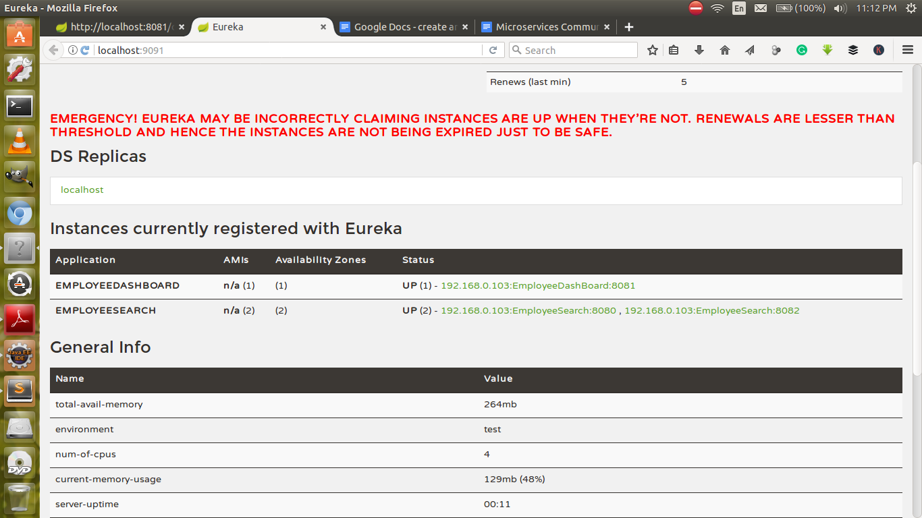

Now, if you hit the URL <http://localhost:8081/dashboard/feign/1> you can see the following response:

1

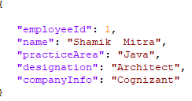

Now open the EmployeeDashBoard Console. You can see the following lines printed in the console:

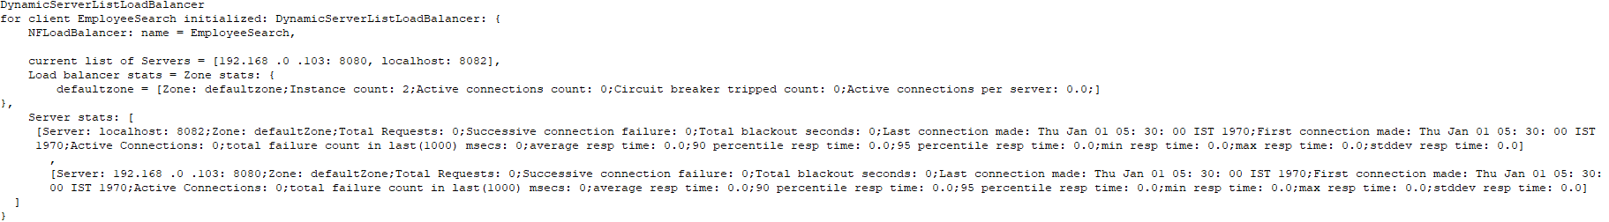



## Use Jetty/Undertow as Embedded Server

* Using Jetty as Embedded Server with Spring Boot

Remove the existing dependency on spring-boot-starter-web and add these in.

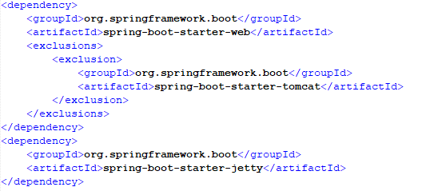

* Using Undertow as Embedded Server with Spring Boot

Remove the existing dependency on spring-boot-starter-web and add these in.

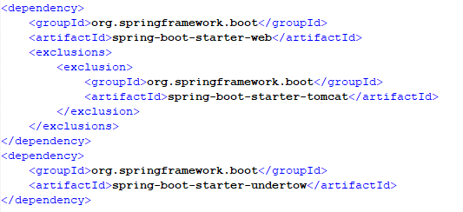

* Embedded Server Spring Boot Configuration

Spring Boot provides a number of options to configure the embedded server through application.properties

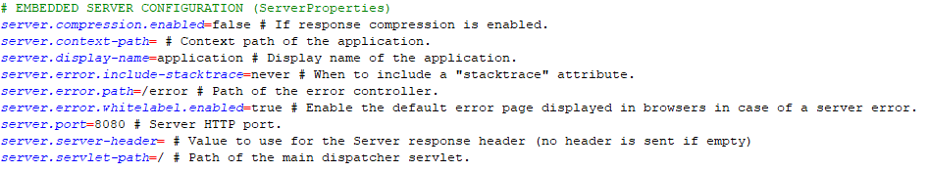

Here are a few Jetty specific options



You can also configure ssl on the embedded server

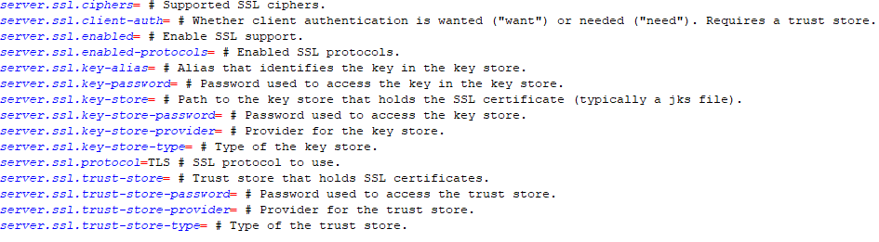

Few Tomcat specific properties are listed below

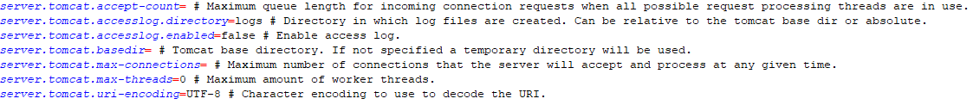

## To deploy microservice on JBoss or any External Server

* **Separate the Embedded Tomcat Server from the Spring Boot App**

There are two approaches to separate the tomcat server from the Sprint Boot application

1. Approach 1(Recommended):

Open the pom.xml and add the Tomcat dependency. Next, you can change the scope to the provided. When we make the scope as provided that means this dependency will be available during compile time only and will not be available at run-time. This is because we need this dependency in compile time to compile the web-component-related files.

Adding the Tomcat dependency and changing the scope to provided will give us the following:

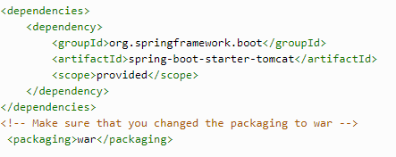

1. Approach 2(Not Recommended):

We should write some additional configuration in your Maven pom.xml file. Apart from changing the packaging method to generate a Spring Boot war package, you can exclude now the embedded tomcat server (you don’t need it) and specify a provided dependency with the javax.servlet API.

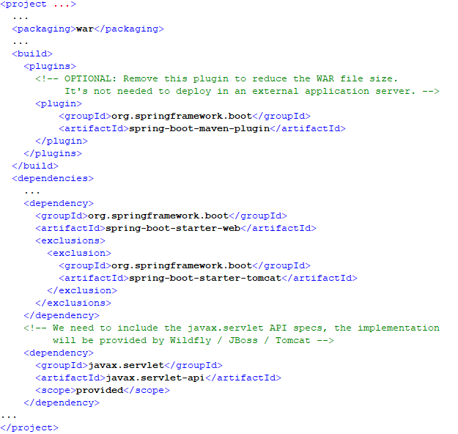

As you can see in the notes above, you can even remove the spring-boot-maven-plugin plugin, since you don’t need it when deploying on the external server. This will save you some extra megabytes in the WAR file.

Note that you can also choose to specify the spring-boot-starter-tomcat as provided, instead of excluding it from the starter web artifact. If you do that, you don’t need the javax.servlet-api artifact to build your application. However, the alternative we follow within this post saves us some megabytes in the resulting WAR file.

* **Extend the** **SpringBootServletInitializer** **class in your Spring Boot main class**

Extend the SpringBootServletInitializer class in your Spring Boot main class and override the configure method. We need to do this to initialize the application in any other servlet container like JBoss.

Override the configure method and point your sources to this same class (it’s the entry point of your application). Use the passed argument, SpringApplicationBuilder. If you don’t do that, your different components won’t be detected, won’t be injected in the context so your application won’t work.

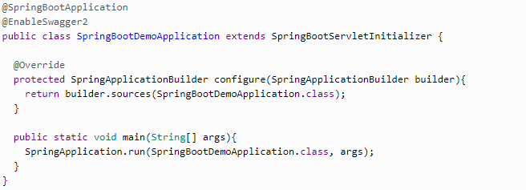

With this configuration, the application is ready to deploy to any external application server.

Once this is done, you can package your Spring Boot application as a war and deploy it to the JBoss server. To do that, you need to run mvn clean package, which will generate the war file.

* **Creating a Dockerfile to deploy the app to Wildfly**

You can find a Dockerfile and a bash script with the sources. The Docker image is based on the official one with OpenJDK 11 and Wildfly 18: [jboss/wildfly:18.0.0.Final](https://hub.docker.com/r/jboss/wildfly/" \t "_blank).

In the Dockerfile, you just need to copy the deployable spring boot war file into the deployments folder of the Wildfly server, which will take care of the rest and serve our application. To give it a friendlier name to the context, you can rename the file when copying it. By default, the base image we’re using also exposes the default web port of Wildfly, 8080.

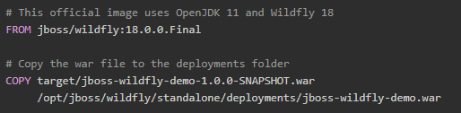

**Testing our Wildfly Spring Boot application with Docker**

To compile the sources and build the images you can use the script docker-build.sh in the [GitHub repository](https://github.com/mechero/spring-boot-jboss-wildfly), or follow these steps:

1. Compile and package the app with the maven wrapper using ./mvnw clean package. You need to have a JDK 11 or above installed.
2. Create the Docker image with docker build -t wildfly-springboot-app:1.0 .

With the -t flag, you assign a tag to the docker image so it’s easier to identify. Now we can run a container, exposing the port 8080 so it’s accessible from your host:

$ docker run -p 8080:8080 -it wildfly-springboot-app

Then you can access our application’s REST API by navigating to this URL with your browser: http://localhost:8080/jboss-wildfly-demo/hola

Using [HTTPie](https://httpie.org/doc" \l "installation" \t "_blank):

$ http :8080/jboss-wildfly-demo/hola

HTTP/1.1 200 OK

Connection: keep-alive

Content-Length: 11

Content-Type: text/plain;charset=UTF-8

Hola Amigo!

Note that jboss-wildfly-demo is the name of the file we used when copying the war file. This is what Wildfly will use to create the context for the web application. Also, if you’re running Docker with a different host IP, you may need to change localhost for that specific host.

* **Deploying the Spring Boot app to Tomcat without embedded server**

We’ve been using Wildfly as the example through this article but the instructions to deploy to Tomcat are exactly the same. To prove it, you can find a different Dockerfile in the repo that deploys the application to a Tomcat 9 container:

# This is the official image for Tomcat 9.x and OpenJDK 11

FROM tomcat:9-jdk11-openjdk-slim

# Copy the war file to the deployments folder

COPY target/jboss-wildfly-demo-1.0.0-SNAPSHOT.war

/usr/local/tomcat/webapps/tomcat-demo.war

In this case, we use the file name tomcat-demo so that will be our application context in Tomcat. We build this new image using a different Dockerfile name:

$ docker build -t tomcat-app:1.0 -f ./Dockerfile-tomcat .

And we run a container the same way as before. Remember to stop the previous one so you can use the same port number:

$ docker run -p 8080:8080 -it tomcat-app:1.0

You’ll see the “Hola Amigo!” message this time when you navigate to http://localhost:8080/tomcat-demo/hola.

## RestTemplate Vs FeignClient Vs WebClient

Calling rest service from Spring application can be done in multiple ways.

* **RestTemplate**

**RestTemplate** is used for making the synchronous call. When using RestTemplate, the URL parameter is constructed programmatically, and data is sent across to the other service. In more complex scenarios, ***we will have to get to the details of the HTTP APIs provided by RestTemplate or even to APIs at a much lower level***.

private static void getEmployees()

{

RestTemplate restTemplate = new RestTemplate();

String result = restTemplate.getForObject("http://api.example.com", String.class);

System.out.println(result);

}

* **Feign Client**

**Feign** is a Spring Cloud Netflix library for providing a higher level of abstraction over REST-based service calls. So w***hen using Feign, we write declarative REST service interfaces at the client, and use those interfaces to program the client***.

***Spring Cloud Feign works on a declarative principle means It*** is a declarative REST library that uses annotations-based architecture with thread-per-request model.

This means that the thread will block until the feign client receives the response. The problem with the blocking code is it must wait until the consuming thread completes, hence think memory and CPU cycles.

* **WebClient**

Spring WebClient is a **non-blocking** reactive client to make HTTP requests. Hence if you intend to use [Spring Reactive Stream API](https://docs.spring.io/spring-framework/docs/5.0.0.M1/spring-framework-reference/html/web-reactive.html) to stream data asynchronously then this is the way to go. Think event-driven architecture. WebClient is part of the [Spring WebFlux](https://docs.spring.io/spring-framework/docs/current/reference/html/web-reactive.html) library. So use Spring **WebClient** when needing non-blocking HTTP requests otherwise **Feign** due to simple usage model.

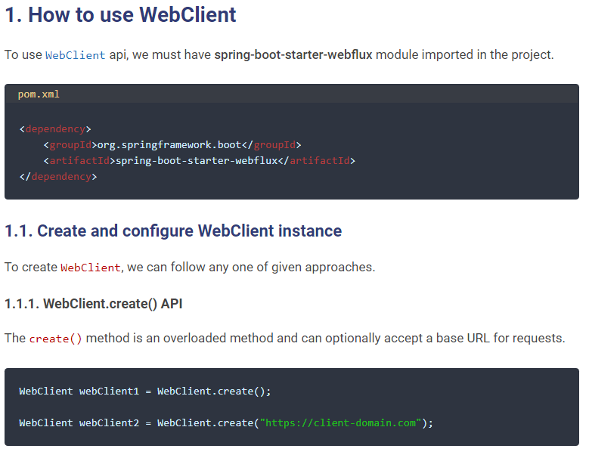

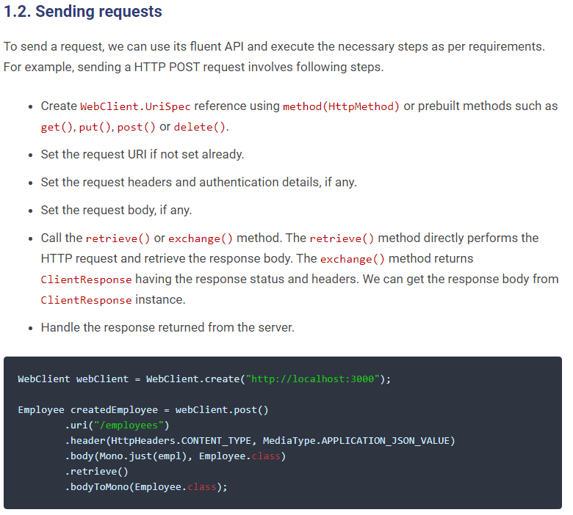

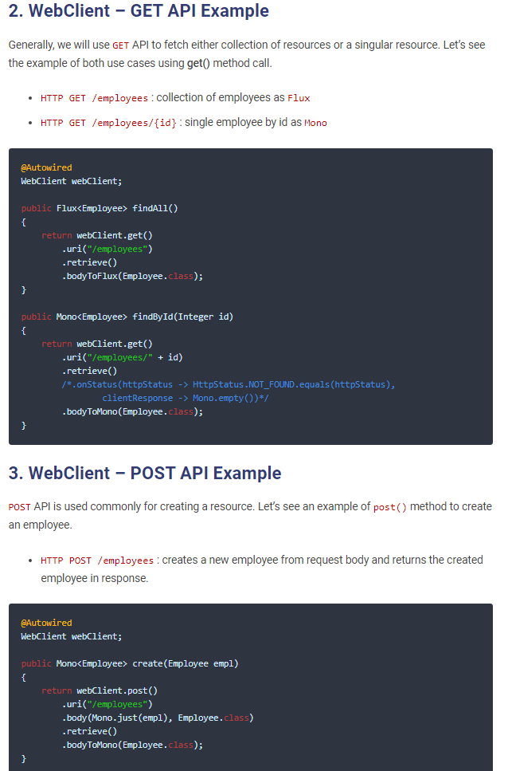

Because Flux and Mono are Reactive Streams types, they are also lazy: nothing happens until you subscribe to it. There are several methods that can achieve that goal, and subscribe or block are amongst those.

Usually, Spring WebFlux applications don't subscribe directly and actually return those reactive types; without more context in your case, I can't really say what would be the right approach here.

Check out the [Reactor project reference documentation on Flux and Mono](http://projectreactor.io/docs/core/release/reference/#core-features), this should help you understand the core principles behind this.

**How to Choose:** Since RestTemplate is now deprecated, I would really recommend using at least feign in its place, but i personally would go with webClient

## Ehcache Cache

This service will be used by other microservices to cache the reference entities. For example, this service will communicate with the people-mgmt-service, project-mgmt-service and user-mgmt-service using feign client to cache its entities.

Caching is a technique that involves the intermediate storage of data in very fast memory, usually. This means that this data can be made available much more quickly for subsequent requests since it does not have to be retrieved or recalculated from the primary and usually slower memory first.

Ehcache is an open source library implemented in Java for implementing caches in Java programs, especially local and distributed caches in main memory or on the hard disk. Thanks to the implementation of JSR-107, Ehcache is fully compatible with the javax.cache API.

* Create the Project using spring Starter Project.

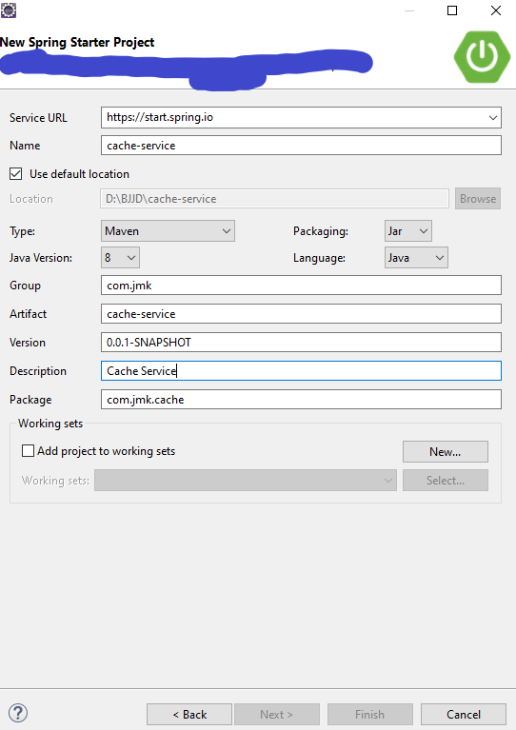

* Click on Next and Finish.
* Import the project.

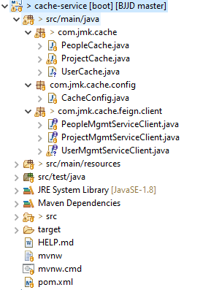

* Add the following dependencies in pom.xml with the following considerations:
  + Spring Boot Starter Parent: update the version: 2.2.4.RELEASE highlighted in yellow colour.
  + Spring Cloud version: upgraded to Hoston.SR4. It is highlighted in yellow colour.
  + Maven Jar Plugin Version: After the above updates, pom is giving compiler error in pom.xml so downgraded version of maven jar plugin to 3.1.1. It is highlighted in yellow colour.
  + Ehcache dependencies-api: ehcache, spring-boot-starter-cache and cache-api used to cache the entities.
  + Fiegn-Client: used to communicate with other microservices.

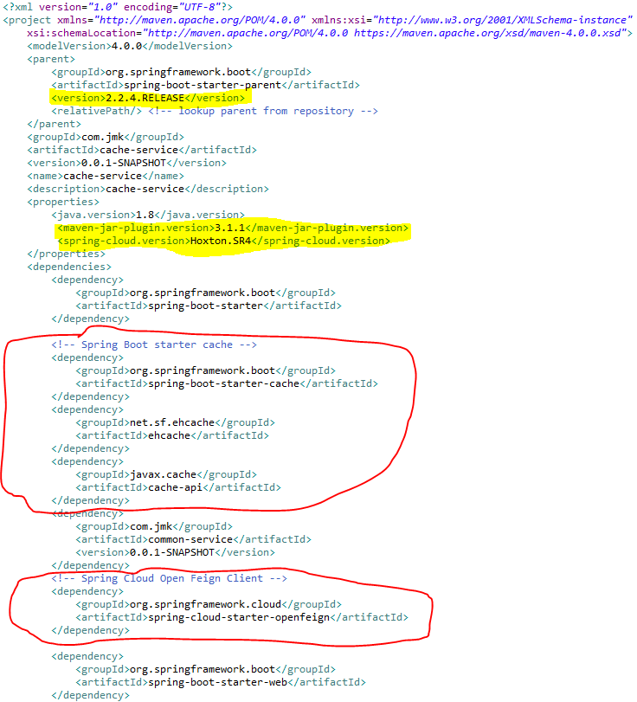

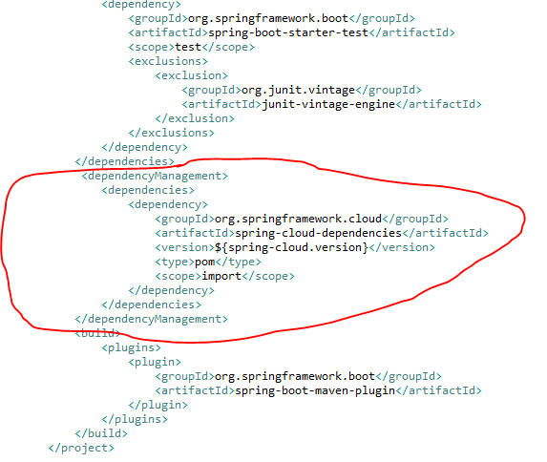

* Make application.properties empty as it is not required and will be referred by other microservices.
* Enable caching: To enable caching support in Spring Boot, we need a simple configuration class that must be annotated with @EnableCaching. Up to this point, we don’t need to do anything more as the following code shows:

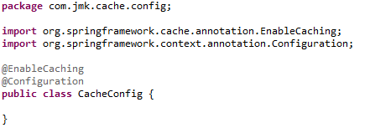

* **Cacheable operations**

Caching in Spring is basically applied to methods so that especially the calls of very costly operations can be reduced. We now want to add the result of this calculation to a cache depending on the radius passed by parameter, so that the calculation does not have to be repeated every time. To do this, we annotate the method with the @Cachable annotation:

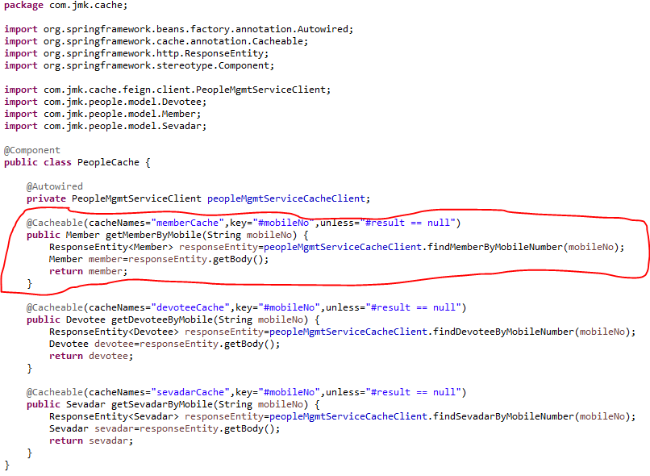

Each time this method is called with a radius greater than 5, the caching behavior is applied. This checks whether the method has already been called once for the specified parameter. If so, the result is returned from the cache and the method is not executed. If no, then the method is executed and the result is returned and stored in the cache.

The following parameters, among others, are available for annotation:

|  |  |
| --- | --- |
| **Annotation parameter** | **Description** |
| value / cacheNames | Name of the cache in which the results of the method execution are to be stored. |
| Key | The key for the cache entries as [Spring Expression Language (SpEL)](https://springframework.guru/introduction-spring-expression-language-spel/). If the parameter is not specified, a key is created for all method parameters by default. |
| keyGenerator | Name of a bean that implements the KeyGenerator interface and thus allows the creation of a user-defined cache key. |
| Condition | Condition as Spring Expression Language (SpEL) that specifies when a result is to be cached. |
| Unless | Condition as Spring Expression Language (SpEL) that specifies when a result should not be cached. |

**Similar way, we have written cacheable operations for ProjectCache and UserCache**

**Project Cache**

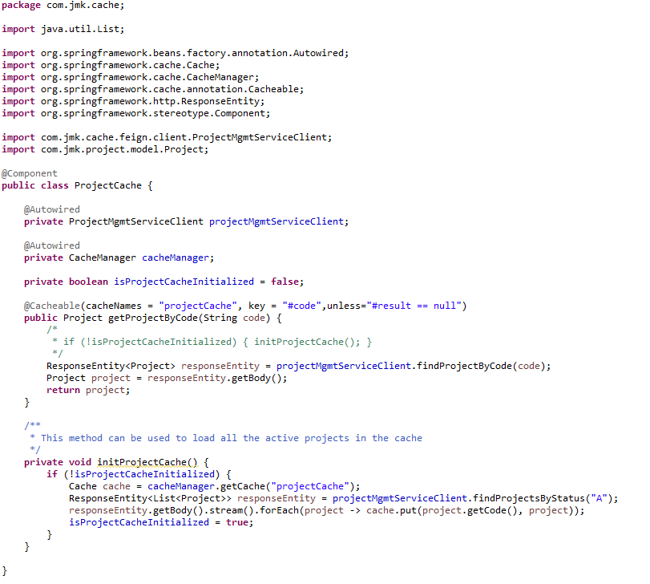

**UserCache**

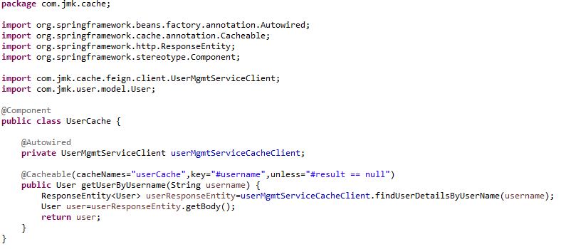

* **Ehcache Cache Configuration**

Now the configuration of the Ehcache cache has to be done. The configuration is XML-based. We create the XML file ehcache.xml in the resource folder of our application.

ehcache.xml is the configuration file used to configure the cache of entities.

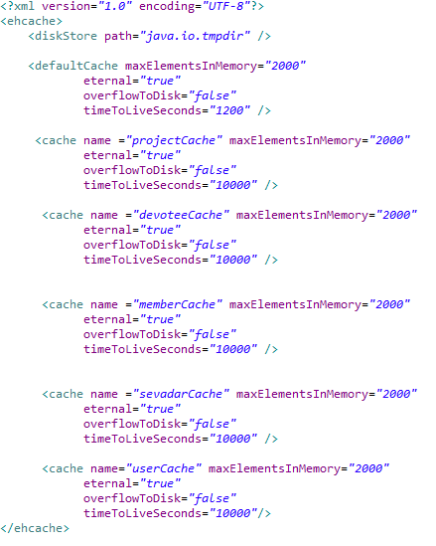

* Feign Client is being used to cache entities.
  + **FeignClient: ProjectMgmtServiceClient**

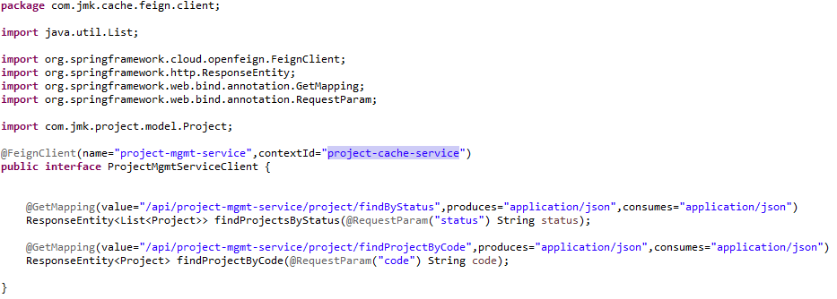

* + **FeignClient: PeopleMgmtServiceClient**

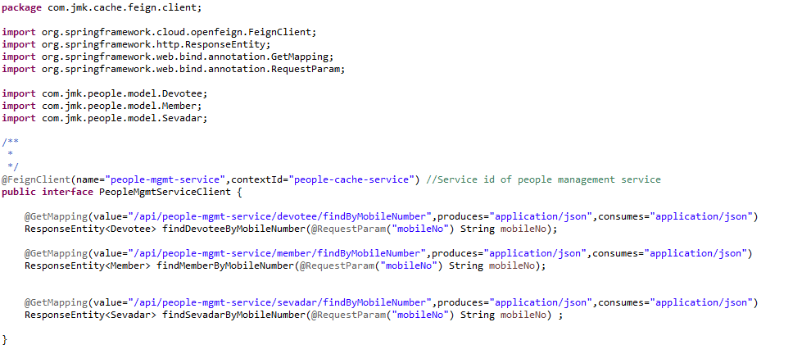

* + **FeignClient: UserMgmtServiceClient**

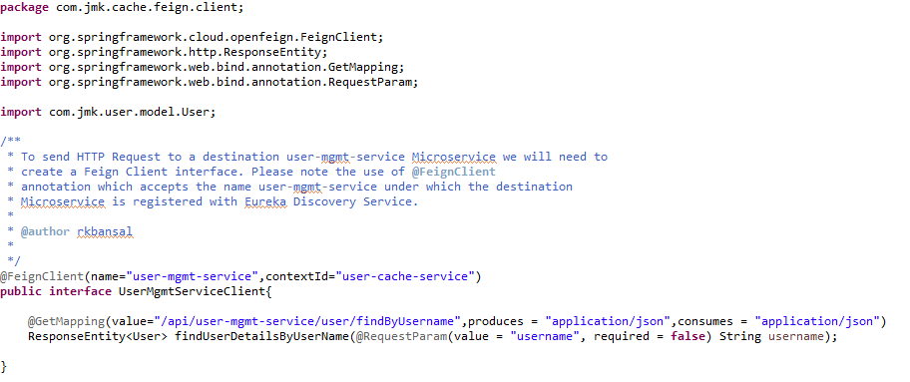

* **How to use the Cache in other projects.**

For example: darshan-mgmt-service

* 1. Import the dependency of cache-service

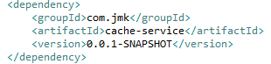

* 1. Enable the package scan of FeignClient which is used by cache class.

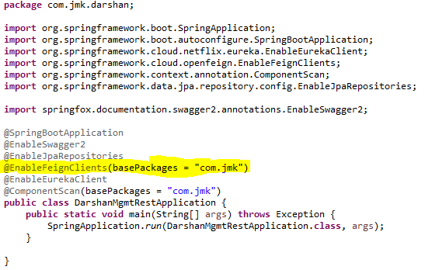

* 1. **Cache used In DarshanApiController**

